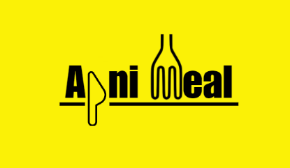

ApniMeal: A Hyper-Local Food Marketplace

  - Requirement and Design Document

Submitted by: Saima Arora(2310991117)

Table of contents

Introduction & Purpose 3
Overall Description 4
System Users & Roles 5
Functional Requirements 6
Non-Functional Requirements 10
System Architecture (High-Level Design) 12
Database Design 15
API Design 18
Frontend Design 19
Backend Design 20
Data Flow & System Flow 21
Security Design 22
Testing Strategy 23
Future Enhancements 23

Introduction & Purpose
ApniMeal is a specialized full-stack web application designed to bridge the gap between university hostel students and home cooks in neighbouring communities. While mainstream food delivery platforms often overlook niche hyper-local ecosystems, this project provides a dedicated platform where students can access nutritious, home-cooked meals while empowering local residents—specifically home cooks in nearby villages—to digitize their culinary businesses.

Purpose
The primary objective of this project is to create a seamless, transparent, and efficient marketplace that handles food discovery, order management, and status tracking. By focusing on a specific user demographic (students and local cooks), the system simplifies the logistics of traditional food delivery into a streamlined digital experience.

Scope
The application encompasses a complete end-to-end solution, including:
- A User Authentication system with role-based access for Students and Cooks.
- A Food Management module for cooks to list and price their dishes.
- A Discovery Engine allowing students to search and filter available home-cooked meals.
- An Order Processing pipeline that manages the lifecycle of a meal from "Pending" to "Delivered."
- Interactive Dashboards for both user roles to track activity and history.

Overall Description

Product Perspective
ApniMeal is a standalone web application designed using the MERN (MongoDB, Express, React, Node.js) stack. It operates as a localized ecosystem where the "Student" and the "Cook" are digitally connected. The system manages the entire lifecycle of a food order—from the moment a home cook lists a dish to the final delivery confirmation for the student.

Product Functions
The system provides three core functional areas:
- Discovery & Selection: A searchable marketplace where students can filter meals by name, description, and dietary preferences (Veg/Non-Veg).
- Order Lifecycle Management: A state-driven system that moves orders through four distinct phases: Pending, Accepted, Preparing, and Delivered.
- Business Management for Cooks: A dedicated interface for home cooks to manage their digital storefront, including price setting, dish availability toggles, and revenue tracking.
User Classes and Characteristics
The platform identifies two primary user roles:
- Students: Users located in hostels who require affordable, healthy, home-cooked meal options. They interact primarily with the marketplace and order tracking features.
- Home Cooks: Residents of nearby villages who provide the food. They require a simple interface to manage their daily menu and monitor incoming orders.

Operating Environment
- Client Side: Compatible with modern web browsers (Chrome, Firefox, Safari, Edge).
- Server Side: Runs on Node.js environment.
- Database: MongoDB (Cloud-hosted via Atlas or local instance).

Design and Implementation Constraints
- Security: User passwords must be hashed before storage, and session management must be handled via stateless JWT tokens.
- Data Consistency: The system must ensure that an order cannot be placed if a dish is marked as "Unavailable" by the cook.

System Users & Roles
The system utilizes Role-Based Access Control (RBAC) to ensure that students and cooks only access the features relevant to their needs. It enforces security through Middleware. Every request to a "Cook-only" route (like adding a dish) or a "Student-only" route (like placing an order) is intercepted by the backend to verify the user's role stored within their JWT. If a student attempts to access a cook’s dashboard, the system will return an Unauthorized Access error.

User Roles and Responsibilities
User Role | Primary Responsibility | Key Interactions
Student | Consumer | Browsing menus, searching for specific dishes, placing orders, and tracking the status of their meals.
Home Cook | Provider | Managing their digital kitchen, listing available dishes, setting prices, and processing incoming orders through various stages.

Detailed Role Permissions
  - Student Permissions
The Student role is designed for a consumption-focused experience. Students are permitted to:
- Profile Management: Register, login, and maintain a personal profile.
- Food Discovery: View all available food items from various home cooks and use the Text Search feature to find specific meals (e.g., "Rajma," "Paneer").
- Order Management: Add items to a cart, place new orders, and view their personal Order History.
- Real-Time Tracking: Monitor the current state of their active orders (e.g., whether the cook has "Accepted" or is "Preparing" the food).
  - Home Cook Permissions
The Home Cook role is designed for a management-focused experience. Cooks are permitted to:
- Menu Management (CRUD): * Create: Add new dishes with titles, descriptions, and pricing.
  - Update: Edit existing dish details or toggle the "Available" status if a dish is sold out.
  - Delete: Remove dishes that are no longer offered.
- Order Fulfillment: Receive notifications of new orders and manually update the status (e.g., moving an order from Pending to Accepted).
- Revenue Tracking: Access a dashboard that summarizes total orders and total revenue earned.

Functional Requirements
The functional requirements define the specific behaviours and services the system must provide. These are categorized by the core modules of the marketplace, ensuring a comprehensive breakdown of the project’s capabilities.

User Authentication and Profile Management
This module handles the security and identity of all users on the platform.
- User Registration
  - The system shall allow new users to create an account by providing their Name, Email, and Password.
  - Users must select a role during registration: Student or Home Cook.
  - The system shall ensure that all email addresses are unique in the database.
- User Login
  - The system shall authenticate users using their registered Email and Password.
  - Upon successful login, the system shall generate and return a JSON Web Token (JWT) to be used for session management.
- Persistent Session
  - The system shall store the JWT on the client side to keep the user logged in across page refreshes.
- Profile Retrieval
  - The system shall provide an endpoint to fetch the logged-in user's profile details based on the stored token.

Home Cook: Food Management (CRUD)
This module empowers the home cooks to manage their digital kitchen and menu.
- Create Food Item
  - The system shall allow a cook to add a new dish by providing a Title, Description, Price, and Veg/Non-Veg status.
  - The system shall automatically associate the food item with the ID of the cook who created it.
- Read/View Personal Menu
  - The system shall allow cooks to view a list of all dishes they have uploaded to the platform.
- Update Food Item
  - The system shall allow cooks to modify the details (Price, Title, Description) of existing dishes.
  - The system shall provide an "Availability Toggle" to mark a dish as currently available or out of stock.
- Delete Food Item
  - The system shall allow cooks to permanently remove a dish from their menu.

Student: Food Discovery and Search
This module provides the interface for students to find meals within the marketplace.
- Global Menu Feed
  - The system shall display a list of all available food items from all cooks on the Student Home Page.
- MongoDB Text Search
  - The system shall allow students to search for food using keywords.
  - The search functionality must query the Title and Description fields of the Food collection using text indexing.
  - Example: Searching for "Paratha" should return all dishes where "Paratha" appears in the name or description.
- Food Item Details
  - The system shall display the price, dietary preference (isVeg), and the name/ID of the cook for every listed item.

Order Placement and Processing
This module facilitates the transaction and communication between the student and the cook.
- Order Creation
  - The system shall allow students to place an order for a specific food item.
  - The order must capture the Student ID, Cook ID, Food Item ID, Quantity, and calculate the Total Price.
- Initial Order State
  - Every new order must be created with a default status of "Pending."
- Order Tracking (Student)
  - The system shall provide students with a "My Orders" view to see the status of their current and past orders.
- Order Management (Cook)
  - The system shall provide cooks with a view of all incoming orders placed for their food.

Order Status Workflow
This module defines the state machine for the order delivery process.
- Status Updates
  - The system shall allow the Home Cook to update the status of an order through the following sequence:
    - Accepted: The cook acknowledges the order.
    - Preparing: The cook is currently making the food.
    - Delivered: The food has reached the student.
- Status Validation
  - The system shall ensure that only the assigned cook can update the status of an order.

Dashboards and Analytics
This module provides summarized data for both user roles to monitor their activity.
- Student Dashboard
  - The system shall display a summary of Active Orders and Order History for the student.
- Cook Dashboard
  - The system shall display the Total Orders received.
  - The system shall display a count of Pending Orders that require immediate attention.
  - The system shall calculate and display the Total Revenue generated by the cook.

Backend System Requirements
These are background functionalities required to support the UI.
- Error Handling
  - The system shall implement global error-handling middleware to catch and return meaningful error messages to the frontend.
- Input Validation
  - The system shall validate all incoming request data (e.g., ensuring prices are positive numbers and email formats are correct) before processing.

Non-Functional Requirements
While functional requirements define what the system does, non-functional requirements define how the system performs. These constraints ensure ApniMeal is secure, reliable, and user-friendly.

Performance Requirements
- Response Time: The backend API should respond to standard requests (like fetching food items or user profiles) within 200-500ms under normal load.
- Search Efficiency: Utilizing MongoDB Text Indexes on the title and description fields, the system must retrieve search results in under 100ms, even as the Food collection grows.
- Concurrency: The system should be capable of handling multiple simultaneous orders from different students without data race conditions, managed by the asynchronous nature of Node.js.

Security Requirements
- Data Protection: All user passwords must be encrypted using bcrypt hashing before being stored in the MongoDB database. Plain-text passwords must never be stored.
- Authentication: Access to protected routes (e.g., placing an order, adding a dish) must strictly require a valid JWT (JSON Web Token) passed in the HTTP Authorization header.
- Authorization: The system must implement Role-Based Access Control (RBAC) to ensure a Student cannot access Cook-specific functions (like addFoodItem) and vice versa.

Reliability and Availability
- Database Integrity: The system must use Mongoose Schemas to enforce data types and required fields, preventing "dirty data" from entering the MongoDB collections.
- Error Resilience: The backend must utilize a Global Error Handling Middleware to catch runtime exceptions, preventing the Node.js server from crashing and providing the user with a "500 Internal Server Error" message instead of a blank screen.
- Uptime: The system should aim for high availability, ensuring that students can place orders during peak meal times without service interruptions.

Scalability
- Database Scalability: By using MongoDB (a NoSQL database), the system is designed to scale horizontally as the number of users and order documents increases.

Usability
- Interface Simplicity: The React frontend must provide a clear distinction between the Student Dashboard and the Cook Dashboard to prevent user confusion.
- State Visibility: Users must receive immediate visual feedback when an action is performed (e.g., a "Loading" spinner during API calls or a "Success" toast notification after placing an order).

System Architecture (High-Level Design)
The system follows a Client-Server architecture using the MERN (MongoDB, Express, React, Node.js) stack. This architecture ensures a clear separation of concerns, where the frontend handles the user experience and the backend manages the business logic and data persistence.

Architectural Diagram
The following diagram illustrates the flow of data from the User Interface down to the Database.
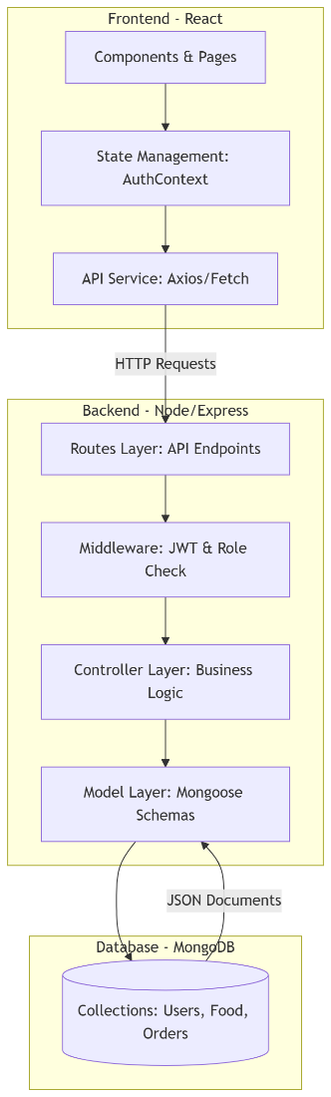

Component Responsibilities
Frontend (React)
The frontend acts as the View layer in our architecture. Its primary responsibilities include:
- Routing: Managing navigation between pages (Home, Login, Dashboards) using React Router.
- State Management: Utilizing AuthContext to store the logged-in user's details and JWT globally.
- API Consumption: Using a dedicated api.js service to communicate with the backend.
- Dynamic UI: Rendering reusable components like FoodCard and OrderCard based on data fetched from the server.
  - Backend (Node.js & Express)
The backend acts as the Controller and Logic layer. It is structured to handle:
- RESTful Routing: Mapping specific URLs (endpoints) to their respective logic.
- Middleware: Executing pre-processing tasks such as verifying JWTs and validating user roles.
- Business Logic: Processing orders, calculating revenue for cooks, and handling food item CRUD operations.
- Security: Hashing passwords and generating secure tokens for session management.
  - Database (MongoDB)
The database acts as the Model layer. It provides:
- Document Storage: Storing data in flexible, JSON-like documents.
- Data Integrity: Using Mongoose to enforce schemas for Users, Food, and Orders.
- Efficient Retrieval: Supporting text-based indexing for high-speed food searching.

Component Interaction Details
- The Routes Layer: Acts as the entry point for all incoming API requests. It defines the URL structure (e.g., /api/foods) and directs the request to the correct controller.
- The Middleware Layer: Functions as a security gatekeeper. It intercepts requests to verify the JWT (Authentication) and checks if the user has the correct role—Student or Cook—to perform the action (Authorization).
- The Controller Layer: This is the "Brain" of the backend. It contains the logic for calculating order totals, updating food availability, and generating dashboard statistics.
- The Model Layer: This layer uses Mongoose to define the shape of the data. It ensures that every "Order" document has a student ID, a cook ID, and a valid status before it is saved to MongoDB.

Request-Response Lifecycle
- Trigger: A user performs an action on the React UI (e.g., clicks "Place Order").
- Request: The frontend sends an asynchronous HTTP request (POST) containing the order data and the user's JWT in the header.
- Processing: * The Express Backend receives the request.
  - AuthMiddleware verifies the token.
  - The OrderController validates the input and communicates with MongoDB via Mongoose.
- Database Action: MongoDB creates a new document in the Orders collection.
- Response: The backend sends a success status code (201 Created) and the order details back to the frontend.
- Update: The React frontend updates the Student Dashboard to reflect the new "Pending" order.

Implementation Stack Summary
Layer | Technology | Key Responsibility
User Interface | React.js | Render dynamic dashboards and search bars.
State Management | React Context API | Store user role and authentication token.
Web Server | Node.js/Express.js | Handle REST API requests and process logic.
Authentication | JWT & Bcrypt | Secure login and role-based permissions.
Database | MongoDB | Persist user, food, and order data.

Database Design
This section outlines the data modeling strategy for our NoSQL database. We utilize Mongoose ODM to enforce structure on MongoDB collections, ensuring data integrity across the student and cook workflows.

Schema Relationships
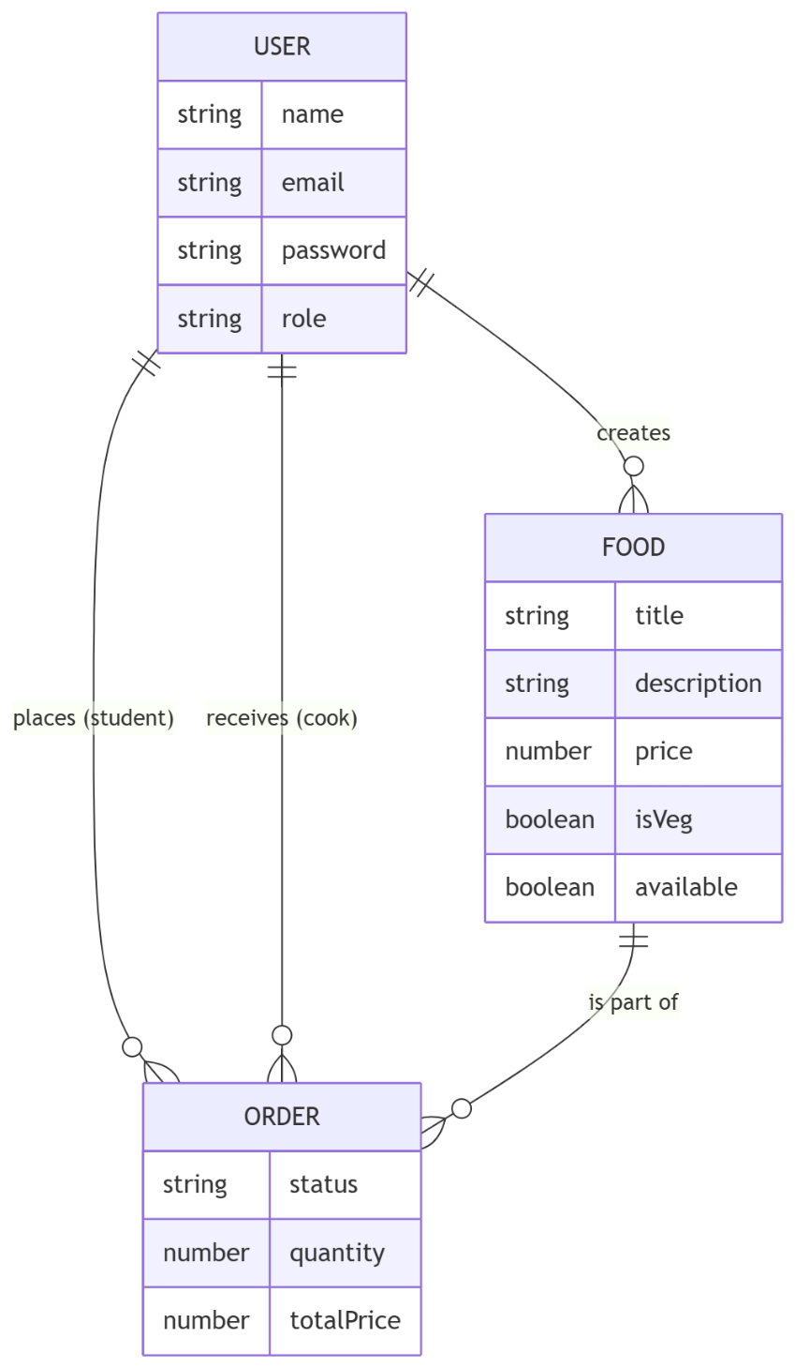
The system follows a relational-document hybrid approach. We use ObjectIds to create references between collections, allowing us to link orders to specific users and food items.

Users
This collection stores credentials and profile data for both Students and Home Cooks.
Field | Type | Description
_id | ObjectId | Unique identifier (Auto-generated).
Name | String | Full name of the user.
Email | String | Unique login email.
Password | String | Hashed password (Bcrypt).
Role | String | Must be either 'student' or 'cook'.
createdAt | Date | Timestamp of account creation.

Food Items
This collection manages the menu items offered by home cooks. It includes a Text Index on the title and description fields to facilitate student searches.
Field | Type | Description
_id | ObjectId | Unique identifier.
Title | String | Name of the dish (e.g., "Aloo Paratha").
Description | String | Brief details about ingredients/taste.
Price | Number | Cost per unit/plate.
isVeg | Boolean | Dietary filter (True for Veg, False for Non-Veg).
Cook | ObjectId | Links to the User ID of the creator.
Available | Boolean | Toggle for "Out of Stock" status.

Orders
This collection tracks the transaction history and the current progress of food preparation.
Field | Type | Description
_id | ObjectId | Unique identifier
Student | ObjectId | User ID of the student who ordered.
Cook | ObjectId | User ID of the cook fulfilling the order.
foodItem | ObjectId | Food ID being purchased.
Quantity | Number | Number of portions ordered.
totalPrice | Number | Calculated as Food.price * quantity.
Status | String | Enum: ['pending', 'accepted', 'preparing', 'delivered'].
orderedAt | Date | Timestamp when order was placed.

Order State Transitions
To ensure consistency, the status field in the Order collection must follow a logical progression:
- Pending: Default state when a student places an order.
- Accepted: Set by the cook to confirm they can fulfill the request.
- Preparing: Indicates the meal is currently being cooked.
- Delivered: Final state indicating completion of the transaction.

API Design
This section defines the RESTful communication interface between the React frontend and the Node.js backend. All requests and responses are exchanged in JSON format, and protected routes require a JWT in the Authorization header.

Authentication APIs
Method | Endpoint | Description
POST | /api/users/register | Create a new Student or Cook account.
POST | /api/users/login | Authenticate user and return a JWT.
GET | /api/users/profile | Fetch details of the currently logged-in user.

Food Management APIs
These endpoints allow cooks to manage their menu and students to browse/search for food.
Method | Endpoint | Description | Role Allowed
GET | /api/foods | Fetch all available food items (Marketplace). | Student/Cook
GET | /api/foods/search | Search food by title or description via query params. | Student
POST | /api/foods | Add a new dish to the menu. | Cook
PUT | /api/foods/:id | Update dish details or toggle availability. | Cook
DELETE | /api/foods/:id | Permanently remove a dish from the menu. | Cook

Order Management APIs
These endpoints facilitate the transaction and tracking process.
Method | Endpoint | Description | Role Allowed
POST | /api/orders | Place a new order for a specific food item. | Student
GET | /api/orders/my-orders | Fetch orders related to the logged-in user. | Student/Cook
PUT | /api/orders/:id/status | Update order status (Pending → Delivered). | Cook

Frontend Design
The frontend is built as a Single Page Application (SPA) using React. It is designed to be highly modular, separating reusable UI elements from complex page-level logic. The architecture focuses on role-based views and efficient state management.

Component Breakdown
  - Core Components
- Navbar.js: A persistent header that changes links based on the user's role (e.g., showing "My Orders" for students vs. "My Menu" for cooks).
- FoodCard.js: Displays dish details (title, price, description). Includes an "Order Now" button for students and "Edit/Delete" buttons for cooks.
- OrderCard.js: Visualizes an order's current status using color-coded badges (e.g., Yellow for Pending, Green for Delivered).
Key Pages
- StudentDashboard.js: Lists active orders and allows students to track real-time status updates.
- CookDashboard.js: Displays high-level stats (Total Orders, Revenue) and provides an interface to manage incoming order requests.
- LoginPage.js / RegisterPage.js: Secure forms for user entry with client-side validation.

State Management (AuthContext)
To avoid "prop drilling," the application uses the React Context API to manage global state. The AuthContext stores:
- User Object: Contains name, email, and role.
- Token: The JWT retrieved from the backend.
- Loading State: Tracks whether the authentication check is in progress.
Workflow: Upon login, the token is saved in localStorage. On application load, the useAuth hook checks for this token and restores the user's session automatically.

UI Workflow (Student Perspective)
- Home Page: Browse the global list of food items.
- Search: Type "Paratha" to filter the list dynamically.
- Action: Click "Order." The frontend sends a request to the backend and navigates the user to the Student Dashboard.
- Feedback: The dashboard shows the new order as "Pending," updating automatically when the cook changes the status.

Backend Design
The backend is engineered using Node.js and the Express.js framework. It follows a modular architecture to separate the entry point, configuration, routing, and business logic. This ensures that the codebase remains maintainable as the marketplace scales.

Core Backend Logic Implementation
Business Logic (Controllers)
The Controller layer acts as the bridge between the HTTP request and the Database.
- Order Processing: When an order is placed, the controller fetches the food price from the database, calculates the totalPrice based on quantity, and saves the order with a reference to both the Student and the Cook.
- Search Engine: The food controller utilizes a MongoDB $text search query to filter results based on the student’s input string.
  - Global Middleware
The system implements a specialized middleware stack:
- Authentication Middleware: Extracts the Bearer token from headers, verifies it using the JWT_SECRET, and attaches the user object to the request (req.user).
- Role-Based Access Control (RBAC): Custom logic that checks req.user.role to ensure, for example, that only a user with the role cook can access the deleteFood endpoint.
- Error Handling Middleware: A centralized function that catches all errors (404, 500, etc.) and sends a consistent JSON response to the frontend.

Backend Flow Diagram
The following diagram illustrates how a single request travels through the backend layers.
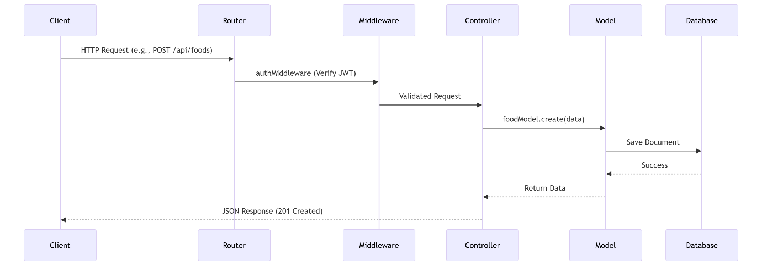

Data Flow & System Flow
This section describes the logical movement of data throughout ApniMeal. It tracks how a user's action on the frontend triggers a series of backend operations, database updates, and state changes.

Authentication Flow (JWT Strategy)
The system employs a stateless authentication mechanism. The flow ensures that user credentials are exchanged for a secure token, which then governs all subsequent interactions.
- Submission: The user enters their email and password on the LoginPage.
- Validation: The frontend sends a POST request to /api/users/login.
- Verification: The backend finds the user by email, compares the provided password with the hashed version in MongoDB using Bcrypt, and validates the role.
- Token Generation: If valid, the server generates a JWT containing the userId and role.
- Persistence: The frontend receives the token, stores it in localStorage, and updates the AuthContext state.
- Authorized Access: For every future request (e.g., adding a dish), the token is attached to the Authorization header.

Order Placement and Fulfilment Flow
The core value of the platform is the transaction between the student and the cook. The following flow handles the lifecycle of an order:
Step | Actor | Action | System Response
1 | Student | Clicks "Order Now" on a FoodCard. | Frontend sends POST /api/orders with foodId and quantity.
2 | Backend | Validates JWT and role. | Fetches foodPrice, calculates totalPrice, and creates an Order document with status: pending.
3 | Cook | Logs into the CookDashboard. | Backend fetches all orders where cookId matches the logged-in user.
4 | Cook | Clicks "Accept Order." | Backend updates the status to accepted in the database.
5 | Student | Refreshes "My Orders." | The UI reflects the status change from pending to accepted.

Security Design
The security architecture of ApniMeal is built on the principle of Defense in Depth. It ensures that user data is protected at rest, in transit, and during processing, while strictly enforcing role-based permissions.

Authentication and Session Management
The system utilizes a stateless authentication strategy to ensure scalability and security.
- Password Hashing: User passwords are never stored in plain text. The system uses Bcrypt with a salt factor of 10 to hash passwords before saving them to MongoDB.
- JWT Issuance: Upon successful login, the server issues a JSON Web Token (JWT) signed with a secret key (JWT_SECRET). This token contains the user’s unique ID and role.
- Token Storage: The frontend stores the JWT in localStorage and includes it in the Authorization: Bearer <token> header for all protected API calls.
Authorization & Role-Based Access Control (RBAC)
The backend implements a two-tier verification process for every sensitive request:
- Identity Verification: The authMiddleware verifies the validity and expiration of the JWT.
- Role Verification: A specialized middleware check ensures that only users with the correct role can execute specific actions.
Resource/Action | Required Role | Logic
Add/Edit/Delete Food | Cook | if (req.user.role !== 'cook') return Access Denied
Place Order | Student | if (req.user.role !== 'student') return Access Denied
Update Order Status | Cook | Verifies the cookId in the order matches the req.user.id.

Data Security and Integrity
- Input Sanitization: To prevent NoSQL Injection, the system uses Mongoose schemas to strictly enforce data types. All incoming strings are trimmed and validated.
- Cross-Origin Resource Sharing (CORS): The backend is configured to only accept requests from the official frontend domain, preventing unauthorized third-party scripts from interacting with the API.
- Error Masking: In production, the system is configured to hide stack traces and internal server details from error responses, providing only generic, user-friendly messages to prevent information leakage.

Testing Strategy
To ensure the reliability of the platform, a multi-layered testing approach is adopted, focusing on the core business logic and API stability.

API & Backend Testing
- Endpoint Validation: Using Postman, every route is tested for expected status codes:
  - 200 OK for successful fetches.
  - 201 Created for successful registrations/orders.
  - 401 Unauthorized when a token is missing or invalid.
  - 403 Forbidden when a student tries to access cook-only features.
- Payload Testing: Ensuring the backend rejects incomplete payloads (e.g., trying to create a food item without a price).

Functional & UI Testing
- Authentication Flow: Testing the "Happy Path" (successful login) and "Edge Cases" (wrong password, expired token).
- State Persistence: Verifying that a page refresh does not log the user out if a valid token exists in localStorage.
- Search Accuracy: Confirming that the MongoDB text index correctly returns "Aloo Paratha" when searching for "paratha".

Future Enhancements
Real-Time Notifications: Implementing WebSockets (Socket.io) to notify students instantly when a cook updates their order status.
Advanced Validation: Integrating express-validator for more granular check on user inputs.
Pagination: Adding limit and page parameters to the /api/foods endpoint to optimize performance as the menu grows.
Image Uploads: Allowing cooks to upload photos of their dishes using Cloudinary or AWS S3.

