Demo Project to Blockchain Simulator

I am using this project as a demonstration in my Graduate Software Design course at Drexel University (SE575).

**Introduction**

The purpose of this project is to demonstrate the “Blockchain Simulator”. I used Node.js for this project. I used Express.js framework. I used JavaScript as the frontend. The demo of this video will be found here: <https://www.youtube.com/watch?v=kdofx9OhmHk&feature=youtu.be>

**Instructions**

Because these are node projects, after cloning this repo you will need to run the following

>> npm install

>> npm install express

The run command for this project is:

>>npm start

**Architecture**

Context Diagram

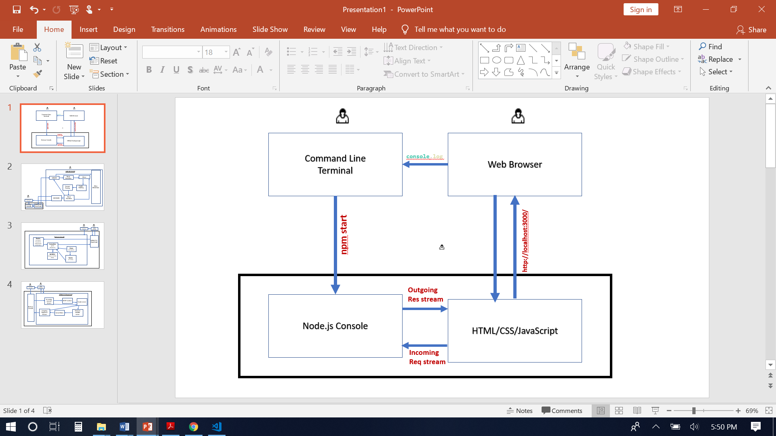

Container Diagram

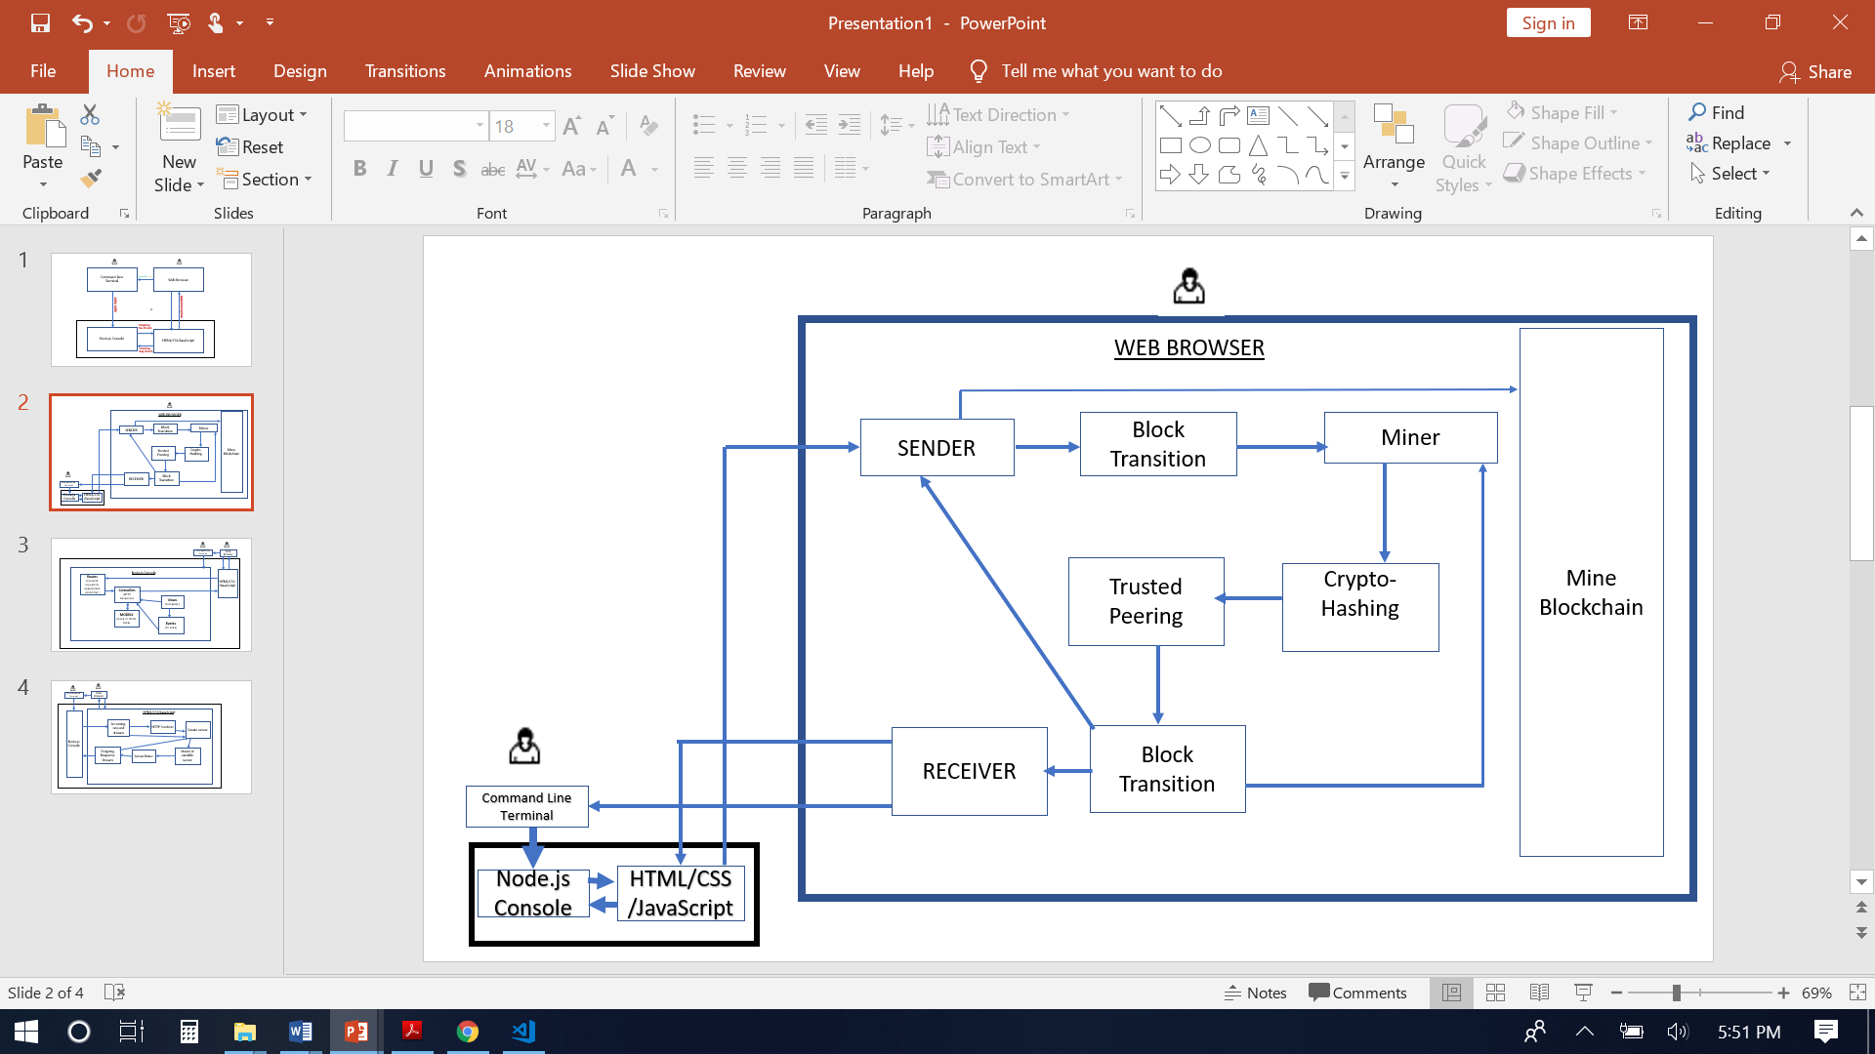

Container Diagram

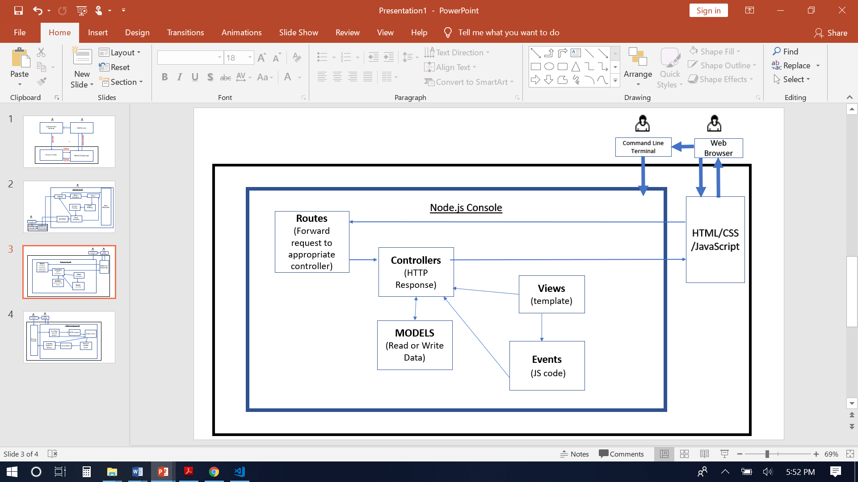

Container Diagram

