Unit name: Interface Design

Assignment title: IND_Assignment 1

Student details: Shaokai Guan, S5060383.

Date: 03/11/2018

Figure 1

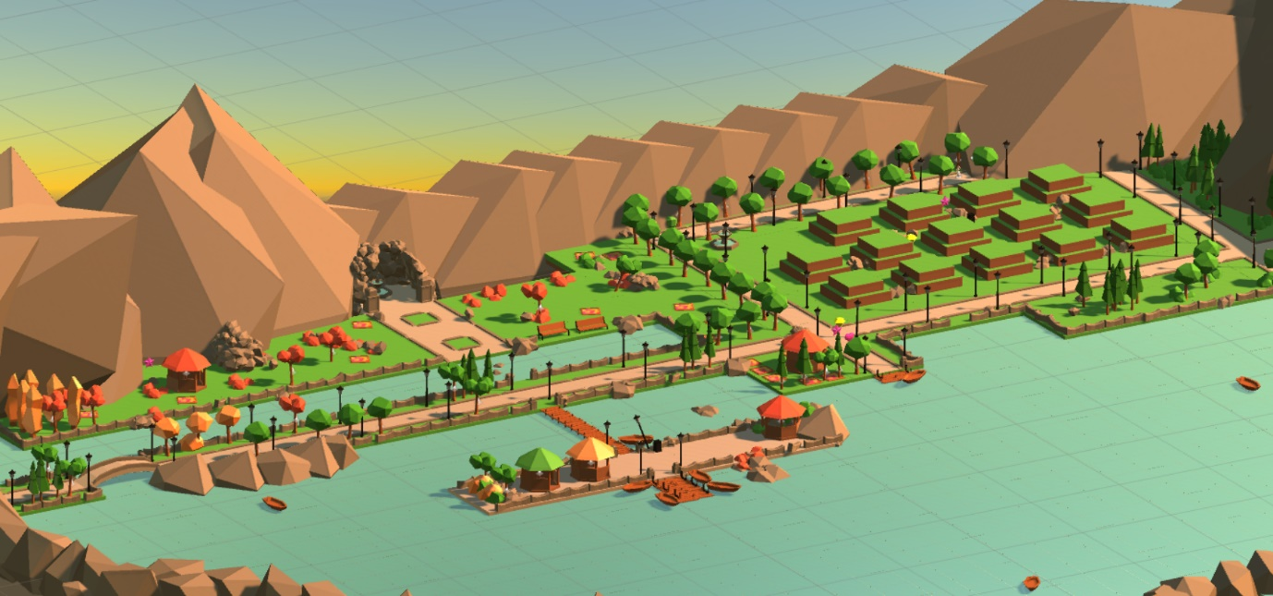I have designed this level for my click and collect based game, this game only involves simple mechanics where the player can master the control easily. For an easy game like this to be enjoyable and immersive to the player, I believe the map itself must be interesting and well made, for instance in between two games that was given with the same mechanics, the one with better design (the game level, the UI and the story etc) will be considered first by the customer. In my gameplay, there will be no time limit and foes that will force the player to implement certain action. This map is divided into three major areas (the maze, the field and the beach), all the grounds are fully accessible for the player from the beginning, but there is a limited space to explore since the map is set on an isolated landscape surrounded by large rocks and water. While exploring the map, the player is supposed to collect the collectables (stars, hearts and diamonds) and examine the special items (trash bin, water fountain and boats) when they find one, these special items are Easter eggs that will offer the player with a positive or negative buff at a 50/50 chance and they get to see the customized lore written about these items.

Figure 2 - (all the assets used are legally downloaded from the Unity assets store)

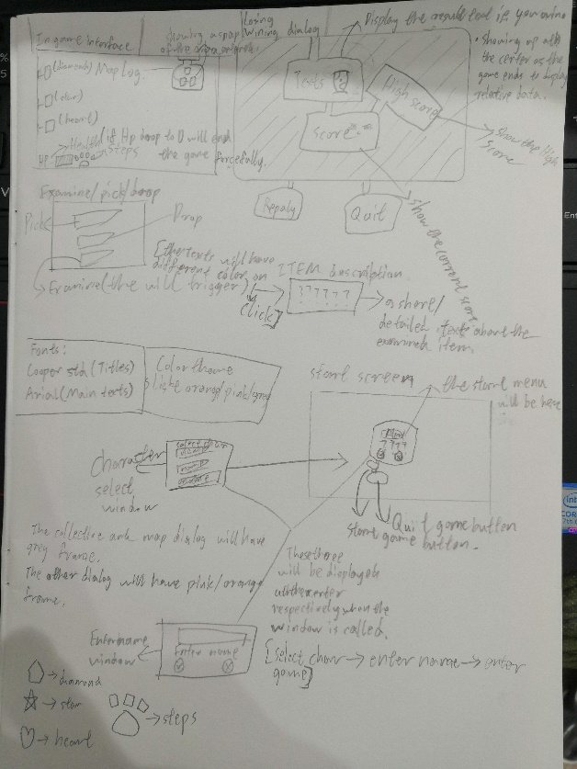Here is my low fidelity interface prototype. My initial idea was to create a complex UI system for my game, but this idea was eventually out of the basket as I realised how it would distract and burden the player from the gameplay. When drawing the sketch, I ensured that the interface I drew is succinct, and the relevant information will only appear when necessary, for instance, the Hp bar and score dialogs will not show up until the gameplay starts.

Figure 3

The theme of my interface will be in cartoon style since the assets are the same. To ensure that I don’t go wrong when making the high-fidelity UI, I have also determined the font (Cooper std for titles, Arial for texts), colour usage (orange, pink and white), and the structure of the UI in advance.

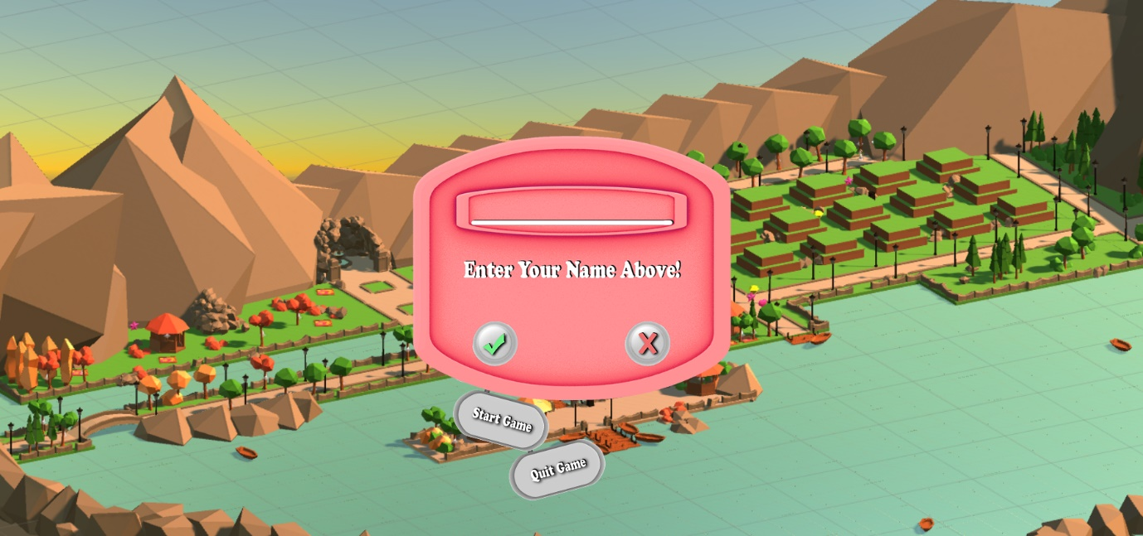

Figure 4

Once the game is launched, the player will be asked to enter a name for their save file, and their name will be used and displayed alongside with their final score at the end.

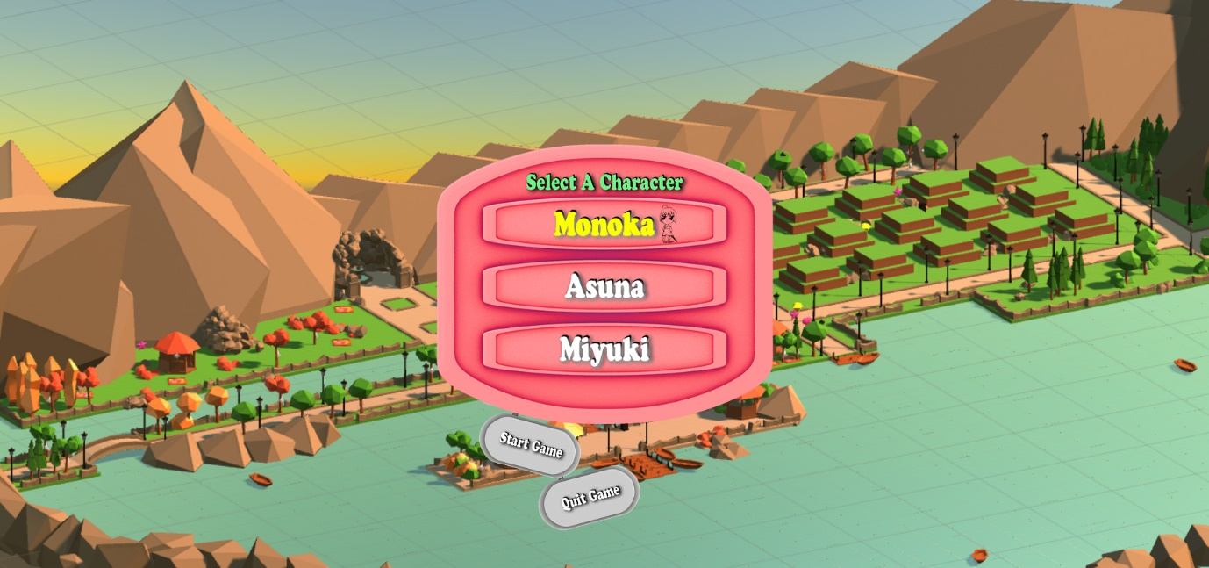

Figure 5

This character selection dialog will take over when the save file is registered. The player will need to pick a character from the three listed on the menu, a small avatar of the character will show up when the mouse pointer is over the name.

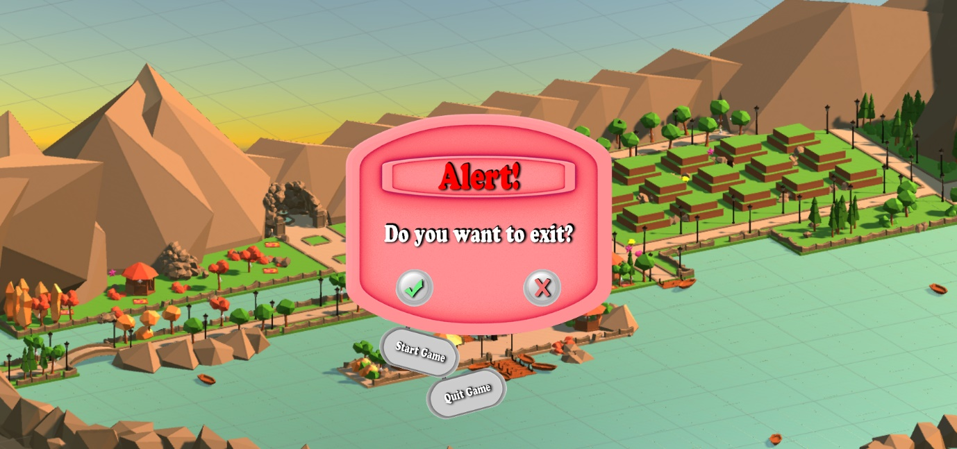

Figure 6

Well, mistakes are common, this alert dialog is designed for that matter. When the player clicks on “quit game”, this window will show up to confirm with the player once more.

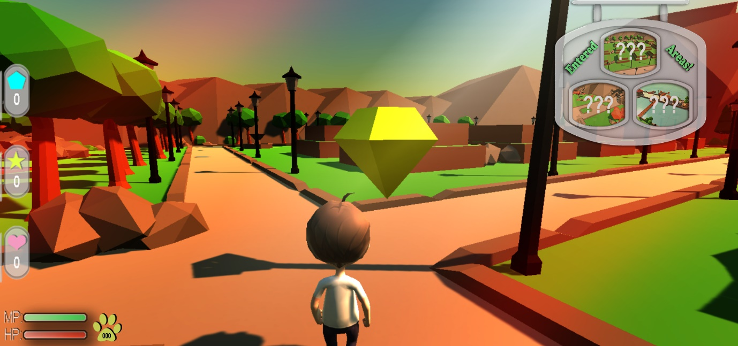

Figure 7

Immediately as the game starts, you will see the following UIs; the map dialog, the collectable menu, Hp/ Mp bar, and foot step recorder. All these UIs are arranged to the edges to avoid drawing too much attention from the player.

**The map dialog,** exploring the level is part of the gameplay, and this dialog is there to give hints to the player with a snapshot of these zones, every time the player enters a new area, the name of that area will show up on the map dialog over of the snapshot. This dialog can be minimized and only left with a grey bar if the player indicates to click on it.

**The collectable menu** is there to display what the player has picked up, you may have noticed that I didn’t name these items, because I have made 2D graphic icons to represent the collectables instead.

**The Hp bar** display the hit point of the character, when the Hp reaches zero it means the player has failed to complete the level.

**The Mp bar** gives a temporary speed boost to the character until it is drained out.

**The foot step recorder** is there to keep track of the foot steps made by the character, this serves as part of the score system at the end, the larger the value is, the more you score lose.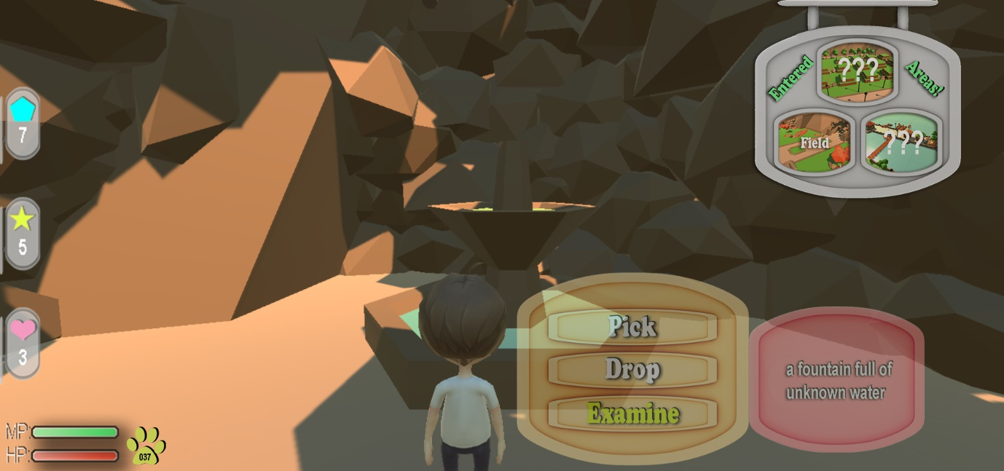

Figure 8

As the players explore the map, they will eventually find these special objects, they can right click on it to trigger this dialog with three options; Pick, Drop and Examine. A short description of that item will show up if the player chooses to examine the object, and a respective buff can be acquired by the player if they pick it up, for instance the water in the fountain could be holy water or toxic water, one will heal the player and one would poison the player.

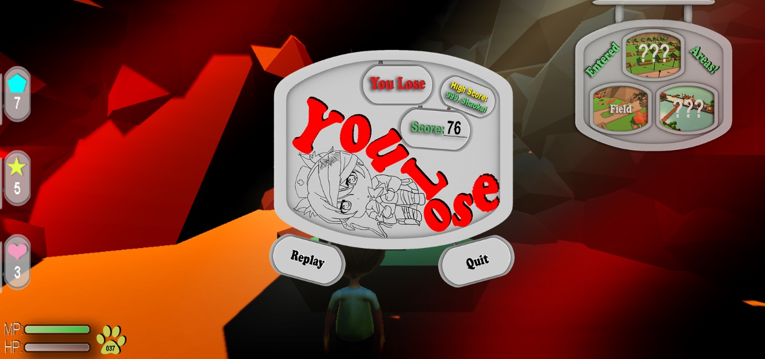

Figure 9

If the player fails to complete the stage, a death screen will show up, the colour red is used here to present the message for losing. In addition, the player can also see their personal score of their current run, the best player’s name with the score and I have added the replay and exit button for the interface as required.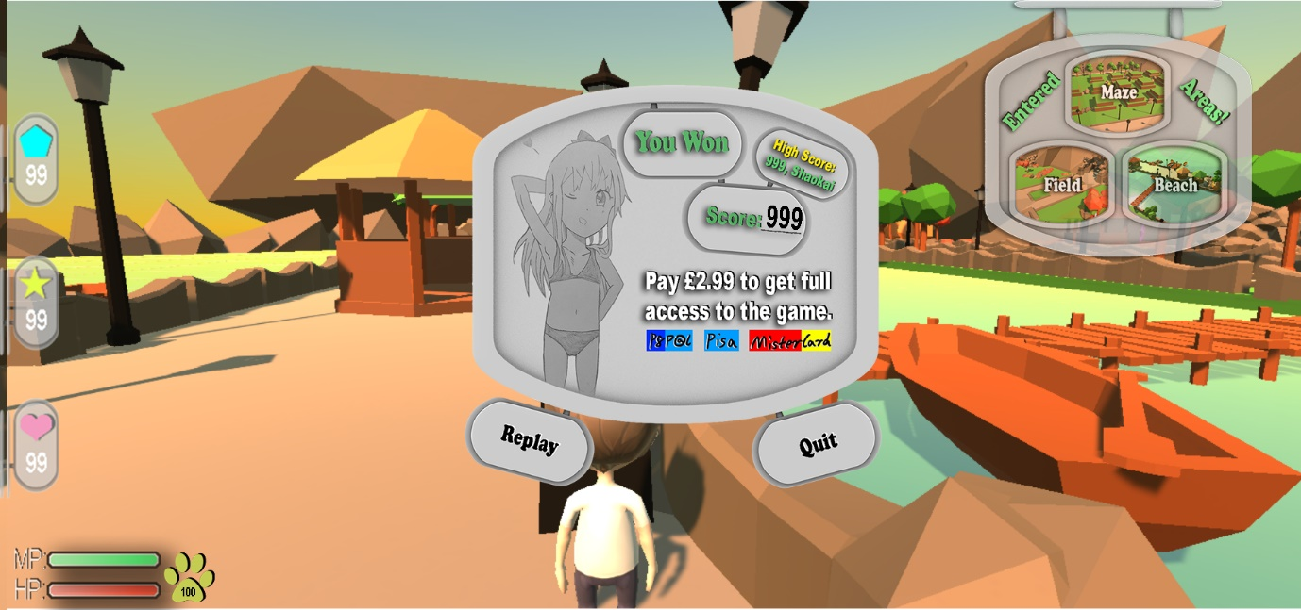

Figure 10

This is what my winning screen looks like, the colour green is used here for the winning text. Just like any other casual games on the market, the player only gets to have access to the early stages of the game for free and they will need to pay for full access at the end. Every game must have a way to earn profit for its business, under this premise I have added a mock up payment system to the winning dialog to make the game look more like an official game.

**References:**

Bournemouth University, BU logo*,* Available at:

<https://microsites.bournemouth.ac.uk/partnermarketing/files/2012/06/BU-Visual-Identity-Guide-2014.pdf>

2 Unity Asset Store, THUNDERENT’S ASSETS, *Low-Poly Park,* Available at:

<https://assetstore.unity.com/packages/3d/environments/urban/low-poly-park-61922>

3 Unity Asset Store, SUPERCYAN, *Character Pack: Free Sample,* Available at:

<https://assetstore.unity.com/packages/3d/characters/humanoids/character-pack-free-sample-79870>

4 Unity Asset Store, AURYNSKY, *Simple Gems Ultimate Animated Customizable Pack,* Available at:

<https://assetstore.unity.com/packages/3d/props/simple-gems-ultimate-animated-customizable-pack-73764>