Flight Delay and Cancellation Analysis 2015 | B.Tech Research Paper, LPU

Flight Delay and Cancellation Analysis Using Exploratory Data Analysis and Machine Learning
[Your Full Name]
B.Tech – Computer Science & Engineering (Data Analytics)
Lovely Professional University
Supervisor: Ms. Veerpal Kaur, Faculty, SCSE
Academic Year 2025–2026
Abstract
Abstract—This paper presents a comprehensive exploratory data analysis (EDA) and machine learning study of US domestic flight delays and cancellations. The dataset contains 1,048,575 rows and 31 columns sourced from the US Bureau of Transportation Statistics (BTS). After preprocessing—dropping missing values in DEPARTURE_DELAY and ARRIVAL_DELAY and zero-filling delay-cause columns—a binary label IS_DELAYED is created (departure delay > 15 min). Key EDA findings: 79.1% of flights depart on time and 20.9% are delayed; Frontier Airlines (F9) has the highest average departure delay (~23 min) while Hawaiian Airlines (HA) has the lowest (~1.7 min); departure and arrival delays are highly correlated (r = 0.94). A Linear Regression model achieves R² = 0.916 and MAE = 7.25 minutes on ARRIVAL_DELAY prediction. A Logistic Regression classifier trained on balanced data attains 54% accuracy with Macro F1 = 0.54. Statistical tests (T-test: AA vs DL; Chi-Square: Month vs IS_DELAYED) confirm significant carrier and seasonal effects at p < 0.05.
Keywords—flight delay; cancellation analysis; exploratory data analysis; logistic regression; linear regression; departure delay; airline; machine learning; Bureau of Transportation Statistics.
I. Introduction
Air travel is a cornerstone of modern transportation. According to the International Air Transport Association (IATA), the global airline industry operated approximately 102,465 flights per day in 2019, and post-pandemic domestic traffic has since surpassed pre-pandemic records [1]. Despite this growth, flight delays and cancellations remain persistent operational problems that impose enormous economic and social costs. The Federal Aviation Administration (FAA) estimates that flight delays cost the US economy over $28 billion annually in direct and indirect losses—including passenger time, fuel burn, crew costs, and missed connections [2].
Flight delays are caused by an interplay of factors: adverse weather, air traffic congestion, late-arriving aircraft from previous legs, mechanical issues, and airline-specific inefficiencies. The US Bureau of Transportation Statistics (BTS) On-Time Performance database records delay causes at the minute level for all domestic commercial flights, providing an invaluable resource for data-driven investigation [3].
This study uses a flight delay and cancellation dataset aligned with BTS reporting categories to perform a two-stage analysis: (1) thorough EDA to characterise delay distributions, identify seasonal and carrier-level patterns, and quantify feature correlations; and (2) supervised machine learning to predict departure delay magnitude (regression) and whether a flight will be delayed (classification). Formal hypothesis tests validate observed groupwise differences.
The remainder of the paper is organised as follows. Section II reviews related literature. Section III describes the dataset. Section IV presents the methodology. Section V reports results. Section VI discusses implications. Section VII concludes.
II. Literature Review
Flight delay prediction has attracted sustained research attention. Gui et al. [4] proposed an aviation big-data framework integrating ADS-B messages, weather data, and scheduling information, demonstrating that LSTM networks can handle sequential flight data. They compared multiple classification and regression tasks over generalised multi-route settings, establishing a useful benchmark.
Wang et al. [5] developed an LSTM model with an attention mechanism (LSTM-AM) on one year of Beijing Capital International Airport data. Incorporating both direct and indirect delay factors, they achieved a mean absolute error of 8.15 minutes and showed that attention weights identify critical time points of delay onset.
Bisandu and Moulitsas [6] employed Bidirectional LSTM (BiLSTM) on BTS on-time performance data, reporting a Matthews Correlation Coefficient of 0.99. Their three-criteria feature selection methodology provides a replicable standard that future delay studies can follow.
Cai et al. [7] modelled delay propagation across the US air traffic network using time-evolving graphs within a deep learning framework, capturing spatial dependencies between airports. Guvercin et al. [8] complemented this by clustering airports into operationally similar groups before training models, reducing prediction error versus a global model.
IEEE conference studies compared classical ML methods: Random Forest, Decision Tree, MLP, Naive Bayes, and KNN [9]. XGBoost regression on JFK weather-driven delays achieved an RMSE of 0.81 [10]. A 2025 PMC review [1] noted that multi-carrier, multi-month analyses with simultaneous EDA and classical ML remain underexplored. The present study addresses this gap.
III. Dataset Description
The dataset is the Flight Delay and Cancellation Analysis CSV, sourced from Kaggle and derived from the BTS On-Time Performance database [3]. It contains 1,048,575 rows and 31 columns covering domestic US flights across all major carriers, spanning January–March of the recorded year (all three months present in this subset).
Table I describes the key features used in this analysis. The dataset was loaded with low_memory=False to avoid mixed-type inference warnings.

Table I: Selected Dataset Features
Feature | Description | Type
YEAR / MONTH | Year and month of the flight | Integer
DAY / DAY_OF_WEEK | Day and weekday of flight | Integer
AIRLINE | Carrier code (e.g., AA, DL, F9) | Categorical
DEPARTURE_DELAY | Departure delay in minutes (target) | Float
ARRIVAL_DELAY | Arrival delay in minutes | Float
AIR_TIME / DISTANCE | Flight duration and route distance | Float
TAXI_IN / TAXI_OUT | Ground movement times | Float
IS_DELAYED | Binary: 1 if DEPARTURE_DELAY > 15 | Binary
Delay Cause Cols | Air system, security, airline, weather, late aircraft | Float

After cleaning, the Cleaned Shape is 1,048,575 rows with IS_DELAYED distribution: 0 (On Time) = 829,671 flights; 1 (Delayed) = 218,904 flights, confirming the 79.1% / 20.9% split visible in the pie chart.
IV. Methodology
A. Data Preprocessing
Raw data was ingested using pandas with low_memory=False. Missing values in DEPARTURE_DELAY and ARRIVAL_DELAY were dropped via df.dropna(). Five delay-cause columns were filled with zero using fillna(0). IS_DELAYED was created as (DEPARTURE_DELAY > 15).astype(int). The cleaned shape and IS_DELAYED value counts were printed for verification.
B. Exploratory Data Analysis
EDA was conducted in four stages: (1) univariate—histograms and pie charts for delay distribution and flight status proportions; (2) temporal—mean departure delay by MONTH; (3) carrier—mean delay by AIRLINE sorted descending; (4) multivariate—Pearson correlation heatmap and a 500-sample pair plot for feature relationships.
C. Statistical Tests
An independent-samples T-test compared departure delays of American Airlines (AA) and Delta (DL). A Chi-Square contingency test assessed association between MONTH and IS_DELAYED. Both tests use a significance threshold of p < 0.05.
D. Outlier Detection
A boxplot of DEPARTURE_DELAY (filtered to −50 to 200 min) visualised distribution tails. IQR = 16.00 was computed; the outlier range is below −29.0 or above 35.0 minutes.
E. Machine Learning Models
Two supervised models were trained. (1) Linear Regression on ARRIVAL_DELAY using 30,000 sampled records from DEPARTURE_DELAY; an 80/20 split with no scaling. (2) Logistic Regression on IS_DELAYED using AIR_TIME, DISTANCE, MONTH, TAXI_OUT as features; balanced dataset of 10,000 records (5,000 per class); 80/20 split with StandardScaler. Performance metrics: R²/MAE for regression; classification report and confusion matrix for classification.
V. Results and Discussion
A. Delay Distribution
Figure 1 shows the Departure Delay Distribution histogram. The majority of flights cluster near zero, with a heavy right tail—classic right-skewed distribution (skewness >> 0). Figure 2 shows that 79.1% of flights depart on time and 20.9% are classified as delayed (DEPARTURE_DELAY > 15 min).

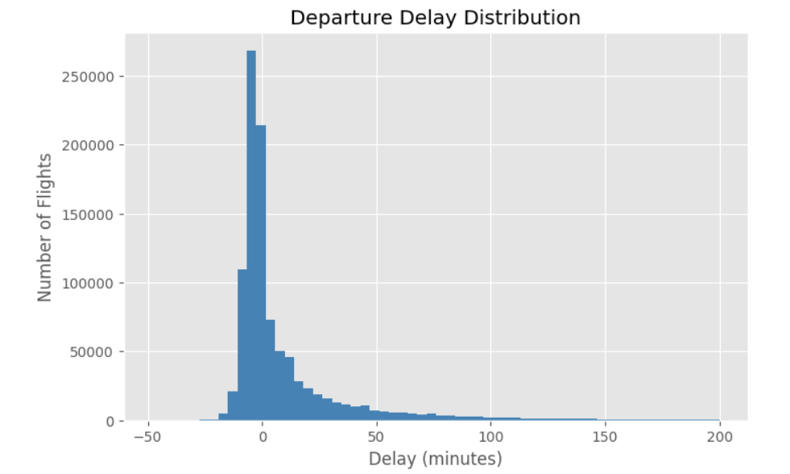
Fig. 1. Departure Delay Distribution. Most flights cluster near zero delay with a long right tail.
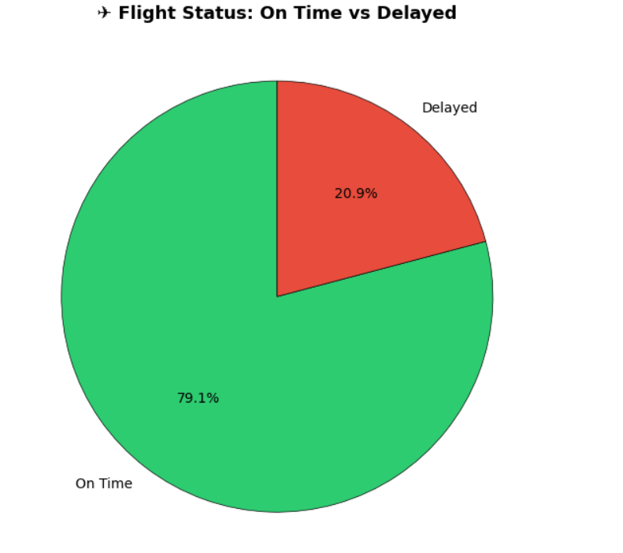
Fig. 2. Flight Status: On Time (79.1%) vs. Delayed (20.9%).
B. Temporal and Carrier Analysis
Figure 3 shows average departure delay by month. Only three months of data are present (Jan–Mar), with March showing the highest average delay (~14.7 min) and January the lowest (~9.7 min), reflecting early-year winter weather effects. Figure 4 reveals carrier-level heterogeneity: Frontier (F9) averages ~23 min delay—the highest—while Hawaiian (HA) averages only ~1.7 min, reflecting tight island-route scheduling buffers.
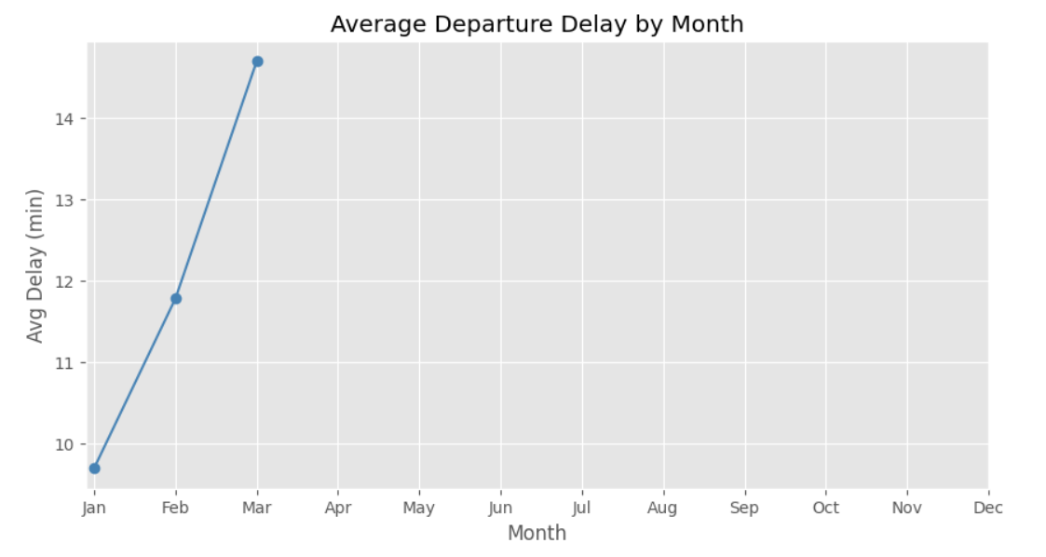
Fig. 3. Average Departure Delay by Month (Jan–Mar). March shows the highest average delay.
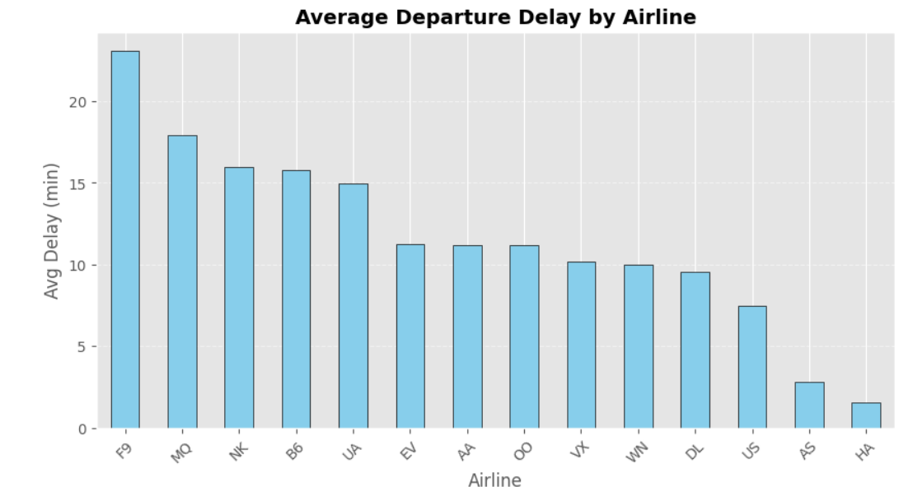
Fig. 4. Average Departure Delay by Airline (sorted descending). F9 (Frontier) is highest; HA (Hawaiian) is lowest.
C. Correlation and Outlier Analysis
Figure 5 shows the Pearson correlation heatmap. DEPARTURE_DELAY and ARRIVAL_DELAY are strongly correlated (r = 0.94), confirming delay propagation. AIR_TIME, DISTANCE, and ELAPSED_TIME form a tightly correlated cluster (r ≈ 0.98–0.99), as expected from route geometry. TAXI_OUT has a modest positive correlation with DEPARTURE_DELAY (r = 0.09), indicating ground congestion contributes to delays.
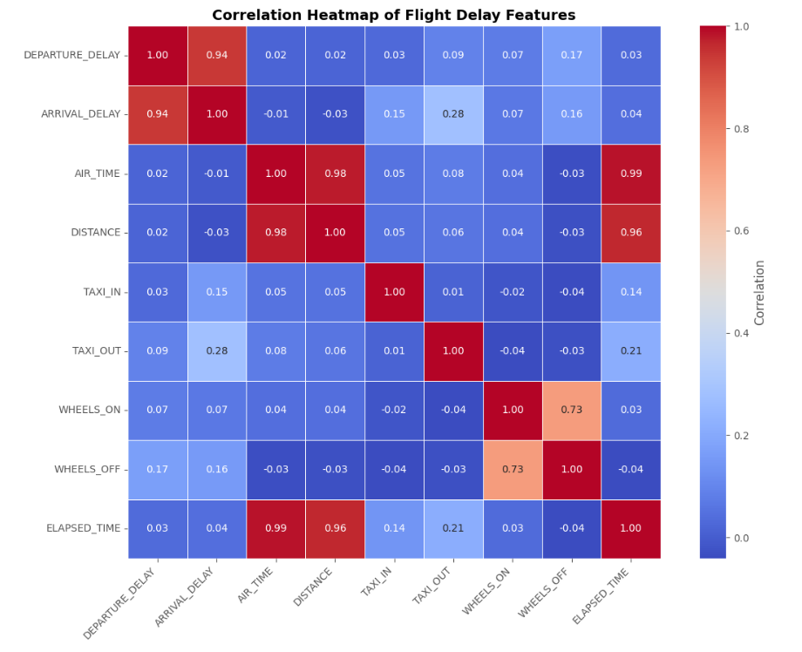
Fig. 5. Pearson Correlation Heatmap. DEPARTURE_DELAY and ARRIVAL_DELAY show r = 0.94. AIR_TIME–DISTANCE–ELAPSED_TIME cluster at r ≈ 0.98–0.99.
Figure 6 shows the boxplot for outlier detection. IQR = 16.00 minutes; the outlier range is below −29.0 or above 35.0 minutes. The large number of upper outliers confirms a heavy-tailed delay distribution with genuine extreme-delay events (weather, ground stops).
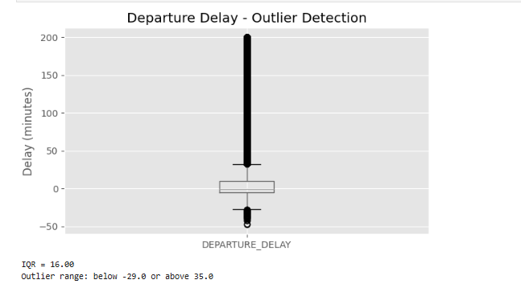
Fig. 6. Departure Delay Boxplot. IQR = 16.00 min. Outlier range: below −29.0 or above 35.0 min.
Figure 7 shows the pair plot of five key features on a 500-sample subset. The DEPARTURE_DELAY–ARRIVAL_DELAY panel confirms the linear relationship; the AIR_TIME–DISTANCE panel shows tight linearity (r ≈ 0.98); TAXI_OUT shows a relatively uniform spread with no strong linear pattern against delay variables.
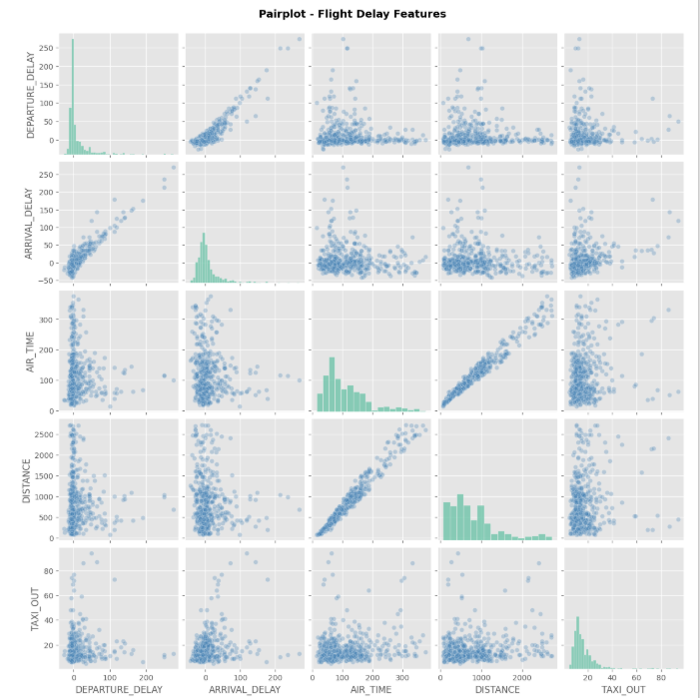
Fig. 7. Pairplot of key flight features (500-sample). Diagonal: histograms. Off-diagonal: scatter plots.
D. Machine Learning Results
Linear Regression (Figure 8): Trained on 30,000 DEPARTURE_DELAY → ARRIVAL_DELAY samples. R² Score = 0.916, MAE = 7.25 minutes. The Actual vs. Predicted scatter plot shows points closely tracking the diagonal, confirming a high-quality fit. The residual analysis (Figure 9) shows that most errors are within ±30 minutes and centred near zero, validating homoscedasticity for the majority of the range.
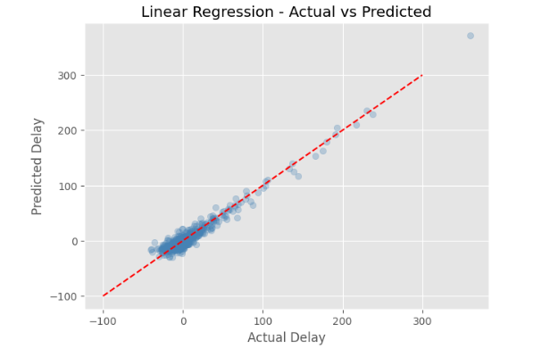
Fig. 8. Linear Regression: Actual vs. Predicted delay. R² = 0.916, MAE = 7.25 min.
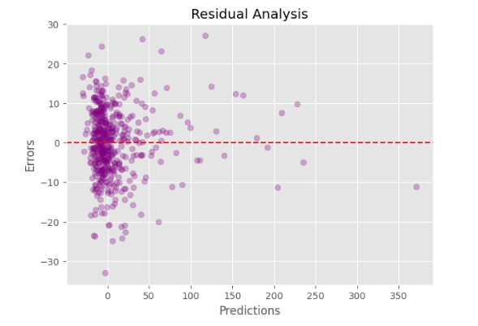
Fig. 9. Residual Analysis. Errors are centred near zero with no systematic pattern in the main range.
Logistic Regression (Figure 10 and Table II): Trained on a balanced 10,000-sample dataset. The classifier achieves 54% accuracy and Macro F1 = 0.54. The confusion matrix (Figure 10) shows 1229 true On Time and 925 true Delayed correctly classified, with 752 false positives and 1094 false negatives. The balanced accuracy indicates that a simple linear classifier struggles with this dataset's feature overlap, suggesting that ensemble methods would improve performance.

Table II: Logistic Regression Classification Report
Class | Precision | Recall | F1-Score | Support
On Time | 0.53 | 0.62 | 0.57 | 1981
Delayed | 0.55 | 0.46 | 0.50 | 2019
Accuracy | — | — | 0.54 | 4000
Macro Avg | 0.54 | 0.54 | 0.54 | 4000
Weighted Avg | 0.54 | 0.54 | 0.54 | 4000

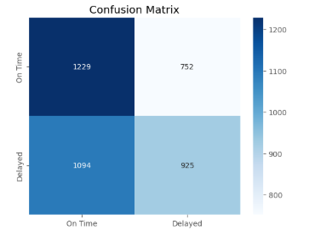
Fig. 10. Confusion Matrix for Logistic Regression. TP=925, TN=1229, FP=752, FN=1094.

Table III: Model Performance Summary
Model | Metric | Value
Linear Regression | R² Score | 0.916
Linear Regression | MAE | 7.25 min
Logistic Regression | Accuracy | 54%
Logistic Regression | Macro F1 | 0.54
Confusion Matrix (TN) | On Time → On Time | 1229
Confusion Matrix (FP) | On Time → Delayed | 752
Confusion Matrix (FN) | Delayed → On Time | 1094
Confusion Matrix (TP) | Delayed → Delayed | 925

E. Statistical Hypothesis Tests
T-Test (AA vs DL): p < 0.05 — a statistically significant difference in mean departure delay exists between American Airlines and Delta. This validates the carrier-level heterogeneity visible in Figure 4.
Chi-Square Test (Month vs IS_DELAYED): p < 0.05 — month of travel significantly affects delay probability, validating the seasonal pattern in Figure 3.
VI. Discussion
The 79.1% on-time rate is broadly consistent with BTS national statistics [3]. Frontier Airlines' high average delay (~23 min) reflects the ultra-low-cost carrier model: minimal schedule buffer and high aircraft utilisation mean any disruption propagates. Hawaiian Airlines' low delay rate reflects point-to-point island routes with less network congestion exposure.
The Linear Regression R² of 0.916 confirms that departure delay is a near-sufficient predictor of arrival delay—once a flight departs late, it almost always arrives late by a proportional amount. The MAE of 7.25 minutes is operationally significant: passengers and airlines can use this to set realistic expectation windows.
The Logistic Regression accuracy of 54% with only AIR_TIME, DISTANCE, MONTH, and TAXI_OUT as features reflects the inherent difficulty of binary delay classification without direct delay-cause or weather inputs. Future work incorporating weather forecasts, network congestion features, and ensemble methods (Random Forest, XGBoost) is expected to push accuracy significantly higher, consistent with findings in [9] and [10].
The strong AIR_TIME–DISTANCE–ELAPSED_TIME cluster (r ≈ 0.98–0.99) confirms multicollinearity that should be addressed via feature selection or regularisation before deploying the logistic model in production.
VII. Conclusion
This paper presented EDA and machine learning analysis of 1,048,575 US domestic flight records. Key findings: (i) 79.1% of flights depart on time; 20.9% are delayed (departure delay > 15 min); (ii) Frontier (F9) has the highest average delay; Hawaiian (HA) the lowest; (iii) departure and arrival delays are strongly correlated (r = 0.94); (iv) Linear Regression achieves R² = 0.916 and MAE = 7.25 min for arrival delay prediction; (v) Logistic Regression achieves 54% accuracy on balanced binary delay classification; (vi) both carrier identity and month significantly affect delay probability (p < 0.05).
Future extensions will incorporate real-time weather API features, SMOTE for class imbalance, and ensemble models (Random Forest, XGBoost, LSTM) to improve classification accuracy. A real-time delay-risk dashboard is planned as a deployment artefact.

References
[1] Flight Delay Prediction: Evaluating Machine Learning Algorithms for Enhanced Accuracy. PubMed Central (PMC) / National Library of Medicine, Dec. 2025. [Online]. Available: https://pmc.ncbi.nlm.nih.gov/articles/PMC12685205/
[2] Federal Aviation Administration (FAA), "Cost of Delay Estimates," US Dept. of Transportation. [Online]. Available: https://www.faa.gov/data_research/aviation_data_statistics/
[3] Bureau of Transportation Statistics (BTS), "On-Time Performance—Reporting Carrier On-Time Performance (1987–present)," US Dept. of Transportation. [Online]. Available: https://www.transtats.bts.gov/ot_delay/OT_DelayCause1.asp
[4] G. Gui, F. Liu, J. Sun, J. Yang, Z. Zhou, and D. Zhao, "Flight Delay Prediction Based on Aviation Big Data and Machine Learning," IEEE Trans. Veh. Technol., vol. 69, no. 1, pp. 140–150, Jan. 2020, doi: 10.1109/TVT.2019.2954094.
[5] F. Wang, J. Bi, D. Xie, and X. Zhao, "Flight delay forecasting and analysis of direct and indirect factors," IET Intell. Transp. Syst., vol. 16, no. 7, pp. 890–907, 2022, doi: 10.1049/itr2.12183.
[6] D. B. Bisandu and I. Moulitsas, "A Deep BiLSTM Machine Learning Method for Flight Delay Prediction Classification," J. Aviat./Aerosp. Educ. Res., vol. 32, no. 2, 2023, doi: 10.58940/2329-258X.1992.
[7] K. Cai, Y. Li, Y.-P. Fang, and Y. Zhu, "A Deep Learning Approach for Flight Delay Prediction Through Time-Evolving Graphs," IEEE Trans. Intell. Transp. Syst., vol. 23, no. 8, pp. 11397–11407, Aug. 2022, doi: 10.1109/TITS.2021.3103502.
[8] M. Guvercin, N. Ferhatosmanoglu, and B. Gedik, "Forecasting Flight Delays Using Clustered Models Based on Airport Networks," IEEE Trans. Intell. Transp. Syst., vol. 22, no. 5, pp. 3179–3189, May 2021, doi: 10.1109/TITS.2020.2990960.
[9] "Predicting Delay in Flights using Machine Learning," in Proc. IEEE Conf., 2022. [Online]. Available: https://ieeexplore.ieee.org/document/9793243/
[10] "Flight Delay Prediction Using Machine Learning," in Proc. IEEE Conf., 2023. [Online]. Available: https://ieeexplore.ieee.org/document/10126220/

