**EAE 298 Aeroacoustics, Fall Quarter 2016**

**Homework #1: Computation of Sound Pressure Level and Octave Band Spectrum   
for a Sonic Boom using Matlab (Due Date: 10/18/2016)**

|  |  |  |
| --- | --- | --- |
|  | **Name :** |  |

***[Prob. 1, 50 pts]*** The wav file, ‘Boom_F1B2_6.wav’, is a recording of a sonic boom. The time history of the pressure is shown in a figure below.

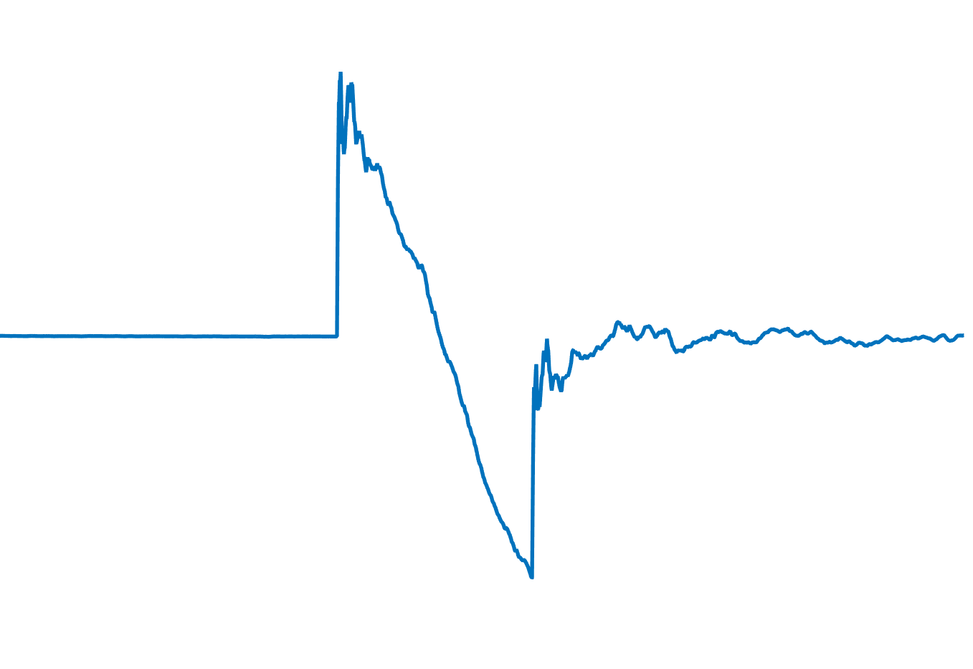

Play the file. You can set up a player object using Matlab audioplayer. Please use a sample code below for audioplayer to play and listen to the sound

*% Audioplayer in Matlab  
fs=44100;  
pvolts=yy/max(abs(yy));  
pvolts=[pvolts];  
ppobj=audioplayer(pvolts,fs);  
play(ppobj);*

The values in the wav file are in volts. B&K measurement microphones invert the pressure – a negative voltage from the microphone corresponds to a positive pressure. When you apply the calibration constant, account for this sign reversal. For this problem, the pre-calculated constant calibration factor is – 116 pascals/volt. Convert the time series in voltage to pascals. (Assume that all of the power in the boom waveform is within the range of flat response of the microphone).

1. Plot the waveform in pascals as a function of time. What is the peak pressure in the time domain? Notice the shape of the first arrival – it has the classic “N” wave shape of a sonic boom. Notice the duration in time from the positive-pressure peak to the negative-pressure peak. [10 pts]
2. Calculate and plot the single-sided power spectral density function (Gxx). Use a single record for the boom waveform (and don’t bother using a window – there isn’t much power at either end of the waveform). [30 pts]
3. In acoustics it is common (for better or worse) to convert levels to decibels. Convert and plot the standard narrowband sound pressure level with the reference pressure of 20 micro-Pascal. [10 pts]

**[Prob. 2, 50 Pts]** Write a computer program to convert the narrow band spectra to one-third octave and octave band spectra.

1. Convert the narrowband spectrum to one-third octave band spectrum and make a plot [20 pts]
2. Convert the one-third octave band spectrum to octave band spectrum and make a plot [20 pts]
3. Convert the octave band spectrum to the overall sound pressure level [10 pts]

***Please submit the report and upload the source codes on Canvas.***