1. Recursion graphic

* What happened if you change the size value to -100?

: The tree size value = -100 will go opposite.

* What happened if you change the input level to be -4?

: It has been infinite loop.

* To produce a tree below, what are the values for levels, the two turn degrees, and the two constant multipliers for size during recursive calls.

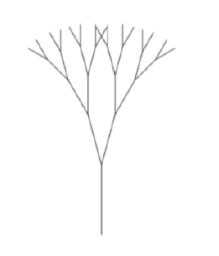

: set levels value to 5, set two turn degree to 20 degrees, set two constant multipliers to 0.9.

1. H-tree

* Set the angle operation to 90 degrees.
* Set two constant multipliers to 0.65.
* turtle_draw(10, 250)

Photo next slide 🡪

Panuwat Kongkaew 6310545558

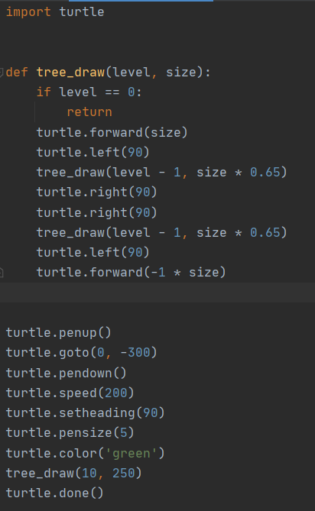

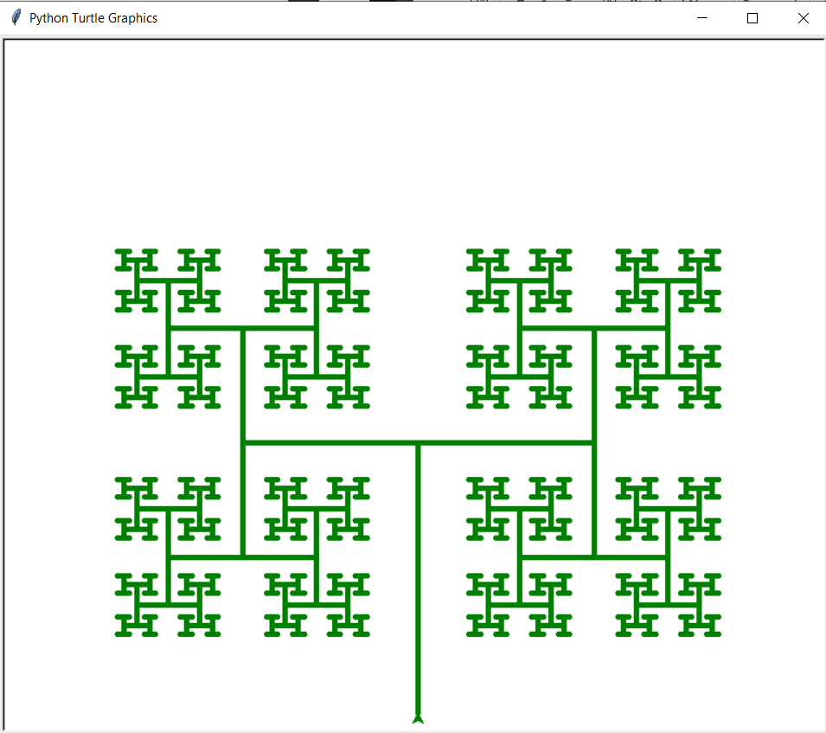

Panuwat Kongkaew 6310545558