ICP2

Name: Kollu Sainath Reddy

Banner id: 700740523

Video link: <https://drive.google.com/file/d/16JUtYy9AG3dp6-PBkCJDtf8kYix0KxVK/view?usp=drive_link>

Git hub link: <https://github.com/Sainath1359/icp2/blob/main/ICP_2_Neural_Network.ipynb>

1. Write a program that takes two strings from the user: first_name, last_name. Pass these variables to fullname function that should return the (full name). o For example: ▪ First_name = “your first name”, last_name = “your last name” ▪ Full_name = “your full name” o Write function named “string_alternative” that returns every other char in the full_name string.

Output:

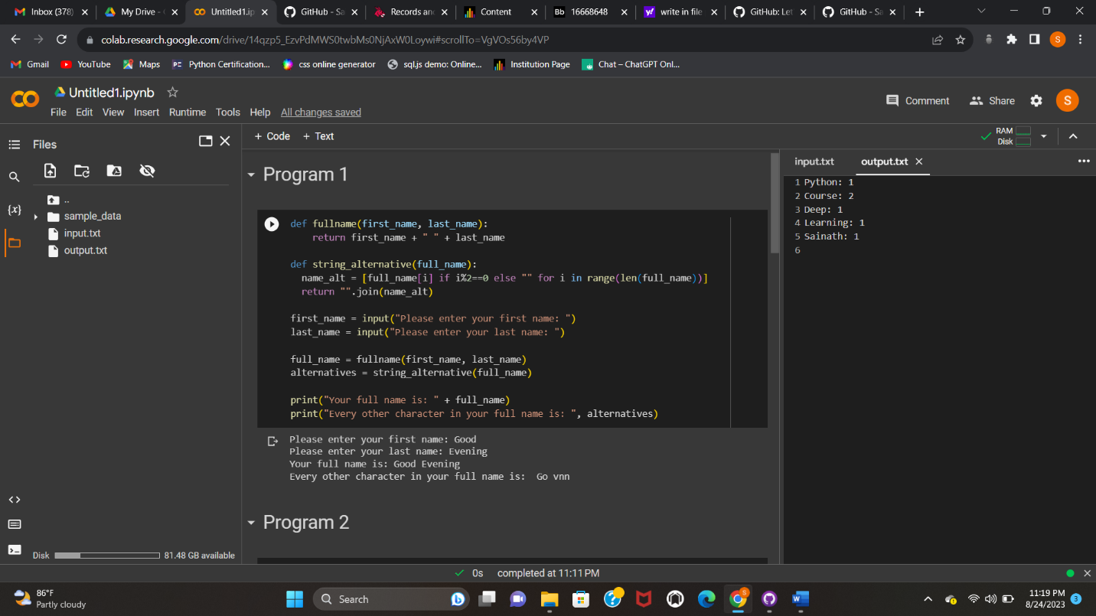

1. Write a python program to find the wordcount in a file (input.txt) for each line and then print the output. o Finally store the output in output.txt file.

Output: 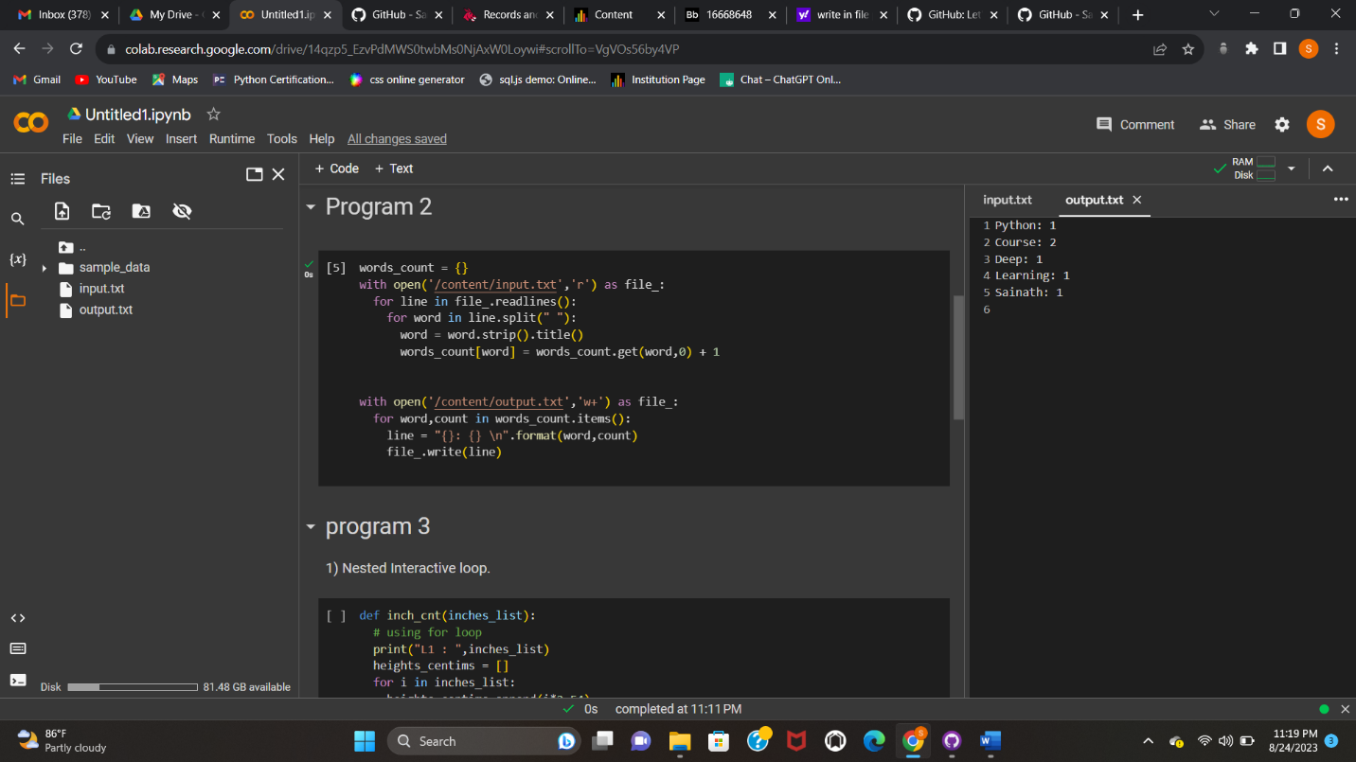

1. Write a program, which reads heights (inches.) of customers into a list and convert these heights to centimeters in a separate list using: 1) Nested Interactive loop. 2) List comprehensions

