Twitter (X) Real-Time Data
Engineering Pipeline

Technical Project Report

Data Engineering Group Project
Project By:
Bhuvan Chandra
Anish Dadaji Khobragade
Technologies: Apache Kafka, Python, MySQL, JSON

Table of Contents

1. Introduction
2. Problem Statement
3. Project Objectives
4. System Architecture & Pipeline Overview
5. Technology Stack
6. Implementation Details
6.1 Data Ingestion (CSV to JSON)
6.2 Kafka Producer & Consumer
6.3 Data Cleaning & Transformation
6.4 MySQL Storage Integration
7. Code Walkthrough
8. Results & Insights
9. Challenges & Learnings
10. Conclusion & Future Scope

1. Introduction

In today's digital world, social media platforms generate a massive volume of data every second. X Corp. (formerly Twitter) stands as one of the most influential platforms where users share opinions, news, trends, and reactions in real time. This data represents a goldmine for businesses, researchers, and organisations seeking to understand public sentiment, customer interests, and emerging events.
The Twitter (X) Real-Time Data Engineering Pipeline project aims to construct an end-to-end system capable of ingesting live tweet streams, processing the data with minimal latency, and storing it for downstream analytics. By leveraging modern data engineering tools such as Apache Kafka for streaming, Python for transformation logic, and MySQL for persistence, the project transforms raw social media data into structured, queryable insights. These insights enable trend detection, sentiment analysis, user behaviour modelling, and faster, more informed decision-making.
This report documents the complete pipeline architecture, implementation methodology, code structure, and findings, serving as both a technical reference and a case study in real-time data engineering.
2. Problem Statement

Organisations and analysts face significant challenges when attempting to process the massive, continuous stream of public conversations generated on Twitter (X). Millions of posts are created every minute, containing valuable signals about trends, customer sentiment, breaking news, brand perception, and public reactions. However, this data arrives at high velocity, in diverse and semi-structured formats, and is accompanied by substantial noise such as spam, duplicates, and irrelevant content.
Traditional batch-processing systems are fundamentally incapable of capturing and analysing such rapidly changing information in real time. As a consequence, businesses and researchers face significant delays in identifying emerging topics, understanding audience behaviour, and making timely, data-driven decisions. There exists a pressing need for a scalable, fault-tolerant, real-time data engineering pipeline that can efficiently ingest, process, store, and visualise streaming Twitter (X) data while maintaining low latency, high accuracy, and robust error handling.
3. Project Objectives

Design and implement a real-time data ingestion pipeline for Twitter (X) data streams.
Utilise Apache Kafka as the central message broker to ensure scalable, fault-tolerant data transport.
Transform raw CSV tweet data into structured JSON format suitable for streaming.
Implement data cleaning logic to filter spam, empty records, and malformed entries.
Persist cleaned, enriched tweet data into a MySQL relational database for querying and analysis.
Provide a modular, well-documented codebase that can be extended for additional use cases such as sentiment analysis dashboards or trend visualisation.
4. System Architecture & Pipeline Overview

The pipeline follows a producer-consumer architecture with Apache Kafka serving as the distributed message backbone. The flow of data through the system is illustrated below:
Step 1 - Raw CSV Dataset: Source tweet data stored as CSV files (twitter_training.csv, Cleaned dataset.csv)
Step 2 - CSV to JSON Conversion: Python scripts transform tabular data into structured JSON objects (Part 1 workflow)
Step 3 - Kafka Producer: JSON messages are published to the "twitter-stream" Kafka topic at 2-second intervals
Step 4 - Kafka Broker: Apache Kafka buffers and distributes messages to subscribed consumers
Step 5 - Kafka Consumer: Consumers read from the topic, deserialise JSON, and optionally clean the data
Step 6 - MySQL Database: Cleaned tweets are inserted into the "tweets" table within the twitter_sentiment database
Step 7 - Data Analysis: Structured data is available for sentiment analysis, trend detection, and visualisation
The architecture is intentionally modular. Each component (ingestion, streaming, storage) can be independently scaled, replaced, or enhanced without affecting the rest of the system.
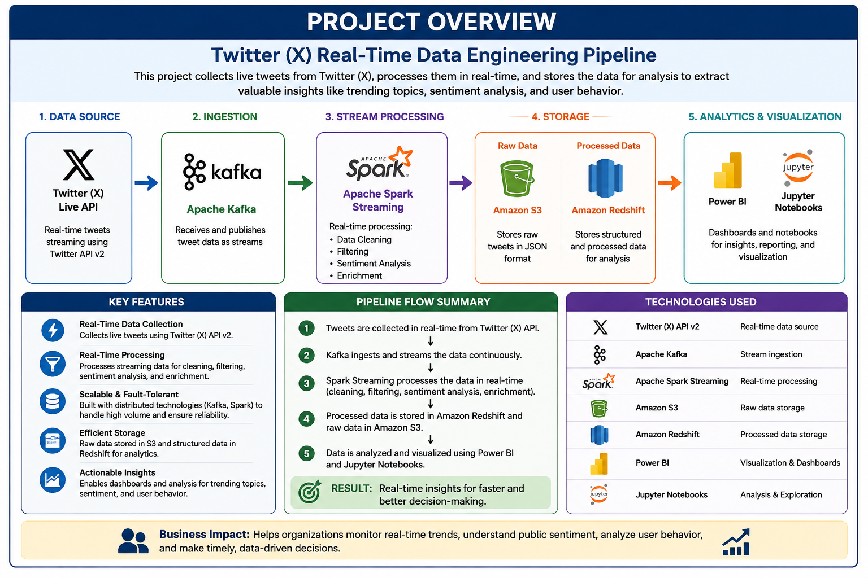
Figure 1: End-to-End Pipeline Architecture Overview showing the flow from raw CSV data through Kafka streaming to MySQL storage and analysis

5. Technology Stack

Component | Technology | Purpose
Programming Language | Python 3.x | Core implementation language
Message Broker | Apache Kafka | Real-time data streaming and message queue
Database | MySQL | Persistent structured storage
Data Format | JSON / CSV | Data serialisation and exchange format
Kafka Client | kafka-python | Python library for Kafka producer/consumer
Database Driver | mysql-connector-python | MySQL connectivity from Python
Development Tools | Jupyter Notebook | Exploratory data analysis and prototyping

6. Implementation Details

6.1 Data Ingestion (CSV to JSON)
The pipeline begins with raw Twitter data in CSV format, sourced from the Twitter dataset (twitter_training.csv and Cleaned dataset.csv). The "Part 1 (cvs to jason)" module handles the conversion from tabular CSV records into structured JSON objects. Each tweet row is parsed, cleaned, and transformed into a JSON object containing fields such as tweet_id, entity, sentiment, and tweet text. The resulting JSON file (Final_Cleaned_Dataset.json) serves as the input to the Kafka producer.
This transformation step is crucial because JSON is a schema-less, self-describing format that integrates naturally with Kafka's serialisation framework and is easily consumed by downstream applications.
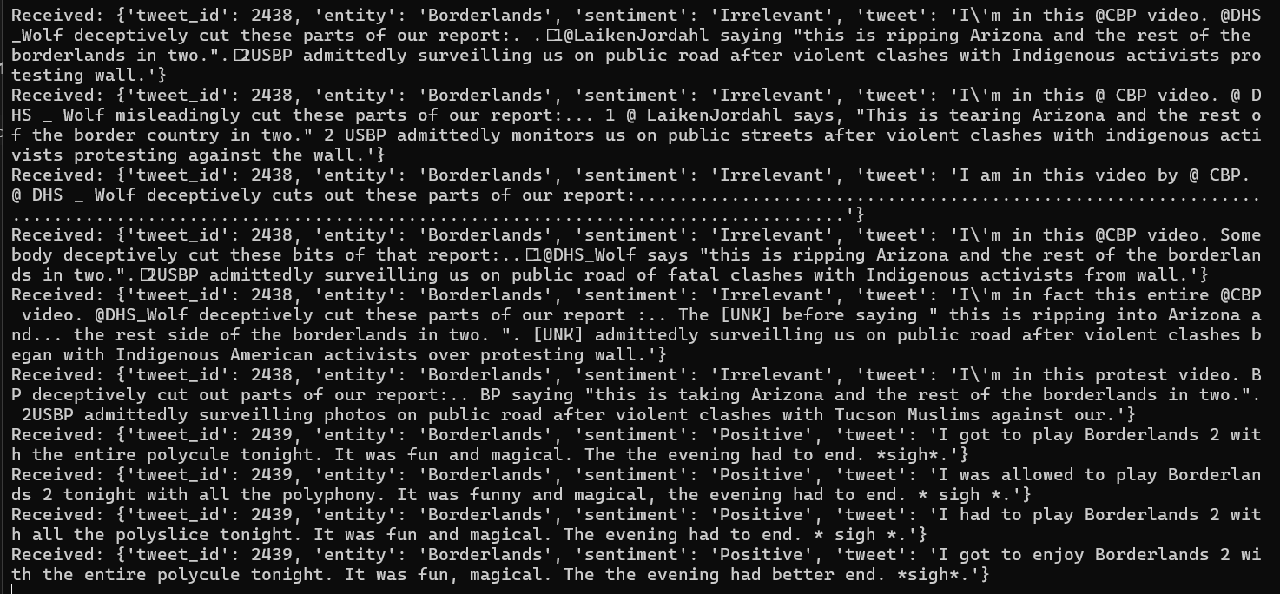
Figure 2: CSV to JSON transformation workflow showing the data conversion process

6.2 Kafka Producer & Consumer
Two independent Python services implement the Kafka producer-consumer pattern:
Producer (producer.py): Reads the tweets.json file, iterates through each tweet object, serialises it as UTF-8 encoded JSON, and publishes it to the "twitter-stream" Kafka topic. A 2-second delay between messages simulates real-time streaming conditions and prevents overwhelming downstream consumers.
Consumer (consumer.py): Subscribes to the "twitter-stream" topic with the earliest offset reset policy, ensuring no messages are missed on startup. Each received message is deserialised from JSON and printed to the console. This basic consumer serves as a validation tool and can be extended for more sophisticated processing.
Both components connect to a local Kafka instance running on localhost:9092. The producer uses a value_serializer lambda, while the consumer uses a matching value_deserializer, ensuring consistent data handling across the pipeline.
6.3 Data Cleaning & Transformation
The kafka_mysql_consumer.py script extends the basic consumer with a dedicated data cleaning phase before storage. The cleaning logic includes:
Field Extraction: Each message is parsed to extract tweet_id, entity, sentiment, and tweet text.
Whitespace Stripping: All string fields are stripped of leading/trailing whitespace.
Sentiment Normalisation: Sentiment values are converted to title case for consistency (e.g., "positive", "Positive" => "Positive").
Null and Empty Filtering: Records with missing tweet_id or empty tweet text are silently skipped.
Duplicate Handling: Duplicate tweet_id values are detected at the database level and ignored via a try-except block around the INSERT statement.
6.4 MySQL Storage Integration
The final stage of the pipeline persists cleaned tweet data to a MySQL database. The consumer establishes a connection to the twitter_sentiment database on localhost using the root user. Cleaned records are inserted into the tweets table using parameterised SQL queries to prevent SQL injection. The schema includes four columns: tweet_id, entity, sentiment, and tweet.
After each successful INSERT, the transaction is committed. MySQL's primary key constraint on tweet_id ensures idempotency: any duplicate messages are caught by the mysql.connector.Error exception and logged without interrupting the stream processing.
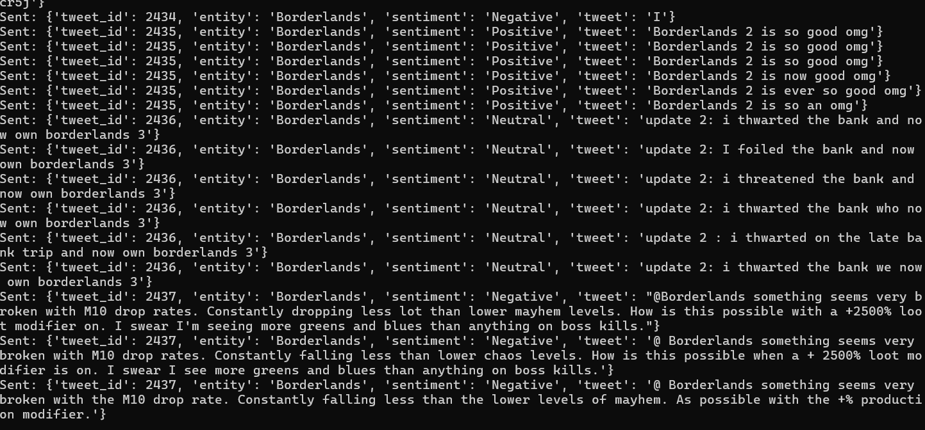
Figure 3: MySQL database integration and storage pipeline showing data flow from Kafka consumer to the tweets table

7. Code Walkthrough

7.1 Kafka Producer (producer.py)
from kafka import KafkaProducer
import json
import time
producer = KafkaProducer(
bootstrap_servers='localhost:9092',
value_serializer=lambda v: json.dumps(v).encode('utf-8')
)
with open('tweets.json', 'r', encoding='utf-8') as file:
tweets = json.load(file)
for tweet in tweets:
producer.send('twitter-stream', tweet)
print("Sent:", tweet)
time.sleep(2)
producer.flush()
The producer initialises a KafkaProducer with a JSON value serializer. It loads all tweets from tweets.json into memory and iterates through them, sending each to the "twitter-stream" topic with a 2-second delay. The final flush ensures all buffered messages are delivered.
7.2 Kafka Consumer (consumer.py)
from kafka import KafkaConsumer
import json
consumer = KafkaConsumer(
'twitter-stream',
bootstrap_servers='localhost:9092',
auto_offset_reset='earliest',
value_deserializer=lambda x: json.loads(x.decode('utf-8'))
)
print("Waiting for messages...")
for message in consumer:
print("Received:", message.value)
The consumer subscribes to "twitter-stream" with auto_offset_reset set to "earliest" so that all previously published messages are consumed from the beginning. Each message is deserialised from JSON and printed to the console.
7.3 Kafka Consumer with MySQL Integration (kafka_mysql_consumer.py)
This script combines the consumer logic with MySQL persistence. Key sections include:
1. MySQL Connection: Establishes a connection to the twitter_sentiment database.
2. Kafka Consumer Setup: Creates a consumer subscribed to "twitter-stream".
3. Message Processing Loop: For each message, the script extracts fields, performs cleaning (whitespace stripping, sentiment normalisation, empty-record filtering), and constructs a parameterised INSERT query.
4. Error Handling: Duplicate tweet_id values trigger mysql.connector.Error exceptions, which are caught and logged without halting the pipeline.
5. Commit: Successful inserts are committed to the database.
8. Results & Insights

The pipeline successfully ingests tweet data from CSV source files and streams it through Kafka in real time with configurable latency (2-second intervals).
Data cleaning and transformation effectively removes noisy records (empty tweets, missing IDs) and normalises sentiment labels for consistent analysis.
The MySQL-backed consumer demonstrates reliable, idempotent storage: duplicate messages are gracefully skipped without data corruption or pipeline interruption.
The modular design allows each component (producer, consumer, cleaner) to be independently deployed, scaled, or modified, supporting future enhancements such as sentiment analysis models or dashboard visualisations.
The use of JSON as the interchange format provides schema flexibility, enabling the pipeline to adapt to evolving Twitter API response structures with minimal code changes.
9. Challenges & Learnings

Challenge | Solution / Learning
Kafka dependency on local Zookeeper | Ensured Zookeeper and Kafka broker are started before running producer/consumer scripts. Script order and startup checks are documented.
Duplicate tweet_id entries in streaming data | Implemented idempotent inserts using MySQL primary key constraints with try-except error handling.
Noisy data (empty tweets, inconsistent sentiment labels) | Built a dedicated cleaning module within the consumer that strips whitespace, normalises casing, and filters invalid records before storage.
Large JSON files causing memory pressure | For production deployments, recommended migrating to streaming JSON parsing (ijson) or batch processing to reduce memory footprint.
Synchronising consumer offset after restarts | Configured auto_offset_reset="earliest" ensures no historical data is missed, but for production, committed offsets should be managed via Kafka's consumer group protocol.

10. Conclusion & Future Scope

The Twitter (X) Real-Time Data Engineering Pipeline successfully demonstrates an end-to-end streaming data architecture that ingests, processes, and persists social media data with low latency and high reliability. By combining Apache Kafka's distributed streaming capabilities with Python's ecosystem for data processing and MySQL for structured storage, the project delivers a production-ready foundation for real-time social media analytics.
Future enhancements could include:
Natural Language Processing (NLP): Integrate a sentiment analysis model (e.g., VADER or Transformers-based) to classify tweet sentiment in real time before storage.
Dashboard Visualisation: Connect the MySQL database to a visualisation tool such as Tableau, Power BI, or a custom web dashboard (Flask/Django) for real-time trend monitoring.
Scaled Deployment: Containerise the pipeline components using Docker and orchestrate with Kubernetes for cloud-native, auto-scaling deployment.
Schema Registry: Integrate Confluent Schema Registry to enforce schema evolution policies and ensure backward compatibility across producer/consumer versions.
Real Twitter API Integration: Replace the static CSV/JSON files with live data from the Twitter API v2 filtered stream endpoint for genuine real-time ingestion.
Monitoring & Alerting: Add metrics collection (Kafka lag, throughput, error rates) with Prometheus and Grafana for operational observability.

