**AWS Content Manager POC – (NJ COURTS)**

Background

A POC for storing the files along with their meta-data. The files can we searched and retrieved on the basis for querying the meta-data.

Requirement

1. AWS S3
2. AWS dynamo DB
3. AWS IAM User groups and User
4. AWS Lambda functions
5. AWS API Gateway
6. Python
7. Boto3 (Python library for accessing AWS resources)
8. Dash (User Interface)

General Pipeline

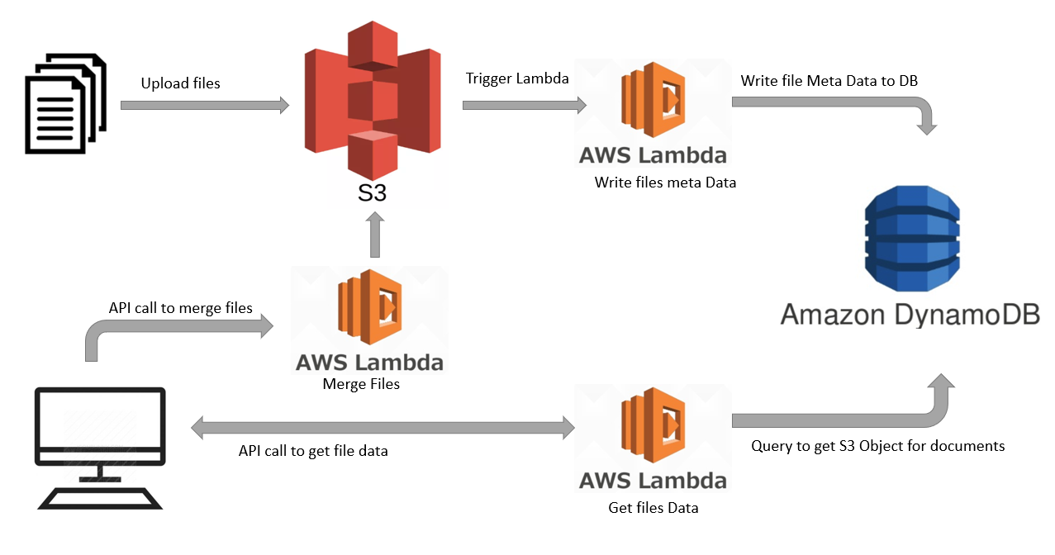

Resources used general information:

**AMAZON S3**

Login to Amazon AWS Console

Go to Services and click on S3 under Storage

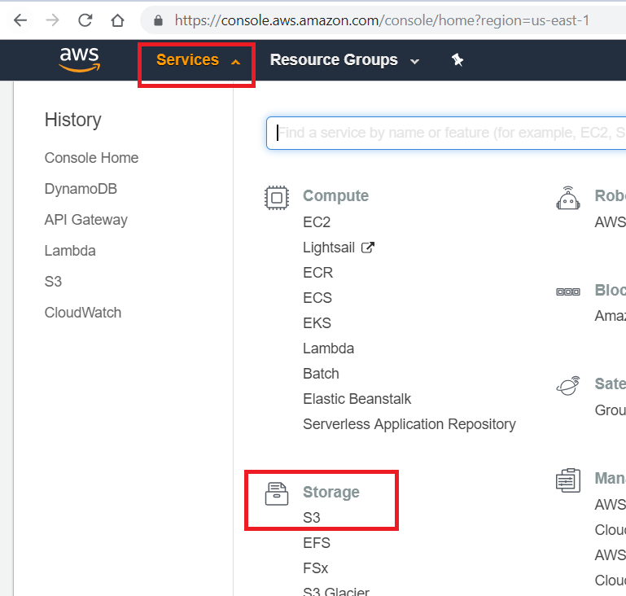

Create Bucket

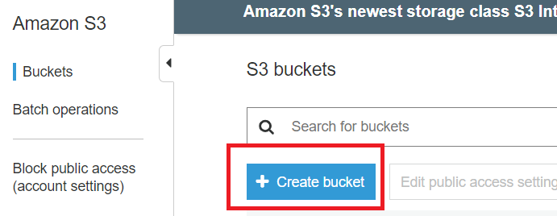

Set required Permissions and create



**AWS Dynamo DB Table**

Under AWS Services Database resources select DynamoDB

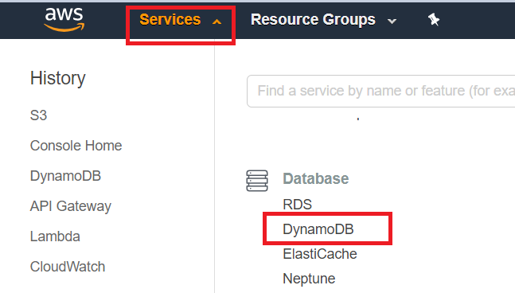

Click on create Table

1. Table Name
2. Partition Key – Acts as Primary key for the table (Unique and required)
3. Sort Key – Extra key for the table (If exist, acts as primary key along with combination of Partition Key)

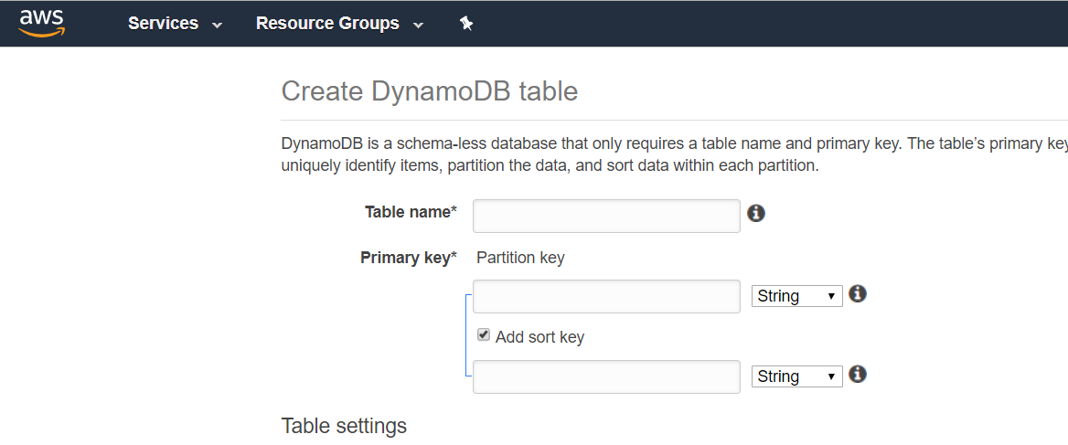

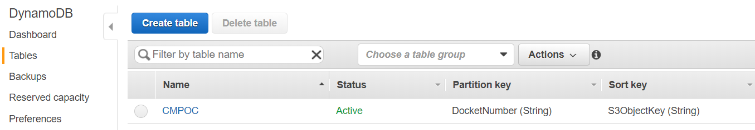

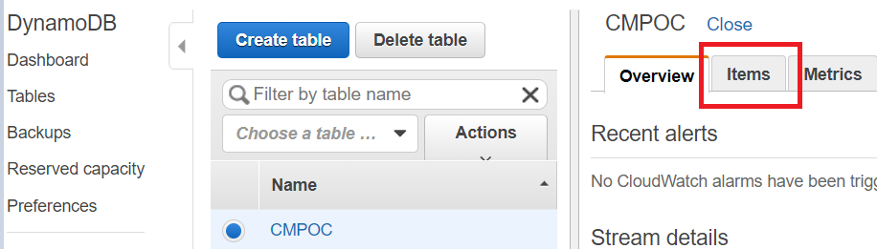

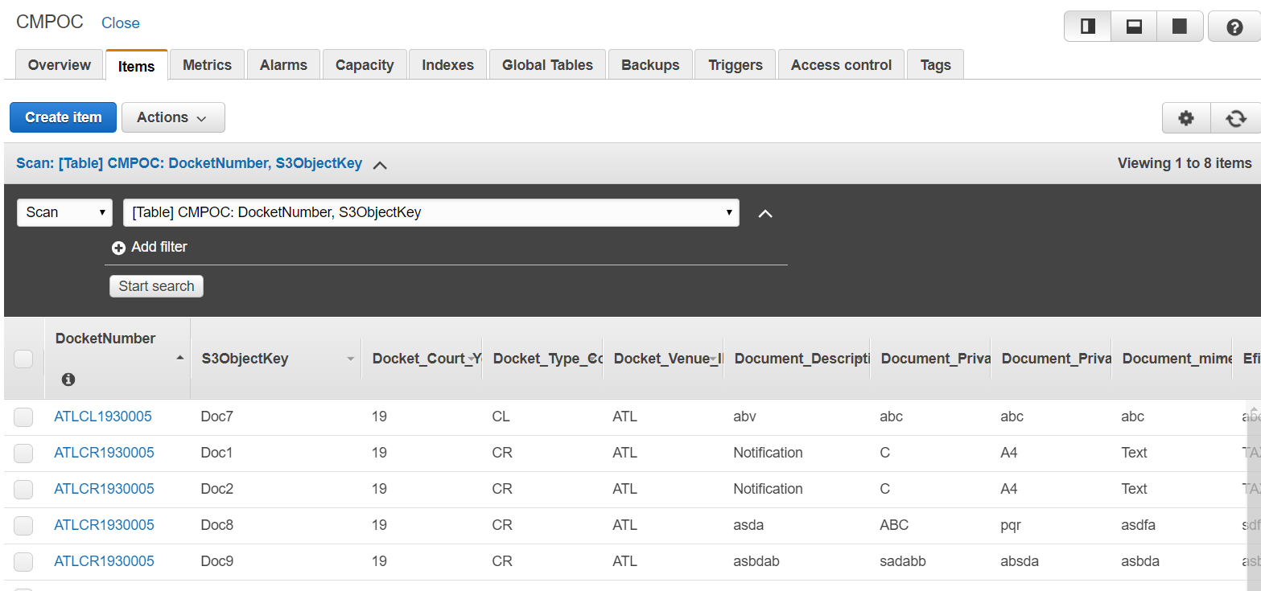

**IAM USER Group and Users**

Go to services and click IAM under security

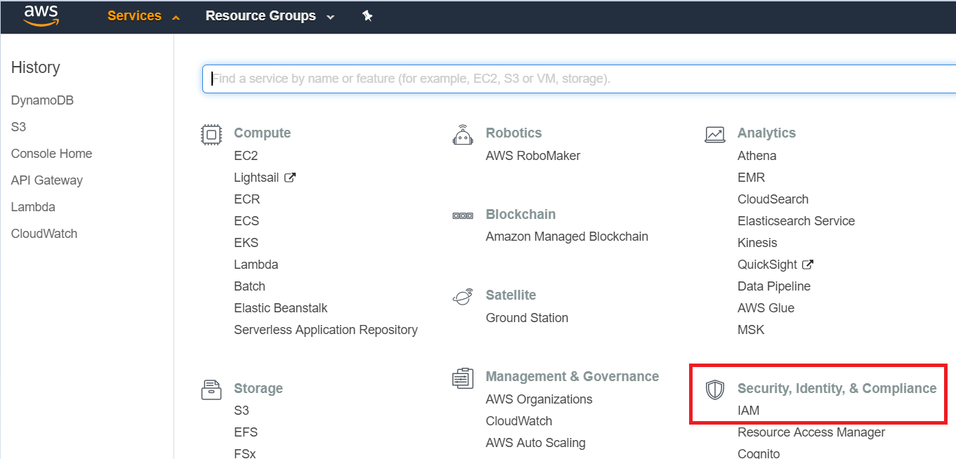

Go to groups and create a new group

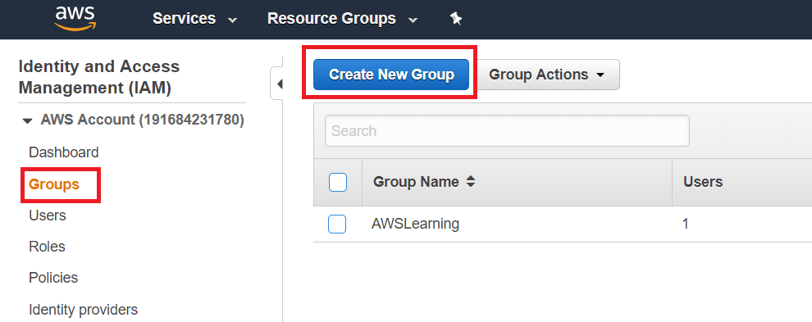

Determine the access for the group

* Administrator access allows access to all the resources for the user

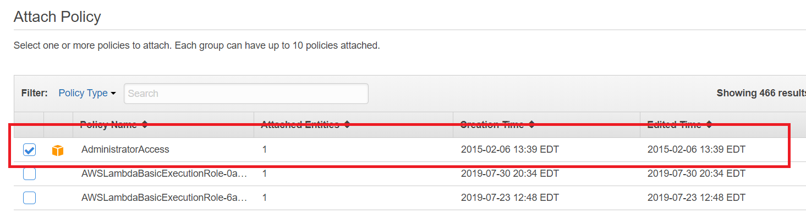

Go to Users and create a user under the Group created earlier

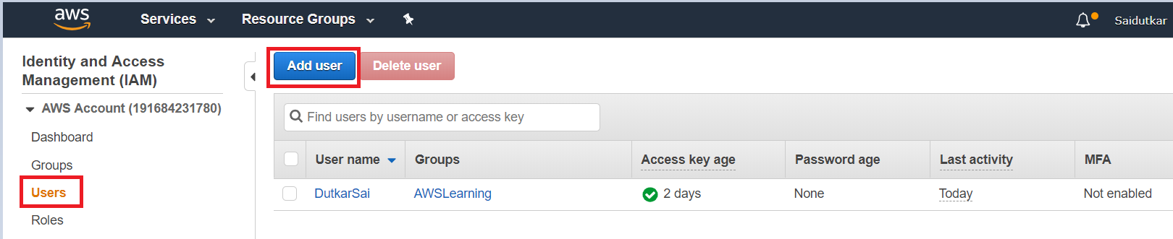

Go to the created user’s profile and under Security credentials, create the access key

Note down the **ACCESS KEY ID** and **ACCESS KEY**

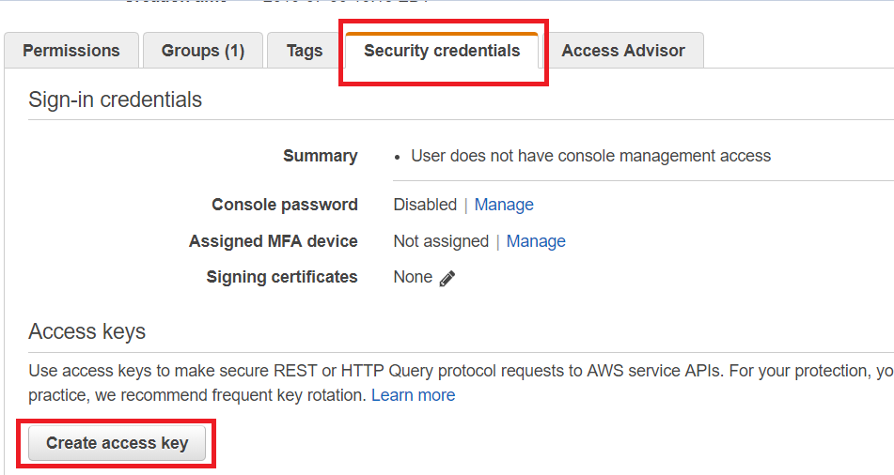

**AWS LAMBDA FUNCTION**

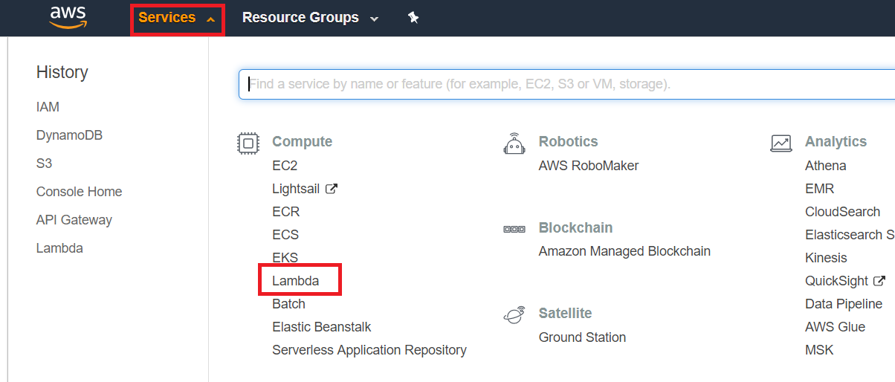

Click on create function

Give the name of function and select the runtime environment as Python 3.6 or Python 3.7

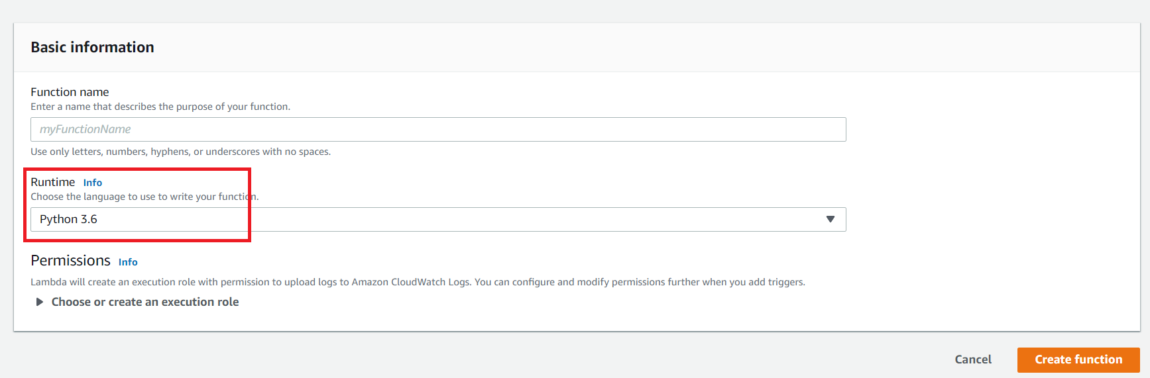

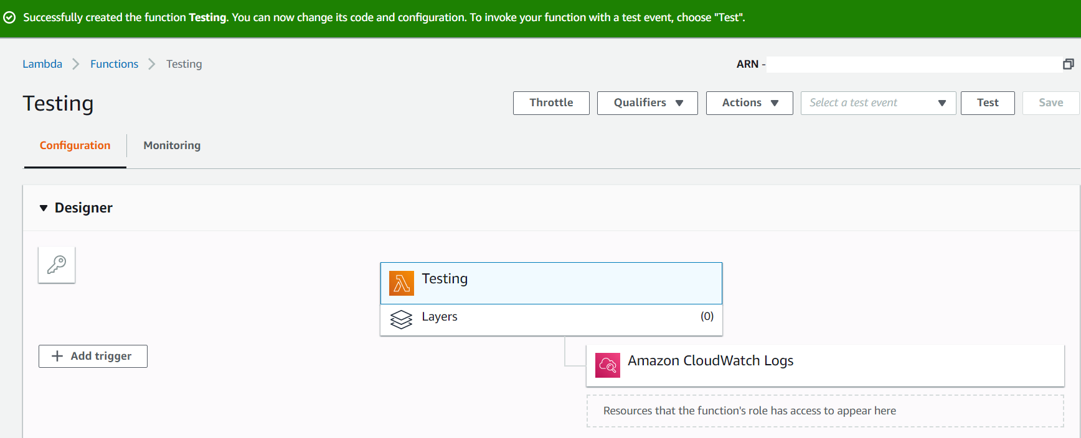 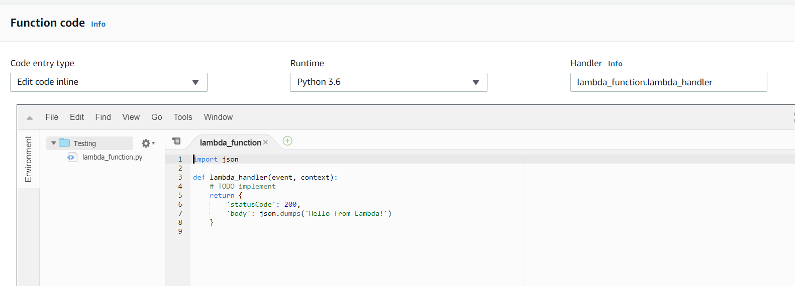

**AWS API GATEWAY**

In the Lambda function, click on Add trigger

Under trigger select API Gateway

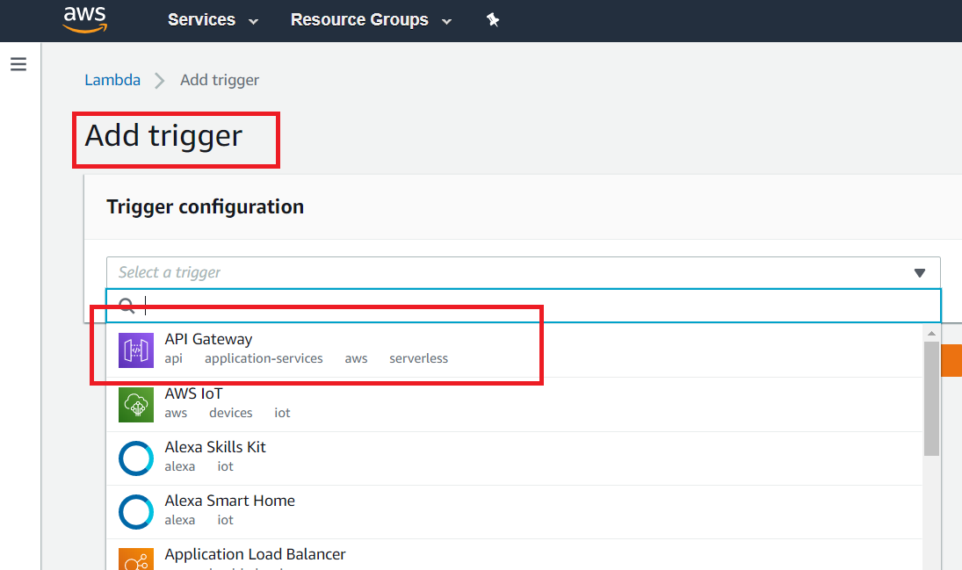

Select the security as required else keep it open

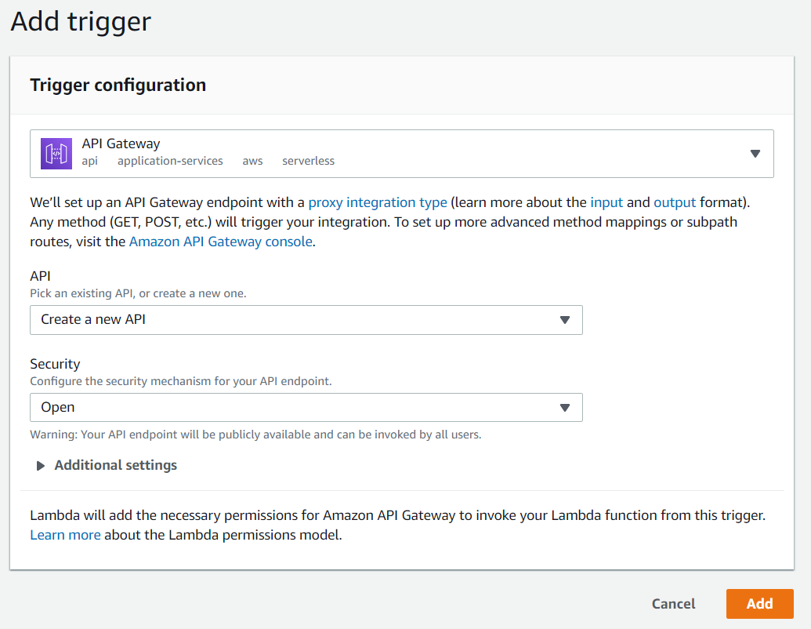

Copy the API endpoint:

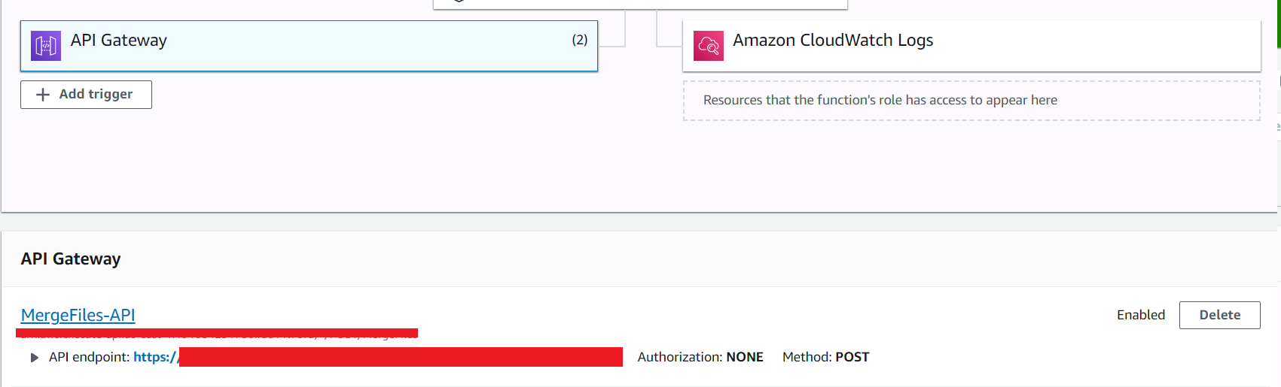

**Adding Lambda trigger on S3 bucket**

On your S3 bucket go to properties

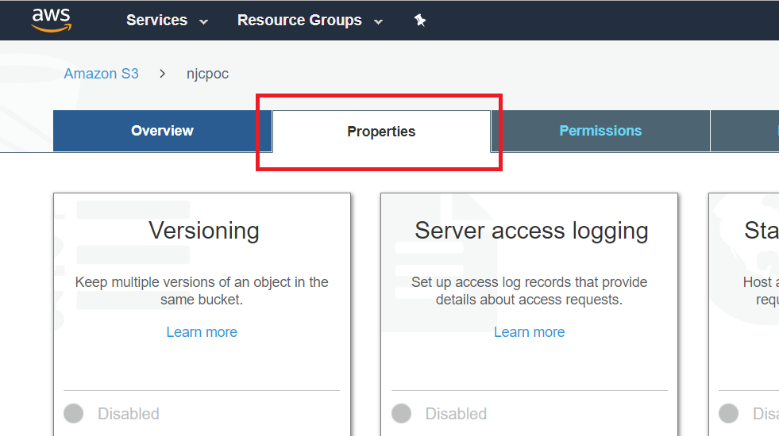

**Click on Events and add trigger to Lambda function on PUT**

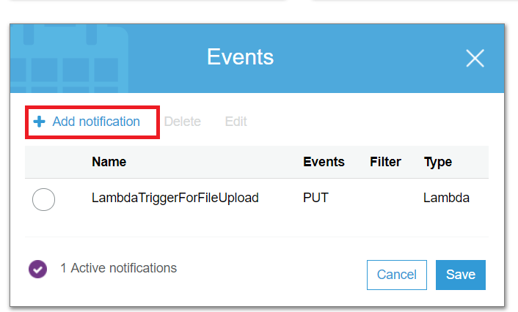

**LAMBDA FUNCTION – To add metadata of file to DynamoDB table**

from __future__ import print_function

import boto3, logging

// *User Access Key and ID*

**access_key_id="***************"**

**secret_access_key= "***************"**

// *S3 resource using boto3*

**s3 = boto3.client('s3',aws_access_key_id=access_key_id,**

**aws_secret_access_key= secret_access_key)**

// *DynamoDB resource using boto3*

**dynamodb = boto3.resource('dynamodb',region_name='us-east-1',aws_access_key_id=access_key_id,aws_secret_access_key=secret_access_key)**

**table = dynamodb.Table('CMPOC')**

logger = logging.getLogger()

logger.setLevel(logging.INFO)

// *Main Lambda function – The file meta data will be a part of event*

**def lambda_handler(event, context):**

for record in event['Records']:

bucket = record['s3']['bucket']['name']

key = record['s3']['object']['key']

response = s3.head_object(Bucket=bucket, Key=key)

// extracting the meta-data of file from event parameter

docket_venue_id = response['Metadata']['docket_venue_id']

docket_court_year= response['Metadata']['docket_court_year']

item_type = response['Metadata']['item_type']

document_description = response['Metadata']['document_description']

document_privacy_reason = response['Metadata']['document_privacy_reason']

docket_type_code = response['Metadata']['docket_type_code']

document_mime_type = response['Metadata']['document_mime_type']

document_privacy_code = response['Metadata']['document_privacy_code']

efiling_court_div = response['Metadata']['efiling_court_div']

document_code = response['Metadata']['document_code']

docket_seq_number = response['Metadata']['docket_seq_number']

DocketNumber = docket_venue_id+docket_type_code+docket_court_year+docket_seq_number

logger.info('Response: {}'.format(response))

// Adding the meta data to DyanmoDB table

table.put_item(

Item={

'DocketNumber': DocketNumber,

'S3ObjectKey': key,

'S3BucketName': bucket,

'Docket_Venue_ID' : docket_venue_id,

'Docket_Court_Year': docket_court_year,

'Item_Type' : item_type,

'Document_Description' : document_description,

'Document_Privacy_Reason' : document_privacy_reason,

'Docket_Type_Code' : docket_type_code,

'Document_mime_Type' : document_mime_type,

'Document_Privacy_Code' : document_privacy_code,

'Efiling_court_Div' : efiling_court_div,

'document_code' : document_code,

'docket_seq_number' : docket_seq_number } )

**Useful resource Links:**

1. Upload-download file from S3 using boto3 <https://qiita.com/hengsokvisal/items/329924dd9e3f65dd48e7>
2. DynamoDB using Boto3

<https://boto3.amazonaws.com/v1/documentation/api/latest/guide/dynamodb.html>

1. Dash installation and examples

<https://dash.plot.ly/installation>

STEPS to replicate project: