Week 1
Yahoo Finance API
Yahoo Finance does not have an official, public API, but the community-maintained library “yfinance” is the gold standard for accessing this data in Python. It is free, easy to use, and does not require an API key.
Installation: pip install yfinance
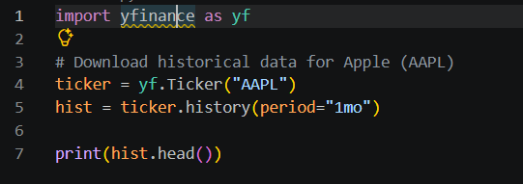
Code snippet:
Output:
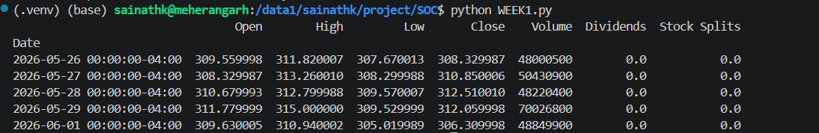
In the above output we can see that the yfinance is able to fetch the stock data of Apple Inc. of about a month’s period. This also includes the open, high, low and close of the daily candle alongwith volume traded during the day.

UN Comtrade API
The UN Comtrade database is the most comprehensive global repository for international trade statistics, housing over 3 billion records from nearly 200 countries. It is primarily used by governments, academic researchers, and enterprises. This API provides official international trade statistics. Unlike yfinance, this is a professional-grade database, so you will need to register for an API key on their Developer Portal.
Installation: pip install comtradeapicall
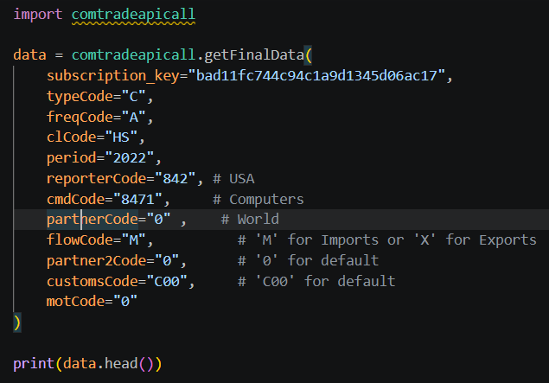
Code Snippet:
Output:
The output you see is a Pandas DataFrame containing a single row of data (with 47 columns).so the breakdown of the output goes like:
Cifvalue(Cost, insurance and Freight): It represents the total value of imports including the cost of shipping and insurance
Fobvalue(Free on Board): It represents the value of the goods at the point of origin, before shipping costs are added
isReproted: This often indicates that the specific value might be estimated or imputed by the UN statistical division rather than being a raw, directly reported figure from a specific customs agency for this aggregate view.
Contorycode/Partnercode: We can say it as the code given to each country.(china:156,Germany:256)
PrimaryValue: It is the monetary value of the trade flow in the currency defined by the record (usually US Dollars). It is considered the "Primary" value because it is the most standard metric used for almost all economic analysis.

