# PROFESSIONAL TRAINING REPORT

**at**

**Sathyabama Institute of Science and Technology (Deemed to be University)**

Submitted in partial fulfillment of the requirements for the award of Bachelor of Engineering Degree in Computer Science and Engineering

By

**RENDLA SAINATH REDDY**.

**(Reg.No.40111054)**



**DEPARTMENT OF COMPUTER SCIENCE AND ENGINEERING SCHOOL OF COMPUTING**

**SATHYABAMA INSTITUTE OF SCIENCE AND TECHNOLOGY JEPPIAAR NAGAR, RAJIV GANDHI SALAI,**

**CHENNAI – 600119, TAMILNADU**

**OCT 2022**

**SATHYABAMA**

**INSTITUTE OF SCIENCE AND TECHNOLOGY**

### (DEEMED TO BE UNIVERSITY)

**Accredited with Grade “A” by NAAC**

**(Established under Section 3 of UGC Act, 1956)**

**JEPPIAAR NAGAR, RAJIV GANDHI SALAI, CHENNAI– 600119**

[**www.sathyabamauniversity.ac.in**](http://www.sathyabamauniversity.ac.in/)

# DEPARTMENT OF COMPUTER SCIENCE AND ENGINEERING

**BONAFIDE CERTIFICATE**

This is to certify that this Project Report is the bonafide work of **RENDLA SAINATH REDDY(40111054)** who carried out the project entitled “**SEVERLESS APPLICATION**” under my supervision from Aug 2022 to Oct 2022.

**Internal Guide Name**

**MS.M.GOWRI**

**Head of the Department**



**Submitted for Viva voce Examination held on 08/11/2022**

**InternalExaminer ExternalExamine**

**DECLARATION**

I RENDLA SAINATH REDDY hereby declare that the Project Report entitled “**SEVERLESS APPLICATION” .**Done by me under the guidance of Dr./Prof./Mr./**Ms MOHAMMED SIR.** at “**CREDO SYSTEMS”.** is submitted in partial fulfillment of the requirements for the award of Bachelor of Engineering degree in Computer Science and Engineering.

**DATE:**

**PLACE: SIGNATURE OF THECANDIDATE**

**ACKNOWLEDGEMENT**

I am pleased to acknowledge my sincere thanks to **Board of Management** of **SATHYABAMA** for their kind encouragement in doing this project and for completing it successfully. I am grateful to them.

I convey my thanks to **Dr. T. Sasikala M.E., Ph.D.**, **Dean**, School of Computing , **Dr.S.Vigneshwari M.E., Ph.D., and Dr.L.Lakshmanan M.E., Ph.D.,** Heads of the Department of Computer Science and Engineering for providing me necessary support and details at the right time during the progressive reviews.

I would like to express my sincere and deep sense of gratitude to my Project Guide

MS.M.GOWRIfor his valuable guidance, suggestions andconstantencouragementpavedwayforthesuccessfulcompletionofmyprojectwork.

I wish to express my thanks to all Teaching and Non-teaching staff members of the **Department of Computer Science and Engineering** who were helpful in many ways for the completion of the project.

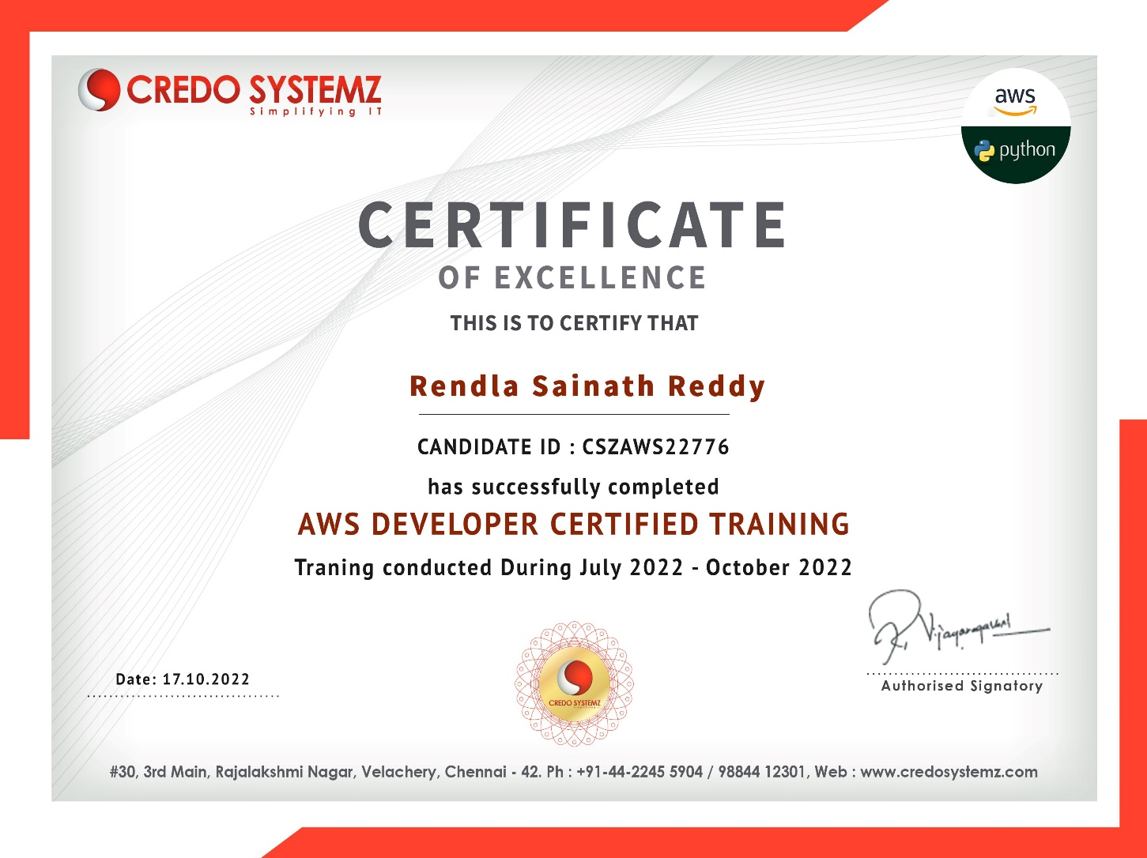

ABSTRACT

Amazon Web Services offers a broad set of global cloud-based products including compute, storage, databases, analytics, networking, mobile, developer tools, management tools, IoT, security, and enterprise applications: on-demand, available in seconds, with pay-as-you-go pricing. From data warehousing to deployment tools, directories to content delivery, over 200 AWS services are available. New services can be provisioned quickly, without the upfront capital expense. This allows enterprises, start-ups, small and medium-sized businesses, and customers in the public sector to access the building blocks they need to respond quickly to changing business requirements. This whitepaper provides you with an overview of the benefits of the AWS Cloud and introduces you to the services that make up the platform.

**CHAPTER NO. TABLE OF CONTENT: PAGE NO.**

1. **INTRODUCTION**  1
   1. BENFITS OF AWS 2-3
   2. CHALLENGES INTO AWS 3-4
2. **INSIGHTS INTO AWS** 4
   1. AWS and Hybrid Cloud Computing 4-5

Model

* 1. AWS SERVICES 5-6
  2. AMAZON MACHINE IMAGE 7-8
  3. AWS LAMBDA 8-9

1. **AMAZON DATABASE SERVICES**
   1. AMAZON SIMPLE STORAGE SYSTEM 10-14
   2. DYNAMODB 15-16
2. **API GateWay**
   1. API GateWay 17-18
   2. Final Output 19

1. **AWS PRICING** 
   1. AWS PRICING/TCO TOOLS 20-22
   2. AWS PRICING CALCULATOR 23-24
   3. MIGRATION EVALUATOR 25

**References**

***INTRODUCTION:***

* The platform was launched by amazon on in july 2002.
* AWS was successful to deliver on-demand cloud computing features to its customers as pay-per-use basis
* It allows different organizations to take advantages of reliable IT infrastructure
* AWS offers more than 100 services and it has over one hundred thousand active customers
* It provides services to the customers when required without any prior commitment or upfront investment
* Aws provides virtual computers having features of the real systems. Some of these features are listed as follows:
  + Operating system
  + Hardware resources such as CPUs, RAM, GPUs and hard disks
  + Software such as CRM. Web browsers, databases, web servers etc.
  + Networking resource
  + Console I/O such as monitor, keyboard and mouse

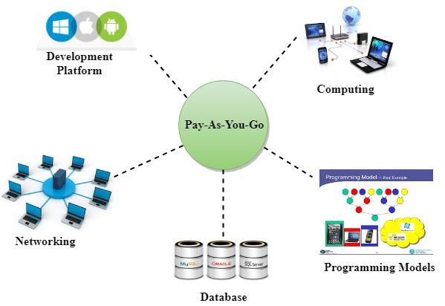

* A Hypervisor is a kind of emulator, it is computer software, firmware or hardware that creates and runs virtual machines

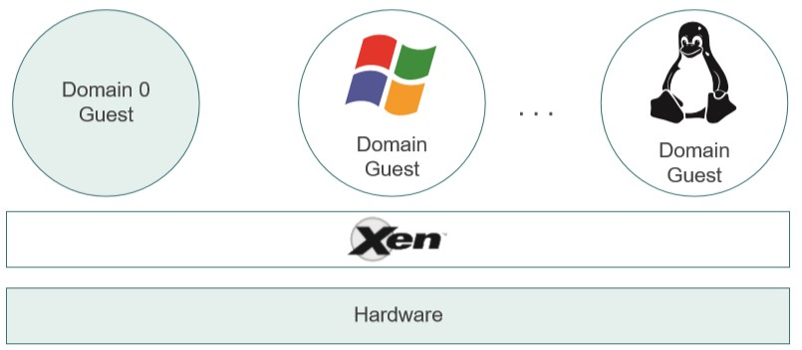

* Amazon uses Xen and Kernel-based Virtual Machine, which are open source and used for virtualizing compute infrastructure that runs on x86 compatible hardware
* The new hypervisor for AWS-EC2 is a component that delivers memory isolation and CPU for all the C5 instances. It built on the Linux Kernel-based Virtual Machine technology

*Benefits of computing with AWS:*

* Cost effective:
  + Beneficial users only as per their resource usage.
  + Pay-per-use pricing model has organizations to reap benefits from AWS services
  + Users can use more than 100 services offered by the AWS with minimum cost
  + For start-ups and small-sized business this is more efficient
* Secure:

AWS’s physical and online infrastructure is highly secure and in strict accordance with international security standards

AWS has its data centers scattered all over the world, providing fail proof access to data and are safeguarded by elite security guards working round the clock.

* Easy to use:

AWS services are very easy to use as owing to their well- documented API to access AWS hosting platforms which enables vendors, ISVs and providers to easily and instantly host their applications.

* High Scalable:

The auto scaling and Elastic Load Balancing tools provisioned by AWS allow applications to be easily scaled up and down depending on the requirements.

* Reliable:

Computing infrastructure with over fifteen years of experience, is of the highest standard, reliable and secure.

* Elastic and Agile:There is elasticity of adding or subtracting resources dynamically and with ease.
* Flexible:

the user has the flexibility to customize his resources as per requirement. There are several options while selecting the web application platform, the operating system, the programming models and languages, the database, the architectures and other resources, which facilitates easy migrations to the cloud.

* No commitment:

AWS does not expect any form of commitment from its users, for using services. Billings are done on an hourly basis. Users can even scale down resources to zero, after which they will not be charged for usage.

*Challenges in adopting AWS:*

* Lack of appropriate skill set :

Although, AWS provides a wide range of services and feature it requires adequate training of IT professionals to judiciously make use of all the services offered.

* Maintaining Consistency :

The migration process is fraught with obstacles, such as data loss concerns, integration issues. Also, even after the process of migration is complete, the task of maintaining consistency and synchronization becomes important, laborious and time consuming.

* Complexity :

The complexity associated with the process of migration can be significantly reduced with the help of tools supplied by AWS.

* Security and Trust :

Challenges of security and trust arise when companies migrate their businesses to AWS.

* Performance :

There are also challenges related to performance. A downtime of even a fraction of a second can result in loss of customers which can further have a long-term, cascading effect on search engine optimization.

* Control :

Another daunting task is choosing to store sensitive data in datacenters, even though Amazon.com provides successful use cases. Organizations need to understand this lack of control over the security of their data before opting for these services.

*Insights into AWS:*

Amazon Web Services (AWS) is a cloud services platform that is secure and on demand. AWS offers numerous sets of infrastructure services that help organizations expand. These infrastructure services include:

* Computing power
* Database storage options
* Networking and databases
* Content delivery

These services are readily available (within seconds) with a pay-as-you-go pricing scheme. Arguably, AWS applications are:

* Flexible
* Scalable
* Reliable

Further, AWS is based on the Service-Oriented Architecture, which involves HTTP, REST, and SOAP transfer protocols, open source and commercial OS, and application servers and browser-based access.

*AWS and Hybrid Cloud Computing Model*

A cloud provider is responsible for providing a range of services implemented through hybrid computing model. AWS has successfully provisioned an array of hybrid capabilities including tools for networking, security, storage, management, and application deployment as an extension to pre-existing resources. Figure explains how a hybrid model is established between AWS and an organization's private data center.

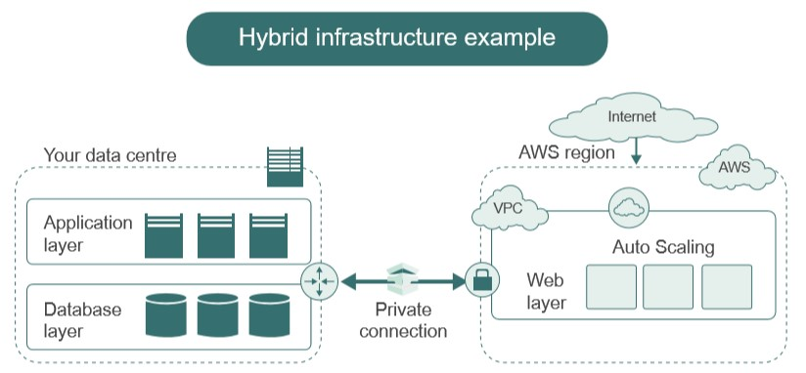

*AWS Services*

Amazon Web Services deliver a wide range of services. They are:

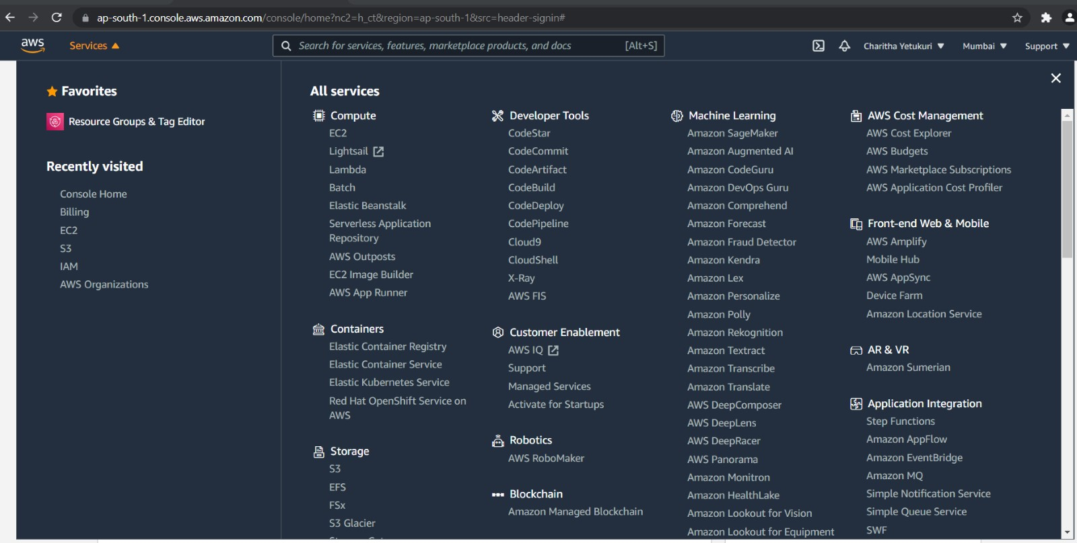

Some of these services are now discussed in detail:

**Amazon Elastic Compute Cloud (EC2):** EC2 is the principal application in the AWS service listing. With datacenters spread worldwide, EC2 applications created are dependable, consistent, scalable and fault tolerant. EC2 is supported by several tools. For example, Amazon Simple Queue Service (SQS) is a message queue or transaction system for distributed Internet-based applications.

**Amazon CloudWatch:** Amazon CloudWatch monitors the EC2 and provides a console or command line display to scan distinct metrics, such as site key performance indexes, resource utilization, and operational indicators for processor demand, disk utilization and network I/O factors.

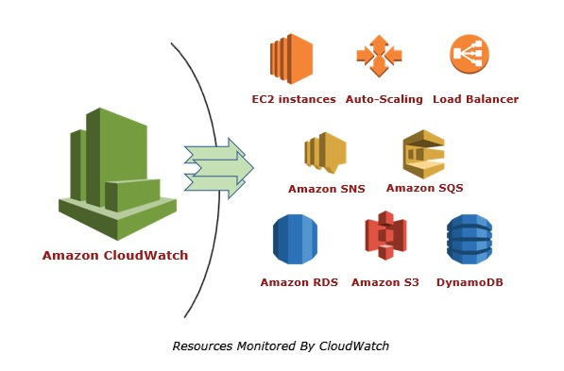

**Amazon Simple Notification Service (SNS):** Messages published from an application and sent to other applications or to subscribers is performed by SNS. It is a technique for triggering actions and empowering users or applications to subscribe to information.

**Amazon Simple Storage System (S3):** S3 is an online backup and storage system having a high-speed data transfer feature known as AWS Import/Export. This feature enables exchange of data to and from AWS using Amazon’s own internal network to another portable device.

**Amazon Elastic Block Store (EBS):** Virtual disks (volume) or block level storage devices are created using the EBS system. EBS is used for Amazon Machine Instances in EC2.

**Amazon SimpleDB:** SimpleDB supports indexing and data queries in both EC2 and

S3. SimpleDB is not a complete database implementation, and rather stores data in “buckets” without the need for creation of database outline. This design allows SimpleDB to be easily scalable.

**Amazon Relational Database Service (RDS):** RDS lets users create instances of MySQL database, which can support websites and other applications requiring datadriven services. MySQL is used ubiquitously in LAMP (Linux, Apache, MySQL, and PERL) web services platform. The inclusion of RDS supports developers in porting source codes, applications and databases directly over to AWS. Thus, earlier investments are retained in this technology.

**Amazon CloudFront:** CloudFront is an edge storage or content-delivery system.

CloudFront is comparable to the Akamai.com system, however, it is a proprietary to Amazon.com and is configured to operate with S3. Amazon CloudFront is also sometimes known as ‘edge computing’ and refers to the content delivery network (CDN).

*Amazon Machine Image:*

An Amazon Machine Image (AMI) creates a template for the root volume of an instance such as application, application server or operating systems which provide information needed to launch a virtual server in the cloud. The virtual server is also known as an instance.

The following are AMIs available for users to select from:

* AMI provided by the user community
* AMI provided by AWS
* AMIs available in the AWS Marketplace.

The user can also create his own AMI and share it with the user community via the AWS marketplace. Figure shows the lifecycle of an AMI. Once your work is completed, the AMIs can be de-re

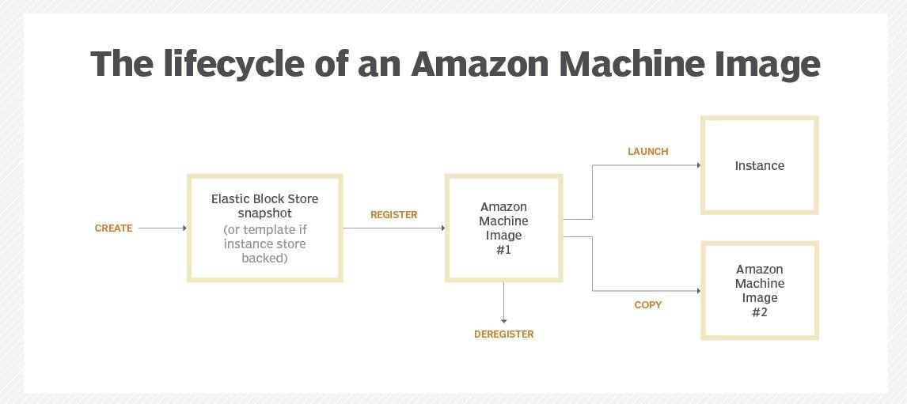

*Benefits of AMI:*

Like cloud computing itself, using an AMI has several important advantages.

* Chief among these is the fact that you can rely on pre-configured templates that allow you to deploy one or more instances.
* With an AMI, you have the ability to quickly and efficiently determine what computing power, memory, storage, and other factors you need for your applications.
* Of course, the low cost is also a major benefit.
* The AMI also speeds up configuration and deployment because the templates are well-known and defined for typical computing infrastructure needs.
* Flexibility is the key benefit as well. An AMI can run Linux, Unix, or Windows, and you can augment the AMI with additional services. As you can expect from an Amazon service, an AMI is compressed, encrypted, and secured no matter which operating system you use.

.

Further, an AMI principally uses the Xen hypervisor. The hypervisor offers two types of Virtual Machines, viz. Hardware Virtual Machines (HVM) and Para Virtual Machines (PV):

**HVM AMI:** A Hardware Virtualized Amazon Machine Image means that it does not require any changes to the operating systems, which do not have any idea of virtualization. With HVM the OS can function on bare metal. Here, the VMs run directly on hypervisors and have no knowledge that they are sharing resources with other users on the same hardware.

**PV AMI:** Para Virtualized AMIs function on a modified version of the OS. A special boot loader called PV-GRUB helps to load the PV AMI. Moreover, these AMIs only support Linux. Traditionally, PV AMIs had better performance as compared to HVM AMIs. This is no longer true currently due to improvements in HVM virtualization and the availability of PV drivers for HVM AMIs.

*AWS Lambda:*

AWS provides an ideal server less environment to run codes and manage resources required by the codes. It is known as AWS Lambda. AWS Lambda is a completely server-less compute service. It does not require provisioning or managing servers, but this does not mean that there is an absence of servers. In fact, your code still runs on servers with the entire management process being handled by AWS.AWS Lambda supports several programming languages:

* Python
* Node.js (JavaScript)
* Java (Java 8 compatible)
* .NET Core

Unlike in EC2, where resources are managed by users, AWS Lambda is responsible for managing the computing resources such as network, memory, CPU, among others. AWS Lambda will handle administrative and operational tasks, such as capacity provisioning, maintaining security, deploying codes, scaling and logging and monitoring functions. However, AWS Lambda does not provide flexibility, which is a feature provisioned by EC2 for its users.

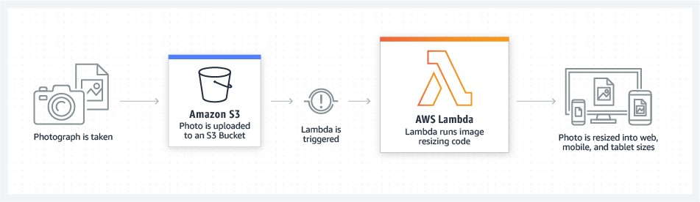

*Features of Lambda:*

**No server to Manage**: Lambda runs your code on highly available, fault-tolerant infrastructure spread across multiple availability zones in a single Region, seamlessly deploying code, and providing all the administration, maintenance, and patches of the infrastructure.

**Continuous Scaling**: Lambda precisely manages scaling of your functions (or application) by running event triggered code in parallel, and processing each event individually.

**Millisecond metering**: With AWS Lambda, you are charged for every 1 millisecond (ms) your code runs, and the number of times your code is triggered. You pay for consistent throughput or execution duration, instead of by server unit.

**Increases innovation**: Lambda frees up your programming resources by taking over the infrastructure management, allowing them to focus more on innovation and development of business logic.

**Modernize your application:** Lambda enables you to use functions with pre-trained machine learning models to inject artificial intelligence into applications easily. A single application programming interface (API) request can classify images, analyze videos, convert speech to text, perform natural language processing, and more.

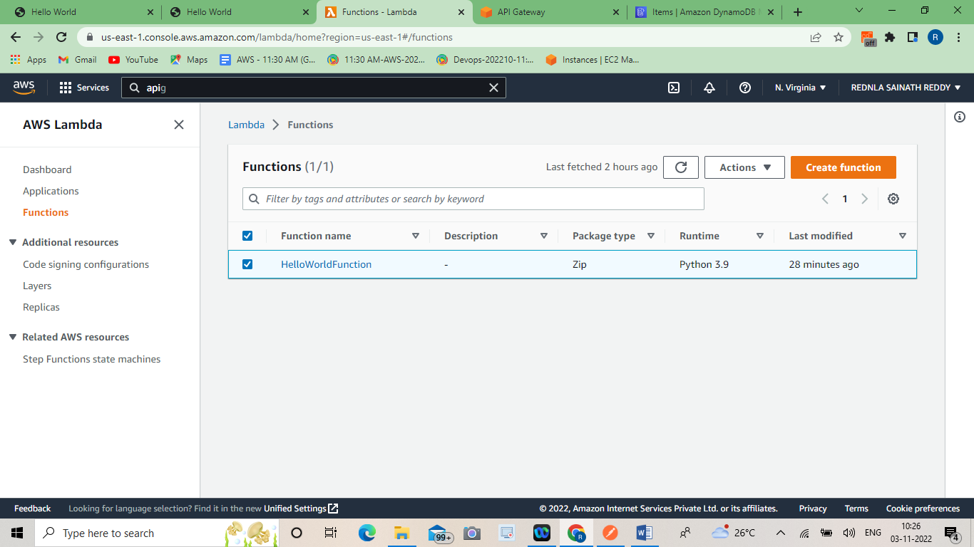

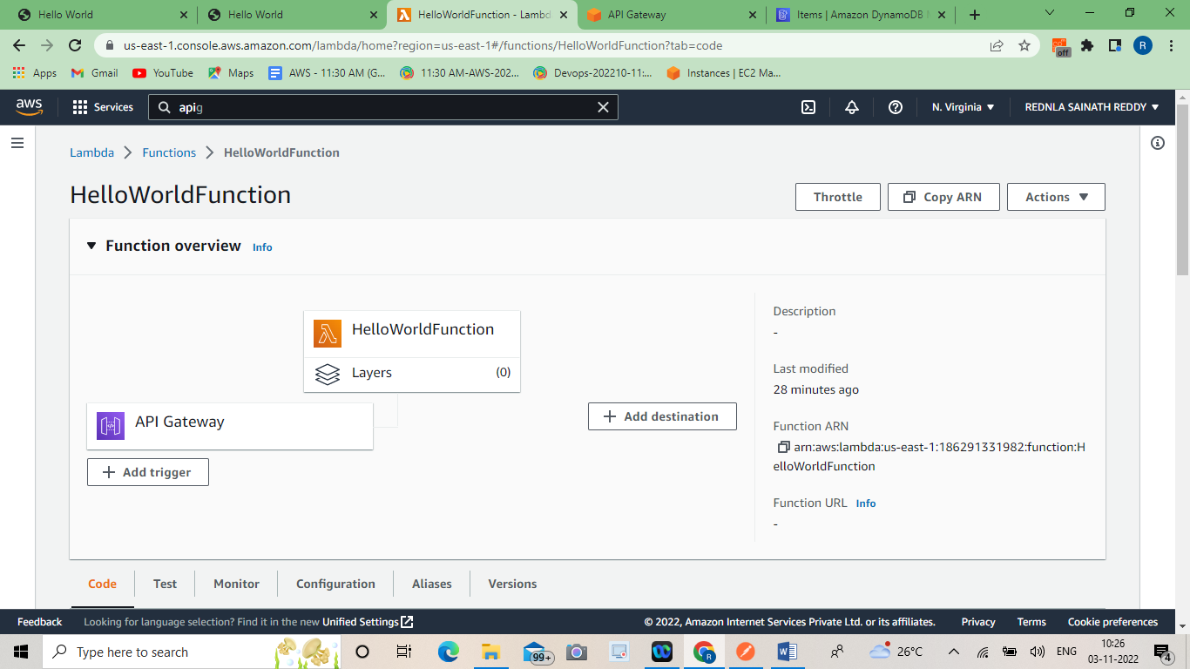

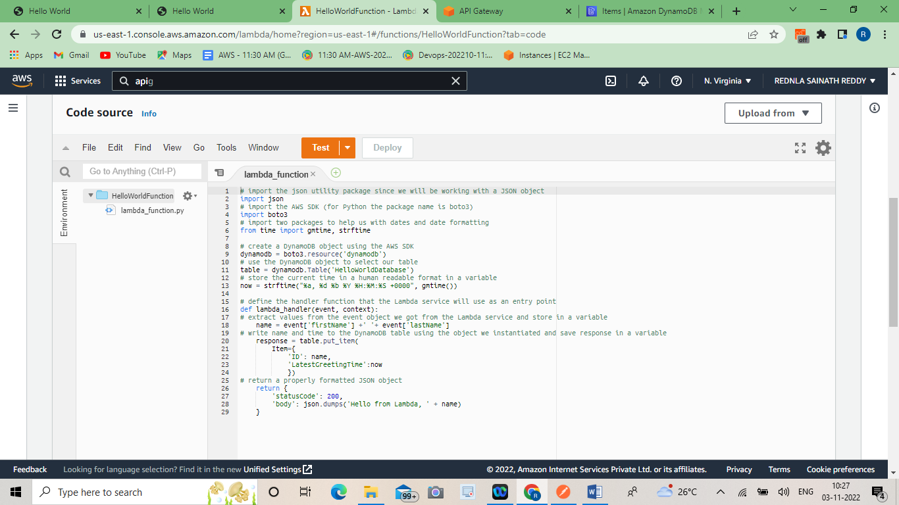

*Amazon Storage Options :*

Once an AMI is created, a certain amount of storage is provisioned for it. This storage is temporary as it only exists for as long as the instance is running. All data contained in that storage is lost when the instance is terminated or suspended. The now free storage is re-assigned to the pool or to another instance for other AWS users. Further, the Amazon S3 provides block storage, however, this is set in a somewhat unique manner as compared to other storage systems. We shall now discuss some of these storage services.

*Amazon Simple Storage System (S3)*

Amazon S3 is a cloud-based storage system that sanctions storage of data objects ranging from 1 byte up to 5 GB in a flat namespace. S3 storage containers have predefined buckets, and these buckets serve as a directory, though there is no object hierarchy to a bucket, and the user can save objects but not files to it. At this juncture, it is important to note that the file system concept is not associated with S3 because they are not supported and hence, not stored. Figure shows diagrammatic representation of S3.

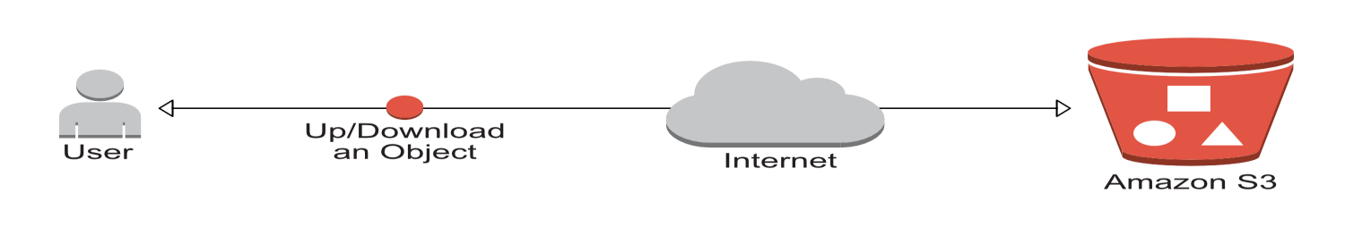

S3 system allows naming of buckets, however, the name used has to be unique in the S3 namespace across all consumers of AWS. The bucket can be accessed through the S3 web API (with SOAP or REST), which functions analogous to a normal disk storage system.

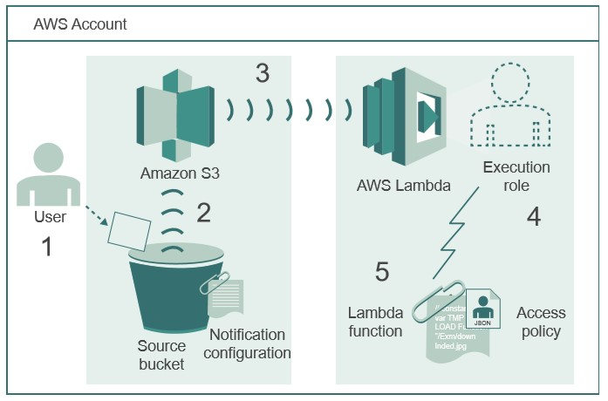

The performance of S3 is restricted to non-operational functions such as data archiving, retrieval and disk backup. The REST(Representational State Transfer) API is preferred over SOAP(Simple Object Access Protocol) API for the ease with which work with large binary objects in REST can be performed. The APIs to manage the bucket has the following features:

* Upload or download new objects to a bucket
* Create new, modify or delete existing buckets
* Identify metadata associated with objects and buckets
* Provide public access to buckets and objects
* Locate objects in buckets
* Specify where the bucket is stored

The S3 service can function as a backup component in a 3-2-1 backup method. 1 implies your original data, 2 implies a copy of your data while 3 refers to an off-site copy of data. In this method, S3 forms the 3rd level of backup.

*Benefits of using Amazon S3:*

**Simple to use:** S3 serves as a unique storage platform. It is designed and built to simplify functions. It has mobile apps, web management console, and APIs which allow firms to integrate the platform with other technologies in use quickly.

**Enhances Security:** S3 supports the transfer of data on SSL. It also enables automatic encryptions of data upon the completion of uploading. Importantly, it allows you to configure policies which will manage permissions grant to an object. It allows you to control the access to valuable information by utilising AWS Identity.

**Reliable and Durable Data Storage:** Amazon S3 offers robust infrastructure for the storage of crucial information. It is designed to provide 99.999 percent durability for the objects. In addition to strength, S3 is reliable since it stores data across different devices and facilities to improve data accessibility.

**Integration:** S3 iseasy to integrate with other services available on AWS. You can directly embed S3 with security platforms such as IAM, alerting services such as Event Notifications, databases including EMR, and computing platforms such as Lambda.

**Migration of Data from Cloud:** S3 provides a platform for you to transfer data to the cloud and out.

AWS offers two types of database services

* + SimpleDB: A non-relational database system
  + AmazonRDS: Amazon Relational Database Service Database services are created with the goal of providing dynamic data access, which is the key element of web services, particularly Web 2.0 services. Since AMI supports a variety of major databases, it is possible to create databases as a component of the AWS SOA .

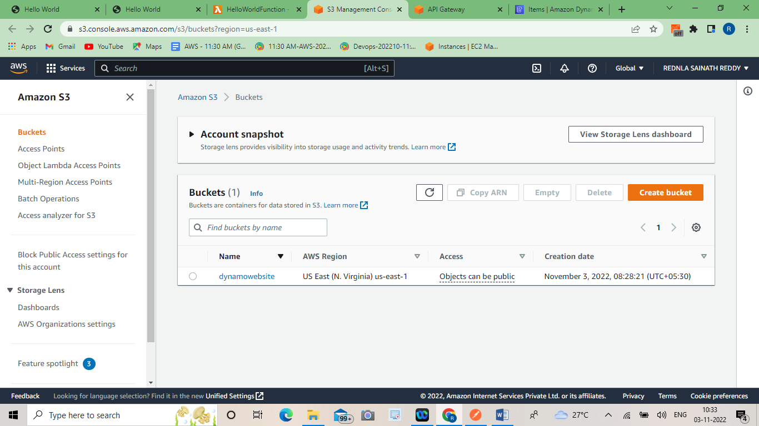

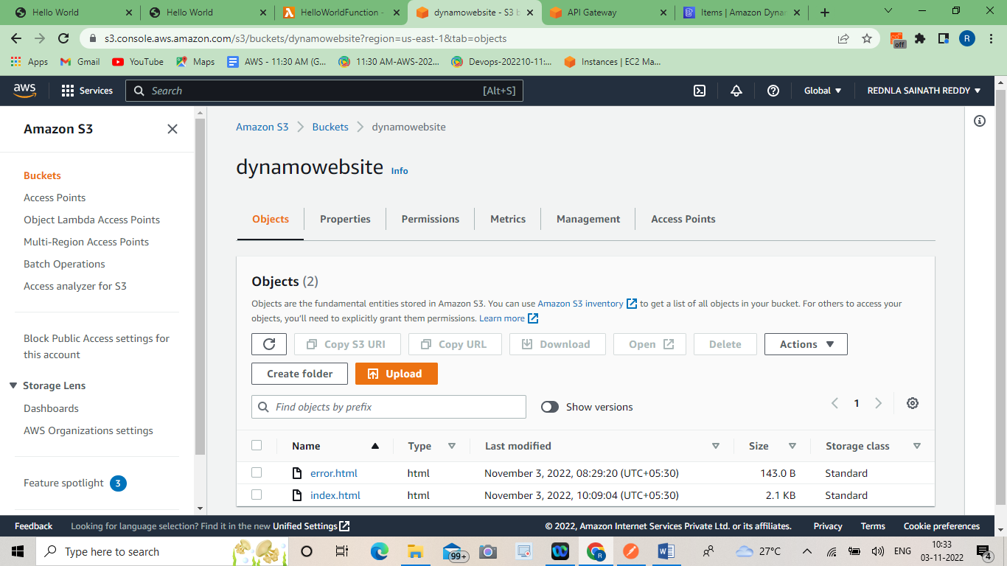

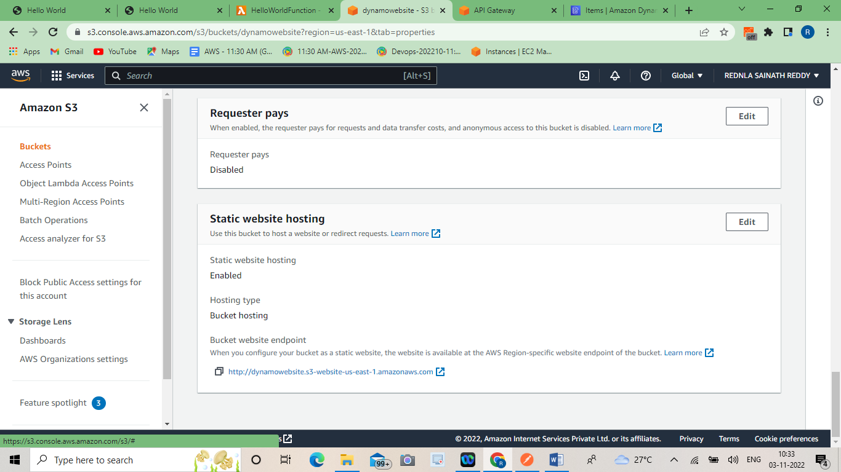

***DynamoDB :***

Amazon DynamoDB is a fully managed, serverless, key-value NoSQL database designed to run high-performance applications at any scale. DynamoDB offers built-in security, continuous backups, automated multi-Region replication, in-memory caching, and data import and export tools.

**Use cases**

**Develop software applications** Build internet-scale applications supporting user-content metadata and caches that require high concurrency and connections for millions of users and millions of requests per second.

**Create media metadata stores** Scale throughput and concurrency for media and entertainment workloads such as real-time video streaming and interactive content, and deliver lower latency with multi-Region replication across AWS Regions.

**Deliver seamless retail experiences** Use design patterns for deploying shopping carts, workflow engines, inventory tracking, and customer profiles. DynamoDB supports high-traffic, extreme-scaled events and can handle millions of queries per second.

### **Scale gaming platforms** Focus on driving innovation with no operational overhead. Build out your game platform with player data, session history, and leaderboards for millions of concurrent users.

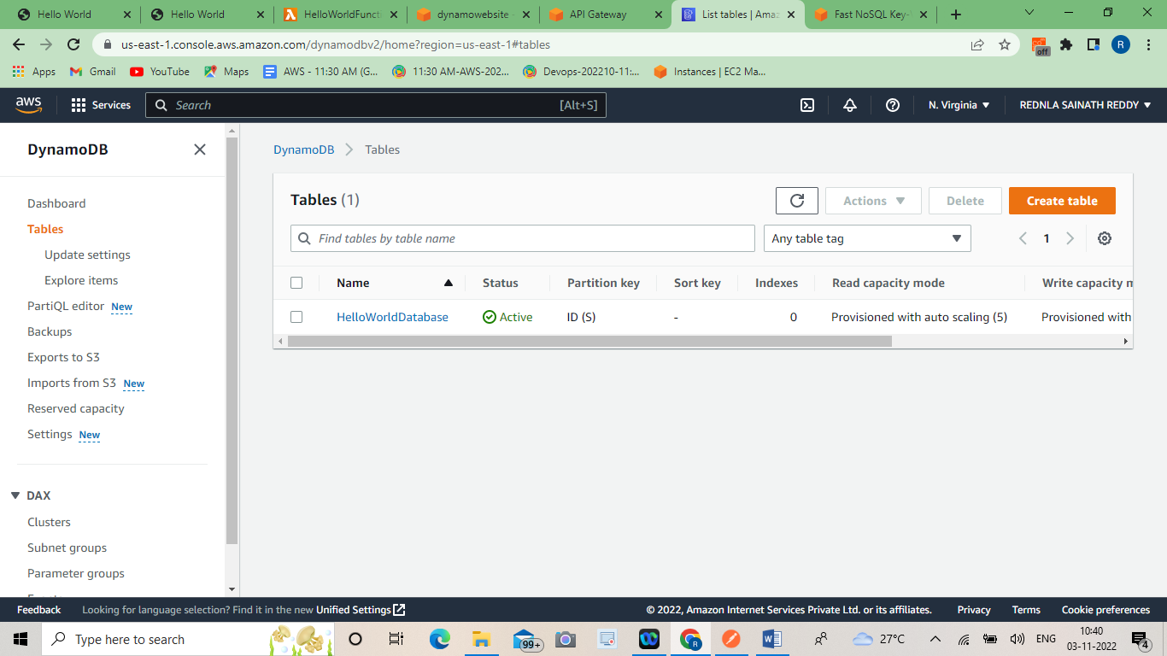

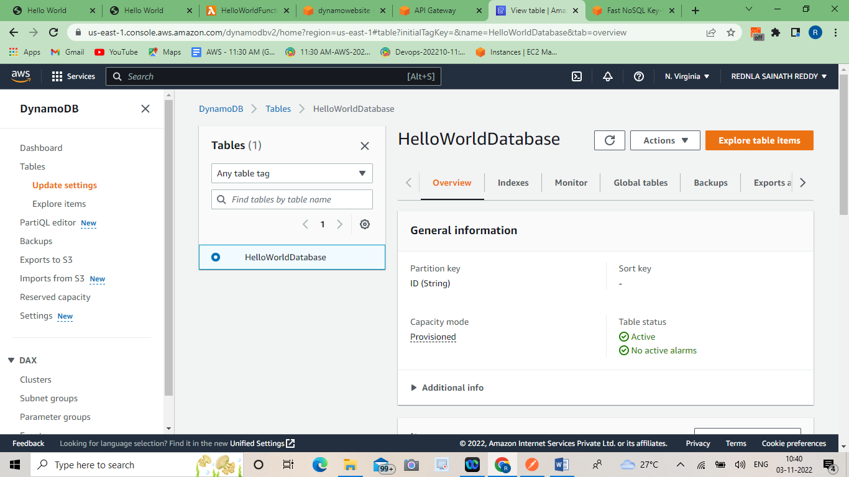

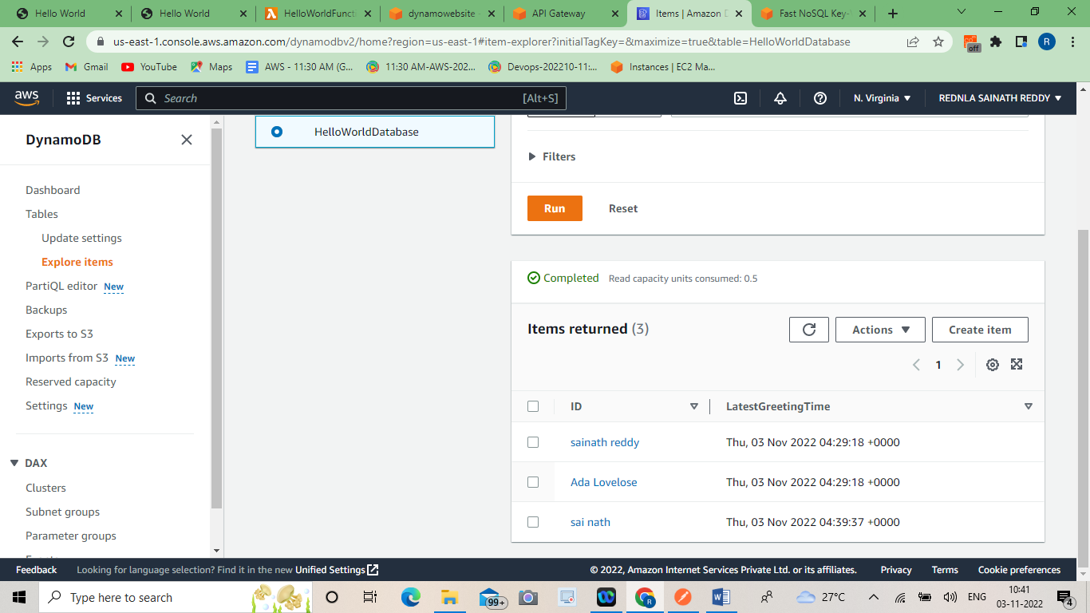

***API GateWay :***

Amazon API Gateway is a fully managed service that makes it easy for developers to create, publish, maintain, monitor, and secure APIs at any scale. APIs act as the "front door" for applications to access data, business logic, or functionality from your backend services. Using API Gateway, you can create RESTful APIs and WebSocket APIs that enable real-time two-way communication applications. API Gateway supports containerized and serverless workloads, as well as web applications.

API Gateway handles all the tasks involved in accepting and processing up to hundreds of thousands of concurrent API calls, including traffic management, CORS support, authorization and access control, throttling, monitoring, and API version management. API Gateway has no minimum fees or startup costs. You pay for the API calls you receive and the amount of data transferred out and, with the API Gateway tiered pricing model, you can reduce your cost as your API usage scales.

Build RESTful APIs optimized for serverless workloads and HTTP backends using HTTP APIs. [HTTP APIs](https://docs.aws.amazon.com/apigateway/latest/developerguide/http-api.html) are the best choice for building APIs that only require API proxy functionality. If your APIs require API proxy functionality and API management features in a single solution, API Gateway also offers [REST APIs](https://docs.aws.amazon.com/apigateway/latest/developerguide/http-api-vs-rest.html).REST APIs and HTTP APIs are both RESTful API products. REST APIs support more features than HTTP APIs, while HTTP APIs are designed with minimal features so that they can be offered at a lower price. Choose REST APIs if you need features such as API keys, per-client throttling, request validation, AWS WAF integration, or private API endpoints. Choose HTTP APIs if you don't need the features included with REST APIs.

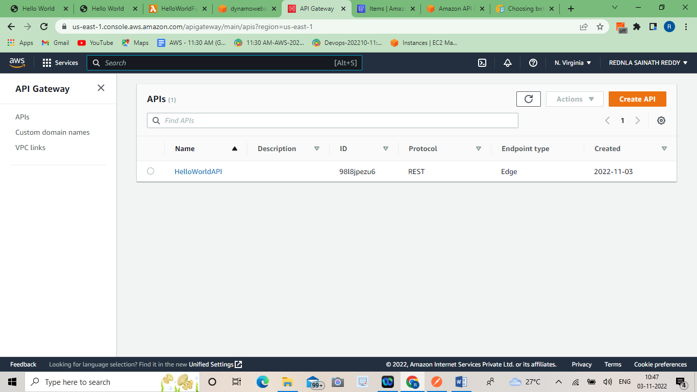

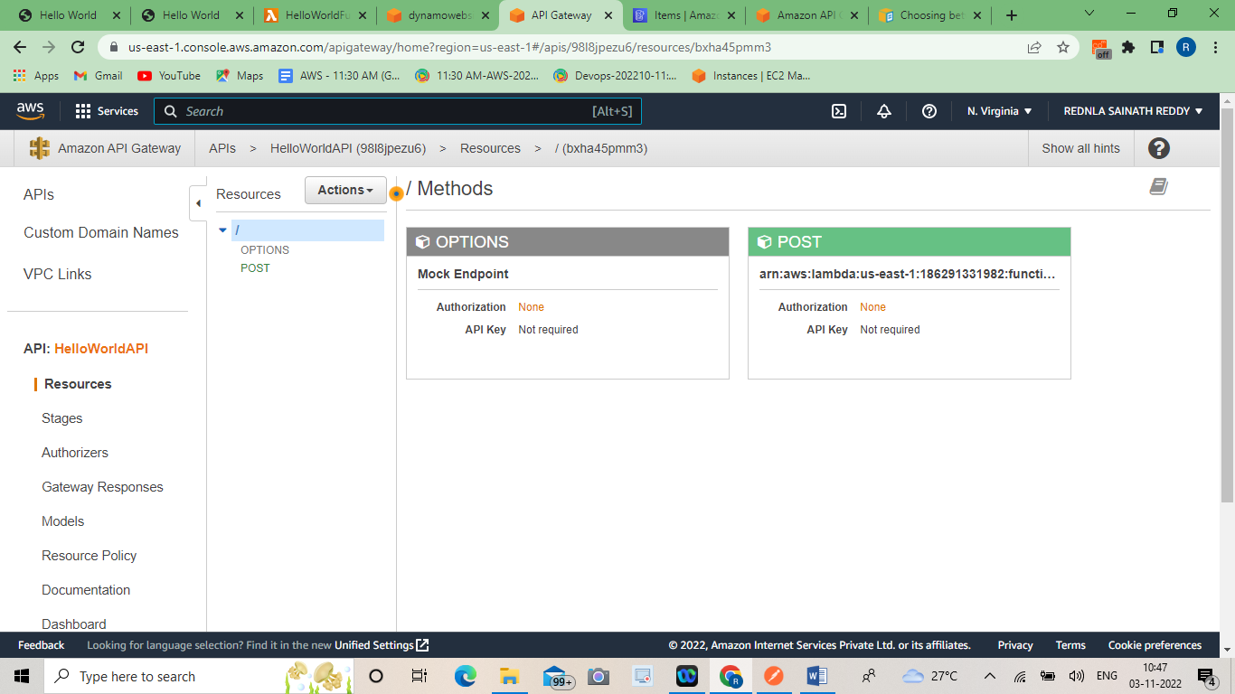

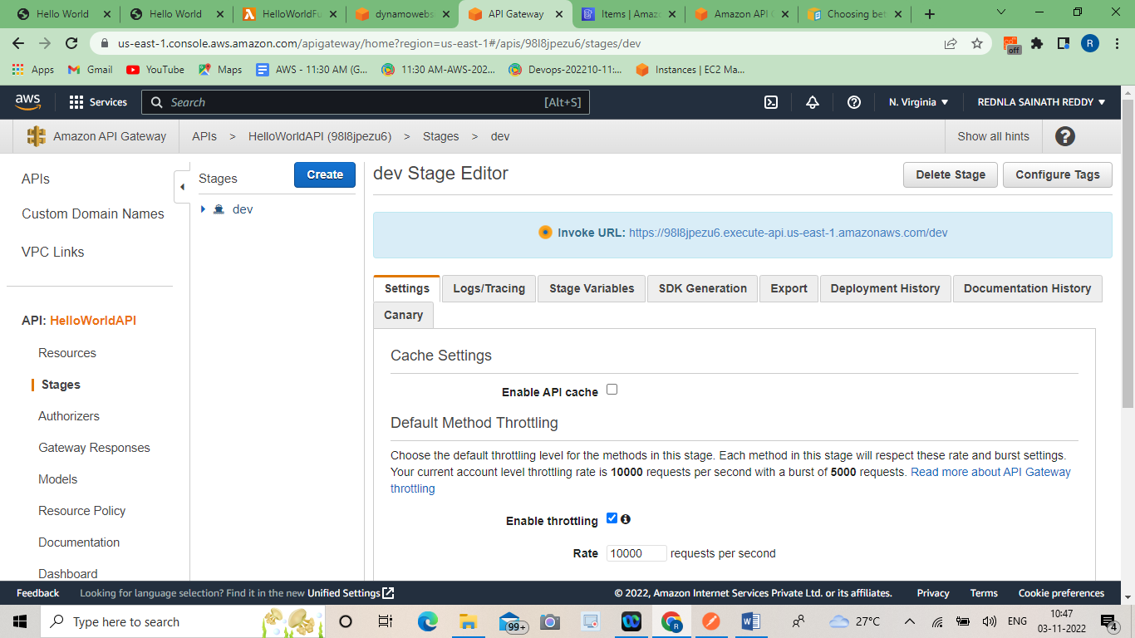

***Final Output:***

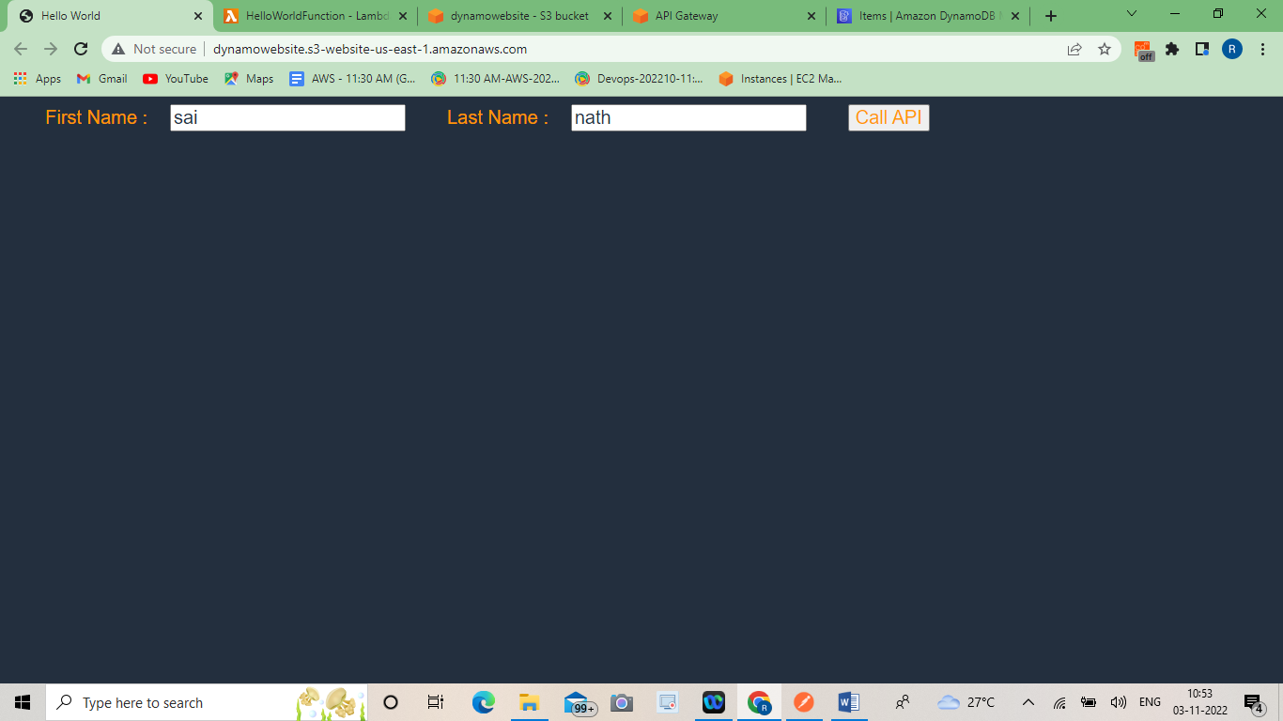

***AWS PRICING :***

AWS offers you a pay-as-you-go approach for pricing for over 160 cloud services. With AWS you pay only for the individual services you need, for as long as you use them, and without requiring long-term contracts or complex licensing. AWS pricing is similar to how you pay for utilities like water and electricity. You only pay for the services you consume, and once you stop using them, there are no additional costs or termination fees.

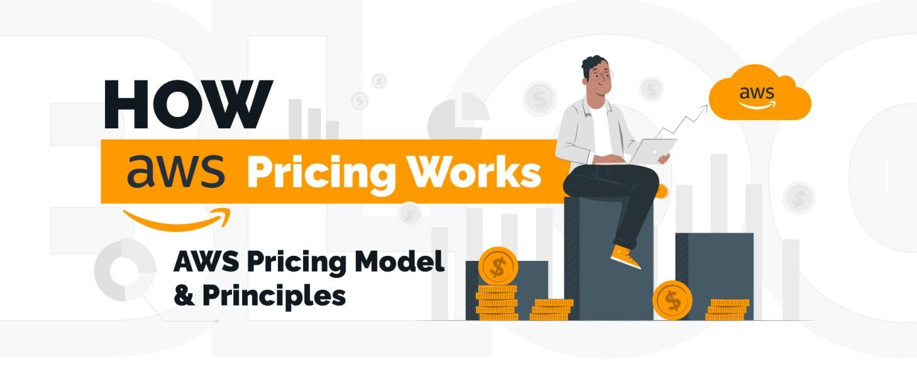

**AWS Free Tier:**

AWS offers free account for a period of 12months of its new customers to help them begin with AWS services and familiarise themselves with the platform as well as their requirements.

• Once where the usage exceeds the free monthly quota, standard pay-asyou go charges become applicable

**Pay-per-use:**

As previously mentioned, AWS does not expect commitment from its customers for its services. Users can pay only for the resources used and can stop availing these services whenever they wish. AWS offers low variable costs which can be opted for by organisations, thereby, saving upfront investments.

**Use more, pay less:**

With AWS, the more you see, the less you pay, i.e., the pricing is tired. Using volume-based discount schemes offered by AWS, you can save more for greater usage.

**Custom pricing:**

Pricing can be customised depending on the necessities of each project, i.e., for their unique requirements. However, custom pricing is only applicable for very large sized projects. In addition, AWS also offers the following services with no additional expenditure incurred by the user:

* Amazon VPC
* AWS CloudFormation
* AWS Elastic Beanstalk
* AWS Identity and Access Management (IAM)
* Elastic Compute Cloud (EC2) instances
* AWS OpsWorks
* Auto Scaling

Use the right pricing model for the job: AWS offers several pricing models depending on product. These include:

**On-Demand Instances** let you pay for compute or database capacity by the hour or second (minimum of 60 seconds) depending on which instances you run with no longterm commitments or upfront payments.

* This type of pricing is ideal for:
* Short term applications having unpredictable workload.
* Users who are not interested to opt for long-term commitment.
* First time users

**Savings Plans** are a flexible pricing model that offer low prices on Amazon EC2, AWS Lambda usage, in exchange for a commitment to a consistent amount of usage (measured in $/hour) for a one- or three-year term.

This type of pricing is ideal for:

Users who urgently require large amounts of computing resources.

* Applications that are feasible for low-priced resources.

**Spot Instances** are an Amazon EC2 pricing mechanism that let you request spare computing capacity with no upfront commitment and at discounted hourly rate (up to 90% off the on-demand price).

* This type of pricing is ideal for:
* Applications that have flexible start and end times
* Applications that are only feasible at very low compute prices
* Users with fault-tolerant and/or stateless workloads

**Reservations** provide you with the ability to receive a greater discount, up to 75 percent, by paying for capacity ahead of time.

This type of pricing is ideal for:

* Users who are already for a 1 to 3 years long commitment period.
* Applications with predictable steady usage curve.

*AWS Pricing/TCO Tools:*

* To get the most out of your estimates, you should have a good idea of your basic requirements. For example, if you're going to try Amazon Elastic Compute Cloud (Amazon EC2), it might help if you know what kind of operating system you need, what your memory requirements are, and how much I/O you need. You should also decide whether you need storage, such as if you're going to run a database and how long you intend to use the servers. You don't need to make these decisions before generating an estimate, though. You can play around with the service configuration and parameters to see which options fit your use case and budget best. AWS offers couple of tools (free of cost) for you to use. If the workload details and services to be used are identified, AWS pricing calculator can help with calculating the total cost of ownership. Migration Evaluator helps with inventorying your existing environment, identifying workload information, and designing and planning your AWS migration.
* TCO or Total Cost of Ownership is a calculator that enables users to compare on premises or co-location expenses with AWS costs.

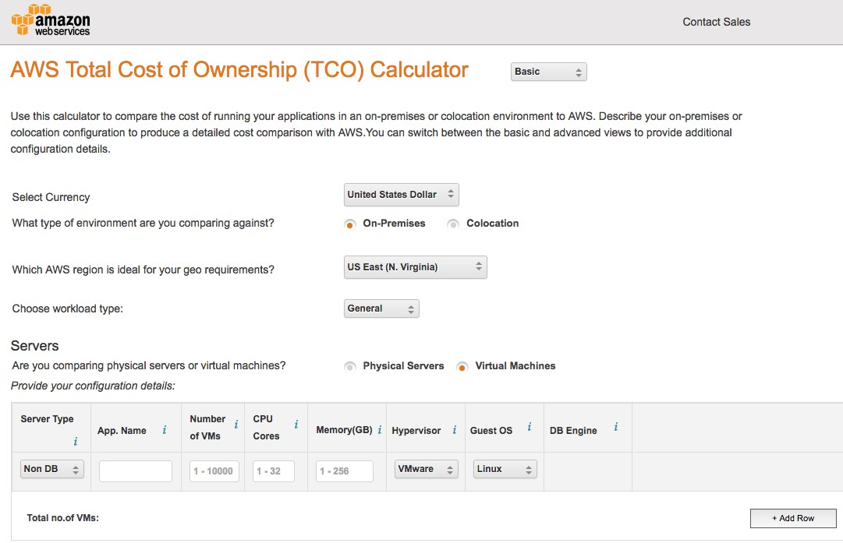

*AWS Pricing Calculator:*

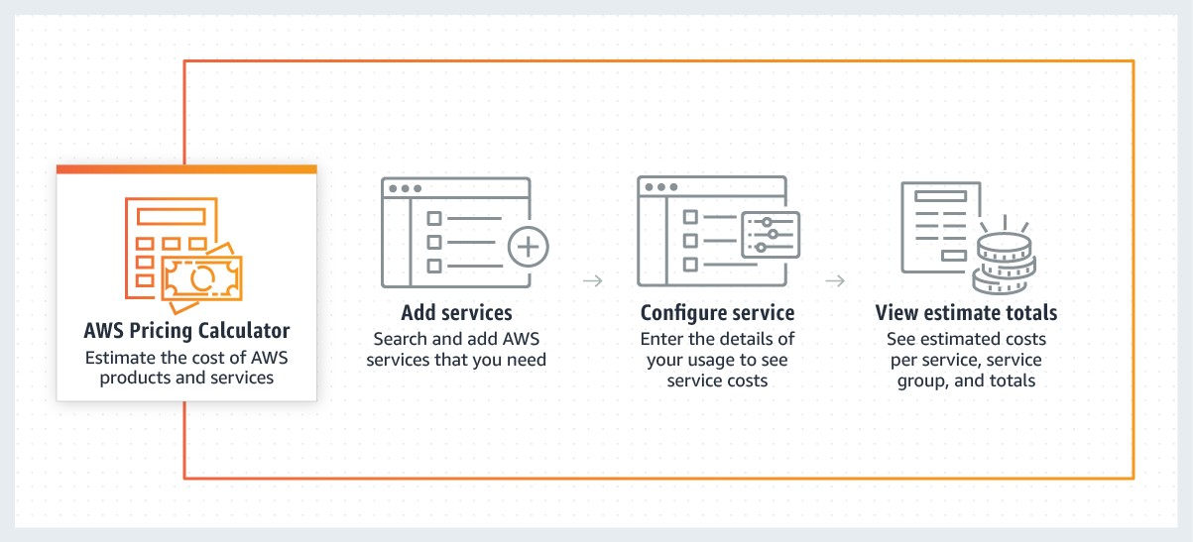

AWS Pricing Calculator is a web-based service that you can use to create cost estimates to suit your AWS use cases. AWS Pricing Calculator is useful both for people who have never used AWS and for those who want to reorganize or expand their usage. You can model your solutions before building them, explore the price

points and calculations behind your estimate, and find the available instance types and contract terms that meet your needs.

**Benefits and features:**

* -Transparent pricing
* -Share your estimates
* -Hierarchical estimates
* -Estimate exports **Use cases:**
* -Reduce your Amazon EC2 spend
* -Find the right Amazon EC2 Instance
* -Estimate your AWS spend
* -Compare service costs per region

*Migration Evaluator:*

Migration Evaluator is a migration assessment service that helps you create a directional business case for AWS cloud planning and migration. ... The software models compute patterns for all instances, showing the projected costs to re-host at AWS and the breakdown of costs by infrastructure and software licenses

With Migration Evaluator (Formerly TSO Logic), you can gain access to insights and accelerate decision-making for migration to AWS at no cost

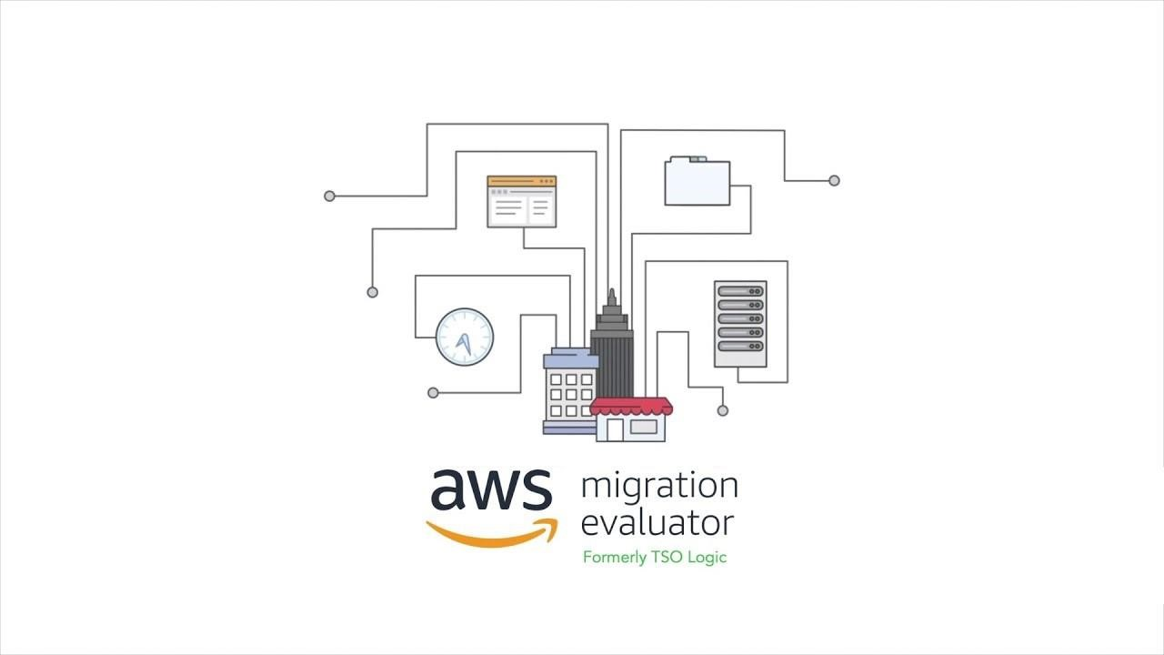

*Interesting facts:*

* Amazon Web Services dominates cloud services.
* Amazon Web Services holds 27% share of all Cloud Infrastructure As Services(IaaS).
* Aws earning is about 6 billion a year and 1.5 billion revenue in Q1 of 2015 alone.
* Aws have Data Centers in 190 countries.
* Each Amazon Data Center holds from 50,000 to 80,000 computers at 2015, 25% of Amazon Web Services uses renewable energies.

*REFERENCES:*

* https://docs.aws.amazon.com/AmazonS3/latest/userguide/Welcome.html
* https://elearning.starcertification.org/pluginfile.php
* https://docs.aws.amazon.com/whitepapers/latest/awsoverview/introduction.html
* https://d1.awsstatic.com/whitepapers/aws-overview.pdf

---------------------------------------- THE END -----------------------------------------