**VIRTUAL LEARNING MANAGEMENT SYSTEM**

Submitted in partial fulfillment of the requirements for the award of Bachelor of Engineering / Technology degree in Computer Science and Engineering

By

#### RAVURI LEELA CHAITANYA (Reg NO - 40111047) RENDLA SAINATH REDDY (Reg NO - 40111054)



**DEPARTMENT OF COMPUTER SCIENCE AND ENGINEERING**

## SCHOOL OF COMPUTING

SATHYABAMA

#### INSTITUTE OF SCIENCE AND TECHNOLOGY (DEEMED TO BE UNIVERSITY) CATEGORY-1 UNIVERSITY BY UGC

**Accredited with Grade “A” by NAAC|12B Status by UGC| Approved by AICTE**

#### JEPPIAAR NAGAR, RAJIV GANDHISALAI, CHENNAI – 600119

**APRIL – 2024**



**DEPARTMENT OF COMPUTER SCIENCE AND ENGINEERING**

**BONAFIDE CERTIFICATE**

This is to certify that this Project Report is the bonafide work of **RENDLA SAINATH REDDY (Reg No - 40111054) and RAVURI LEELA CHAITANYA (40111046)** who

carried out the Project entitled **“VIRTUAL LEARNING MANAGEMENT SYSTEM”**

under my supervision from November 2023 to April 2024.

**Internal Guide**

**Ms. GAYATHRI SIVAKUMAR B.Sc.,CSC.,MCA.**

### Head of the Department

**Dr. L. LAKSHMANAN, M.E., Ph.D.**



**Submitted for Viva voce Examination held on**

**Internal Examiner External Examiner**

#### DECLARATION

I, **RENDLA SAINATH REDDY (Reg No - 40111054),** hereby declare that the Project Report entitled **VIRTUAL LEARNING MANAGEMENT SYSTEM** done by me under the guidance of **Ms. GAYATHRI SIVAKUMAR, B.Sc.,CSC.,MCA.,** at Sathyabama Institute Of Science And Technology is submitted in partial fulfillment of the requirements for the award of Bachelor of Engineering degree in **Computer Science and Engineering**.

#### DATE:

**PLACE: Chennai SIGNATURE OF THE CANDIDATE**

#### ACKNOWLEDGEMENT

I am pleased to acknowledge my sincere thanks to **Board of Management of SATHYABAMA INSTITUTE OF SCIENCE AND TECHNOLOGY** for their kind

encouragement in doing this project and for completing it successfully. I am grateful to them.

I convey my thanks to **Dr. T. Sasikala M.E., Ph. D**, **Dean**, School of Computing,

**Dr. L. Lakshmanan M.E., Ph.D.,** Head of the Department of Computer Science and Engineering for providing me necessary support and details at the right time during the progressive reviews.

I would like to express my sincere and deep sense of gratitude to my Project Guide

**Ms. GAYATHRI SIVAKUMAR, B.Sc.,CSC.,MCA.,** for her valuable guidance, suggestions and constant encouragement paved way for the successful completion of my phase-1 project work.

I wish to express my thanks to all Teaching and Non-teaching staff members of the **Department of Computer Science and Engineering** who were helpful in many ways for the completion of the project.

iv

#### ABSTRACT

In today's fast-paced digital age, the education sector has undergone a significant transformation with the advent of Virtual Learning Management Systems (VLMS). This abstract explores the fundamental aspects of VLMS, focusing on its impact on traditional educational paradigms. VLMS is a sophisticated online platform designed to facilitate seamless interaction between educators and learners, transcending the constraints of time and space. This abstract delves into the key components of VLMS, elucidating its role in fostering interactive and engaging learning experiences. Furthermore, the abstract examines the adaptability of VLMS across diverse educational levels, from K-12 education to higher education and professional development. In conclusion, this abstract emphasizes the transformative potential of Virtual Learning Management Systems in revolutionizing the educational landscape. By harnessing the power of digital technology, VLMS not only enhances the learning experience but also prepares learners for the demands of the 21st-century workforce. The abstract advocates for further research and collaboration in the field of virtual education, aiming to unlock new avenues for accessible, inclusive, and effective learning experiences. This project aims to develop a virtual learning management system (LMS) to facilitate online education and training. The LMS will provide a centralized platform for instructors and learners to create, deliver, and manage educational content. This abstract provides a high- level overview of the virtual learning management system project. The specific features and functionalities can be further tailored to meet the needs of the target audience. The development of the VLMS follows best practices in web development, leveraging modern technologies and frameworks to ensure scalability, reliability, and performance. The project adopts an agile development approach, facilitating iterative improvements and continuous feedback integration to meet evolving user needs and industry standards. Furthermore, the system supports collaborative learning environments through features such as discussion forums, live chat, and group projects. In conclusion, the Virtual Learning Management System presented in this project offers a comprehensive and customizable solution for accessing paid and free educational resources. By leveraging the power of web technologies, the VLMS aims to democratize access to quality education and empower learners to pursue their academic and professional goals effectively.

## TABLE OF CONTENTS

|  |  |  |  |
| --- | --- | --- | --- |
| **Chapter**  **No** | **TITLE** | | **Page**  **No.** |
|  | **ABSTRACT** | | v |
|  | **LIST OF FIGURES** | | viii |
|  | **LIST OF ABBREVIATIONS** | | ix |
| 1 | **INTRODUCTION** | | 1 |
| 2 | **LITERATURE SURVEY** | | 5 |
|  | 2.1 | Inferences from Literature Survey | 7 |
|  | 2.2 | Existing System and Proposed System | 8 |
|  | 2.3 | Open problems in Existing System | 9 |
| 3 | **REQUIREMENTS ANALYSIS** | | 11 |
|  | 3.1 | Risk Analysis of the Project | 11 |
|  | 3.2 | Software Requirements Specification Document | 13 |
| 4 | **DESCRIPTION OF PROPOSED SYSTEM** | |  |
|  | 4.1 | Flow chart of process using machine learning |  |
|  | 4.2 | Selected Methodology or process model |  |
|  | 4.3 | Architecture / Overall Design of Proposed System |  |
|  | 4.4 | Description of Software for Implementation and Testing  plan of the Proposed Model/System |  |
|  | 4.5 | Project Management Plan |  |
| 5 | **IMPLEMENTATION DETAILS** | | 23 |
| 6 | **RESULT AND DISCUSSION** | | 25 |
|  | 6.1 | RESULT | 26 |

|  |  |  |  |
| --- | --- | --- | --- |
| 7 | **CONCLUSION** | | 27 |
|  | 7.1 | CONCLUSION | 27 |
|  | 7.2 | FUTURE WORK | 28 |
| 8 | **REFERENCES** | | 29 |
| 9 | **APPENDIX** | | 30 |
|  | A. | SOURCE CODE | 30 |
|  | B. | SCREEN SHOTS | 59 |
|  | C. | RESEARCH PAPER | 63 |
|  | D. | CERTIFICATES | 71 |
|  |  | |  |
|  |  | |  |

**LIST OF FIGURES**

|  |  |  |
| --- | --- | --- |
| **FIGURE NO** | **FIGURE NAME** | **Page**  **No.** |
| 4.1 | WORKING MECHANISM | 13 |
| 4.2 | SYSTEM ARCHITECTURE | 16 |
| 4.3.1  4.3.2 | USE CASE DIAGRAM  PROPOSED SYSTEM | 17  18 |

## LIST OF ABBREVIATIONS

## VLMS - Virtual Learning Management System

## AI - Artificial Intelligence

## WCAG – Web Content Accessibility Guidelines

## RDBMS - Relational Database Management System

## JWT - JSON Web Tokens

## IDE - Integrated Development Environment

## CI/CD - Continuous Integration/Continuous Deployment

## LMS - Learning Management System

## ELK stack - Elasticsearch, Logstash, and Kibana stack

## CHAPTER-1 INTRODUCTION

#### Introduction to Virtual Learning Management Systems (VLMS)

In the digital era, education has transcended the boundaries of traditional classrooms, thanks to advancements in technology. Virtual Learning Management Systems (VLMS) have emerged as pivotal tools in this educational revolution. These systems represent the fusion of cutting-edge technology with pedagogical expertise, enabling educators and learners to engage in immersive, interactive, and flexible learning experiences. By leveraging the power of the internet and digital platforms, VLMS has redefined the educational landscape, offering unprecedented opportunities for personalized learning, collaborative knowledge exchange, and skill development.

This introduction delves into the foundational concepts of Virtual Learning Management Systems, elucidating their significance in the contemporary educational ecosystem. It explores the evolution of VLMS, tracing their roots from early online learning platforms to the sophisticated, multifaceted systems of today. Additionally, this introduction outlines the overarching goals of VLMS, emphasizing their role in enhancing accessibility, inclusivity, and efficacy in education.

Furthermore, the introduction discusses the core functionalities of VLMS, encompassing features such as multimedia integration, real-time communication tools, data analytics, and artificial intelligence-driven insights. These elements combine to create dynamic virtual classrooms where educators can tailor their teaching methodologies to cater to diverse learning styles, and learners can actively participate in their educational journeys, breaking away from the constraints of traditional, one-size-fits-all education.

The introduction also addresses the challenges and opportunities associated with VLMS implementation, from digital literacy disparities to the potential for global collaboration and knowledge sharing. By exploring these aspects, it becomes

evident that VLMS not only serve as tools for delivering content but also as catalysts for a paradigm shift in education. They empower educators to innovate, adapt, and optimize their teaching methods, ensuring that learners are equipped with the skills and knowledge necessary for success in the digital age.

In this context, the following sections of this discussion will delve deeper into the various dimensions of Virtual Learning Management Systems, exploring their functionalities, impact on pedagogy, challenges faced, and the future trajectory of virtual education. Through this exploration, a comprehensive understanding of the transformative power of VLMS in shaping the future of learning will be elucidated.

#### Key Components of VLMS:

1. **User Management:** VLMS allows administrators to manage users, including students, teachers, and administrators. It provides role-based access control, ensuring that each user has appropriate permissions.
2. **Content Management:** Educators can create and organize learning materials such as documents, videos, quizzes, and assignments. These resources are often accessible in various multimedia formats.
3. **Communication Tools:** VLMS offers communication features like discussion forums, messaging systems, and announcements, fostering interaction between teachers and students.
4. **Assessment and Evaluation:** Educators can create assessments, quizzes, and assignments, which can be graded automatically. This instant feedback enhances the learning process.
5. **Progress Tracking:** VLMS allows learners and instructors to monitor progress. Tracking features include completion percentages, grades, and participation records.
6. **Collaborative Learning:** Many VLMS platforms support collaborative learning experiences, enabling students to work together on projects and assignments in a virtual space.
7. **Analytics and Reporting:** VLMS often come with robust analytics tools, providing insights into student engagement, performance trends, and course effectiveness.

#### The Impact of VLMS

VLMS have transformed education in numerous ways. They have made learning more accessible, allowing individuals from diverse backgrounds to pursue education. They support various learning styles, accommodating visual, auditory, and kinesthetic learners. VLMS also foster a sense of community among learners, even in virtual spaces, enhancing the overall educational experience.

In this digital era, VLMS stand at the forefront of educational innovation, enabling lifelong learning, skill development, and academic pursuits. As technology continues to advance, VLMS will undoubtedly play a pivotal role in shaping the future of education, making learning a truly immersive and enriching experience for all.

#### Advantages & Disadvantages of Virtual Learning Management Systems (VLMS):

**Advantages:**

In the digital age, education has transcended the confines of traditional classrooms, thanks to the advent of Virtual Learning Management Systems (VLMS). These sophisticated platforms represent a revolution in the way knowledge is disseminated, acquired, and shared. VLMS, often referred to as Learning Management Systems (LMS) or Course Management Systems (CMS), leverage cutting-edge technology to create dynamic and interactive virtual learning environments.

At its core, a VLMS is a software application that facilitates the administration, documentation, tracking, reporting, and delivery of educational content. Unlike traditional education methods, VLMS harness the power of the internet and digital tools to enable remote learning experiences. Students and educators can connect from anywhere in the world, transcending geographical barriers and time constraints.

#### Disadvantages:

1. **Digital Divide:** Limited internet access and technology resources create inequalities, making it difficult for some individuals to participate in virtual learning.
2. **Lack of Social Interaction:** Virtual learning may lack the face-to-face social interaction of traditional classrooms, potentially impacting social skills development and a sense of community.
3. **Self-Discipline:** Online learning requires self-motivation and discipline. Some learners might struggle with managing their time effectively or staying motivated without the structure of traditional classes.
4. **Technical Issues:** Technical glitches, such as server outages or software problems, can disrupt the learning process, causing frustration for both educators and learners.
5. **Limited Hands-On Experience:** Certain subjects, especially those requiring hands-on practice or laboratory work, might be challenging to teach effectively in a virtual environment.
6. **Dependence on Technology:** VLMS are reliant on technology; if the platform experiences issues, it can disrupt the entire learning process until the problem is resolved.
7. **Quality Concerns:** The quality of online courses can vary widely. Poorly designed courses or lack of qualified instructors can diminish the learning experience.
8. **Isolation:** Learners might feel isolated and miss out on the social aspects of traditional education, potentially leading to a sense of disconnect. Educators and institutions often work to mitigate these disadvantages by providing additional support, enhancing course design, and fostering a sense of community within virtual learning environments.

## CHAPTER 2 LITERATURE SURVEY

The field of Virtual Learning Management Systems (VLMS) has seen a wealth of research and literature exploring various aspects of online education, technology integration, and pedagogical strategies. Here are some key scholarly articles and books related to VLMS and virtual education:

#### Clark, T., & Sugrue, B. (2022). Research on World Wide Web – Supporting Collaborative Learning. This early study explores the potential of web-based platforms for collaborative learning, laying the foundation for future VLMS research.

1. **Ally, M. (2022). Foundations of Educational Theory for Online Learning. This article provides a theoretical framework for understanding online education, including the role of VLMS in enhancing learning experiences.**

#### Picciano, A. G. (2023). Theories and Frameworks for Online Education: Seeking an Integrated Model. Picciano examines various theoretical frameworks applicable to online education, shedding light on the pedagogical underpinnings of VLMS.

1. **Means, B., Toyama, Y., Murphy, R., Bakia, M., & Jones, K. (2022). Evaluation of Evidence-Based Practices in Online Learning: A Meta-Analysis and Review of Online Learning Studies. This comprehensive meta-analysis evaluates the effectiveness of online learning, including VLMS, based on empirical studies and evidence-based practices.**

#### Garrison, D. R., & Kanuka, H. (2022). Blended Learning: Uncovering its Transformative Potential in Higher Education. This seminal work explores the concept of blended learning, where VLMS often play a crucial role in integrating online and traditional classroom experiences.

1. **Anderson, T., & Dron, J. (2022). Three Generations of Distance Education Pedagogy. This book provides insights into various pedagogical approaches in distance education, offering perspectives on how VLMS fit into these frameworks.**

#### Bates, A. W. (2023). Teaching in a Digital Age: Guidelines for Designing Teaching and Learning. Bates discusses the digital pedagogies essential for effective online teaching, shedding light on the role of VLMS in modern education.

1. **Conole, G. (2022). Designing for Learning in an Open World. Conole explores innovative approaches to online learning design, including the utilization of VLMS for creating engaging and interactive learning environments.**

#### Siemens, G., & Long, P. (2023). Penetrating the Fog: Analytics in Learning and Education. This book delves into learning analytics, including the use of data from VLMS to enhance educational decision-making and student outcomes.

1. **Wiley, D., & Hilton III, J. L. (Eds.). (2022). Defining and Discussing Open Education.* This edited volume discusses open education, which often intersects with VLMS in the form of open educational resources (OER) and Massive Open Online Courses (MOOCs).**

#### These resources provide a comprehensive understanding of the theoretical foundations, pedagogical approaches, and practical implementations of VLMS in the context of virtual education. Researchers, educators, and policymakers often refer to these works for insights and guidance in the field of online learning and VLMS.

* 1. **EXISTING SYSTEM AND PROPOSED SYSTEM**

#### Existing System:

Existing VLMS typically incorporate the following components:

1. **User Management:** Existing VLMS platforms allow administrators to manage user accounts, roles, and permissions. This functionality ensures secure access and appropriate privileges for students, teachers, and administrators.
2. **Content Management:** Educators can upload, organize, and manage various types of learning materials, such as documents, videos, quizzes, and assignments. These resources are made accessible to students based on their enrolled courses.
3. **Communication Tools:** VLMS platforms provide communication features like discussion forums, messaging systems, and announcement boards. These tools facilitate interaction between teachers and students, fostering collaborative learning experiences.
4. **Assessment and Evaluation:** Educators can create quizzes, assignments, and exams within the system. These assessments can be automatically graded, providing timely feedback to students about their performance.
5. **Progress Tracking:** VLMS platforms offer tracking functionalities that allow both educators and students to monitor progress. This includes tracking completed modules, grades, and participation metrics.
6. **Analytics and Reporting**: Most VLMS have built-in analytics tools that provide insights into student engagement, course effectiveness, and other metrics. These analytics aid educators in refining their teaching methods.

#### Proposed System:

Proposed enhancements to VLMS could include the following features:

1. **Personalized Learning Paths:** The proposed system could employ algorithms to analyze individual student performance and learning styles, enabling the creation of personalized learning paths tailored to each student's needs and preferences.
2. **Gamification Elements:** Integrating game elements, such as badges, leaderboards, and interactive challenges, can enhance student engagement and motivation.
3. **Adaptive Learning:** Implementing adaptive learning technologies that adjust the difficulty level of content based on individual student progress, ensuring an optimized learning experience for each learner.
4. **Augmented Reality (AR) and Virtual Reality (VR) Integration:** Utilizing AR and VR technologies to create immersive learning experiences, especially in subjects that require hands-on training, such as science experiments or medical procedures.
5. **Social Learning Enhancements:** Expanding social learning features, enabling real-time collaboration, peer-to-peer learning, and social interaction within the VLMS platform.
6. **Mobile-First Design:** Ensuring that the VLMS is designed to be mobile-friendly, allowing students to access learning materials and participate in activities seamlessly on smartphones and tablets.
7. **Blockchain Credentialing:** Implementing blockchain technology for secure and verifiable certification and credentialing, ensuring the authenticity and integrity of student achievements.
8. **Integration with AI Chatbots**: Integrating AI-powered chatbots for instant student support, answering queries, and providing guidance on course-related matters.
9. **Multilingual Support:** Providing multilingual support to cater to a diverse global audience, ensuring inclusivity for learners from different linguistic backgrounds.
10. **Enhanced Data Analytics:** Utilizing advanced data analytics and machine learning algorithms to provide predictive insights, identifying at-risk students, and recommending personalized interventions to improve learning outcomes.

#### OPEN PROBLEMS IN EXISTING SYSTEM

In the realm of Virtual Learning Management Systems (VLMS), several open problems persist, challenging the current state of online education. These issues require further research, innovation, and collaboration to enhance the effectiveness and accessibility of VLMS. Here are some of the prominent open problems in the existing system of VLMS:

1. **Personalization and Adaptive Learning:** Creating truly adaptive learning experiences tailored to individual students' needs, preferences, and learning styles remains a significant challenge. Developing algorithms and systems that can dynamically adjust content and teaching methods for optimal learning outcomes is an ongoing concern.
2. **Engagement and Motivation:** Sustaining learner engagement and motivation in online courses, especially for students from diverse backgrounds, is a complex problem. Understanding what motivates learners and designing VLMS features that enhance engagement over the course of a learning program is a challenge.
3. **Quality of Content:** Ensuring the quality, accuracy, and relevance of online learning materials, especially in rapidly evolving fields, is a persistent challenge. Developing methods to curate, update, and evaluate content to meet educational standards is crucial.
4. **Assessment and Credentialing:** Designing reliable, secure, and scalable methods for online assessment, including preventing cheating and plagiarism, while also ensuring the integrity of certifications and credentials, is a continuing challenge. Integrating blockchain technology for secure credentialing is a focus area for

improvement.

1. **Social Interaction and Collaboration:** Fostering meaningful social interactions, peer-to-peer learning, and collaborative activities within the virtual learning environment are ongoing challenges. Creating effective virtual communities that enhance learning through discussions, debates, and collaborative projects requires innovative approaches.
2. **Digital Inclusion**: Bridging the digital divide by ensuring that learners from economically disadvantaged backgrounds, rural areas, or developing countries have equal access to VLMS is a pressing concern. Addressing issues related to internet connectivity, device availability, and digital literacy is pivotal.
3. **Teacher Training and Support:** Providing adequate training and support to educators in effectively utilizing VLMS tools, implementing best practices, and managing online classrooms is an ongoing challenge. Ensuring that teachers are well-equipped to navigate the digital landscape is crucial for successful online education.
4. **Data Privacy and Security:** Safeguarding student data and ensuring privacy in online learning environments is a significant concern. Developing robust data security protocols, addressing privacy issues related to student data, and complying with relevant regulations are essential aspects of VLMS

## CHAPTER-3 REQUIREMENT ANALYSIS

#### RISK ANALYSIS OF THE PROJECT

Risk analysis in Virtual Learning Management Systems (VLMS) involves identifying potential risks, assessing their impact, and developing strategies to mitigate or manage these risks effectively. Here's a breakdown of risk factors associated with VLMS and strategies to address them:

#### Security and Data Privacy Risks:

Risk: Unauthorized access, data breaches, and student information exposure. Mitigation: Implement robust encryption, access controls, and authentication methods. Regularly update security protocols and educate users about data security best practices. Adhere to relevant data protection regulations.

#### Technical Risks:

Risk: System failures, downtimes, or software glitches.

Mitigation: Regularly maintain and update the VLMS software. Have backup systems in place to minimize downtime. Conduct stress testing to identify system limitations and address scalability issues.

#### Pedagogical Risks:

Risk: Ineffective teaching methods leading to poor learning outcomes.

Mitigation: Provide comprehensive training for educators on effective online teaching strategies. Implement feedback mechanisms for continuous improvement. Encourage collaboration among educators to share best practices.

#### Engagement Risks:

Risk: Low student engagement, lack of motivation, and participation.

Mitigation: Design interactive and engaging content. Incorporate multimedia elements, discussion forums, and collaborative projects. Encourage social interaction and peer-to-peer learning. Provide timely feedback and recognition for student achievements.

#### Content Quality Risks:

Risk: Outdated or inaccurate learning materials.

Mitigation: Establish a review process for content quality. Regularly update materials to reflect the latest knowledge and advancements. Encourage user-generated content to enhance diversity and relevance.

#### Accessibility Risks:

Risk: Limited access for differently-abled individuals.

Mitigation: Ensure the VLMS platform complies with accessibility standards (e.g., WCAG). Provide alternative formats for content (e.g., transcripts for videos) and tools (e.g., screen readers) for differently-abled students.

#### Social and Behavioral Risks:

Risk: Cyberbullying, inappropriate behavior, or lack of social interaction.

Mitigation: Implement strict codes of conduct. Foster a positive online community. Have moderators for discussion forums. Provide clear guidelines and consequences for inappropriate behavior.

#### Cultural Sensitivity Risks:

Risk: Insensitivity to diverse cultural norms and expectations.

Mitigation: Provide cultural sensitivity training for educators. Design courses and communication methods that respect diverse cultural backgrounds. Encourage open dialogue and mutual respect among students from different cultures.

#### Vendor and Third-Party Risks:

Risk: Reliability and security concerns related to third-party plugins or services integrated into the VLMS.

Mitigation: Thoroughly vet third-party services. Ensure they comply with security standards. Regularly update and patch third-party components to address security vulnerabilities.

Regular risk assessments, user feedback, and staying updated with the latest trends and technologies in both education and cybersecurity are crucial for effectively

managing risks associated with VLMS. Implementing a proactive risk management strategy ensures a safer and more effective learning environment for both educators and students

#### SOFTWARE REQUIREMENTS SPECIFICATION DOCUMENT

* + - **Hardware specifications:**

#### CPU and RAM:

The server should have sufficient CPU cores and RAM to handle concurrent user connections and data processing.

#### Storage:

Use SSD-based storage for improved read/write performance. Consider scalable storage solutions to accommodate growing data.

#### Network:

Ensure a high-speed internet connection and low-latency network infrastructure for fast content delivery.

#### Load Balancing:

Implement load balancers to distribute traffic evenly across multiple servers for scalability.

#### Software specifications:

1. **Operating System:**

Server: Linux (e.g., Ubuntu, CentOS) for stability and security.

Client: Web-based, accessible from various web browsers (Chrome, Firefox, Safari, Edge).

#### Web Server:

Apache, Nginx, or similar web server to serve web content securely.

#### Database:

Relational Database Management System (RDBMS) like MySQL, PostgreSQL, or MariaDB for storing user data, courses, and content.

#### Backend Framework:

A server-side framework like Django (Python), Ruby on Rails, Node.js (using Express), or Laravel (PHP) for building the application logic.

#### Frontend Framework:

JavaScript frameworks like React, Angular, or Vue.js for creating a responsive and interactive.

## CHAPTER 4

**DESCRIPTION OF PROPOSED SYSTEM**

The proposed system aims to revolutionize the traditional Virtual Learning Management System, enhancing the learning experience for both educators and students. This advanced VLMS incorporates innovative features and technologies to create a dynamic, personalized, and engaging online learning environment. The Virtual Learning Management System (VLMS) is a comprehensive platform designed to facilitate online education, offering tools and resources for both educators and learners. Leveraging web development technologies such as JavaScript for front-end interactivity and PHP for server-side functionality, this proposed system aims to provide a seamless virtual learning experience. Below is a detailed description of the key components and features of the VLMS .Users, including students, instructors, and administrators, will have unique login credentials Authentication mechanisms will ensure secure access to the system. Role-based access control will be implemented to define permissions for different user types.

**4.1.1 PROPOSED SYSTEM**

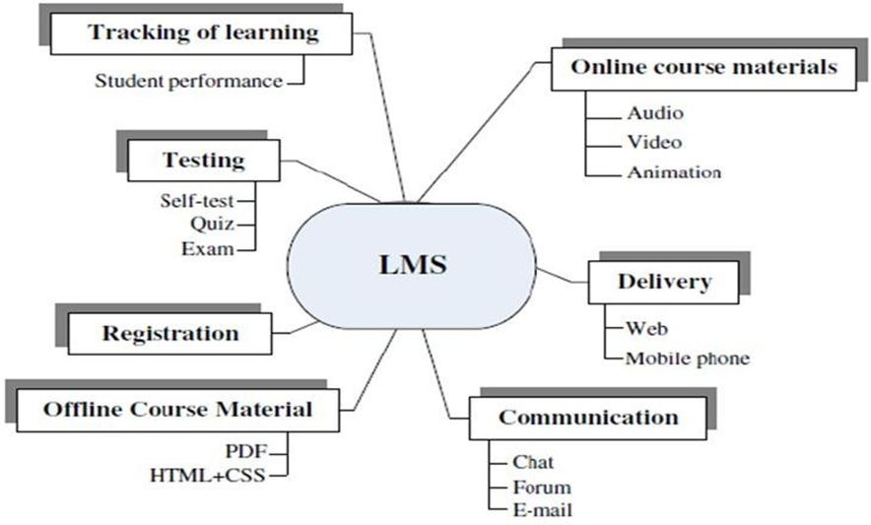

#### METHODS AND ALGORITHMS USED

When selecting a methodology for developing a Virtual Learning Management System (VLMS), it's essential to consider factors such as project requirements, team expertise, project scope, and expected outcomes. Several software development methodologies can be adapted for VLMS projects. Here are a few commonly used ones and their suitability for VLMS development:

#### Agile Methodology:

Agile is an iterative and incremental approach to software development. It emphasizes collaboration, flexibility, and customer feedback.

Suitability for VLMS: Agile is well-suited for VLMS projects, especially when requirements are not fully known at the beginning. It allows for continuous refinement, accommodating changes in educational content and features. Agile also supports active collaboration between developers, educators, and students.

#### Scrum:

Scrum is a specific Agile framework that divides work into fixed-length iterations (sprints) with regular review and adaptation sessions.

Suitability for VLMS: Scrum can work effectively for VLMS development, especially in larger projects with complex requirements. It provides clear roles and responsibilities, ensuring efficient collaboration among team members. Regular sprint reviews allow stakeholders to provide feedback, ensuring the system aligns with educational objectives.

#### Waterfall Methodology:

Waterfall is a linear and sequential approach to software development. Each phase must be completed before the next one begins.

Suitability for VLMS: Waterfall can be suitable for smaller VLMS projects with well-defined and stable requirements. However, it may not be the best choice for projects where requirements are likely to change frequently, as it lacks

flexibility once a phase is completed.

#### Rapid Application Development (RAD):

RAD emphasizes quick development and iteration based on continuous user feedback.

Suitability for VLMS: RAD can be useful for VLMS projects requiring rapid prototyping or proof of concepts. It allows for quick iterations, making it suitable for modules or features that need to be implemented and tested promptly.

#### Incremental Model:

The Incremental Model divides the software development process into smaller, manageable parts (increments), each building upon the previous increment.

Suitability for VLMS: The Incremental Model is suitable for large-scale VLMS projects. It allows the development team to focus on specific modules or features in each increment, ensuring that core functionalities are delivered early and can be tested and refined independently.

#### Spiral Model:

The Spiral Model combines aspects of both iterative development (prototyping) and linear development (Waterfall). It emphasizes risk assessment and allows for incremental releases.

Suitability for VLMS: The Spiral Model is suitable for VLMS projects with a focus on risk management. It allows for continuous evaluation of risks and adaptations, making it useful when dealing with evolving educational requirements and technologies.

The choice of methodology depends on the specific project requirements and the preferences of the development team. Often, a hybrid approach, combining elements from different methodologies, is used to tailor the development process to the unique needs of the VLMS project

* 1. **SYSTEM ARCHITECTURE/OVERALL DESIGN FOR PROPOSED SYSTEM**

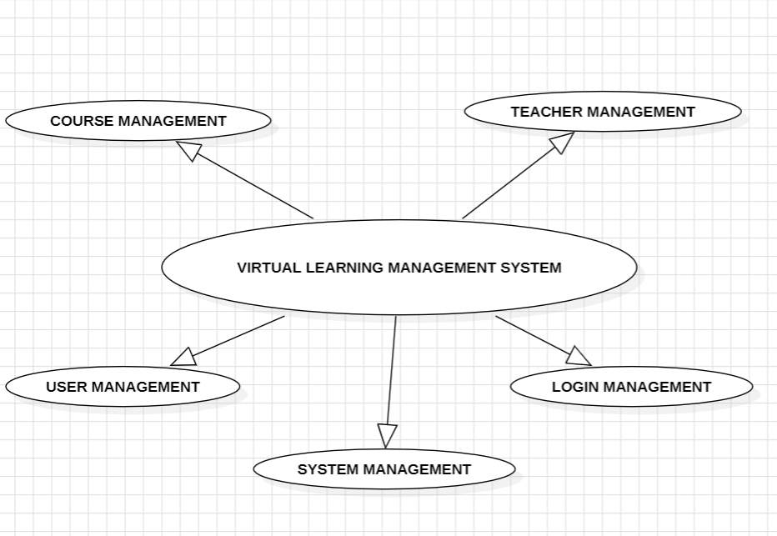

**4.3.1 Working Mechanism**

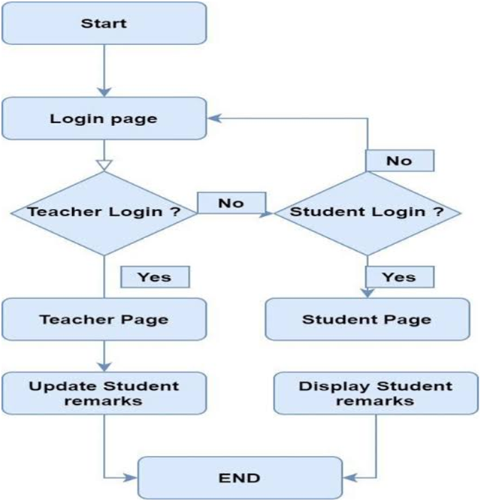

## 4.3.2 USE CASE DIAGRAM:

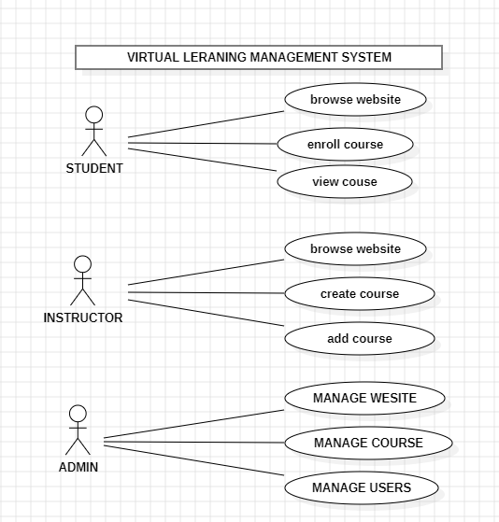

* 1. **DESCRIPTION OF SOFTWARE FOR IMPLEMENTATION AND TESTING PLAN OF THE PROPOSED MODEL/SYSTEM**

**Description of Software for Implementation:**

Implementing the proposed Virtual Learning Management System (VLMS) involves selecting appropriate software technologies and tools. Here's a description of the software stack suitable for developing the proposed model/system:

#### Programming Languages:

Frontend: HTML, CSS, JavaScript (React.js, Angular, or Vue.js for interactive user interfaces)

Backend: Node.js, Python, Ruby on Rails, Java, or PHP for server-side logic Database: MySQL, PostgreSQL, MongoDB, or Firebase for storing user data, course content, and analytics

#### Frameworks and Libraries:

Backend Framework: Express.js (for Node.js), Django (for Python), Ruby on Rails (for Ruby), Spring (for Java)

Database ORM: Sequelize (for Node.js), SQLAlchemy (for Python), ActiveRecord (for Ruby on Rails), Hibernate (for Java)

User Authentication: JSON Web Tokens (JWT) for secure user authentication and authorization

#### Cloud Services:

Hosting: Amazon Web Services (AWS), Microsoft Azure, Google Cloud Platform (GCP)

Storage: Amazon S3, Google Cloud Storage for storing multimedia course content Database Hosting: Amazon RDS, MongoDB Atlas, or managed database services provided by cloud providers

#### Version Control:

Git: Utilize Git for version control, GitHub, GitLab, or Bitbucket for hosting repositories

#### Development Tools:

Integrated Development Environment (IDE): Visual Studio Code, IntelliJ IDEA, PyCharm, Sublime Text

Collaboration: Slack, Microsoft Teams, or other team communication tools Project Management: Jira, Trello, or Asana for managing tasks and tracking project progress

#### Testing Plan for the Proposed VLMS:

Developing a robust testing plan is essential to ensure the functionality, security, and performance of the VLMS. Here's an outline of the testing plan:

#### Unit Testing:

Objective: Validate individual components and functions.

Tools: Jest (for JavaScript), PyTest (for Python), JUnit (for Java)

#### Integration Testing:

Objective: Ensure different components work together as intended. Tools: Mocha (for JavaScript), Behave (for Python), TestNG (for Java)

#### Functional Testing:

Objective: Test the system against functional requirements.

Tools: Selenium, Cypress (for frontend), Postman (for API endpoints)

#### User Interface (UI) Testing:

Objective: Validate the user interface for usability and responsiveness. Tools: Selenium, Jest with Enzyme (for React.js applications)

#### Security Testing:

Objective: Identify and mitigate security vulnerabilities. Tools: OWASP ZAP, Burp Suite, ESLint (for code analysis)

#### Performance Testing:

Objective: Evaluate system performance under various conditions (e.g., high traffic, large datasets).

Tools: Apache JMeter, LoadRunner, Artillery

#### User Acceptance Testing (UAT):

Objective: Validate the system from the end-users' perspective. Tools: Manual testing by real users, feedback forms, surveys

Objective: Ensure that new code changes do not adversely affect existing functionalities.

Tools: Automated testing suites (unit, integration, and functional tests)

#### Accessibility Testing:

Objective: Ensure the system is accessible to users with disabilities. Tools: Axe, WAVE, Lighthouse (for web applications)

#### Load and Stress Testing:

Objective: Evaluate system behavior under extreme conditions. Tools: Apache JMeter, LoadRunner, k6

Regular and automated testing, combined with continuous integration and deployment practices, are essential to maintaining the reliability and quality of the VLMS throughout its development and deployment lifecycle.

* 1. **PROJECT MANAGEMENT PLAN:-**

|  |  |
| --- | --- |
| **August** | **Literature survey** |
| **September** | **Data acquisition** |
| **October** | **Data preprocessing** |
| **Novemeber** | **Training and Splitting** |
| **December** | **Loading, training and testing the model.** |
| **January** | **Predicting the output and generating the final report** |

## CHAPTER-5 IMPLEMENTATION DETAILS

#### Environment Setup :-

* + Install a local development environment like XAMPP, WAMP, or MAMP for PHP.
  + Set up Node.js and npm for React.js development.

#### Back end Development:

* + Create a folder structure for your PHP backend.
  + Set up a MySQL or any preferred database.
  + Use a PHP framework like Laravel or Symfony, or you can go for a micro- framework like Slim or Lumen for building APIs.
  + Implement authentication, authorization, and user management.
  + Develop RESTful APIs for CRUD operations on resources like courses, users, assignments, etc.

#### Front end Development :

* + Initialize a new React.js project using Create React App or any other preferred method.
  + Structure your frontend codebase into components for better organization and reusability.
  + Use React Router for handling client-side routing.
  + Implement state management using Redux or Context API, especially for managing user authentication and application state.
  + Integrate CSS frameworks like Bootstrap or Material-UI for styling components.
  + Implement features like course listings, user dashboards, quizzes, assignments, etc.

#### Integration:

* + Connect your frontend React.js application to the backend PHP APIs using Axios or Fetch API for making HTTP requests.
  + Handle authentication tokens (JWT or sessions) to authenticate API requests.
  + Ensure CORS (Cross-Origin Resource Sharing) is configured properly to allow

frontend requests to the backend.

#### Testing:

* + Write unit tests for both backend PHP code (using PHPUnit) and frontend React.js components (using Jest and React Testing Library).
  + Perform integration tests to ensure the interaction between frontend and backend components works as expected.

#### Deployment:

* + Set up a server (could be a VPS like AWS EC2, Digital Ocean, or a managed service like Heroku).
  + Configure the server environment with PHP, MySQL, and Node.js.
  + Deploy the backend PHP code to the server.
  + Build the React.js frontend for production (npm run build) and deploy the static files to the server.
  + Configure domain, SSL certificates, and any necessary server settings.
  + Set up continuous integration/delivery (CI/CD) pipelines for automated deployments.

#### Monitoring and Maintenance:

* + Implement logging and monitoring solutions (like ELK stack, Prometheus, Grafana) to track errors and performance metrics.
  + Regularly update dependencies and apply security patches.
  + Monitor server health, database performance, and application uptime.

By following these steps, you can set up a robust development and deployment setup for your LMS web development project using PHP for the backend and React.js for the frontend.

**6.1 RESULT:-**

## CHAPTER-6

**RESULT AND DISCUSSION**

Results and discussions for a Virtual Learning Management System (VLMS) project would typically revolve around the effectiveness, usability, and impact of the system on various stakeholders such as students, teachers, administrators, and parents.

#### System Performance and Functionality:-

* + Discuss the technical performance of the VLMS, including its reliability, speed, and scalability.
  + Highlight any technical challenges encountered during the implementation and how they were addressed.
  + Evaluate the system's compatibility with different devices and internet connections.

#### User Engagement and Satisfaction:

* + Present data on user engagement metrics such as active users, frequency of logins, and time spent on the platform.
  + Share feedback from users through surveys, interviews, or focus groups regarding their satisfaction with the VLMS.
  + Discuss any features or functionalities that received positive or negative feedback and how they influenced user satisfaction.

#### Learning Outcomes:

* + Analyze the impact of the VLMS on student learning outcomes, such as academic performance, retention rates, and engagement in course materials.
  + Compare learning outcomes between traditional classroom settings and VLMS- enabled learning environments.
  + Discuss any disparities in learning outcomes among different demographic groups (e.g., gender, socioeconomic status) and potential strategies to address them.

#### Teacher/Administrator Experience:

* + Describe how the VLMS streamlined administrative tasks such as course management, grading, and communication with students.
  + Assess teacher satisfaction with the VLMS in terms of its usability, effectiveness in delivering course content, and support for instructional activities.
  + Discuss any challenges faced by teachers or administrators in adopting and integrating the VLMS into their teaching practices or organizational workflows.

#### Accessibility and Inclusivity:

* + Evaluate the accessibility features of the VLMS and its compliance with accessibility standards (e.g., WCAG).
  + Discuss any barriers to access faced by students with disabilities or diverse learning needs and potential strategies for improving inclusivity.
  + Highlight any initiatives undertaken to promote diversity and inclusion within the VLMS user community.

#### Future Directions and Recommendations:

* + Identify areas for improvement based on the findings of the evaluation, such as enhancing user interface design, expanding course offerings, or integrating additional learning tools and resources.
  + Propose future research directions to further investigate the impact of VLMS on teaching and learning outcomes.
  + Provide recommendations for stakeholders (e.g., educational institutions, software developers) on how to optimize the implementation and use of VLMS to maximize its benefits for all users.

By structuring your results and discussions section in this way, you can effectively communicate the findings of your VLMS project and their implications for the broader educational community.

## CHAPTER 7 CONCLUSION

#### CONCLUSION

An online Learning Management System (LMS) is a powerful and versatile tool that has revolutionized education and training in the digital age. It provides a centralized platform for educational institutions, businesses, and organizations to deliver, manage, and track learning experiences online Learning Management Systems have transformed the way we approach education and training, making learning more accessible, engaging, and data-informed. Their adaptability and potential for customization make them an indispensable tool for educational institutions, businesses, and organizations seeking to deliver effective and scalable learning experiences.

* 1. **FUTURE WORK**

1. **Scalability Solutions:** Research and develop scalability solutions to address the limitations of current blockchain technologies, enabling them to handle a higher volume of transactions and data. Techniques like sharding, layer-2 solutions, and improved consensus algorithms can help achieve this.
2. **Interoperability Standards:** Work on establishing interoperability standards that allow different blockchain networks to seamlessly communicate and share data. This is essential for enabling trust management across diverse blockchain ecosystems.
3. **Smart Contract Enhancements:** Improve smart contract functionality to enable more complex and customizable trust management scenarios. This could involve adding advanced scripting capabilities or integrating oracles for real-world data inputs.
4. **Privacy and Confidentiality:** Develop privacy-preserving technologies within blockchain systems to protect sensitive data while maintaining transparency. Zero-knowledge proofs, confidential transactions, and secure multi-party computation are areas to explore.

#### CHAPTER - 8

#### REFERENCES

1. Akyol, Z., & Garrison, D. R. (2022). Understanding cognitive presence in an online and blended community of inquiry: Assessing outcomes and processes for deep approaches to learning . British Journal of Educational Technology, 42(2), 233-250.
2. Bates, A. W. & Poole, G. (2023). Effective teaching with technology in higher education: Foundations for success. Indianapolis, IN: Jossey-Bass.
3. Bonk, C. J. & Graham, C. R. (Eds.). (2021). Handbook of blended learning: Global Perspectives, local designs. San Francisco, CA: Pfeiffer Publishing.
4. Conceição, S. C. O., & Lehman, R. M. (2021). Managing online instructor workload: Strategies for finding balance and success. San Francisco, CA: Jossey-Bass.
5. Duffy, T. M. & Kirkley, J. (2023). Learner-centered theory and practice in distance education: Cases for higher education. Mahwah, NJ: Lawrence Erblaum Associates
6. Lu S., Li, Z., Qin, Z., Yang, X. and Goh , R.S.M., 2017, December. A hybrid regression technique for house prices prediction. In 2017 IEEE International Conference on Industrial Engineering and Engineering Management (IEEM) (pp. 319- 323), IEEE.
7. Shinde, N. and Gawande , K., 2022, October. Survey on predicting property price. In 2018 International Conference on Automation and Computational Engineering (ICACE) (pp. 1-7). IEEE.
8. Online Documentation: Canvas is another popular LMS, and their guides (https://community.canvaslms.com/t5/Guides/ct-p/guides) can be beneficial.
9. Security Considerations: Familiarize yourself with best practices for web application security, especially when handling user data and authentication.
10. Research Papers: Search for academic papers on e-learning systems, LMS design, and related topics. Platforms like Google Scholar ([https://scholar.google.com](https://scholar.google.com/))

# APPENDIX

1. **Style.CSS**

**body {**

**margin: 0;**

**font-family: Arial, Helvetica, sans-serif;**

**line-height: 1.6;**

**}**

**.carousel {**

**width:50%;**

**height:30%;**

**}**

**.fwh-slide{**

**height: 100vh;**

**box-sizing: border-box;**

**padding: 15px ;**

**}**

**.fwh-slide p {**

**margin: 0;**

**}**

**.topnav {**

**overflow: hidden;**

**background-color: #373240;**

**}**

**.topnav a {**

**float: left;**

**display: block;**

**color: #f2f2f2;**

**text-align: center;**

**padding: 14px 16px;**

**text-decoration: none;**

**font-size: 17px;**

**}**

**.topnav a:hover {**

**background-color: #ddd;**

**color: black;**

**}**

**.topnav a.active {**

**background-color: #4CAF50;**

**color: white;**

**}**

**.topnav .icon {**

**display: none;**

**}**

**@media screen and (max-width: 600px) {**

**.topnav a:not(:first-child) {display: none;}**

**.topnav a.icon {**

**float: right;**

**display: block;**

**}**

**}**

**@media screen and (max-width: 600px) {**

**.topnav.responsive {position: relative;}**

**.topnav.responsive .icon {**

**position: absolute;**

**right: 0;**

**top: 0;**

**}**

**.topnav.responsive a {**

**float: none;**

**display: block;**

**text-align: left;**

**}**

**}**

**/*css brought from the profile*/**

**@import url("https://fonts.googleapis.com/css?family=Quicksand:400,500,700&subset=latin-ext");**

**html {**

**position: relative;**

**overflow-x: hidden !important; }**

**\* {**

**box-sizing: border-box; }**

**body {**

**font-family: 'Quicksand', sans-serif;**

**color: #324e63; }**

**a, a:hover {**

**text-decoration: none; }**

**.icon {**

**display: inline-block;**

**width: 1em;**

**height: 1em;**

**stroke-width: 0;**

**stroke: currentColor;**

**fill: currentColor; }**

**.wrapper {**

**width: 100%;**

**width: 100%;**

**height: auto;**

**min-height: 100vh;**

**padding: 50px 20px;**

**padding-top: 100px;**

**display: flex;**

**background-image: linear-gradient(-20deg, #ff2846 0%, #6944ff 100%);**

**display: flex;**

**background-image: linear-gradient(-20deg, #ff2846 0%, #6944ff 100%); }**

**@media screen and (max-width: 768px) {**

**.wrapper {**

**height: auto;**

**min-height: 100vh;**

**padding-top: 100px; } }**

**.profile-card {**

**width: 100%;**

**min-height: 460px;**

**margin: auto;**

**box-shadow: 0px 8px 60px -10px rgba(13, 28, 39, 0.6);**

**background: #fff;**

**border-radius: 12px;**

**max-width: 700px;**

**position: relative; }**

**.profile-card.active .profile-card__cnt {**

**filter: blur(6px); }**

**.profile-card.active .profile-card-message,**

**.profile-card.active .profile-card__overlay {**

**opacity: 1;**

**pointer-events: auto;**

**transition-delay: .1s; }**

**.profile-card.active .profile-card-form {**

**transform: none;**

**transition-delay: .1s; }**

**.profile-card__img {**

**width: 150px;**

**height: 150px;**

**margin-left: auto;**

**margin-right: auto;**

**transform: translateY(-50%);**

**border-radius: 50%;**

**overflow: hidden;**

**position: relative;**

**z-index: 4;**

**box-shadow: 0px 5px 50px 0px #6c44fc, 0px 0px 0px 7px rgba(107, 74, 255, 0.5); }**

**@media screen and (max-width: 576px) {**

**.profile-card__img {**

**width: 120px;**

**height: 120px; } }**

**.profile-card__img img {**

**display: block;**

**width: 100%;**

**height: 100%;**

**object-fit: cover;**

**border-radius: 50%; }**

**.profile-card__cnt {**

**margin-top: -35px;**

**text-align: center;**

**padding: 0 20px;**

**padding-bottom: 40px;**

**transition: all .3s; }**

**.profile-card__name {**

**font-weight: 700;**

**font-size: 24px;**

**color: #6944ff;**

**margin-bottom: 15px; }**

**.profile-card__txt {**

**font-size: 18px;**

**font-weight: 500;**

**color: #324e63;**

**margin-bottom: 15px; }**

**.profile-card__txt strong {**

**font-weight: 700; }**

**.profile-card-loc {**

**display: flex;**

**justify-content: center;**

**align-items: center;**

**font-size: 18px;**

**font-weight: 600; }**

**.profile-card-loc__icon {**

**display: inline-flex;**

**font-size: 27px;**

**margin-right: 10px; }**

**.profile-card-inf {**

**display: flex;**

**justify-content: center;**

**flex-wrap: wrap;**

**align-items: flex-start;**

**margin-top: 35px; }**

**.profile-card-inf__item {**

**padding: 10px 35px;**

**min-width: 150px; }**

**@media screen and (max-width: 768px) {**

**.profile-card-inf__item {**

**padding: 10px 20px;**

**min-width: 120px; } }**

**.profile-card-inf__title {**

**font-weight: 700;**

**font-size: 27px;**

**color: #324e63; }**

**.profile-card-inf__txt {**

**font-weight: 500;**

**margin-top: 7px; }**

**.profile-card-social {**

**margin-top: 25px;**

**display: flex;**

**justify-content: center;**

**align-items: center;**

**flex-wrap: wrap; }**

**.profile-card-social__item {**

**display: inline-flex;**

**width: 55px;**

**height: 55px;**

**margin: 15px;**

**border-radius: 50%;**

**align-items: center;**

**justify-content: center;**

**color: #fff;**

**background: #405de6;**

**box-shadow: 0px 7px 30px rgba(43, 98, 169, 0.5);**

**position: relative;**

**font-size: 21px;**

**flex-shrink: 0;**

**transition: all .3s; }**

**@media screen and (max-width: 768px) {**

**.profile-card-social__item {**

**width: 50px;**

**height: 50px;**

**margin: 10px; } }**

**@media screen and (min-width: 768px) {**

**.profile-card-social__item:hover {**

**transform: scale(1.2); } }**

**.profile-card-social__item.facebook {**

**background: linear-gradient(45deg, #3b5998, #0078d7);**

**box-shadow: 0px 4px 30px rgba(43, 98, 169, 0.5); }**

**.profile-card-social__item.twitter {**

**background: linear-gradient(45deg, #1da1f2, #0e71c8);**

**box-shadow: 0px 4px 30px rgba(19, 127, 212, 0.7); }**

**.profile-card-social__item.instagram {**

**background: linear-gradient(45deg, #405de6, #5851db, #833ab4, #c13584, #e1306c, #fd1d1d);**

**box-shadow: 0px 4px 30px rgba(120, 64, 190, 0.6); }**

**.profile-card-social__item.behance {**

**background: linear-gradient(45deg, #1769ff, #213fca);**

**box-shadow: 0px 4px 30px rgba(27, 86, 231, 0.7); }**

**.profile-card-social__item.github {**

**background: linear-gradient(45deg, #333333, #626b73);**

**box-shadow: 0px 4px 30px rgba(63, 65, 67, 0.6); }**

**.profile-card-social__item.codepen {**

**background: linear-gradient(45deg, #324e63, #414447);**

**box-shadow: 0px 4px 30px rgba(55, 75, 90, 0.6); }**

**.profile-card-social__item.link {**

**background: linear-gradient(45deg, #d5135a, #f05924);**

**box-shadow: 0px 4px 30px rgba(223, 45, 70, 0.6); }**

**.profile-card-social .icon-font {**

**display: inline-flex; }**

**.profile-card-ctr {**

**display: flex;**

**justify-content: center;**

**align-items: center;**

**margin-top: 40px; }**

**@media screen and (max-width: 576px) {**

**.profile-card-ctr {**

**flex-wrap: wrap; } }**

**.profile-card__button {**

**background: none;**

**border: none;**

**font-family: 'Quicksand', sans-serif;**

**font-weight: 500;**

**font-size: 19px;**

**margin: 15px 35px;**

**padding: 15px 40px;**

**min-width: 201px;**

**border-radius: 50px;**

**min-height: 55px;**

**color: #fff;**

**cursor: pointer;**

**backface-visibility: hidden;**

**transition: all .3s; }**

**@media screen and (max-width: 768px) {**

**.profile-card__button {**

**min-width: 170px;**

**margin: 15px 25px; } }**

**@media screen and (max-width: 576px) {**

**.profile-card__button {**

**min-width: inherit;**

**margin: 0;**

**margin-bottom: 16px;**

**width: 100%;**

**max-width: 300px; }**

**.profile-card__button:last-child {**

**margin-bottom: 0; } }**

**.profile-card__button:focus {**

**outline: none !important; }**

**@media screen and (min-width: 768px) {**

**.profile-card__button:hover {**

**transform: translateY(-5px); } }**

**.profile-card__button:first-child {**

**margin-left: 0; }**

**.profile-card__button:last-child {**

**margin-right: 0; }**

**.profile-card__button.button--blue {**

**background: linear-gradient(45deg, #1da1f2, #0e71c8);**

**box-shadow: 0px 4px 30px rgba(19, 127, 212, 0.4); }**

**.profile-card__button.button--blue:hover {**

**box-shadow: 0px 7px 30px rgba(19, 127, 212, 0.75); }**

**.profile-card__button.button--orange {**

**background: linear-gradient(45deg, #d5135a, #f05924);**

**box-shadow: 0px 4px 30px rgba(223, 45, 70, 0.35); }**

**.profile-card__button.button--orange:hover {**

**box-shadow: 0px 7px 30px rgba(223, 45, 70, 0.75); }**

**.profile-card__button.button--gray {**

**box-shadow: none;**

**background: #dcdcdc;**

**color: #142029; }**

**.profile-card-message {**

**width: 100%;**

**height: 100%;**

**position: absolute;**

**top: 0;**

**left: 0;**

**padding-top: 130px;**

**padding-bottom: 100px;**

**opacity: 0;**

**pointer-events: none;**

**transition: all .3s; }**

**.profile-card-form {**

**box-shadow: 0 4px 30px rgba(15, 22, 56, 0.35);**

**max-width: 80%;**

**margin-left: auto;**

**margin-right: auto;**

**height: 100%;**

**background: #fff;**

**border-radius: 10px;**

**padding: 35px;**

**transform: scale(0.8);**

**position: relative;**

**z-index: 3;**

**transition: all .3s; }**

**@media screen and (max-width: 768px) {**

**.profile-card-form {**

**max-width: 90%;**

**height: auto; } }**

**@media screen and (max-width: 576px) {**

**.profile-card-form {**

**padding: 20px; } }**

**.profile-card-form__bottom {**

**justify-content: space-between;**

**display: flex; }**

**@media screen and (max-width: 576px) {**

**.profile-card-form__bottom {**

**flex-wrap: wrap; } }**

**.profile-card textarea {**

**width: 100%;**

**resize: none;**

**height: 210px;**

**margin-bottom: 20px;**

**border: 2px solid #dcdcdc;**

**border-radius: 10px;**

**padding: 15px 20px;**

**color: #324e63;**

**font-weight: 500;**

**font-family: 'Quicksand', sans-serif;**

**outline: none;**

**transition: all .3s; }**

**.profile-card textarea:focus {**

**outline: none;**

**border-color: #8a979e; }**

**.profile-card__overlay {**

**width: 100%;**

**height: 100%;**

**position: absolute;**

**top: 0;**

**left: 0;**

**pointer-events: none;**

**opacity: 0;**

**background: rgba(22, 33, 72, 0.35);**

**border-radius: 12px;**

**transition: all .3s; }**

**2.header.PHP**

**<?php**

**session_start();**

**?>**

**<!DOCTYPE html>**

**<html>**

**<head>**

**<meta name="viewport" content="width=device-width, initial-scale=1">**

**<link rel="stylesheet" href="style.css">**

**<link rel="stylesheet" href="https://stackpath.bootstrapcdn.com/bootstrap/4.5.0/css/bootstrap.min.css"**

**integrity="sha384-9aIt2nRpC12Uk9gS9baDl411NQApFmC26EwAOH8WgZl5MYYxFfc+NcPb1dKGj7Sk" crossorigin="anonymous">**

**<link rel="stylesheet" href="styleloggedin.css">**

**<title>Learn Academy</title>**

**</head>**

**<body>**

**<div class="topnav" id="myTopnav">**

**<a href="loggedin.php" class="active">Home</a>**

**<?php**

**if (isset($_SESSION['userId'])){**

**echo '<a href="loggedin/profile.php" name="profile">Profile</a>**

**<a href="includes/logout.inc.php" name="logout-submit">SIGN OUT</a>';**

**}else{**

**echo '<a href="#aboutus">ABOUT US</a>**

**<a href="#contact">CONTACT</a>**

**<a href="javascript:void(0);" class="icon" onclick="myFunction()">**

**<i class="fa fa-bars"></i>**

**</a>**

**<a href="signup.php">SIGN UP</a>';**

**echo '<a href="signin.php">SIGN IN</a>';**

**}**

**?>**

**</div>**

**</header>**

**3.INDEX.PHP**

**<!DOCTYPE html>**

**<html lang="en">**

**<head>**

**<title>LAcademy</title>**

**<meta charset="utf-8">**

**<meta name="viewport" content="width=device-width, initial-scale=1, shrink-to-fit=no">**

**<link href="https://fonts.googleapis.com/css?family=Muli:300,400,700,900" rel="stylesheet">**

**<link rel="stylesheet" href="fonts/icomoon/style.css">**

**<link rel="stylesheet" href="css/bootstrap.min.css">**

**<link rel="stylesheet" href="css/jquery-ui.css">**

**<link rel="stylesheet" href="css/owl.carousel.min.css">**

**<link rel="stylesheet" href="css/owl.theme.default.min.css">**

**<link rel="stylesheet" href="css/owl.theme.default.min.css">**

**<link rel="stylesheet" href="css/jquery.fancybox.min.css">**

**<link rel="stylesheet" href="css/bootstrap-datepicker.css">**

**<link rel="stylesheet" href="fonts/flaticon/font/flaticon.css">**

**<link rel="stylesheet" href="css/aos.css">**

**<link rel="stylesheet" href="css/style.css">**

**</head>**

**<body data-spy="scroll" data-target=".site-navbar-target" data-offset="300">**

**<div class="site-wrap">**

**<div class="site-mobile-menu site-navbar-target">**

**<div class="site-mobile-menu-header">**

**<div class="site-mobile-menu-close mt-3">**

**<span class="icon-close2 js-menu-toggle"></span>**

**</div>**

**</div>**

**<div class="site-mobile-menu-body"></div>**

**</div>**

**<header class="site-navbar py-4 js-sticky-header site-navbar-target" role="banner">**

**<div class="container-fluid">**

**<div class="d-flex align-items-center">**

**<div class="site-logo mr-auto w-25"><a href="index.php">LAcademy</a></div>**

**<div class="mx-auto text-center">**

**<nav class="site-navigation position-relative text-right" role="navigation">**

**<ul class="site-menu main-menu js-clone-nav mx-auto d-none d-lg-block m-0 p-0">**

**<li><a href="#home-section" class="nav-link">Home</a></li>**

**<li><a href="#courses-section" class="nav-link">Courses</a></li>**

**<li><a href="#programs-section" class="nav-link">Programs</a></li>**

**<li><a href="#teachers-section" class="nav-link">Teachers</a></li>**

**</ul>**

**</nav>**

**</div>**

**<div class="ml-auto w-25">**

**<nav class="site-navigation position-relative text-right" role="navigation">**

**<ul class="site-menu main-menu site-menu-dark js-clone-nav mr-auto d-none d-lg-block m-0 p-0">**

**<li class="cta"><a href="#contact-section" class="nav-link"><span>Contact Us</span></a></li>**

**</ul>**

**</nav>**

**<a href="#" class="d-inline-block d-lg-none site-menu-toggle js-menu-toggle text-black float-right"><span class="icon-menu h3"></span></a>**

**</div>**

**</div>**

**</div>**

**</header>**

**<div class="intro-section" id="home-section">**

**<div class="slide-1" style="background-image: url('images/hero_1.jpg');" data-stellar-background-ratio="0.5">**

**<div class="container">**

**<div class="row align-items-center">**

**<div class="col-12">**

**<div class="sign">**

**<!--sign-->**

**<div class="container <?php echo (isset($_GET['errorp']) || isset($_GET['signup']))? 'right-panel-active':''; ?>" id="container">**

**<div class="form-container sign-up-container">**

**<form action="includes/signup1.inc.php" method="post" id="signup_form">**

**<h1 class="title">Sign Up</h1>**

**<br>**

**<?php**

**if (isset($_GET['errorp'])){**

**if ($_GET['errorp']=="emptyfields"){**

**echo '<div style="color:red;">Fill in all fields !</div>';**

**}else if ($_GET['errorp']=="invalidmailuid"){**

**echo '<div style="color:red;">Invalid username and e-mail !</div>';**

**}else if ($_GET['errorp']=="invaliduid"){**

**echo '<div style="color:red;">Invalid username !</div>';**

**}else if ($_GET['errorp']=="invalidmail"){**

**echo '<div style="color:red;">Invalid e-mail !</div>';**

**}else if ($_GET['errorp']=="passwordcheck"){**

**echo '<div style="color:red;">Passwords don\'t match!</div>';**

**}else if ($_GET['errorp']=="usertaken"){**

**echo '<div style="color:red;">Username is already taken!</div>';**

**}**

**}elseif (isset($_GET['signup']) ) {**

**if ($_GET['signup']=="success")**

**echo '<div style="color:green;">Signup Successful ! Feel free to login !</div>';**

**}**

**?>**

**<div id="error_signup_name"></div>**

**<input type="text" id="name_signup" name="uid" placeholder="Name" value="<?php if (isset($_GET['errorp'])){**

**if ($_GET['errorp']=='invalidmail' || $_GET['errorp']=='passwordcheck' || $_GET['errorp']=='emptyfields'){**

**echo isset($_GET['uid']) ? $_GET['uid']:'';**

**}else {**

**echo '';**

**}**

**} ?>" />**

**<div id="error_signup_email"></div>**

**<input type="email" id="mail_signup" name="mail" placeholder="E-mail"**

**value="<?php if (isset($_GET['errorp'])){**

**if ($_GET['errorp']=='invaliduid' || $_GET['errorp']=='passwordcheck' || $_GET['errorp']=='emptyfields' || $_GET['errorp']=='usertaken'){**

**echo isset($_GET['mail']) ? $_GET['mail']:'';**

**}else {**

**echo '';**

**}**

**} ?>" />**

**<div id="error_signup_pwd1"></div>**

**<input type="password" id="pwd1_signup" name="pwd" placeholder="Password" />**

**<div id="error_signup_pwd2"></div>**

**<input type="password" id="pwd2_signup" name="pwd-repeat" placeholder="Repeat Password" />**

**<button>Sign Up</button>**

**</form>**

**</div>**

**<div class="form-container sign-in-container">**

**<form action="includes/login.inc.php" method="post" id="signin_form">**

**<h1 class="title">Sign in</h1>**

**<br>**

**<?php**

**if (isset($_GET['error'])){**

**if ($_GET['error']=="emptyfields"){**

**echo '<div style="color:red;">Fill in all fields !</div>';**

**}else if ($_GET['error']=="wrongpwd"){**

**echo '<div style="color:red;">Wrong password!</div>';**

**}else if ($_GET['error']=="nomatch"){**

**echo '<div style="color:red;">There\'s no match for your email !</div>';**

**}elseif (isset($_GET['login']) ) {**

**if ($_GET['signup']=="success")**

**echo '<div style="color:green;">Sign in Successful !</div>';**

**}**

**}?>**

**<div id="error_signin_mail"></div>**

**<input type="email" id="mailsignin" placeholder="Email" name="mailuid" placeholder="Username/E-mail"**

**value="<?php if (isset($_GET['error'])){**

**if ($_GET['error']=="wrongpwd" || $_GET['error']=="emptyfields"){**

**echo isset($_GET['mail'])?$_GET['mail']:'';**

**}else {**

**echo '';**

**}**

**} ?>" />**

**<div id="error_signin_pwd"></div>**

**<input type="password" id="pwdsignin" name="pwd" placeholder="Password" />**

**<a href="mail_input.php">Forgot your password?</a>**

**<button>Sign In</button>**

**</form>**

**</div>**

**<div class="overlay-container">**

**<div class="overlay">**

**<div id="overlay-left" class="overlay-panel overlay-left">**

**<h1>Welcome Back!</h1>**

**<p>To keep connected with us please login with your personal info</p>**

**<button class="ghost" id="signIn">Sign In</button>**

**</div>**

**<div class="overlay-panel overlay-right">**

**<h1>Hello, Learner!</h1>**

**<p>Enter your personal details and start journey with us</p>**

**<button class="ghost" id="signUp">Sign Up</button>**

**</div>**

**</div>**

**</div>**

**</div>**

**</div>**

**<!--end-->**

**</div>**

**</div>**

**</div>**

**</div>**

**</div>**

**</div>**

**</div>**

**<div class="site-section courses-title" id="courses-section">**

**<div class="container">**

**<div class="row mb-5 justify-content-center">**

**<div class="col-lg-7 text-center" data-aos="fade-up" data-aos-delay="">**

**<h2 class="section-title">Courses</h2>**

**</div>**

**</div>**

**</div>**

**</div>**

**<div class="site-section courses-entry-wrap" data-aos="fade-up" data-aos-delay="100">**

**<div class="container">**

**<div class="row">**

**<div class="owl-carousel col-12 nonloop-block-14">**

**<div class="course bg-white h-100 align-self-stretch">**

**<figure class="m-0">**

**<img src="images/img1.jpg" alt="Image" class="img-fluid">**

**</figure>**

**<div class="course-inner-text py-4 px-4">**

**<span class="course-price">$0</span>**

**<div class="meta"><span class="icon-clock-o"></span>4 Lessons / 3 week</div>**

**<h3><a href="#">English</a></h3>**

**<p>Learn English in order to pass IELTS exam. </p>**

**</div>**

**<div class="d-flex border-top stats">**

**<div class="py-3 px-4"><span class="icon-users"></span> 2,193 students</div>**

**<div class="py-3 px-4 w-25 ml-auto border-left"><span class="icon-chat"></span> 2</div>**

**</div>**

**</div>**

**<div class="course bg-white h-100 align-self-stretch">**

**<figure class="m-0">**

**<img src="images/img2.jpg" alt="Image" class="img-fluid">**

**</figure>**

**<div class="course-inner-text py-4 px-4">**

**<span class="course-price">$0</span>**

**<div class="meta"><span class="icon-clock-o"></span>20 Lessons / 4 week</div>**

**<h3><a href="#">Introduction to Chemical Engineering</a></h3>**

**<p>Discover the world of chemical engineering </p>**

**</div>**

**<div class="d-flex border-top stats">**

**<div class="py-3 px-4"><span class="icon-users"></span> 2,100 students</div>**

**<div class="py-3 px-4 w-25 ml-auto border-left"><span class="icon-chat"></span> 9</div>**

**</div>**

**</div>**

**<div class="course bg-white h-100 align-self-stretch">**

**<figure class="m-0">**

**<img src="images/img4.jpg" alt="Image" class="img-fluid">**

**</figure>**

**<div class="course-inner-text py-4 px-4">**

**<span class="course-price">$0</span>**

**<div class="meta"><span class="icon-clock-o"></span>4 Lessons / 12 week</div>**

**<h3><a href="#">Arabic</a></h3>**

**<p>Learn the basics of the arabic language . </p>**

**</div>**

**<div class="d-flex border-top stats">**

**<div class="py-3 px-4"><span class="icon-users"></span> 3,193 students</div>**

**<div class="py-3 px-4 w-25 ml-auto border-left"><span class="icon-chat"></span> 2</div>**

**</div>**

**</div>**

**<div class="course bg-white h-100 align-self-stretch">**

**<figure class="m-0">**

**<img src="images/img_4.jpg" alt="Image" class="img-fluid">**

**</figure>**

**<div class="course-inner-text py-4 px-4">**

**<span class="course-price">$0</span>**

**<div class="meta"><span class="icon-clock-o"></span>3 Lessons / 9 week</div>**

**<h3><a href="#">C++</a></h3>**

**<p>Learn the most famous programming language. </p>**

**</div>**

**<div class="d-flex border-top stats">**

**<div class="py-3 px-4"><span class="icon-users"></span> 1,123 students</div>**

**<div class="py-3 px-4 w-25 ml-auto border-left"><span class="icon-chat"></span> 8</div>**

**</div>**

**</div>**

**<div class="course bg-white h-100 align-self-stretch">**

**<figure class="m-0">**

**<img src="images/img_5.jpg" alt="Image" class="img-fluid">**

**</figure>**

**<div class="course-inner-text py-4 px-4">**

**<span class="course-price">$0</span>**

**<div class="meta"><span class="icon-clock-o"></span>2 Lessons / 5 week</div>**

**<h3><a href="#">JAVA</a></h3>**

**<p>java is a must learn versatile language. </p>**

**</div>**

**<div class="d-flex border-top stats">**

**<div class="py-3 px-4"><span class="icon-users"></span> 1,523 students</div>**

**<div class="py-3 px-4 w-25 ml-auto border-left"><span class="icon-chat"></span> 6</div>**

**</div>**

**</div>**

**<div class="course bg-white h-100 align-self-stretch">**

**<figure class="m-0">**

**<img src="images/img_6.jpg" alt="Image" class="img-fluid">**

**</figure>**

**<div class="course-inner-text py-4 px-4">**

**<span class="course-price">$0</span>**

**<div class="meta"><span class="icon-clock-o"></span>5 Lessons / 7 week</div>**

**<h3><a href="#">Python</a></h3>**

**<p>Begin your journey in the world of AI. </p>**

**</div>**

**<div class="d-flex border-top stats">**

**<div class="py-3 px-4"><span class="icon-users"></span> 2,453 students</div>**

**<div class="py-3 px-4 w-25 ml-auto border-left"><span class="icon-chat"></span> 5</div>**

**</div>**

**</div>**

**</div>**

**</div>**

**<div class="row justify-content-center">**

**<div class="col-7 text-center">**

**<button class="customPrevBtn btn btn-primary m-1">Prev</button>**

**<button class="customNextBtn btn btn-primary m-1">Next</button>**

**</div>**

**</div>**

**</div>**

**</div>**

**<div class="site-section" id="programs-section">**

**<div class="container">**

**<div class="row mb-5 justify-content-center">**

**<div class="col-lg-7 text-center" data-aos="fade-up" data-aos-delay="">**

**<h2 class="section-title">Our Programs</h2>**

**<p>We aim to make studying SIMPLE, EASY and ACCESSIBLE to EVERYONE thus we collected the BEST COURSES in the world in one place.</p>**

**</div>**

**</div>**

**<div class="row mb-5 align-items-center">**

**<div class="col-lg-7 mb-5" data-aos="fade-up" data-aos-delay="100">**

**<img src="images/undraw_youtube_tutorial.svg" alt="Image" class="img-fluid">**

**</div>**

**<div class="col-lg-4 ml-auto" data-aos="fade-up" data-aos-delay="200">**

**<h2 class="text-black mb-4">We Are Excellent In Education</h2>**

**<p class="mb-4">Education is an art and we are the artists.</p>**

**<div class="d-flex align-items-center custom-icon-wrap mb-3">**

**<span class="custom-icon-inner mr-3"><span class="icon icon-graduation-cap"></span></span>**

**<div><h3 class="m-0">2,931 Yearly Graduates</h3></div>**

**</div>**

**<div class="d-flex align-items-center custom-icon-wrap">**

**<span class="custom-icon-inner mr-3"><span class="icon icon-university"></span></span>**

**<div><h3 class="m-0">50 Universities Worldwide</h3></div>**

**</div>**

**</div>**

**</div>**

**<div class="row mb-5 align-items-center">**

**<div class="col-lg-7 mb-5 order-1 order-lg-2" data-aos="fade-up" data-aos-delay="100">**

**<img src="images/undraw_teaching.svg" alt="Image" class="img-fluid">**

**</div>**

**<div class="col-lg-4 mr-auto order-2 order-lg-1" data-aos="fade-up" data-aos-delay="200">**

**<h2 class="text-black mb-4">Strive for Excellent</h2>**

**<p class="mb-4">our goal is your success.</p>**

**<div class="d-flex align-items-center custom-icon-wrap mb-3">**

**<span class="custom-icon-inner mr-3"><span class="icon icon-graduation-cap"></span></span>**

**<div><h3 class="m-0">2,931 Yearly Graduates</h3></div>**

**</div>**

**<div class="d-flex align-items-center custom-icon-wrap">**

**<span class="custom-icon-inner mr-3"><span class="icon icon-university"></span></span>**

**<div><h3 class="m-0">50 Universities Worldwide</h3></div>**

**</div>**

**</div>**

**</div>**

**<div class="row mb-5 align-items-center">**

**<div class="col-lg-7 mb-5" data-aos="fade-up" data-aos-delay="100">**

**<img src="images/undraw_teacher.svg" alt="Image" class="img-fluid">**

**</div>**

**<div class="col-lg-4 ml-auto" data-aos="fade-up" data-aos-delay="200">**

**<h2 class="text-black mb-4">Education is life</h2>**

**<p class="mb-4">Beginning of a never ending journey of learning.</p>**

**<div class="d-flex align-items-center custom-icon-wrap mb-3">**

**<span class="custom-icon-inner mr-3"><span class="icon icon-graduation-cap"></span></span>**

**<div><h3 class="m-0">2,931 Yearly Graduates</h3></div>**

**</div>**

**<div class="d-flex align-items-center custom-icon-wrap">**

**<span class="custom-icon-inner mr-3"><span class="icon icon-university"></span></span>**

**<div><h3 class="m-0">50 Universities Worldwide</h3></div>**

**</div>**

**</div>**

**</div>**

**</div>**

**</div>**

**<div class="site-section" id="teachers-section">**

**<div class="container">**

**<div class="row mb-5 justify-content-center">**

**<div class="col-lg-7 mb-5 text-center" data-aos="fade-up" data-aos-delay="">**

**<h2 class="section-title">Our Teachers</h2>**

**<p class="mb-5">The best we promise the best we are !</p>**

**</div>**

**</div>**

**<div class="row">**

**<div class="col-md-6 col-lg-4 mb-4" data-aos="fade-up" data-aos-delay="100">**

**<div class="teacher text-center">**

**<img src="images/person_1.jpg" alt="Image" class="img-fluid w-50 rounded-circle mx-auto mb-4">**

**<div class="py-2">**

**<h3 class="text-black">Aouini Oussama</h3>**

**<p class="position">WEB Teacher</p>**

**<p>Made over 100 websites with years of experience, taught over 500 students.</p>**

**</div>**

**</div>**

**</div>**

**<div class="col-md-6 col-lg-4 mb-4" data-aos="fade-up" data-aos-delay="200">**

**<div class="teacher text-center">**

**<img src="images/person_2.jpg" alt="Image" class="img-fluid w-50 rounded-circle mx-auto mb-4">**

**<div class="py-2">**

**<h3 class="text-black">Abidi Nidhal</h3>**

**<p class="position">AI Teacher</p>**

**<p>Over 20 years of experience Worked at NASA and done so many projects .</p>**

**</div>**

**</div>**

**</div>**

**<div class="col-md-6 col-lg-4 mb-4" data-aos="fade-up" data-aos-delay="300">**

**<div class="teacher text-center">**

**<img src="images/person_3.jpg" alt="Image" class="img-fluid w-50 rounded-circle mx-auto mb-4">**

**<div class="py-2">**

**<h3 class="text-black">Zemmali Mohamed</h3>**

**<p class="position">IOT Teacher</p>**

**<p>Leading expert in the domain of IOT, taught many students over the years.</p>**

**</div>**

**</div>**

**</div>**

**</div>**

**</div>**

**</div>**

**<div class="site-section bg-image overlay" style="background-image: url('images/hero_1.jpg');">**

**<div class="container">**

**<div class="row justify-content-center align-items-center">**

**<div class="col-md-8 text-center testimony">**

**<img src="images/person_4.jpg" alt="Image" class="img-fluid w-25 mb-4 rounded-circle">**

**<h3 class="mb-4">Najem Märzouky</h3>**

**<blockquote>**

**<p>&ldquo; I was struggling with my studies but it all changed when I learned about LAcademy, I'm now a senior software engineer making a 6 figure salary per year.This website is a real game changer. &rdquo;</p>**

**</blockquote>**

**</div>**

**</div>**

**</div>**

**</div>**

**<div class="site-section pb-0">**

**<div class="future-blobs">**

**<div class="blob_2">**

**<img src="images/blob_2.svg" alt="Image">**

**</div>**

**<div class="blob_1">**

**<img src="images/blob_1.svg" alt="Image">**

**</div>**

**</div>**

**<div class="container">**

**<div class="row mb-5 justify-content-center" data-aos="fade-up" data-aos-delay="">**

**<div class="col-lg-7 text-center">**

**<h2 class="section-title">Why Choose Us</h2>**

**</div>**

**</div>**

**<div class="row">**

**<div class="col-lg-4 ml-auto align-self-start" data-aos="fade-up" data-aos-delay="100">**

**<div class="p-4 rounded bg-white why-choose-us-box">**

**<div class="d-flex align-items-center custom-icon-wrap custom-icon-light mb-3">**

**<div class="mr-3"><span class="custom-icon-inner"><span class="icon icon-graduation-cap"></span></span></div>**

**<div><h3 class="m-0">2,931 Yearly Graduates</h3></div>**

**</div>**

**<div class="d-flex align-items-center custom-icon-wrap custom-icon-light mb-3">**

**<div class="mr-3"><span class="custom-icon-inner"><span class="icon icon-university"></span></span></div>**

**<div><h3 class="m-0">50 Universities Worldwide</h3></div>**

**</div>**

**<div class="d-flex align-items-center custom-icon-wrap custom-icon-light mb-3">**

**<div class="mr-3"><span class="custom-icon-inner"><span class="icon icon-graduation-cap"></span></span></div>**

**<div><h3 class="m-0">Top Professionals in The World</h3></div>**

**</div>**

**<div class="d-flex align-items-center custom-icon-wrap custom-icon-light mb-3">**

**<div class="mr-3"><span class="custom-icon-inner"><span class="icon icon-university"></span></span></div>**

**<div><h3 class="m-0">Expand Your Knowledge</h3></div>**

**</div>**

**<div class="d-flex align-items-center custom-icon-wrap custom-icon-light mb-3">**

**<div class="mr-3"><span class="custom-icon-inner"><span class="icon icon-graduation-cap"></span></span></div>**

**<div><h3 class="m-0">Best Online Teaching Assistant Courses</h3></div>**

**</div>**

**<div class="d-flex align-items-center custom-icon-wrap custom-icon-light">**

**<div class="mr-3"><span class="custom-icon-inner"><span class="icon icon-university"></span></span></div>**

**<div><h3 class="m-0">Best Teachers</h3></div>**

**</div>**

**</div>**

**</div>**

**<div class="col-lg-7 align-self-end" data-aos="fade-left" data-aos-delay="200">**

**<img src="images/person_transparent.png" alt="Image" class="img-fluid">**

**</div>**

**</div>**

**</div>**

**</div>**

**<div class="site-section bg-light" id="contact-section">**

**<div class="container">**

**<div class="row justify-content-center">**

**<div class="col-md-7">**

**<h2 class="section-title mb-3">Message Us</h2>**

**<p class="mb-5">We are more than happy to receive your suggestions.</p>**

**<!-- Beginning of the php for the contact form -->**

**<?php**

**// Message Vars**

**$msg = '';**

**$msgClass = '';**

**// Check For Submit**

**if(filter_has_var(INPUT_POST, 'submit')){**

**// Get Form Data**

**$name = htmlspecialchars($_POST['name']);**

**$email = htmlspecialchars($_POST['email']);**

**$message = htmlspecialchars($_POST['message']);**

**$subject = htmlspecialchars($_POST['subject']);**

**// Check Required Fields**

**if(!empty($email) && !empty($name) && !empty($message) && !empty($subject)){**

**// Passed**

**// Check Email**

**if(filter_var($email, FILTER_VALIDATE_EMAIL) === false){**

**// Failed**

**$msg = 'Please use a valid email';**

**$msgClass = 'alert-danger';**

**} else {**

**// Passed**

**$toEmail = 'support@lacademy.com';**

**$body = $subject.'<h4>Name</h4><p>'.$name.'</p>**

**<h4>Email</h4><p>'.$email.'</p>**

**<h4>Message</h4><p>'.$message.'</p>';**

**// Email Headers**

**$headers = "MIME-Version: 1.0" ."\r\n";**

**$headers .="Content-Type:text/html;charset=UTF-8" . "\r\n";**

**// Additional Headers**

**$headers .= "From: " .$name. "<".$email.">". "\r\n";**

**if(mail($toEmail, $subject, $body, $headers)){**

**// Email Sent**

**$msg = 'Your email has been sent';**

**$msgClass = 'alert-success';**

**} else {**

**// Failed**

**$msg = 'Your email was not sent';**

**$msgClass = 'alert-danger';**

**}**

**}**

**} else {**

**// Failed**

**$msg = 'Please fill in all fields';**

**$msgClass = 'alert-danger';**

**}**

**}**

**?>**

**<?php if($msg != ''): ?>**

**<div class="alert <?php echo $msgClass; ?>"><?php echo $msg; ?></div>**

**<?php endif; ?>**

**<!-- End of the php for the contact form -->**

**<form method="post" action="index.php#contact-section" data-aos="fade" id="contact_form">**

**<div class="form-group row">**

**<div class="col-md-12">**

**<div id="error_contact_fullname"></div>**

**<input type="text" name="name" id="contact_fullname" class="form-control" placeholder="Full name" value="<?php echo isset($_POST['name']) ? $name : ''; ?>">**

**</div>**

**</div>**

**<div class="form-group row">**

**<div class="col-md-12">**

**<div id="error_contact_subject"></div>**

**<input type="text" id="contact_subject" name="subject" class="form-control" placeholder="Subject" >**

**</div>**

**</div>**

**<div class="form-group row">**

**<div class="col-md-12">**

**<div id="error_contact_email"></div>**

**<input type="email" id="contact_email" name="email" class="form-control" placeholder="Email" value="<?php echo isset($_POST['email']) ? $email : ''; ?>">**

**</div>**

**</div>**

**<div class="form-group row">**

**<div class="col-md-12">**

**<div id="error_contact_message"></div>**

**<textarea class="form-control" id="contact_message" name="message" cols="30" rows="10" placeholder="Write your message here."><?php echo isset($_POST['message']) ? $message : ''; ?></textarea>**

**</div>**

**</div>**

**<div class="form-group row">**

**<div class="col-md-6">**

**<input type="submit" name="submit" class="btn btn-primary py-3 px-5 btn-block btn-pill" value="Send Message">**

**</div>**

**</div>**

**</form>**

**</div>**

**</div>**

**</div>**

**</div>**

**<footer class="footer-section bg-white">**

**<div class="container">**

**<div class="row">**

**<div class="col-md-4">**

**<h3>About LAcademy</h3>**

**<p>An E-Learning platform rich of resources, We make learning easy and simple for Everyone.</p>**

**</div>**

**<div class="col-md-3 ml-auto">**

**<h3>Links</h3>**

**<ul class="list-unstyled footer-links">**

**<li><a href="#home-section" class="nav-link">Home</a></li>**

**<li><a href="#courses-section" class="nav-link">Courses</a></li>**

**<li><a href="#programs-section" class="nav-link">Programs</a></li>**

**<li><a href="#teachers-section" class="nav-link">Teachers</a></li>**

**</ul>**

**</div>**

**<div class="col-md-4">**

**<h3>Subscribe</h3>**

**<p>Keep yourself up to date and receive all kind of news about LAcademy.</p>**

**<form action="https://mailchi.mp/064deb47eeaa/lacdemy" target="_blank" class="footer-subscribe">**

**<div class="d-flex mb-5">**

**<input type="submit" class="btn btn-primary rounded-0" value="Subscribe">**

**</div>**

**</form>**

**</div>**

**</div>**

**<div class="row pt-5 mt-5 text-center">**

**<div class="col-md-12">**

**<div class="border-top pt-5">**

**<p>**

**<!-- Link back to Colorlib can't be removed. Template is licensed under CC BY 3.0. -->**

**Copyright &copy;<script>document.write(new Date().getFullYear());</script> All rights reserved**

**<!-- Link back to Colorlib can't be removed. Template is licensed under CC BY 3.0. -->**

**</p>**

**</div>**

**</div>**

**</div>**

**</div>**

**</footer>**

**</div> <!-- .site-wrap -->**

**<script src="js/jquery-3.3.1.min.js"></script>**

**<script src="js/jquery-migrate-3.0.1.min.js"></script>**

**<script src="js/jquery-ui.js"></script>**

**<script src="js/popper.min.js"></script>**

**<script src="js/bootstrap.min.js"></script>**

**<script src="js/owl.carousel.min.js"></script>**

**<script src="js/jquery.stellar.min.js"></script>**

**<script src="js/jquery.countdown.min.js"></script>**

**<script src="js/bootstrap-datepicker.min.js"></script>**

**<script src="js/jquery.easing.1.3.js"></script>**

**<script src="js/aos.js"></script>**

**<script src="js/jquery.fancybox.min.js"></script>**

**<script src="js/jquery.sticky.js"></script>**

**<script src="js/main.js"></script>**

**</body>**

**</html>**.PHP

## B. SCREENSHOTS

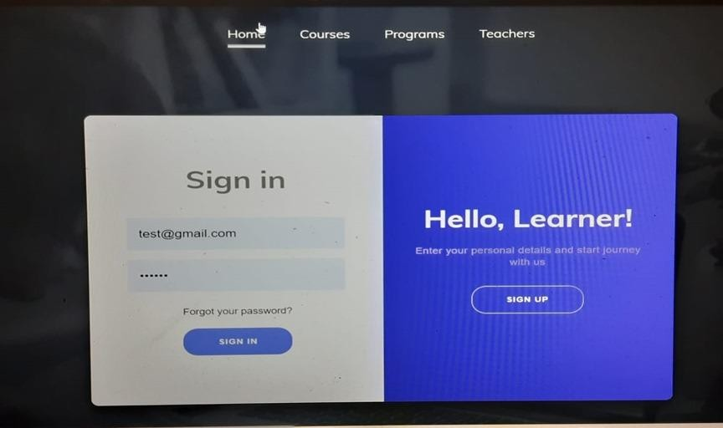

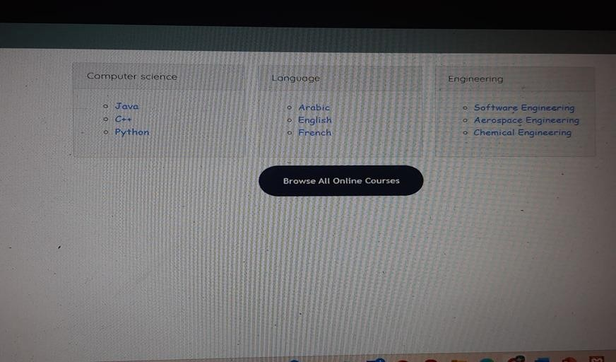

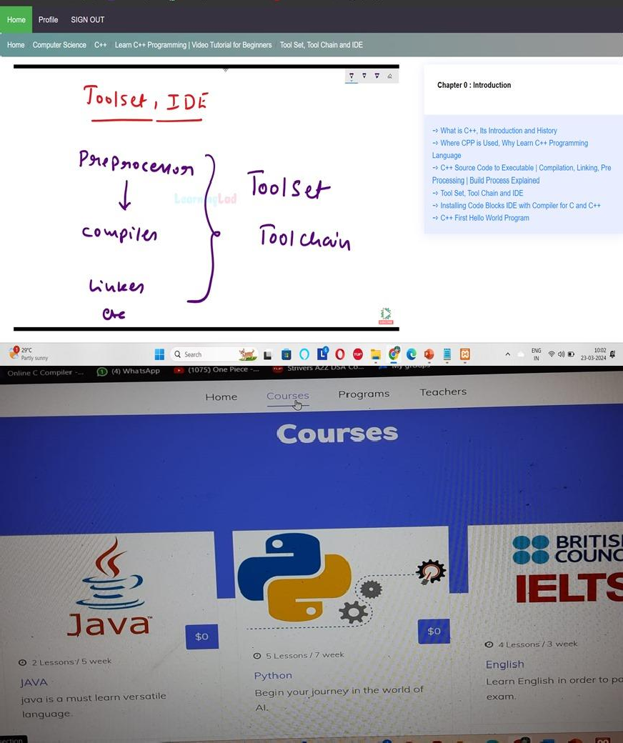

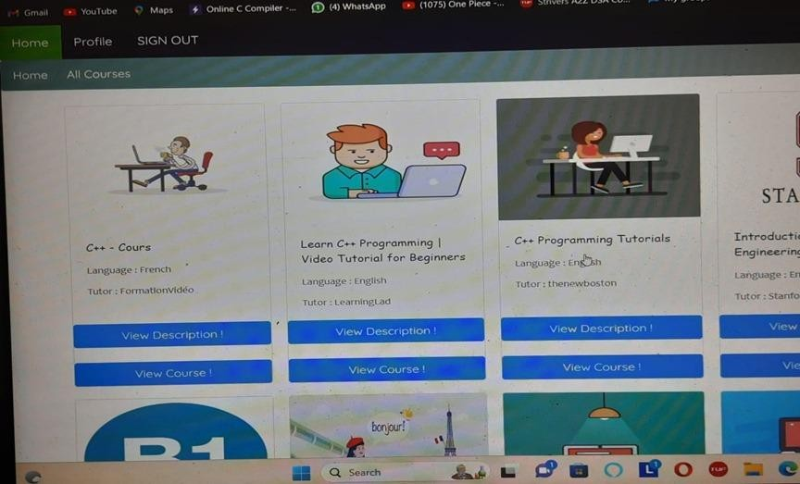

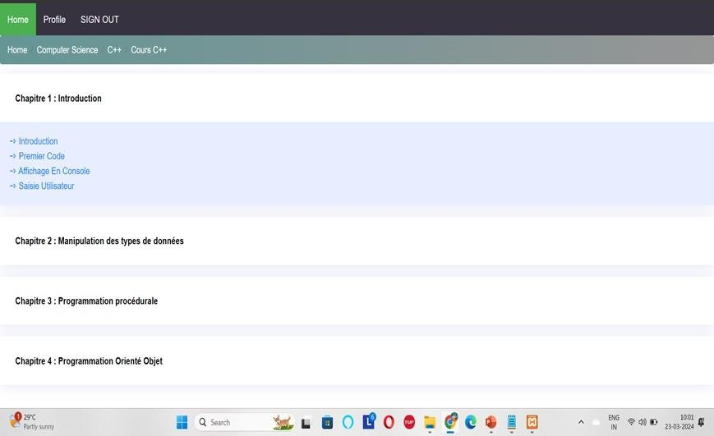

**C.RESEARCH PAPER**













12

9

## D. CERTIFICATES



**D.CERTIFICATES**

