**Homework – 3**

**RESULTS**

Rashik Reddy Gurrala – 1002031534

Saketh Bandaru – 1002026743

Natraj Hullikunte – 1001912794

Venkata Sainath Reddy Palvala – 1001949223

Training image:

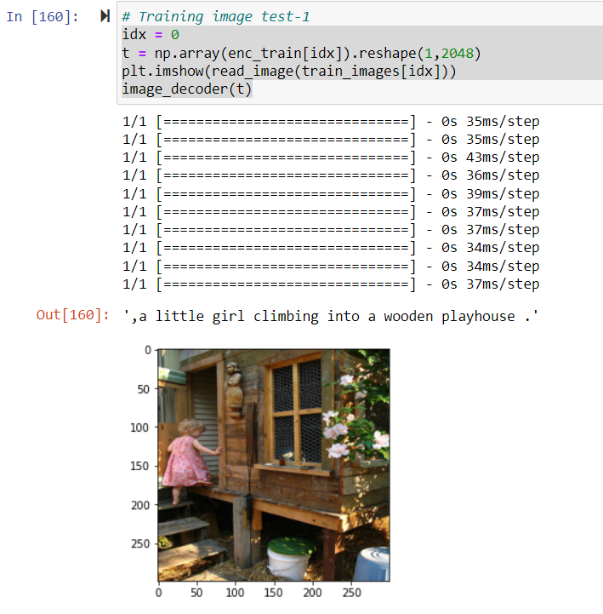

Testing Image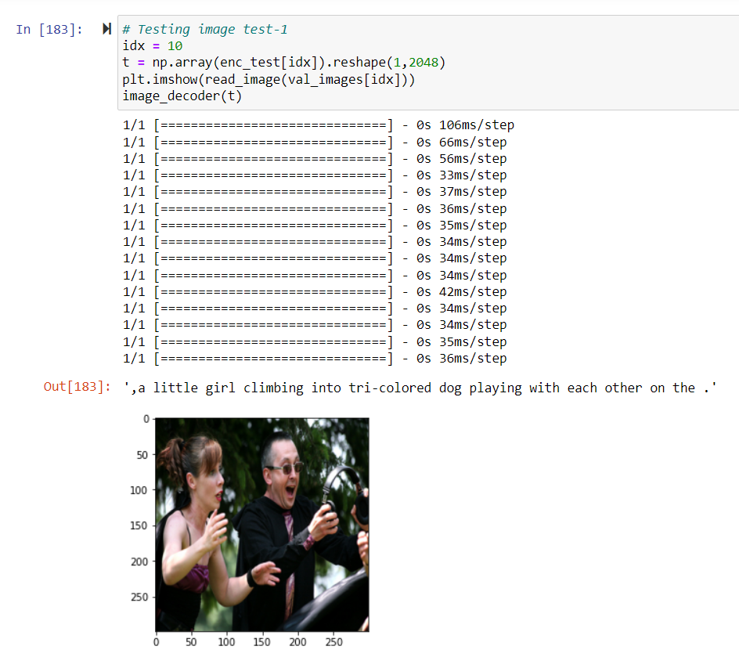

Beam Search

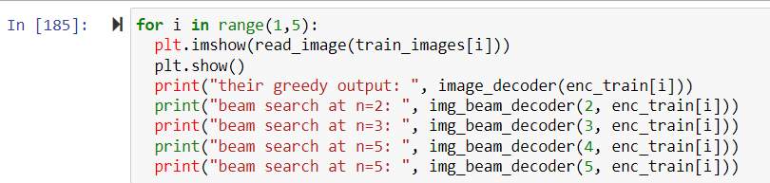

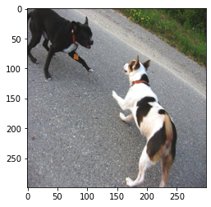

their greedy output: a black dog and a tri-colored dog playing with each other on the road.

beam search at n=2: ,a black dog and a tri-colored dog playing with each other on the road . <END> <END> <END> <END> <END> <END> <END> <END> <END> <END> <END> <END> fighting <END> <END> a <END> <END> <END> <END> <END>

beam search at n=3: ,a black dog and a tri-colored dog playing with each other on the road . <END> <END> <END> <END> <END> <END> <END> <END> <END> <END> <END> <END> fighting <END> <END> a <END> <END> <END> <END> <END>

beam search at n=5: ,a black dog and a white dog with brown spots are staring at each other in the street . <END> <END> <END> <END> <END> <END> <END> <END> <END> fighting <END> <END> <END> <END> <END> <END> <END> <END> <END> <END>

beam search at n=5: ,a black dog and a white dog with brown spots are staring at each other in the street . <END> <END> <END> <END> <END> <END> <END> <END> <END> fighting <END> <END> <END> <END> <END> <END> <END> <END> <END> <END>

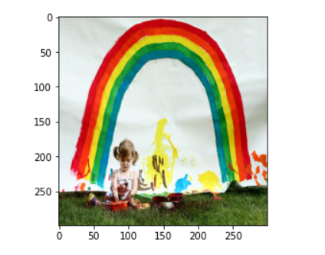

their greedy output: ,a little girl climbing into tri-colored dog into with each other on the .

beam search at n=2: ,a little girl climbing into spotted with with brown spots are staring at each other in the . <END> <END> <END> <END> <END> <END> <END> <END> <END> <END> <END> <END> <END> <END> <END> <END> <END> <END> <END> <END> <END>

beam search at n=3: ,a little girl climbing into tri-colored dog into with each other on the . <END> <END> <END> <END> <END> <END> <END> <END> <END> <END> <END> a <END> <END> <END> <END> <END> <END> <END> <END> <END> <END> <END> <END> <END>

beam search at n=5: ,a little girl climbing into tri-colored dog into with each other on the . <END> <END> <END> <END> <END> <END> the <END> <END> <END> <END> <END> <END> <END> <END> <END> <END> <END> <END> <END> <END> <END> <END> <END> <END

beam search at n=5: ,a little girl climbing into tri-colored dog into with each other on the . <END> <END> <END> <END> <END> fighting <END> <END> <END> <END> <END> <END> <END> <END> <END> <END> <END> <END> <END> <END> <END> <END> <END> <END> <END>

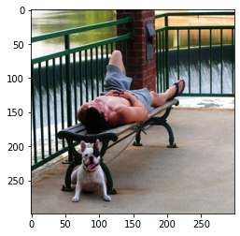

their greedy output: ,a little girl climbing into tri-colored dog playing with each other on the .

beam search at n=2: ,two dogs of different breeds looking at each other other on the . <END> <END> <END> <END> <END> <END> <END> <END> <END> <END>

beam search at n=3: ,two dogs of different breeds looking at each other other other the the . <END> <END> <END> <END> <END> <END> <END> <END> <END> a <END> a <END>

beam search at n=5: ,two dogs of different breeds looking at each other other other the the . <END> <END> <END> <END> <END> the <END> the <END> <END> <END> <END> <END>

beam search at n=5: ,two dogs of different breeds looking at each other other other the the . <END> <END> <END> <END> <END> the <END> the <END> <END> <END> <END>

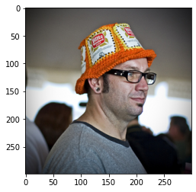

their greedy output: ,a little girl climbing into a wooden playhouse .

beam search at n=2: ,a child in a pink dress is climbing up a set of stairs in an entry way . <END> <END> <END> <END> <END> <END> <END> way <END> <END> <END> <END> <END> <END> <END> <END> dog <END> dog <END> <END>

beam search at n=3: ,a child in a pink dress is climbing up a set of stairs in an entry way . <END> <END> <END> <END> <END> <END> <END> way <END> <END> <END> <END> <END> <END> <END> <END> dog <END> dog <END> <END>

beam search at n=5: ,a child in a pink dress is climbing up a set of stairs in an entry way . <END> <END> <END> <END> <END> <END> way <END> <END> <END> <END> <END> <END> <END> <END> <END> dog <END> <END> dog <END>

beam search at n=5: ,a child in a pink dress is climbing up a set of stairs in an entry way . <END> <END> <END> <END> <END> <END> <END> way <END> <END> <END> <END> <END> <END> <END> <END> dog <END> dog <END> <END>