GUI – JP Boomerung Complex, Noida

Step 1 – Connect the Ipad ( touch controller) in same wifi range.
Wifi name – TP-Link_AE2E
Password – 93880886

Step 2 – Open browser, e.g. Safari in Ipad ( touch controller) , type the ip address http://10.254.192.59/Interface/.

Step 3 - After that , Welcome page is come, than press “Tap to Begin”.
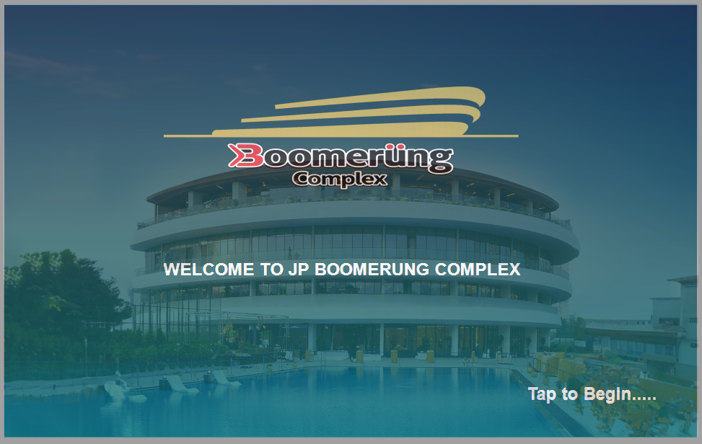

Step 4 - After that , Loading page is come, than wait for around 1 minute.
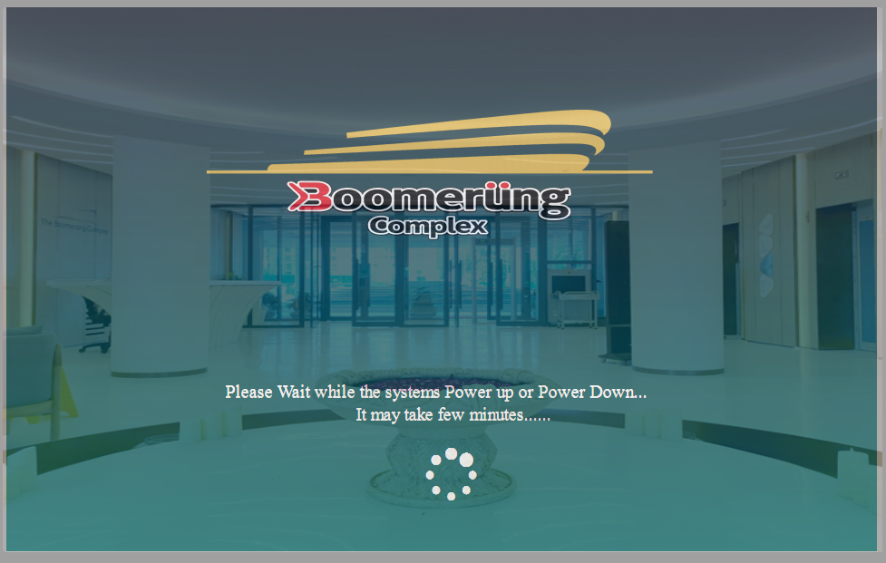

Step 5 - After that , Mainpage is come, here the features / navigation that we can perform.
- Zoom – During zoom meeting / video conferencing mode the task we can do like camera selection, multi-view mode selection (PIP, POP etc.), display selection for zoom and content.

- Multiview – Here we can select the multi-view mode selection that go to far end, like PIP, POP, Quad, single camera view.

- Presentation – Here we can perform the action that show locally not the far end.

- Camera control – In this we can control the camera like angle, preset etc.

- HDMI Switcher – Here we can switch the displays like in which display we want to show the camera, content or zoom pc view.

- Home - After click the Home button it navigate to the Mainpage.

- Help - After click the Help button it navigate to the help page for any support contact to the Business Octane Technical support team.

- Shutdown – It can shutdown the program.

- Back - After click the Back button it navigate to the pevious page.

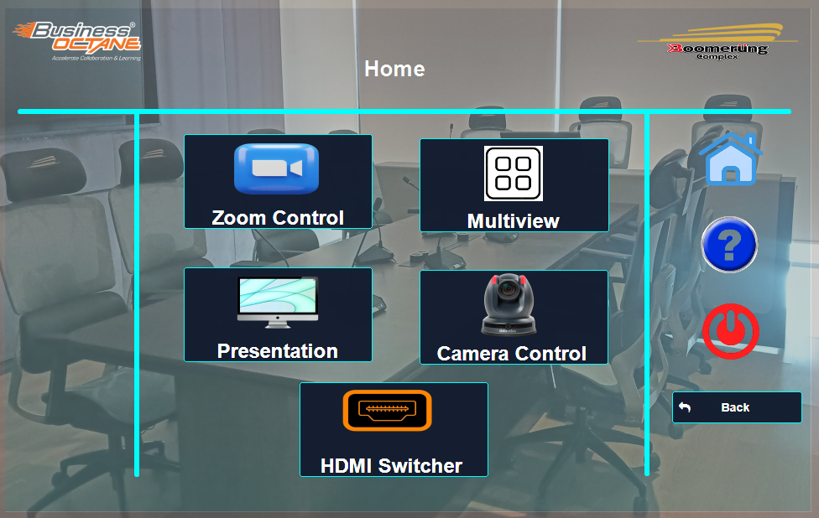

Step 6 - In VC Mode page navigation, In this we can select the window layout for VC mode like PIP (Picture-In-Picture) mode, POP (Picture-Out-Picture) mode, QUAD mode means four cameras are shows of same window layout, Full view mode means only camera with full view room goes to far end side or individual camera like Left , Right , Front camera view.
Also for Display we can select the desired input zoom pc / content pc. Zoom all / content all will display view on all display.

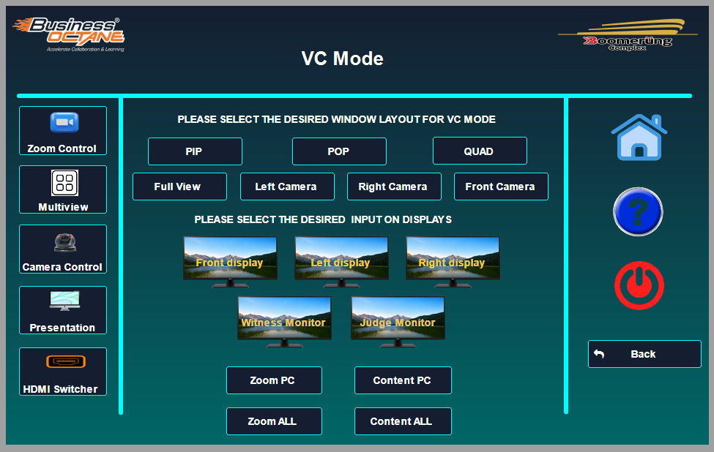

Step 7 - In Multi-view page navigation, In this we can select the window layout for VC mode like PIP (Picture-In-Picture) mode, POP (Picture-Out-Picture) mode, QUAD mode means four cameras are shows of same window layout, Full view mode means only camera with full view room goes to far end side or individual camera like Left , Right , Front camera view.

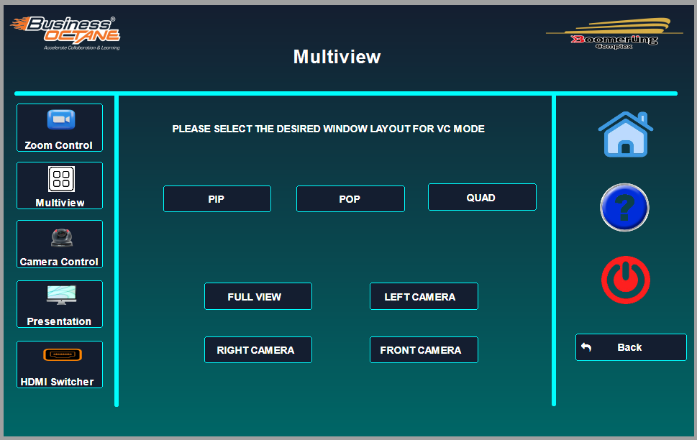

Step 8 - In Camera control mode, we can control the each camera like Left , Right , Front camera and Full view camera. We can perform camera movement, zoom in /out, create preset etc.

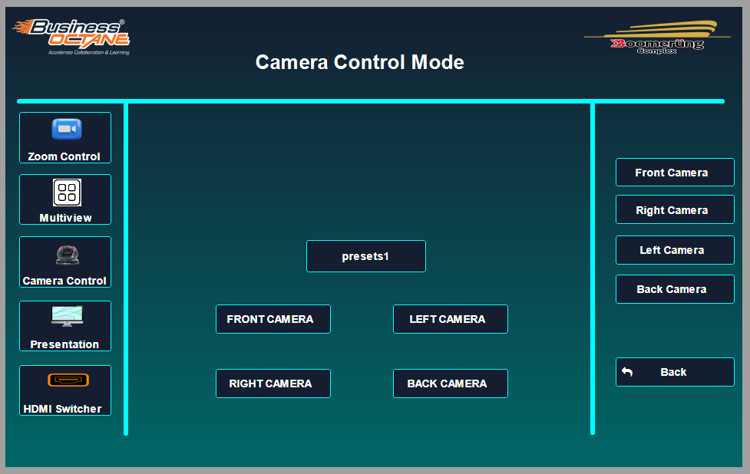

Step 8 - In Camera control mode, we can control the each camera like Left , Right , Front camera and Full view camera. We can perform camera movement, zoom in /out, create preset etc.
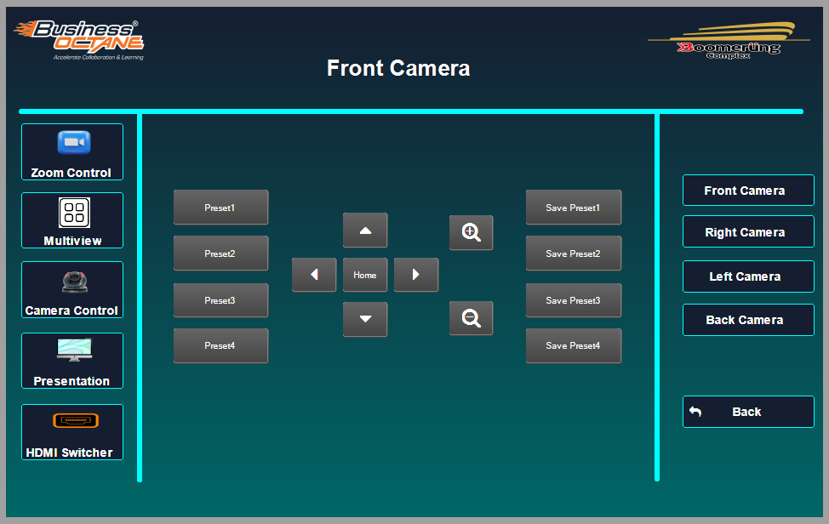

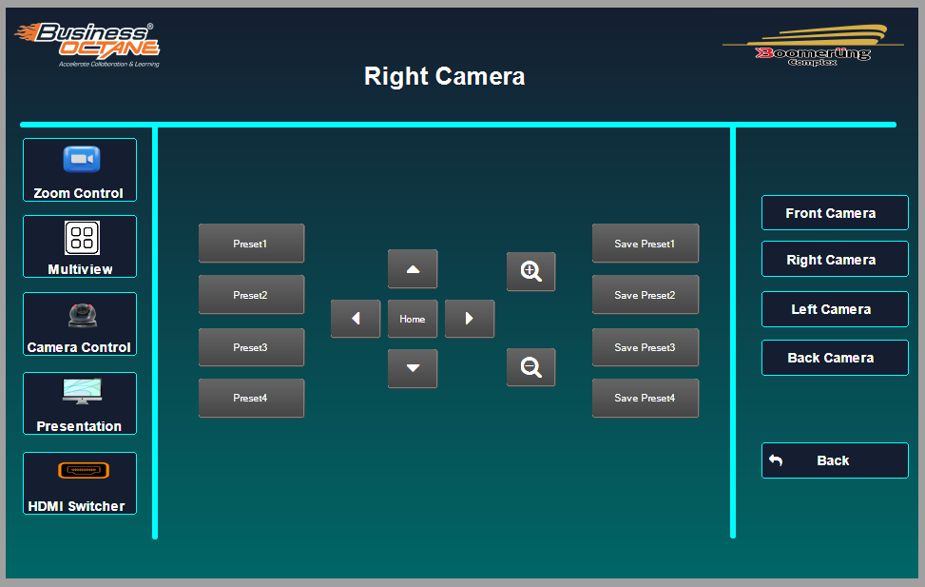

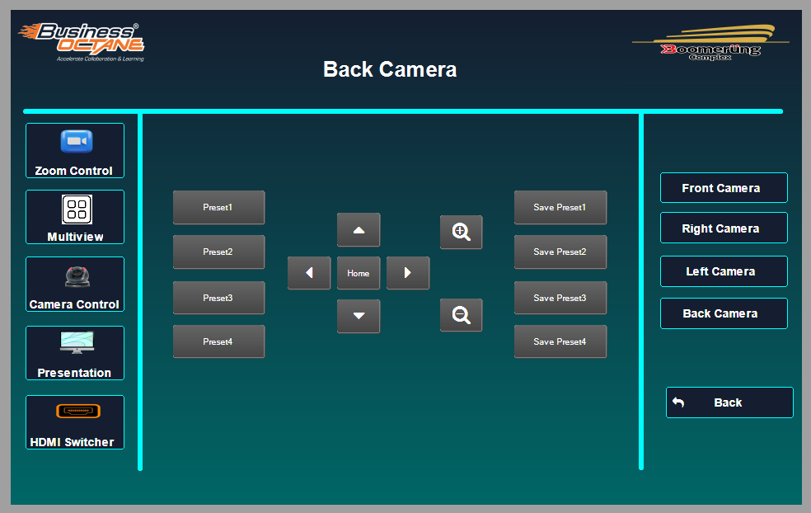

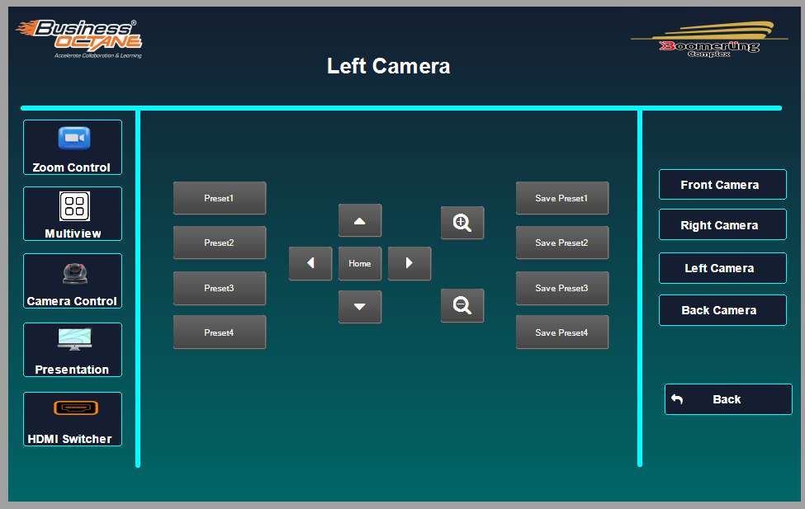
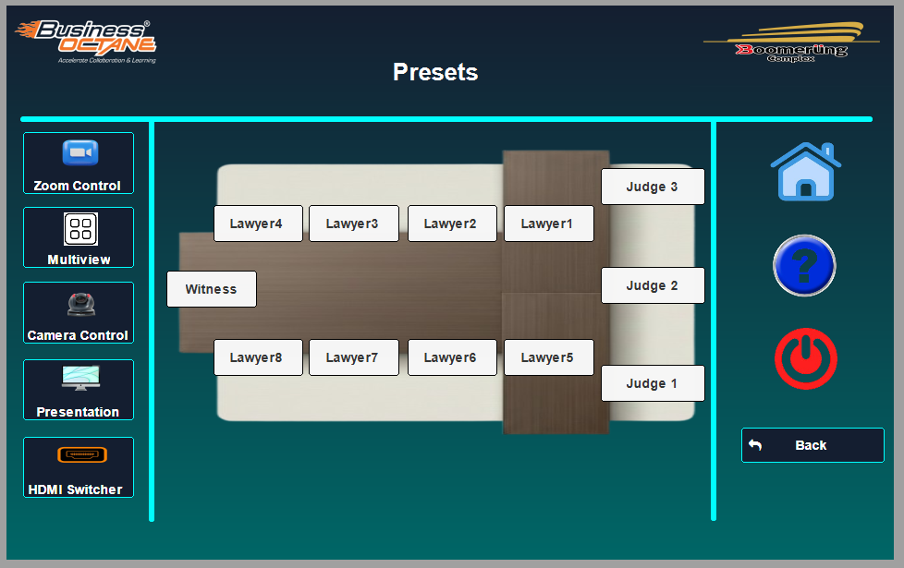

This is the overall arrangement like court room were each camera preset are save.

Step 9 - In Help navigation, for any technical support or query contact on below details.

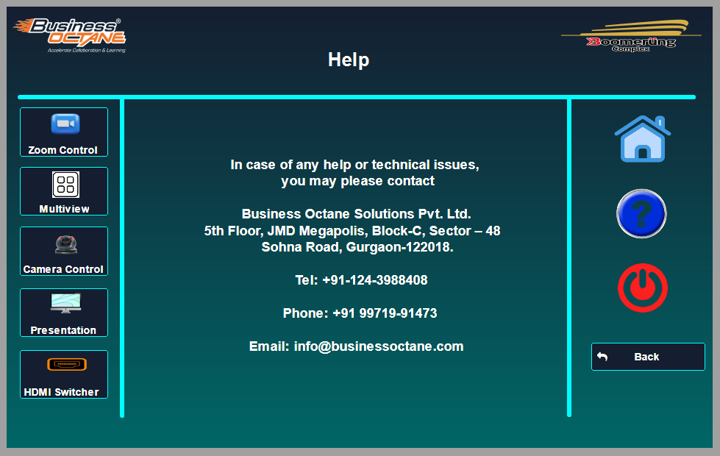

Step 10 - In Shutdown mode, we can Shutdown the all system.

