Chhaya
IoT Device Identification via Network Traffic Fingerprinting
Project Report
A privacy-preserving prototype for identifying IoT devices, detecting rogue traffic, and detecting behavioural spoofing.
RAIoT Lab Innovation Project
Version 2.0

Executive Summary
Chhaya is an IoT security prototype that identifies devices from their network behaviour rather than from packet content or easily spoofed identifiers. It observes only packet metadata: timestamp, packet size, source address, rate, and burst pattern. From a rolling traffic window, it derives four behavioural features and uses a Random Forest classifier to identify three reference device profiles: SensorNode, CameraStream, and SmartSwitch.
The system also provides two security controls. Rogue detection flags traffic that is inconsistent with every known profile. Spoofing detection compares a known device's current feature vector with its own learned rolling baseline and raises a critical alert when the behavioural drift is statistically significant. The project presents the results through a live Flask and SocketIO dashboard, including device state, feature values, packet-rate traces, and reviewable alerts.
The current implementation supports an in-process simulator, direct UDP input from ESP8266 or ESP32 boards, optional Scapy capture on a monitored interface, and a combined software mode in which a real phone can send UDP packets while the simulated devices continue to run. This makes the system suitable for a reproducible lab demonstration and provides a clear path to deployment at a network gateway or switch mirror port.

1 Project Overview
The project name Chhaya means shadow. The central idea is that encryption protects message content but does not remove observable traffic behaviour. Devices still differ in the size of packets they send, the timing between packets, the rate at which they communicate, and the extent to which their traffic occurs in bursts. Chhaya uses those characteristics as a device fingerprint without opening or storing application payloads.

1.1 Problem Statement
IoT environments contain many low-cost and minimally managed devices. Conventional identification often depends on IP or MAC address registries, but those identifiers can be changed or imitated. At the same time, encryption limits content inspection. The problem addressed by Chhaya is how to identify and monitor device behaviour using metadata that remains available at an appropriate network observation point.

1.2 Objectives
- Identify known IoT traffic profiles from packet size and timing features without reading payload content.
- Display live device state, extracted features, and traffic rate on a browser-based dashboard.
- Detect unknown or anomalous traffic and generate a rogue-device alert.
- Detect behavioural drift from a known device baseline and generate a spoofing alert.
- Support a low-cost hardware demonstration and a hardware-free software demonstration.

2 System Architecture
Chhaya follows a modular pipeline. Each capture source produces the same metadata-only packet record. The pipeline groups records by source IP, maintains a rolling window, extracts features, classifies the traffic, applies anomaly detection, persists events locally, and publishes updates to the dashboard.
Layer | Implemented Component | Responsibility
Traffic generation | ESP8266/ESP32 firmware or Python simulator | Produces repeatable sensor, camera, switch, rogue, and spoofing patterns.
Capture | InProcessSource, UdpSource, CombinedSource, LiveCaptureSource | Normalises simulated, direct UDP, combined phone, and optional Scapy capture into one packet representation.
Feature extraction | src/features.py | Computes average packet size, inter-packet interval, packets per minute, and burstiness for each source.
Classification | src/classifier.py | Runs the trained Random Forest and returns a device label and confidence.
Detection | src/detector.py | Performs rogue distance checks and rolling-baseline spoofing analysis.
Presentation | Flask, Flask-SocketIO, Chart.js | Streams device state, packet-rate history, and alerts to the dashboard.

3 Operating Modes
Mode | Command | Use Case
Software simulation | python scripts/run_demo.py | Runs three virtual device profiles and supports dashboard attack controls without hardware.
Software plus phone | python scripts/run_demo.py --phone | Runs the simulator and receives real UDP packets from a phone or other device on port 9999.
Direct UDP hardware | python scripts/run_demo.py --mode udp | Receives packets sent to the laptop by ESP8266/ESP32 boards; no Npcap is required.
Passive live capture | python scripts/run_demo.py --mode live --interface Wi-Fi | Uses Scapy on a monitored interface; Npcap is required on Windows.

In combined phone mode, the phone and laptop must be on the same local network. A UDP sender app sends datagrams to the laptop's Wi-Fi IPv4 address on port 9999. The phone appears as an additional source after sufficient traffic is observed. A new phone is normally reported as unknown or rogue unless its packet size and timing happen to resemble one of the trained profiles.

4 Traffic Fingerprinting Method

4.1 Metadata Collection
Chhaya records only the source IP, destination IP, packet size, timestamp, and protocol label. It intentionally does not parse or display the UDP payload. This is an implementation-level privacy constraint: feature extraction operates on timestamps and sizes rather than message contents.

4.2 Rolling Feature Window
Packets are grouped by source address in a rolling 12-second window. The pipeline processes available device windows at a 2.5-second classification interval. This permits the dashboard to update continuously while retaining enough observations to distinguish a stable sensor from a bursty camera or an event-driven switch.
Feature | Meaning | Example Interpretation
Average packet size | Mean datagram size in the window | Small periodic sensor messages versus large camera frames.
Inter-packet interval | Average time gap between consecutive packets | A sensor may report every few seconds; camera traffic uses short gaps within bursts.
Packets per minute | Rate normalised from the current window | Separates low-rate periodic traffic from sustained streams.
Burstiness | Variation in packet timing | Distinguishes steady traffic from irregular or clustered communication.

5 Machine Learning and Security Detection

5.1 Classification
The project trains a Random Forest model on synthetic examples generated from the three reference profiles. The classifier outputs a label and a confidence score. Predictions below the configured confidence threshold are treated as uncertain rather than being accepted as a definite identity.
Reference Profile | Typical Pattern | Purpose in the Demonstration
SensorNode | Approximately 72-byte packets at about five-second intervals | Represents steady environmental telemetry.
CameraStream | Approximately 1200-byte packets in rapid bursts | Represents high-rate streaming traffic.
SmartSwitch | Small, irregular packets | Represents event-driven control traffic.

5.2 Rogue Detection
Rogue detection combines classifier uncertainty with a scale-aware distance from the known class prototypes. If a feature vector is far from every known profile, the system raises an amber alert with the source IP and timestamp. This prevents an unrecognised device from being silently forced into the nearest known label.

5.3 Spoofing Detection
Spoofing detection is a separate stage from classification. For an established known device, the system retains a rolling baseline of feature values. New traffic is compared with that baseline using z-score logic. A sustained threshold breach produces a red alert. The suspicious traffic does not update the trusted baseline that it is being compared against, which prevents an attack from gradually redefining normal behaviour.

6 Dashboard and Demonstration Evidence
The dashboard is the operator-facing view of the pipeline. It shows identified devices and their current state, the four computed features, a packet-rate graph, a security-alert feed, and controls for the software demonstration. The dashboard is served locally on port 5000 and receives live updates through SocketIO.
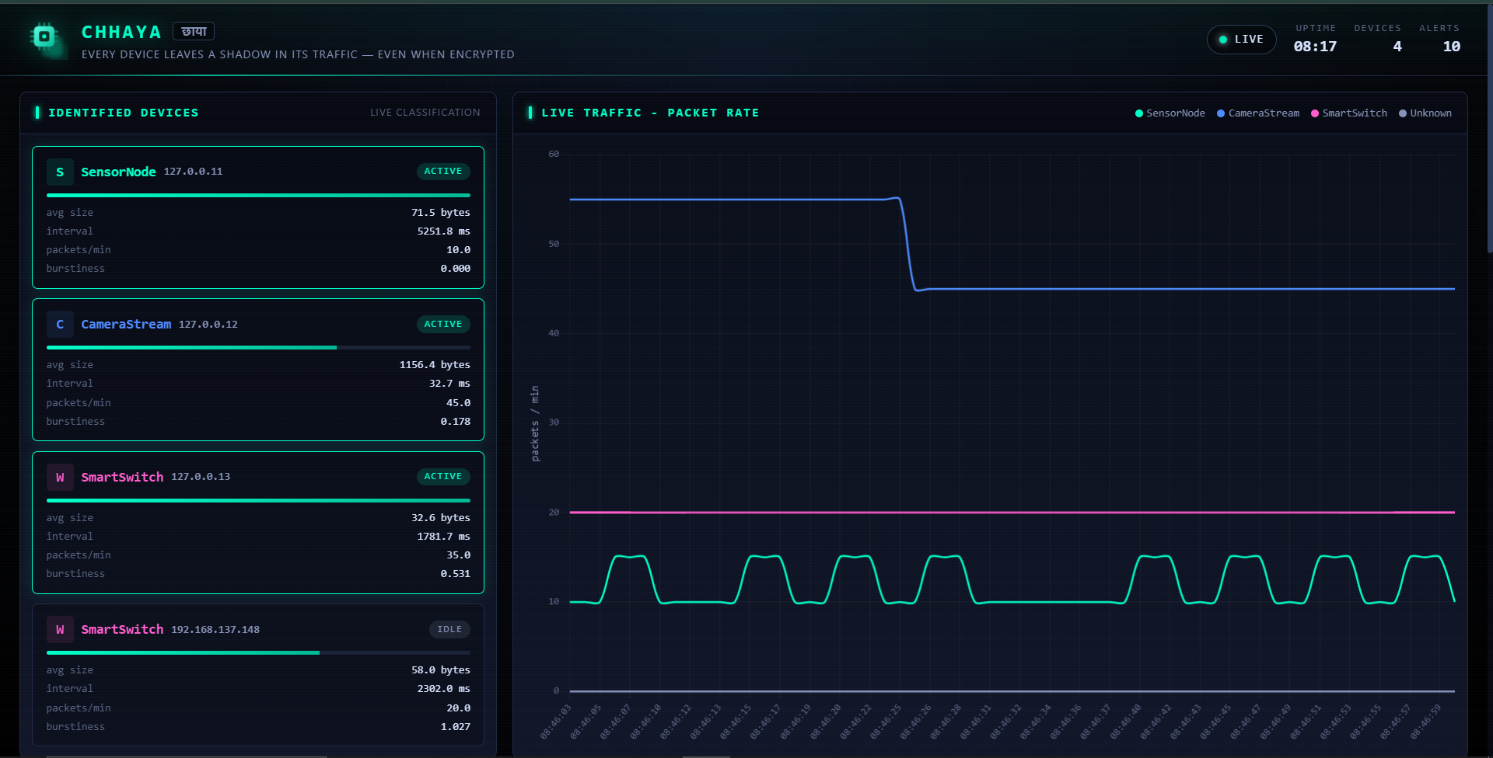
Figure 1. Live Chhaya dashboard showing simulated profiles and a real network source.
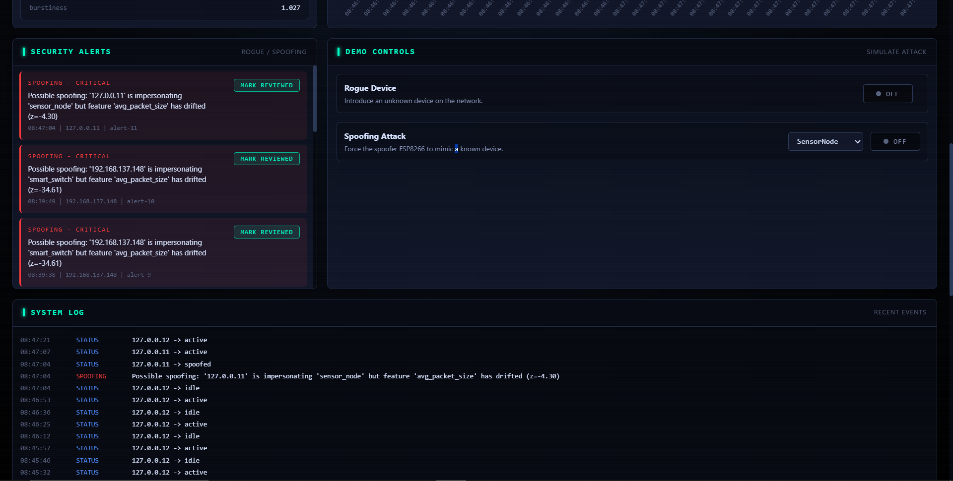
Figure 2. Security-alert feed and controls for rogue and spoofing scenarios.
The software demonstration is repeatable because the simulator supplies known traffic profiles. The phone mode supplements this with a real network source. The hardware demonstration uses an ESP8266 or ESP32 board as a controlled traffic generator; it is not a required component of the analytical system itself.

7 Testing and Validation
The repository includes automated tests for feature extraction, classifier behaviour, rogue detection, spoofing detection, simulator traffic, and dashboard endpoints. A smoke-test script exercises the end-to-end simulated workflow. The combined source was additionally checked by sending a UDP datagram through the listener while retaining the in-process simulator interface.
Validation Area | Evidence in the Project | Expected Result
Feature extraction | tests and src/features.py | Four metadata-derived features are generated for each source window.
Classifier | tests/test_classifier.py | Known profiles yield labels and confidence; low confidence can be marked uncertain.
Rogue detection | tests and dashboard controls | Unrecognised profile produces an amber alert.
Spoofing detection | tests, simulator, detector baseline | Sustained drift from an established profile produces a red alert.
Phone integration | CombinedSource and --phone option | Real UDP sender can appear alongside software-simulated devices.

8 Deployment, Privacy, and Limitations

8.1 Deployment Path
For a home or small office, Chhaya can run on a Raspberry Pi-class device on or behind the router. For a managed enterprise network, the capture component can operate from a switch SPAN or mirror port. In both cases, the intended observation point is where device traffic already passes; endpoint agents are not required.

8.2 Privacy and Security Boundary
Chhaya is designed to inspect metadata, not payload content. HTTPS, VPN, and application data remain outside the system's analysis. This does not eliminate all privacy considerations because traffic metadata can itself be sensitive; deployment should therefore follow local network policy and use only authorised observation points.

8.3 Current Limitations
- The trained classes represent three controlled traffic profiles; real commercial devices require labelled data collection and retraining.
- A device behind network address translation may not be individually distinguishable from the observation point if multiple devices share one visible source address.
- The prototype is intended for local demonstration and research, not as a complete enterprise intrusion-detection product.
- An attacker that precisely reproduces all behavioural statistics over time may reduce detection reliability; the system raises the cost of impersonation but does not guarantee perfect attribution.

9 Hardware, Software, and Cost
Item | Role | Required for Basic Demo
Laptop or PC | Runs the Python pipeline and dashboard | Yes
Python 3, Flask, Flask-SocketIO, scikit-learn | Application and ML runtime | Yes
ESP8266 or ESP32 board | Optional controlled Wi-Fi traffic generator | No; useful for hardware demonstration
Phone with UDP sender app | Optional real traffic source for combined mode | No; useful for combined demonstration
Npcap and Scapy | Optional passive live-capture mode on Windows | No; direct UDP mode does not require them

The lowest-cost demonstration runs entirely on a laptop in software mode. A single ESP8266/ESP32 board and a USB cable are sufficient for the recommended hardware demonstration. Hardware costs vary by board, cable, and local market price; all core software dependencies are open-source.

10 Conclusion
Chhaya demonstrates a practical approach to IoT device identification and monitoring based on behavioural traffic fingerprints. The system separates content privacy from behavioural visibility: it does not read messages, but it can still identify characteristic communication patterns and flag unusual or drifting behaviour. With software simulation, direct UDP hardware support, optional passive capture, a combined phone mode, and a live dashboard, the project provides a complete and reproducible security demonstration with a realistic deployment direction.

