Research Report on Common Network Security Threats

Internship Domain:
Security Analyst

Organization:
Oasis Infobyte

Task:
Task 4 – Research Report

Submitted by:
Cheedella Sai Nikhil

1. Introduction
Computer networks play a vital role in modern communication systems by enabling data exchange, online services, and digital transactions. With the increasing reliance on internet-based technologies, networks have become highly vulnerable to cyber threats. Attackers exploit weaknesses in network infrastructure, protocols, and user practices to gain unauthorized access, disrupt services, or steal sensitive data.
Network security threats primarily target the three fundamental principles of information security: confidentiality, integrity, and availability. Understanding these threats is essential for building secure and reliable network systems.
This report presents a detailed study of three widely occurring network security threats:
- Denial of Service (DoS) attacks
- Man-in-the-Middle (MITM) attacks
- Spoofing attacks
Each threat is analysed based on its working mechanism, consequences, real-world occurrences, and preventive measures.

2. Denial of Service (DoS) Attacks
2.1 Overview
A Denial of Service (DoS) attack is an intentional attempt to interrupt the normal functioning of a network service by flooding it with excessive or malicious traffic. The goal of the attacker is to exhaust system resources so that legitimate users are unable to access the service.
When such an attack is executed using multiple compromised systems simultaneously, it is referred to as a Distributed Denial of Service (DDoS) attack.

2.2 Working Principle of DoS Attacks
DoS attacks take advantage of the limited processing power and bandwidth of servers and networks.
Attack flow:
- The attacker generates a high volume of illegitimate requests.
- These requests are sent continuously to the target system.
- The target’s resources become overloaded.
- Genuine user requests are delayed or rejected.
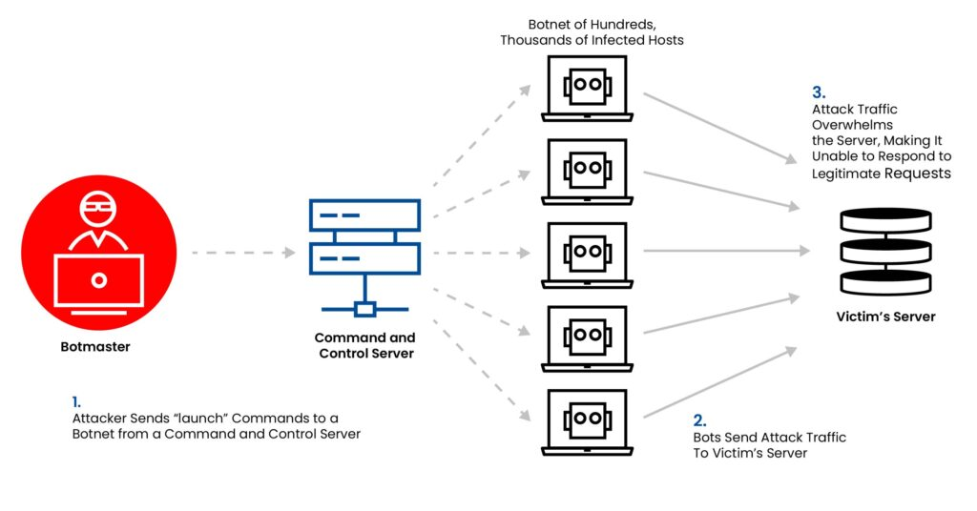

2.3 Common DoS Attack Techniques
- SYN Flood Attack – Exploits the TCP connection setup process.
- UDP Flood Attack – Overwhelms the target using UDP packets.
- ICMP Flood Attack – Uses excessive ping requests.
- HTTP Flood Attack – Targets web applications with massive HTTP requests.

2.4 Effects of DoS Attacks
- Unavailability of websites and online services
- Business and revenue losses
- Increased operational and recovery costs
- Damage to brand image and customer trust
- Disruption of critical infrastructure services

2.5 Real-World Incident
In 2016, a large-scale DDoS attack targeted a major DNS service provider, causing outages for several well-known websites. The attack was carried out using compromised Internet of Things (IoT) devices, highlighting the risks associated with unsecured smart devices.

2.6 Prevention and Control Measures
- Deployment of firewalls and intrusion prevention systems
- Use of cloud-based DDoS mitigation services
- Traffic filtering and rate-limiting mechanisms
- Load balancing techniques
- Continuous monitoring of network traffic
- Regular system and firmware updates

3. Man-in-the-Middle (MITM) Attacks
3.1 Overview
A Man-in-the-Middle (MITM) attack occurs when an attacker secretly intercepts communication between two parties. Both parties assume they are communicating directly, while the attacker monitors or modifies the transmitted data.
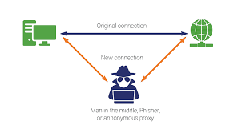

3.2 How MITM Attacks Operate
- The attacker positions themselves between the sender and receiver.
- Network traffic is intercepted without the knowledge of the users.
- Sensitive information such as credentials or session tokens is captured.
- The attacker may alter the data before forwarding it.

3.3 Common MITM Methods
- ARP poisoning
- DNS manipulation
- Fake or malicious Wi-Fi access points
- SSL stripping
- Session hijacking

3.4 Consequences of MITM Attacks
- Theft of usernames and passwords
- Exposure of confidential data
- Financial fraud and identity theft
- Manipulation of transmitted information
- Unauthorized system access

3.5 Practical Example
Public Wi-Fi networks are frequent targets for MITM attacks. Attackers often create fake wireless networks in public places. Unsuspecting users connect to these networks, allowing attackers to intercept sensitive information.

3.6 Mitigation Techniques
- Use of encrypted communication protocols (HTTPS, TLS)
- Avoidance of unsecured public Wi-Fi networks
- Use of Virtual Private Networks (VPNs)
- Strong authentication mechanisms
- Implementation of HSTS policies
- Network traffic analysis and monitoring

4. Spoofing Attacks
4.1 Overview
Spoofing is a technique in which an attacker impersonates a legitimate entity by falsifying identity information. This allows attackers to deceive systems and users into trusting malicious traffic.

4.2 Types of Spoofing Attacks
- IP address spoofing
- ARP spoofing
- DNS spoofing
- Email spoofing

4.3 Mechanism of Spoofing Attacks
- Attackers modify packet headers or identity fields.
- The target system assumes the traffic is from a trusted source.
- Security controls are bypassed.
- Further attacks such as MITM or phishing may follow.
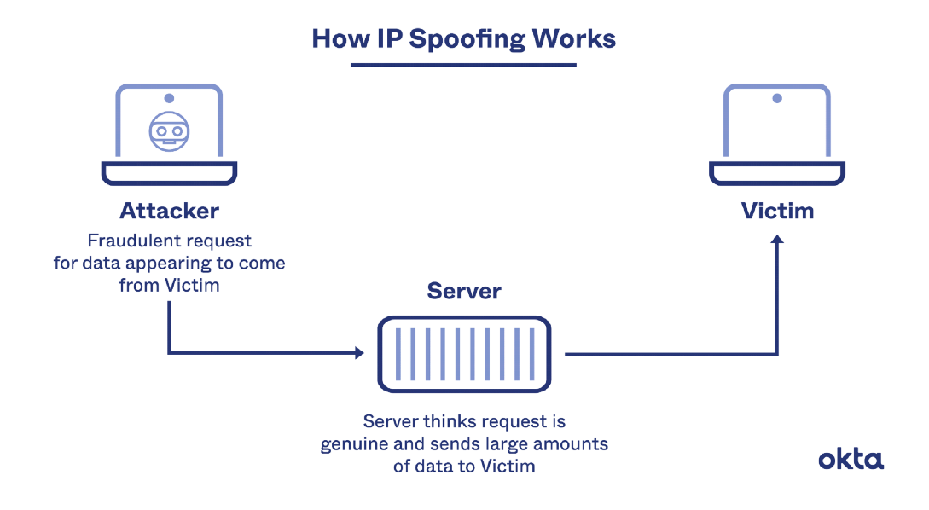

4.4 Impact of Spoofing
- Unauthorized access to networks
- Data leakage and manipulation
- Spread of malicious software
- Phishing and social engineering attacks
- Network performance degradation

4.5 Real-World Scenario
Email spoofing is commonly used in phishing attacks where cybercriminals impersonate banks or organizations to trick users into revealing confidential details such as passwords and one-time passwords (OTPs).

4.6 Prevention and Mitigation
- Implement packet filtering and ingress filtering
- Use DNSSEC for DNS protection
- Enable email security protocols (SPF, DKIM, DMARC)
- Apply strong authentication controls
- Conduct regular network audits

5. Comparative Analysis of Threats
Threat Type | Main Goal | Common Method | Impact Level
DoS | Service disruption | Traffic flooding | High
MITM | Data interception | Packet interception | High
Spoofing | Identity impersonation | Header manipulation
  Medium–High

6. Importance of Network Security
Effective network security helps in:
- Protecting sensitive information
- Ensuring availability of services
- Preventing financial losses
- Maintaining user confidence
- Complying with cybersecurity standards
A layered security approach, also known as defense in depth, is essential to counter modern cyber threats.

7. Conclusion
Network security threats such as DoS, MITM, and Spoofing attacks continue to pose serious challenges to individuals and organizations. A clear understanding of these threats and their behavior is crucial for implementing effective security measures. By adopting encryption, authentication, monitoring, and proactive defense strategies, organizations can significantly reduce the risk of network-based attacks. Continuous awareness and security improvement are necessary in an evolving cyber threat landscape.
“This report was prepared as part of a self-learning research activity during the Security Analyst internship.”

8. References
1. OWASP – Network Security Attacks
https://owasp.org/www-community/attacks/
2. NIST Cybersecurity Framework
https://www.nist.gov/cyberframework
https://csrc.nist.gov/publications
3. https://www.cloudflare.com/learning/ddos/what-is-a-ddos-attack/
4. https://www.cloudflare.com/learning/security/threats/man-in-the-middle-attack/
5.IBM Security – Cybersecurity Topics
https://www.ibm.com/think/topics/cybersecurity

