**TechThinkers**

**IntelliAgro**

**Team Leader :** Sai Shrujan Kasha, Sri Indu College of Engineering

**Team members : 1.** Sai Nithin Kadarla, OUCE

**2.** Surarchitha Challagali, NMREC

**Abstract**

**We are presently focused on three parameters:**

1. While using the Drip Irrigation Pipes in an open environment like farmlands and exposure to different climatic conditions, the drip pipes may lose their build quality eventually after a certain usage. This may cause drip pipes to slit/tear, which will cause water leakages at unnecessary areas. And in other cases, any dust particles in the water may cause blockage in the Drip pipe Holes, this will cause drip pipe to bulge and explode or cause uneven watering. [Watering is done based on Moisture levels or Timings].
2. To interface sensors data to internet so that they can analyze the feedback of sensors over internet through the microcontroller with Wi-Fi capability. To reduce the cost of establishing internet connection for every farmland, we establish only one internet connection in an area. And in an area with multiple farmlands, each farmland with a microcontroller is interconnected with each other using mesh N/W and interfaced to internet.
3. While working in the farmland there might me some harmful species like snakes, rats etc., To overcome this risk, we can use a microwave repellent to keep these species away.

**Key Features and Functionality:**

1. Drip Pipes Health monitoring
2. Auto Drip irrigation (based on Moisture levels or Timings)
3. Repellents

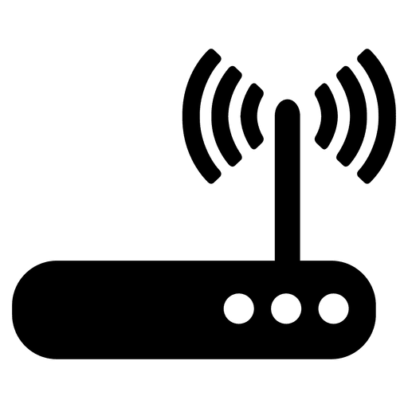**Block diagram**

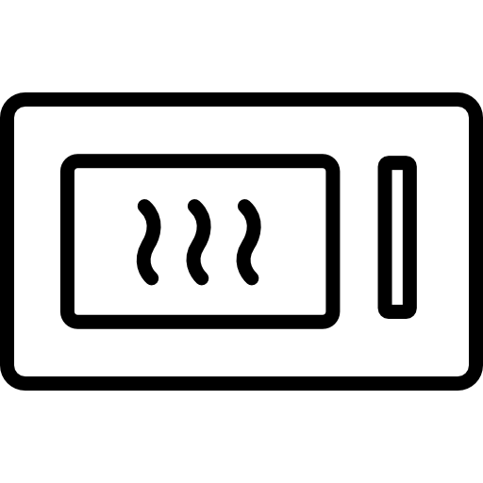

**Farm Field 1**

Moisture Sensor 2

Moisture Sensor 1

Thingspeak

Microcontroller [ESP32]

WaterFlow Sensor 2

WaterFlow Sensor 1

Snakes & Rat Repellent

Drip Irrigation Unit

**Farm Field 2**

Moisture Sensor 2

Moisture Sensor 1

Thingspeak

Microcontroller [ESP32]

WaterFlow Sensor 2

WaterFlow Sensor 1

Snakes & Rat Repellent

Drip Irrigation Unit

**Flow Chart**