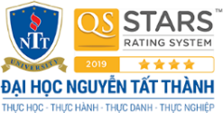

**NGUYEN TAT THANH UNIVERSITY**

**FACULTY OF FOREIGN LANGUAGES**



**INTERNSHIP REPORT**

**REPORT TITLE**

**Major: ENGLISH STUDIES**

**Minor: BUSINESS ENGLISH**

**Student: Tang Thi Minh Anh - 1911547891**

**Academic supervisor: MS. NGUYEN LE TUONG PHUONG**

**Ho Chi Minh City, December 2022**

Table of Contents

**List of charts/figures/tables/pictures**

**ACKNOWLEDGEMENT**

At the end of this 8-week internship period, although the internship period is not too long, the actual work has provided the final year students with many practical skills and useful knowledge. I have learned a lot from the work about the attitude and interest of the members in the company, the sharing, the enthusiasm is a great motivation for the team.

In addition, I would like to thank Ms. Tuong Phuong as my internship instructor who helped me with all her enthusiasm. I would like to thank Mr. Minh Chau for helping me get a good internship like in Titkul. And finally, I want to thank Ms. Ngan Thuyen and all employees of TitKul Joint Stock Company for helping, caring and guiding me very enthusiastically and timely during the internship period so that I can have a good perspective. Overview of the practical and professional working environment. To successfully complete this internship is a team effort. I would like to thank everyone as well as the school.

The time that I practice here for me is very precious and unforgettable. The management brothers and sisters of the company guided me, showed me the vision I need to equip in the present and my destination in the future. That is like a source of motivation. I am in the process of constantly improving myself, improving my weaknesses and developing my strengths.

This working environment has many obstacles and difficulties. Because this is the first time I have to face the real environment, the market is competitive in finding customers. That helped me realize how seriously studying during my university years has really helped me in my current job. And a very necessary and urgent thing is to create for

myself relationships to create potential sources of relationships that may be useful to your future work.

When I was studying at the university, there were many subjects that made it difficult for me to acquire knowledge, but when I did an internship at a company and interacted with real customers, it was more stressful than studying . This knowledge base and applicability is really hard to apply, but really the company has helped me a lot in improving my personal level. Finally, I would like to wish everybodys all good health and success

**CHAPTER 1: INTRODUCTION**

* 1. BACKGROUND OF THE REPORT

It is necessary to equip the knowledge in the learning process at school and face the challenges in the actual working process. At first, I thought that companies only prioritized recruiting people with advanced degrees and good experience, but when I was exposed to a practical working environment, that was not all. What the company needs today is sharing, enthusiasm, responsibility for work is the first requirement that the company where I practice. The success or failure of an organization depends on human factors, namely the personality, spirit, and capacity of the workforce of that organization. Even if an organization has modern facilities and many financial resources, it cannot exist without the sharing of a collective.

My 8-week internship at TitKul Corporation is described in detail in this report. Although eight weeks wasn't enough time for an internship, it was a valuable time to get a glimpse of what I could do in the future. I had the opportunity to demonstrate my ability to behave and complete the assigned tasks on time, contributing to the company's development.

1.2 AIMS OF THE REPORT

The main purpose of this report is to tell about my knowledge and internship experience during my 8 week internship at TitKul company. Through this report, readers can understand the professional operation of an organization and the strategy of a business. At the same time, understand more about the working process from the beginning to the end of an intern that has brought value to the company.

In terms of knowledge, I have collected and recorded professional knowledge. I was trained in communication skills, how to solve professional problems. Interview skills, job acceptance skills. The attitude must always be in the spirit of helping and actively learning from everyone in the department.

1.3 ORGANIZATION OF THE REPORT

There are 5 key chapters in this report. They will list details of the working process as well as the knowledge that I gained during the internship at Titkul.

* Chapter 1: INTRODUCTION
* Chapter 2: COMPANY PROFILE:
* Chapter 3: POSITION, RESPONSIBILITIES AND TASKS ASSIGNED
* Chapter 4: INTERNSHIP EXPERIENCE
* Chapter 5: CONCLUSION AND RECOMMENDATIONS

**CHAPTER 2: COMPANY PROFILE**

2.1 OVERVIEW OF THE COMPANY

**General information of Titkul:**

* Full name: **TITKUL JOINT STOCK COMPANY**
* Trading name: **TITKUL**
* Legal representative: Mr. NGUYỄN NGỌC PHƯƠNG
* Established date: 21/12/1991
* Head office: 35 Nguyen Thong, Vo Thi Sau Ward, District 3, Ho Chi Minh City
* Phone number: 0942.429.989
* Website: Titkul.com
* Email: [titkul2020@gmail.com](mailto:titkul2020@gmail.com)

**Vision:**

* Titkul Joint Stock Company aspires to become one of the top technology companies in Vietnam and the region by putting in the work, persistent creativity, and dedication necessary to offer positive and enduring values from technology to the community and society.

**Mission:**

* For customers: provide the most appropriate and optimal technology solutions to improve the operational efficiency of customers, bringing benefits for sustainable growth.
* For partners: commit to cooperate with quality solutions and suitable with trends and markets; Accompany to conquer the market in Vietnam and the region.
* For the community: committed to bringing sustainable development values through innovative and always-updated technological solutions.
* For company employees: TitKul will be an environment where employees can learn and share with their own work, hands and brains; where everyone will have the opportunity to freely develop their career.

**Core Values:**

* Reliability: demonstrated through the promise of employment, product quality, stable service, knowledgeable and professional staff.
* Dedication: in addition to the brain, each solution is a mindset, the collective thinking to make the most effective and most suitable for its customers.
* Accompanying: sharing understanding and accompanying development throughout with partners and customers, using technology as an effective lever for partners and customers to improve work and management efficiency.

**Team capacity:**

* Develop computer software solutions and provide solution gifstechnology related to computer software, computer networks and systems;
* Building IOT device management systems;
* Producing IoT products for businesses and for training;
* Building a Stem training system from equipment to training deployment;
* Consulting on business digitization, administrative and non-business agencies;
* Design circuit boards and build software for automation systems.

2.2 THE COMPANY’S ORGANIZATION:

**2.2.1. The company’s organizational chart:**

**2.2.2. Departments/Divisions and their functions**

TitKul Joint Stock Company's organizational structure is as follows:

*1.Board of Directors:*

* As chairman of the board of directors, Mr. *Nguyen Ngoc Phuong* represents the company's stockholders.
* As the business's official representative, Ms. *Nguyen Thi An* serves as CEO.
* CEO Mr. *Tran Anh Tuan* is responsible for leading and running the business.
* The company's financial and accounting reports are handled by Ms. *Hoang Thi Nhung*, chief of the accounting division.
* Mr*. Trinh Minh Tri* serves as both a business executive and a business director.
* The head of the sales department, Ms. Nguyen Thi Thai Binh, works in business.
* As the department's chief of marketing, Ms. Dang Thi Ngan Thuyen has the following responsibilities:
  + Receive the leadership's marketing plan, put it into action, and keep an eye on it.
  + Using the allotted budget, actively plan, organize, and assess the success of advertising and communication efforts.
  + Control the system for the company's marketing channels, including its website, email,...
  + Inform supervisors of any problems involving Titkul's marketing initiatives.
* Mr*. Nguyen Xuan Duong* has the following responsibilities as the implementation department's head:
  + Conduct testing of the system's features before deployment
  + Design the user manual for the system
  + Conduct training and show partners the system
  + Oversee a group of employees.
  + Report operational-related difficulties to superiors
* Ms. Lam Thuy Ngan holds a job that includes a specific marketing responsibility, such as running the business's fan page, website, email,...
* As Head of Department, Mr. Lam Van Sang will have the following responsibilities:
  + Leader of TK EDU. system
  + Supervising a software team
  + Managing a virtual private server system
  + Creating new features for the system
  + Manage system and backend
  + Report operational-related difficulties to superiors.
* Mr*. Le Duc Tuan* serves as department head and is responsible for backend, system, and HRS. Work specifics include:
  + System Leader for TK HRS
  + Management of the software team
  + Manage the VPS system, research technology for the system, develop new features for the system, manage the system's backend,
  + And report operational-related difficulties to superiors.
* Mr*. Nam Van Bang* the FrontEnd Web role of the Head of FE Department includes particular tasks like:
  + Technical support partners, such as corporations and schools...
  + Writing front-end web programming code
  + Report operational-related difficulties to superiors.
* Mr. Pham Duc Minh is a technician with the role of Kiosk (improvement, installation ...)
* Mr. Nguyen Anh Vu is a technician with the role of FrontEnd Web, specific jobs include:
  + Programming FrontEnd APP of TK EDU, TK HRS . system
  + Developing new features for the system
  + Report to superiors on operational related issues.
* Mr*. Pham Dinh Thien* is a technician with the role of FrontEnd App, specific jobs include:
  + Programming FrontEnd APP of TK EDU, TK HRS. system
  + Developing new features for the system
  + Report to superiors on operational related issues.

2.3 THE COMPANY’S BUSINESS ACTIVITIES

TitKul Joint Stock Company is a unit specializing in developing and providing management technology solutions for educational institutions, career agencies, businesses, etc. At TitKul they orient the development and packaging of solutions. company's law before implementing it in schools, or businesses. It can be the Smart School Management solution package - TK Smart Vision Edu, or the intelligent Human Resource Management solution package - TK HRS. Besides, they are also very willing to learn, develop and build functional systems and modules suitable for each specific requirement of each partner and customer.

Join a large potential market TK Smart Vision Edu solution is a combination of hardware called attendance kiosk and management software system.

* Attendance with facial recognition technology even when wearing a mask.
* Measure body temperature by sensor camera in just 2 seconds.
* Automatic hand sanitizer system.

**For school customers:**

All the traditional management of the school will be replaced effectively, simply, and economically with the **School Management System (SMS)** with the following functions:

* School System Manager
* Classroom System Manager
* Manage student and teacher lists;
* Online Timetable Management
* Newsletter, contact, electronic application for permission, etc

In addition, with the Online Teaching and **Learning Management System (LMS**), suitable for schools both online and offline, with the following features:

* Online classrooms
* Upload lesson online
* Send and submit assignments online
* Create essay and quizzes
* Essay test or online quiz
* Grade, comment and evaluate assignments, exams, etc.

**Documents/Dispatch related to Titkul JSC and TK Smart solution Vision Ed.**

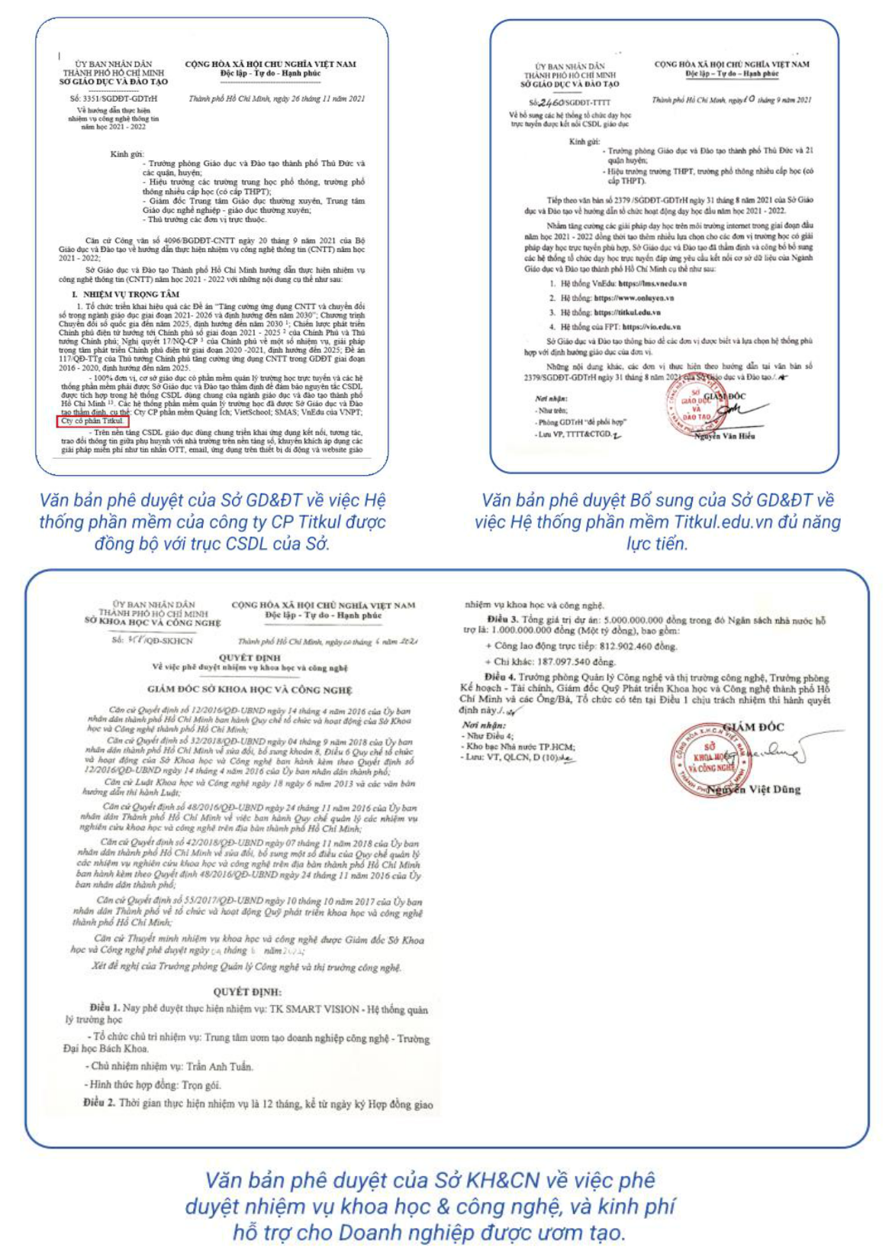

**For Business Customers:**

**Smart Human Resource Management Solution – TK HRS**. Is the solution that Titkul created specifically for businesses in human resource management. Suitable not only for small and medium-sized businesses with a size of less than 50 people, but also effectively with businesses with a size of 1,000 employees or more, with the following features and advantages:

* Time attendance using face recognition technology, even when wearing a mask.
* Digitize and centrally manage enterprise data.
* Optimize the process of storing personnel records in bulk.
* Flexible management when management tasks can be done right on Web and App applications.

In addition, TitKul also has development of solutions, functional module as customers requirements – outsource:

Design websites on demand, build ERP systems, manage CRMs, build mobile apps, provide customized software and meet customer requirements.

* Meet most of the fields from organizations, and businesses to enterprises.
* Digitize and centrally manage enterprise data.
* Optimize the process of storing personnel records in bulk
* Flexible management when management tasks can be done right on Web and App applications.

**Smart Human Resource Management Solution – TK HRS** is optimized when it is possible to combine facial recognition technology through TK ROBOT AI and HRS human resource management software system.

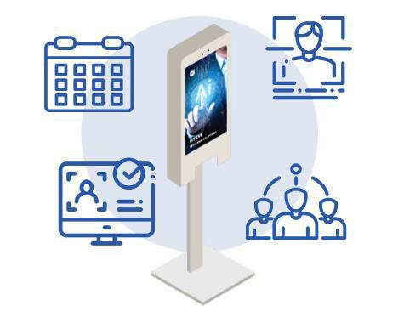

**ACHIEVEMENTS**

* Top 50 artificial intelligence (AI) competitions in HCMC.
* Top 50 HIS COVID competitions in 2021 organized by the Department of Science and Technology.
* One of three projects approved by the Department of Science and Technology
* of Ho Chi Minh City. Ho Chi Minh City to invest in the 2021-2025 period.
* Incubated at the Technology Business Incubation Center of the Polytechnic
* One of three projects incubated at the incubator of the high-tech zone in Ho Chi Minh City. Thu Duc, City. Ho Chi Minh.
* One of the five units is connected to the database axis of the Department of
* Top 15 DigiTrans contests held by Ho Chi Minh City Hi-Tech Park incubator. Thu Duc, City. Organized by Ho Chi Minh.

**Partners and businesses that have developed with TitKul**:

**CHAPTER 3: POSITION, RESPONSIBILITIES AND TASK ASSIGNED**

3.1 POSITION AND RESPONSIBILITIES

I have experienced many roles and positions at TitKul, and thanks to Ms. Thuyen, I can try my hand in many fields from marketing to telesales then sales. In addition, I also lead a small marketing team consisting of 4 members, during the working process we gained a lot of experience and good achievements together, supporting each other whenever there are members in the group. get out of sight or slow down the progress of work. My position is Marketing staff and Sales of products through Facebook, besides I am responsible for the management of my team members. Responsibility is also a very headache for me when I have to support the team while also creating ideas, setting up content, managing the project's Facebook page, and finding customer data, but I am very fortunate to have very energetic and enthusiastic teammates. So my job doesn't have too many obstacles. They also help me understand more about my current job and support a lot to develop together.

3.2 DAILY TASKS ASSIGNED

From the first days of working and exposed to a professional and dynamic working environment like Titkul. Almost all of my work plans and schedules are prepared in detail and are most suitable for me to learn and develop myself.

My team was assigned by the company to do a new project of the company, in this project we will search and develop with a new industry the company has never done before and we will lay the foundation and strategy. for this project.

The first week, the week that started here, I was assigned management responsibility as well as based on the weekly plan laid out and strategized for the whole team and assigned tasks to each individual in the group.

Over the following weeks, my general daily duties will include:

* Collect opinions of team members to make marketing strategies on Facebook
* Manage posts and content on Facebook
* Make marketing strategies and propose them
* Support potential customers
* Telesale and chat with customers
* Search customer data
* Support the development of the company's Tiktok channel.

Every week, the Company will have meetings to discuss strategy as well as answer work questions for employees.

Every weekend, I will summarize and report on the progress of the group's work completion according to the previously set weekly goals to report to my superiors what has been done and what has not been done so that my superiors can understand the progress. work level and timely support.

**CHAPTER 4: INTERNSHIP EXPERIENCE**

4.1 ADVANTAGES AND CHALLENGES

After completing the internship, I have gained a lot of experience, that is when starting any job or project, it is important to grasp the advantages and challenges that I am about to face from there. relying on acquired experience and skills for problem solving and strategic planning are factors that should not be overlooked. Thanks to these advantages as well as grasping the challenges of the field in which I work, I can make the most of the value and experience that I have.

**4.1.1 Avantages**

The big advantage that I have during my internship is the time, rich experience and enthusiastic support from the management and the company, not to mention the people who fought with me, Those are precious friends and teammates. In addition, the knowledge gained during my study period has also supported me a lot in the process of working here. In the future I believe that what I have learned here will help me a lot in finding a suitable environment in which I can develop and dedicate myself. After all, being able to bring a long-term value as well as accumulate a lot of new knowledge is the core that I always aim for.

**4.1.2 Challenges**

As a field that is not too new in modern society, and at the same time it is difficult to maximize its potential, running a business website for businesses as well as learning software, Titkul may have many challenges. need to pay attention to.

* Audience: The current audience that Titkul is targeting is new businesses, currently Titkul is starting a Website project for companies, newly opened, small and medium-sized businesses. From there, they will introduce them to more software, management packages as well as SEO development, long-term market marketing. For the current School audience, accessing to website design is very difficult because they almost have it for themselves. So Titkul will take the opportunity to develop management and teaching software for them, using technology to approach and develop.
* Competitors: Currently, in the Website segment alone, there are many big competitors that have been present for a long time. Therefore, defining marketing strategies and policies will create many turning points as well as a big difference.
* Product: This is a product that is not difficult to make because they are almost easy to buy and almost all large companies will have a technical department to develop their own website and now the software is also available. such as websites that create business websites according to templates or self-designed with low cost and easy to use are appearing more and more. So making a difference as well as the attached packages will create unique advantages for Titkul.
* Price: As mentioned above (3), the price will also partly determine whether customers choose your product or not. In addition, it is also necessary to measure and measure to avoid loss and unprofitability.
* Time: Currently, this is a difficult time because after the pandemic many companies and businesses have had to stop operating and go bankrupt. This is no longer the time for websites, but for e-commerce channels such as Tiktok, Shoppe, Lazada, Facebook,... with the development of new technology and times, Titkul will have to face challenges. dominance of new technologies as well as constant market changes. Therefore, personal and product development is indispensable and must not be stopped.
* Human Resources: Determining human resources as well as assigning strategies from Marketing, to Sales, and most importantly, a team of software technicians. As a software company, having a professional and dynamic software development team is indispensable. Besides, the marketing and business development team will be a big turning point to create an advantage before competitors in the market.

4.2 KNOWLEDGE ACQUIRED

During my internship, I gained a lot of practical knowledge, I learned how to manage a team, as well as online marketing. In addition, I also know more about websites and multi-tasking system management software, and how to build websites from the beginning until the website is completed and handed over to users. I also understand more about how a large company works, the problems encountered, and how to approach, overcome weaknesses, and improve product quality. I also learned how to market how to reach customers more effectively, not only by selling products but also by creating real value for customers, helping customers increase sales as well as adding value to products and brands. I feel that I have grown more and more each day through this internship time.

4.3 SKILLS DEVELOPED AND HONED

During my internship at TitKul, I trained and learned many skills at the company, to improve myself to suit the work I was assigned by my superiors and the professional office environment. Those things have helped me a lot in my work, to the soft skills needed to support my future career.

I have the opportunity to improve my knowledge, more confident in communicating with customers, consulting services with many different customers, improving communication skills in a professional working environment.

Over the past 8 weeks, I feel more mature and more professional at work. What I learned the most when I was an intern at the company was the skill of consulting the need to register for website services and products from the company for customers and here I also learned creative and writing skills. Learned how to create article content about the company's products and services to post on social networking sites to find customers. In addition, when I practiced at TitKul, I also learned and improve and

develop effective teamwork skills, individual and small group management skills, problem-solving skills, and other soft skills.

4.4 EXPERIENCE GAINED

After working here, I have gained valuable experience, not only that, my expertise has also improved a lot from how to approach customers from indirect to direct and how to communicate to approach customers. the needs of customers in the most effective and professional way possible, these are knowledge that hardly any book can teach. Besides, I also have many friends, many employees at the company are always interested, ready to help me when I have difficulties at work and feel inspired to learn from them.

This working environment helps me feel highly professional, and at the same time helps me learn more about the serious and professional working style of everyone in the company.

I have always wanted to develop a business for myself, from what I have learned and concluded here, I have gradually been able to form the path and image of the company that I will develop.

**CHAPTER 5: CONCLUSION AND RECOMMENDATIONS**

5.1 CONCLUSION

With the core values gained during the past 8 weeks of the internship, I have some feelings as well as an objective assessment of the internship. First, thank you to Nguyen Tat Thanh University and Titkul Company for creating conditions for me to approach and experience as much as possible. I find that to have the perfect opportunity to collide with business and society, help students can grasp the trend as well as make the most of the knowledge they have learned and gain the most practical experience. Interns can practice at any company that they like or the industry they are studying. That will partly help students gain more experience and knowledge. And at the end of the internship, I found that the knowledge I learned in school was the premise, creating the foundation to do everything in the corporate environment.

For me, the experience that I have been intern at the company is extremely important along with the knowledge in the classroom can greatly affect my future work. For example, in school, I learned that marketing and sales are essential parts of the staff in any business. The job of the marketing and sales department includes creating demand and finding customers of the company, consulting some services that customers are interested in, and updating customer information when customers are interested in packages. services directly at the company or online, etc. But, during my internship at the company, I realized that each function of the marketing and sales department has many different processes and functions of the department. Marketing and sales are not like what I just understood and learned in school.

Based on the knowledge I learned at school, helps me quickly absorb new knowledge and easily apply the basic knowledge to work, but there are still many things I don't know to do so I need to try to learn. ask more about what I practice. in consulting customers, and researching to expand the system of customer needs to use the company's new services. But it still works according to the basic knowledge principles that I have learned.

Therefore, the knowledge in university is the foundation that helps me speed up my work and complete it in the best way.

5.2 RECOMMENDATIONS

Here are some tips for students, as mentioned in the Challenge section, it can be seen that there are many things that are difficult not only in terms of knowledge, but also in terms of systems and vision that the owner of the business where you have been, are and will work. Finding out the relevant information and the difficulties that the industry you are working in will partly help your work become less stressful. and easier. Grasp the advantages of the business and yourself, then choose the usefull knowledge and path for you. You may not be too good, but if you know how to absorb and learn constantly, success will always come to you. Look for crucial factors and keys to self-development. The most important thing is to master the knowledge that you have available during your studies in school and the advice and experience in the work process will help you be more successful in the future.

**REFERENCES**

INTERNSHIP REPORT WRITING GUIDANCE

Trello.com/Group-intern

<https://drive.google.com/drive/folders/1g7fhOuS0D2-OfIjvOYSM5DvGl6_Vt_5F>

https://www.facebook.com/TITKUL2020

**APPENDIX (IF ANY)**

Titkul Profile.pdf

Employment diagram.xlsx

https://www.facebook.com/webone2030 https://www.facebook.com/webone2030

https://titkul.com/

<https://www.youtube.com/channel/UC3aQvBIAMmmU0dJTbyCw11w/featured>