BÀI TẬP 5: TẠO HỒ SƠ UX

# MỤC TIÊU

* **Tạo bảng user interview, observation, card sorting và vẽ các biểu đồ phân tích**

# HƯỚNG DẪN

## Tạo bảng user interview

**III. DISCOVER**

**1. Tạo bảng user interview từ nhóm khác đề tài trong lớp**

***A. CUSTOMER INTRO QUESTIONS***

Câu hỏi ví dụ:

What does your typical weekday look like?

When do you normally first use the Internet in a typical day?

What are some of the apps and websites you use the most?

Tell me about your role at your company?

Any lifestyle questions that are related to your topic / product.?

***B. TOPIC SPECIFIC QUESTIONS:***

Câu hỏi ví dụ:

What’s your relationship like with [topic … e.g. money, fitness, etc]

How do you currently go about [problem / task]?

How much time do you typically spend on [problem / task]?

Tell me about the last time you tried to [problem / task]?

What do you like about how you currently [problem / task]?

What is the biggest pain point related to [problem / task]?

Why do you keep doing [problem / task] … why is it important to you?

What type of work arounds have you cerated to help you with this?

What’s the hardest part about [problem / task]?

What are you currently doing to make this [problem / task] easier?

How does this [problem / task] impact other areas of your life / work?

What other products or tools have you tried out?

Have you paid for any of these other products or tools?

How did you hear about these other products or tools?

What do you like or dislike about these other products or tools?

Are you looking for a solution or alternative for [problem / task]?

***C. PRODUCT OPPORTUNITY QUESTIONS***

Câu hỏi ví dụ:

What do you think of this product? (meant to be asked at the homepage to gauge initial reaction) Why do you think someone would use this product?

Can you see yourself ever using this product?

Why do you think you can trust this product?

How do you think this product is going to help you?

Would you use this product today?

What might keep people from using this product?

What’s the most you would be willing to pay for this product?

Does this remind of you any other products?

***D. PRODUCT REACTION QUESTIONS***

Câu hỏi ví dụ:

What’s most appealing about this product?

What’s the hardest part about using this product?

Was there anything surprising or unexpected about this product?

What could be done to improve this product?

Was there anything missing from this product that you expected?

Would you keep using this product after what you saw today?

**2. Tạo bảng kết quả observation**

Ví dụ:

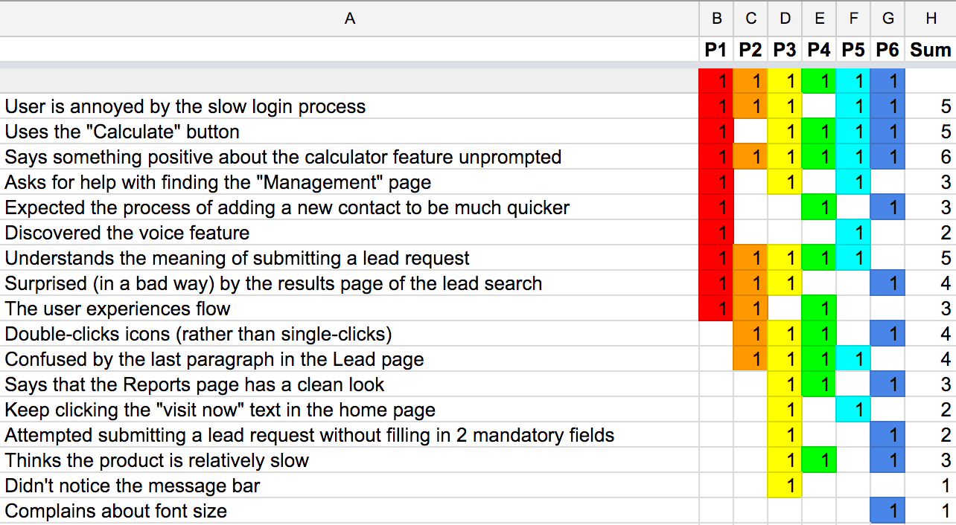

**3. Chọn 1 phương pháp card sorting để gom nhóm menu (Opened card sorting, closed card sorting, reversed card sorting, ranking card sorting), ghi rõ phương pháp nào bạn sử dụng và lập bảng như ví dụ:**

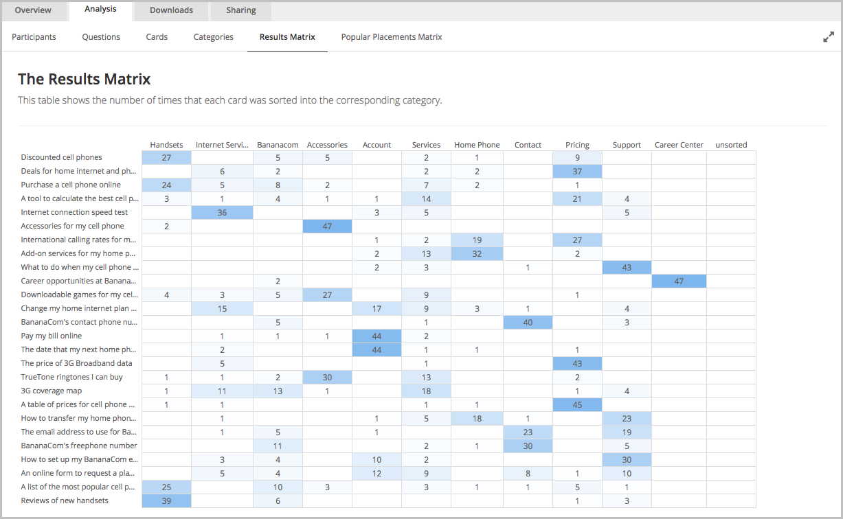

# Sử dụng biểu đồ để đo lường phân tích như 3 ví dụ sau:

**Ví dụ 1: https://www.behance.net/gallery/111593467/iHome-UX-Case-Study?tracking_source=search_projects_recommended%7CUX%20case%20study**

**Ví dụ 2: https://www.behance.net/gallery/112184627/UX-UI-case-study-Expert-app?tracking_source=search_projects_recommended%7CUX%20case%20study**

**Ví dụ 3:** [**https://www.behance.net/gallery/113994573/Travel-UX-UI-Case-Study?tracking_source=search_projects_recommended%7CUX%20case%20study**](https://www.behance.net/gallery/113994573/Travel-UX-UI-Case-Study?tracking_source=search_projects_recommended%7CUX%20case%20study)

