CMPG 325 — Computer Networks
Milestone 2: Client Implementation Review
Project ID: CMPG325-2026-086 | Client ID: CLI-086 | Student: Morake, TM (39510484)

1. Working Packet Tracer File
The full network for Mpho HR Consulting has been implemented and tested in Cisco Packet Tracer. The topology comprises one Cisco 1941 router (R1) and one Cisco 2960-24TT switch (SW1), connected via an 802.1Q trunk, with 24 end devices distributed across four departmental VLANs. The .pkt file is included in the GitHub repository's /packet-tracer folder and opens directly to reproduce the working solution.
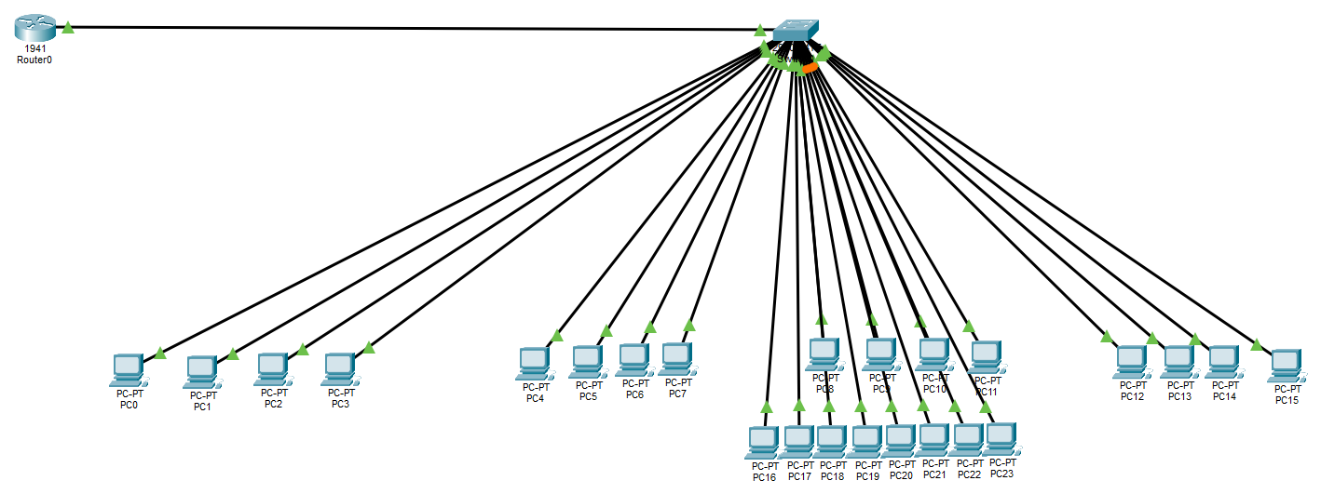
Figure 1: Final physical topology in Packet Tracer, showing all 24 devices (16 original + 8 added under CR1) connected to SW1, with SW1 trunked to R1.

2. Assigned Feature Implemented: VLANs (Switch-Based Segmentation)
The assigned technical challenge - VLAN-based switch segmentation - was implemented using a router-on-a-stick design. Four VLANs were created on SW1, one per department, with access ports assigned accordingly. SW1's uplink to R1 (Fa0/1) was configured as an 802.1Q trunk carrying all four VLANs plus an unused native VLAN (99) for trunk security. R1's single physical interface (Gi0/0) was divided into dot1Q subinterfaces, each acting as the default gateway for its VLAN.
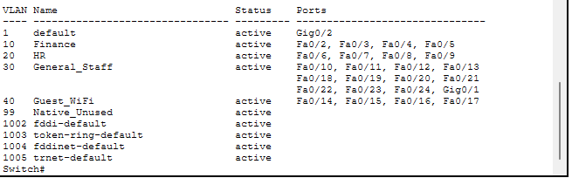
Figure 2: 'show vlan brief' on SW1 — all four VLANs active with correct port assignments (VLAN 30 shows 12 ports following the CR1 expansion).
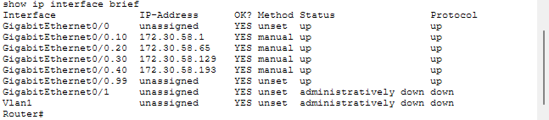
Figure 3: 'show ip interface brief' on R1 — all four VLAN subinterfaces up/up with correct gateway addresses.
To satisfy the design constraint (Finance must be isolated from all general users), an extended access control list, ISOLATE_FINANCE, was written and applied inbound on all four subinterfaces. It denies bidirectional IP traffic between the Finance subnet (172.30.58.0/26) and every other department subnet, while a trailing permit ip any any preserves normal routing for all non-Finance traffic.
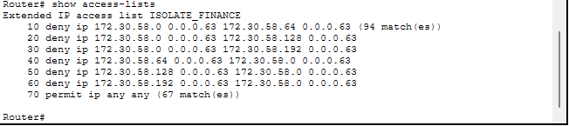
Figure 4: 'show access-lists' on R1 — the ISOLATE_FINANCE ACL with active match counters, confirming the rules are being evaluated against real traffic.

3. Testing Evidence

3.1 DHCP addressing
Each VLAN is served by its own DHCP pool on R1. PCs in Finance and General Staff were confirmed to receive addresses from their correct respective pools.
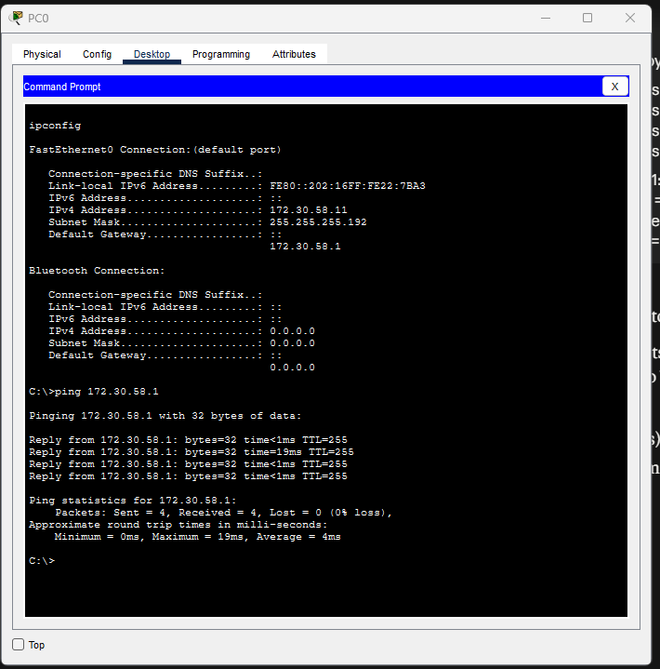
Figure 5: Finance PC (PC0) — DHCP-assigned 172.30.58.11, gateway 172.30.58.1 (correct Finance range).
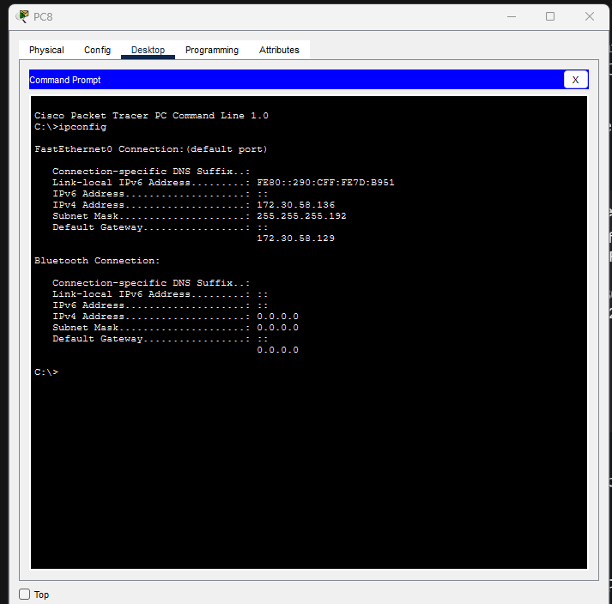
Figure 6: General Staff PC (PC8) — DHCP-assigned 172.30.58.136, gateway 172.30.58.129 (correct General Staff range).

3.2 Gateway reachability
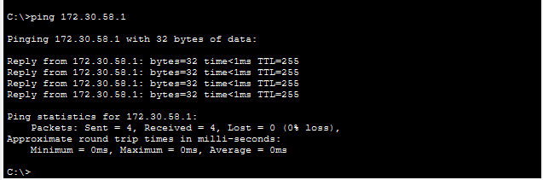
Figure 7: Finance PC successfully pings its own gateway (172.30.58.1) — 4/4 replies, 0% loss.

3.3 Finance isolation (design constraint verification)
A ping from a Finance PC to an HR PC (172.30.58.71) was tested. The result confirms complete isolation: 100% packet loss, with 'Destination host unreachable' returned by R1 itself - proving the router is actively enforcing the ACL rather than the failure being a routing fault.
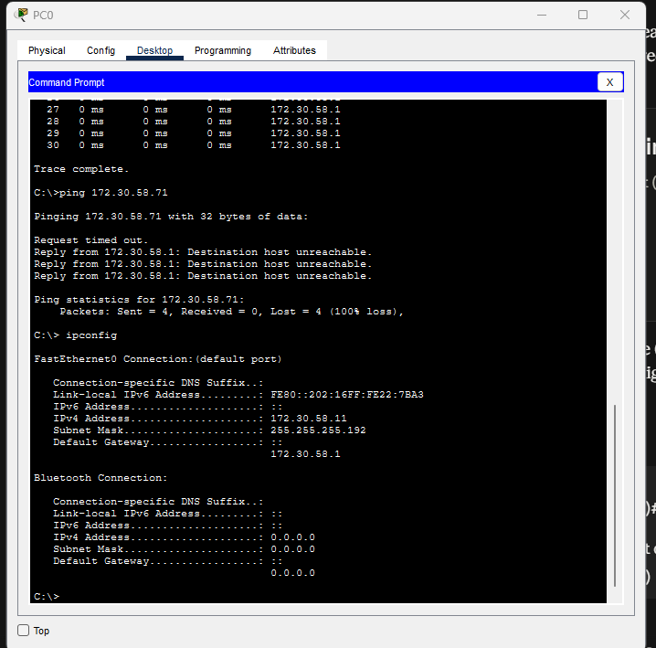
Figure 8: Finance-to-HR ping blocked by the ISOLATE_FINANCE ACL — 100% loss, 'Destination host unreachable' from the gateway.

3.4 Non-Finance connectivity (isolation correctly scoped)
To confirm the ACL does not over-restrict the network, connectivity between two non-Finance departments (HR and General Staff) was tested and succeeded normally.
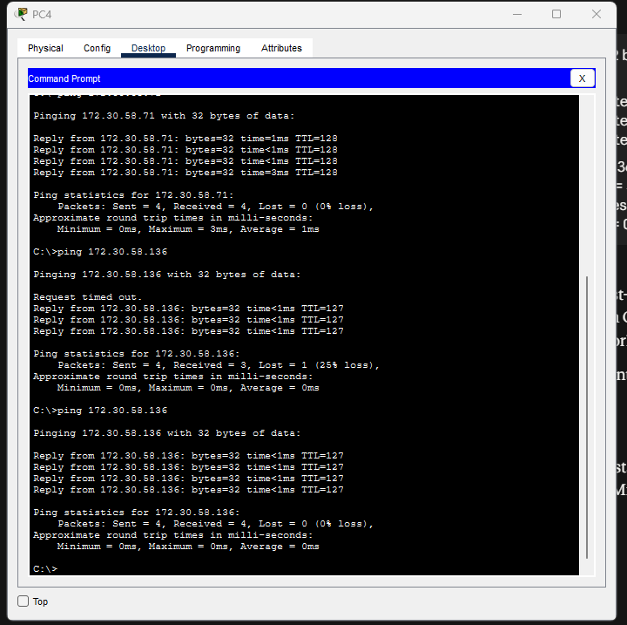
Figure 9: HR-to-General Staff ping succeeds (4/4 replies after initial ARP resolution) — confirms isolation is scoped to Finance only.

3.5 Client Change Request (CR1) verification
Per CR1, 8 additional staff were added to the General Staff department. This was achieved by cabling 8 new PCs to previously spare switch ports (Fa0/18-24 and Gig0/1), assigning those ports to the existing VLAN 30, and enabling DHCP - with zero changes to the router configuration, VLAN structure, or IP addressing plan.
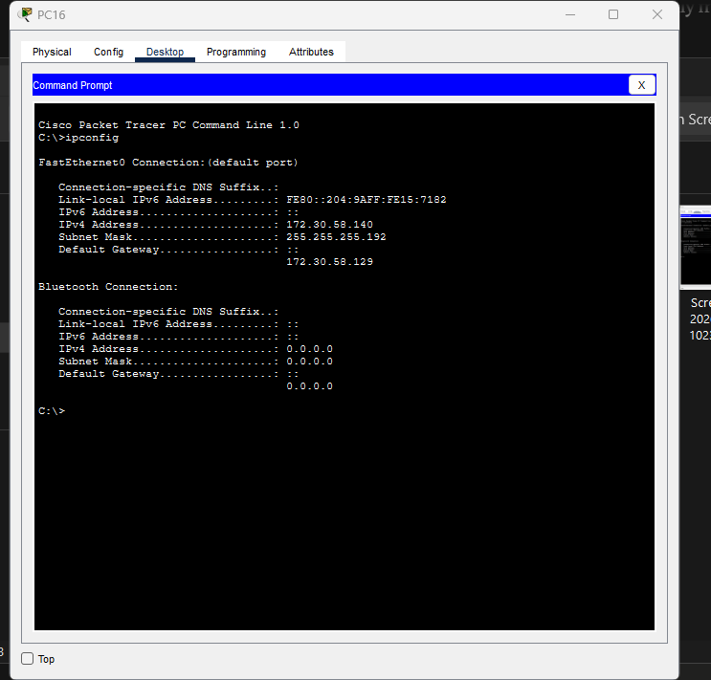
Figure 10: A newly added General Staff PC (PC16) receives 172.30.58.140 from the existing GENERAL_STAFF_POOL — confirming CR1 was absorbed without any redesign.

3.6 Testing summary
Test | Expected Result | Actual Result
Finance PC DHCP addressing | Address in 172.30.58.0/26 | 172.30.58.11 - Pass
General Staff PC DHCP addressing | Address in 172.30.58.128/26 | 172.30.58.136 - Pass
Finance to own gateway | Success | 4/4, 0% loss - Pass
Finance to HR | Blocked (isolation constraint) | 100% loss, unreachable - Pass
HR to General Staff | Success (not restricted) | 4/4, 0% loss - Pass
CR1: new General Staff PC | Address in same subnet, no redesign | 172.30.58.140 - Pass

4. Updated GitHub Portfolio
The GitHub repository established at Milestone 1 has been updated with the working Packet Tracer file and this Milestone 2 documentation, organised as follows:
- /packet-tracer — mpho_hr_consulting.pkt (the working file)
- /testing — all evidence screenshots referenced in Section 3 above
- /requirements — Milestone 1 and Milestone 2 documentation
- /design — topology diagrams and IP addressing plan (from Milestone 1)
Repository link: https://github.com/Saint202/cmpg325-2026-086-mpho-hr-consulting

— End of Milestone 2 submission —

