**Output:**

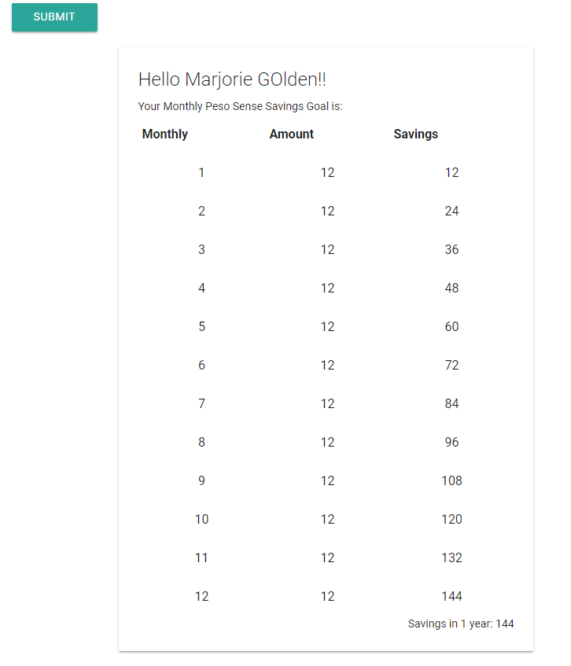

**Raw code:**

<?php

$ishide = '';

isset($_POST['name'])? $name = $_POST['name'] : $name='';

isset($_POST['amt'])? $amt = $_POST['amt'] : $amt='';

isset($_POST['freq'])? $freq = $_POST['freq'] : $ishide='hidden';

?>

<html>

<head>

<!--Import Google Icon Font-->

<link href="https://fonts.googleapis.com/icon?family=Material+Icons" rel="stylesheet">

<!--Import materialize.css-->

<link rel="stylesheet" href="https://cdnjs.cloudflare.com/ajax/libs/materialize/0.100.2/css/materialize.min.css">

<!--Let browser know website is optimized for mobile-->

<meta name="viewport" content="width=device-width, initial-scale=1.0"/>

</head>

<body>

<div class="container">

<form action="midterm.php" method="post" id="form1">

<p><label for="name">Enter Your Name</label><input id="name" placeholder="John Dela Cross" type="text" name="name" value="<?php echo $name; ?>">

</p>

<p><label for="amt">Enter Savings Amount</label>

<input id="amt" placeholder="500" type="number" name="amt" value="<?php echo $amt; ?>">

</p>

<p><label>Choose the frequency of savings</label></p>

<p>

<input name="freq" type="radio" id="fD" value="Daily"/>

<label for="fD">Daily</label>

</p>

<p>

<input name="freq" type="radio" id="fW" value="Weekly"/>

<label for="fW">Weekly</label>

</p>

<p>

<input name="freq" type="radio" id="fM" value="Monthly"/>

<label for="fM">Monthly</label>

</p>

<button type="submit" class="waves-effect waves-light btn">Submit</button>

</form>

<div class="row" <?php echo $ishide;?>>

<div class="col s12 m8 push-m2 l6">

<div class="card darken-1">

<div class="card-content">

<span class="card-title">Hello <?php echo $name;?>!!</span>

<p>Your <?php echo $freq;?> Peso Sense Savings Goal is:</p>

<p>

<table class=" centered highlight">

<tr>

<th><?php echo $freq;?></th>

<th>Amount</th>

<th>Savings</th>

</tr>

<?php

switch($freq){

case "Daily": $freqnum = 365; break;

case "Weekly": $freqnum = 52; break;

case "Monthly": $freqnum = 12; break;

}

for($i=1;$i<=$freqnum;$i++){

$savings = $i * $amt;

echo "<tr>

<td>$i</td>

<td>$amt</td>

<td>$savings</td>

</tr>";

}

?>

</table>

</p>

<p class="right-align">Savings in 1 year: <?php echo $amt * $freqnum;?></p>

</div>

</div>

</div>

</div>

</div>

<script type="text/javascript" src="https://code.jquery.com/jquery-3.2.1.min.js"></script>

<script src="https://cdnjs.cloudflare.com/ajax/libs/materialize/0.100.2/js/materialize.min.js"></script>

</body>

</html>