PROBLEM 1:

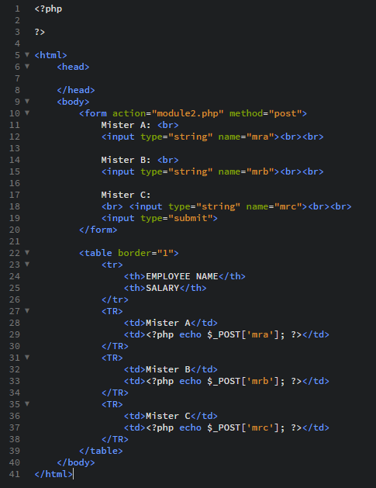

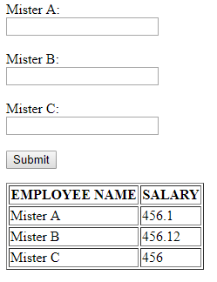

PROBLEM 2:

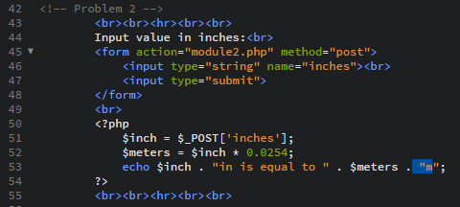

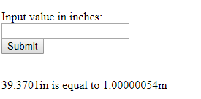

PROBLEM 3:  
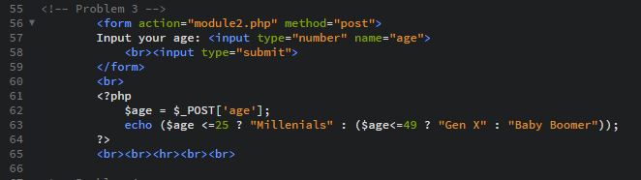



PROBLEM 4:

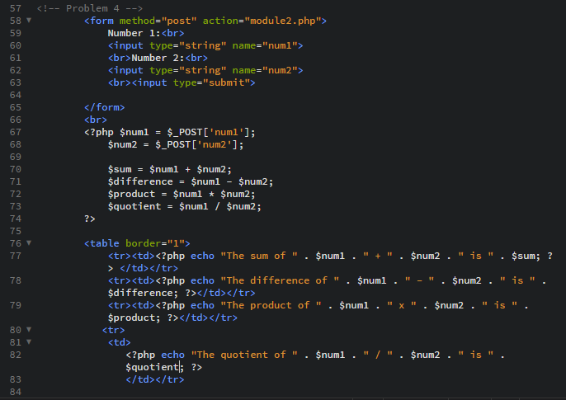

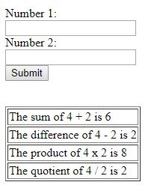

RAW:

<html>

<head>

</head>

<body>

<!-- Problem 1 -->

<form action="module2.php" method="post">

Mister A: <br>

<input type="string" name="mra"><br><br>

Mister B: <br>

<input type="string" name="mrb"><br><br>

Mister C:

<br> <input type="string" name="mrc"><br><br>

<input type="submit">

</form>

<table border="1">

<tr>

<th>EMPLOYEE NAME</th>

<th>SALARY</th>

</tr>

<TR>

<td>Mister A</td>

<td><?php echo $_POST['mra']; ?></td>

</TR>

<TR>

<td>Mister B</td>

<td><?php echo $_POST['mrb']; ?></td>

</TR>

<TR>

<td>Mister C</td>

<td><?php echo $_POST['mrc']; ?></td>

</TR>

</table>

<!-- Problem 2 -->

<br><br><hr><br><br>

Input value in inches:<br>

<form action="module2.php" method="post">

<input type="string" name="inches"><br>

<input type="submit">

</form>

<br>

<?php

$inch = $_POST['inches'];

$meters = $inch * 0.0254;

echo $inch . "in is equal to " . $meters . "m";

?>

<br><br><hr><br><br>

<!-- Problem 3 -->

<form action="module2.php" method="post">

Input your age: <input type="number" name="age">

<br><input type="submit">

</form>

<br>

<?php

$age = $_POST['age'];

echo ($age <=25 ? "Millenials" : ($age<=49 ? "Gen X" : "Baby Boomer"));

?>

<br><br><hr><br><br>

<!-- Problem 4 -->

<form method="post" action="module2.php">

Number 1:<br>

<input type="string" name="num1">

<br>Number 2:<br>

<input type="string" name="num2">

<br><input type="submit">

</form>

<br>

<?php $num1 = $_POST['num1'];

$num2 = $_POST['num2'];

$sum = $num1 + $num2;

$difference = $num1 - $num2;

$product = $num1 * $num2;

$quotient = $num1 / $num2;

?>

<table border="1">

<tr><td><?php echo "The sum of " . $num1 . " + " . $num2 . " is " . $sum; ?> </td></tr>

<tr><td><?php echo "The difference of " . $num1 . " - " . $num2 . " is " . $difference; ?></td></tr>

<tr><td><?php echo "The product of " . $num1 . " x " . $num2 . " is " . $product; ?></td></tr>

<tr>

<td>

<?php echo "The quotient of " . $num1 . " / " . $num2 . " is " . $quotient; ?>

</td></tr>

</table>

<br><br><hr><br><br>

</body>

</html>