**PROBLEM 1**

Output:

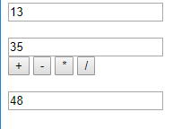

Code:

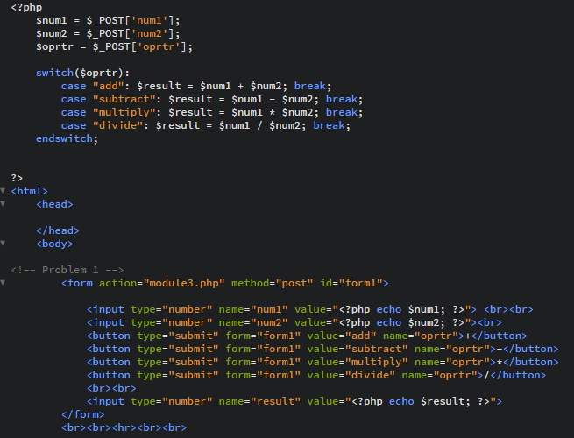

**PROBLEM 2**

Output:



Code:

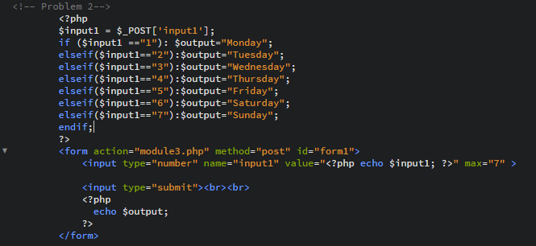

**RAW:**

<?php

$num1 = $_POST['num1'];

$num2 = $_POST['num2'];

$oprtr = $_POST['oprtr'];

switch($oprtr):

case "add": $result = $num1 + $num2; break;

case "subtract": $result = $num1 - $num2; break;

case "multiply": $result = $num1 * $num2; break;

case "divide": $result = $num1 / $num2; break;

endswitch;

?>

<html>

<head>

</head>

<body>

<!-- Problem 1 -->

<form action="module3.php" method="post" id="form1">

<input type="number" name="num1" value="<?php echo $num1; ?>"> <br><br>

<input type="number" name="num2" value="<?php echo $num2; ?>"><br>

<button type="submit" form="form1" value="add" name="oprtr">+</button>

<button type="submit" form="form1" value="subtract" name="oprtr">-</button>

<button type="submit" form="form1" value="multiply" name="oprtr">*</button>

<button type="submit" form="form1" value="divide" name="oprtr">/</button><br><br>

<input type="number" name="result" value="<?php echo $result; ?>">

</form>

<br><br><hr><br><br>

<!-- Problem 2-->

<?php

$input1 = $_POST['input1'];

if ($input1 =="1"): $output="Monday";

elseif($input1=="2"):$output="Tuesday";

elseif($input1=="3"):$output="Wednesday";

elseif($input1=="4"):$output="Thursday";

elseif($input1=="5"):$output="Friday";

elseif($input1=="6"):$output="Saturday";

elseif($input1=="7"):$output="Sunday";

endif;

?>

<form action="module3.php" method="post" id="form1">

<input type="number" name="input1" value="<?php echo $input1; ?>" max="7" >

<input type="submit"><br><br>

<?php

echo $output;

?>

</form>

</body>

</html>