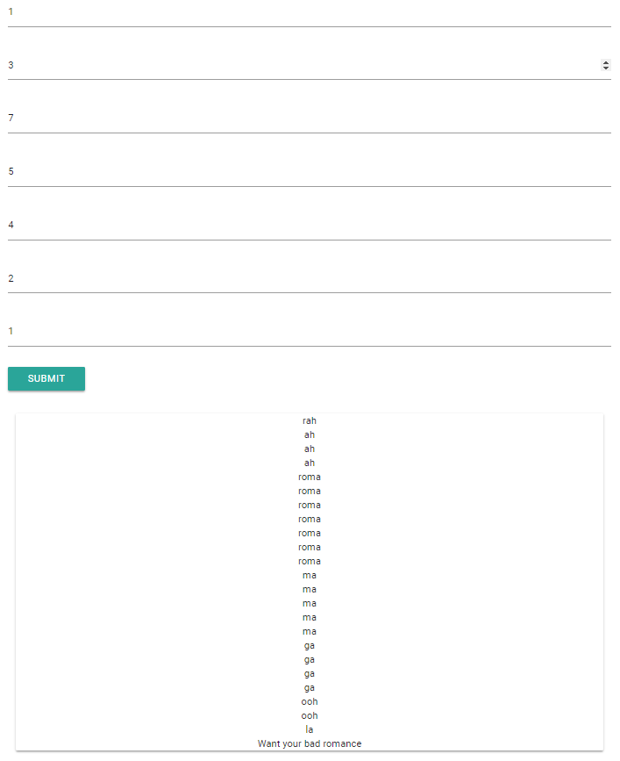

**RAW CODE:**

<?php

function rah($x){

for($i=1; $i<=$x; $i++){

print "rah<br>";

}

}

function ah($x){

for($i=1; $i<=$x; $i++){

print "ah<br>";

}

}

function roma($x){

for($i=1; $i<=$x; $i++){

print "roma<br>";

}

}

function ma($x){

for($i=1; $i<=$x; $i++){

print "ma<br>";

}

}

function ga($x){

for($i=1; $i<=$x; $i++){

print "ga<br>";

}

}

function ooh($x){

for($i=1; $i<=$x; $i++){

print "ooh<br>";

}

}

function la($x){

for($i=1; $i<=$x; $i++){

print "la<br>";

}

}

if(isset($_POST['rah'])){

$rah = $_POST['rah'];

$ah = $_POST['ah'];

$roma = $_POST['roma'];

$ma = $_POST['ma'];

$ga = $_POST['ga'];

$ooh = $_POST['ooh'];

$la = $_POST['la'];

}

?>

<html>

<head>

<!--Import Google Icon Font-->

<link href="https://fonts.googleapis.com/icon?family=Material+Icons" rel="stylesheet">

<!--Import materialize.css-->

<link rel="stylesheet" href="https://cdnjs.cloudflare.com/ajax/libs/materialize/0.100.2/css/materialize.min.css">

<!--Let browser know website is optimized for mobile-->

<meta name="viewport" content="width=device-width, initial-scale=1.0"/>

</head>

<body>

<div class="container">

<div class="row" >

<div class="l6 xl6 m8">

<form method="post" action="bad_romance.php">

<p>

<input name="rah" type="number" id="rah" placeholder="rah" value="<?php echo $rah;?>"/>

</p>

<p>

<input name="ah" type="number" id="ah" placeholder="ah" value="<?php echo $ah;?>"/>

</p>

<p>

<input name="roma" type="number" id="roma" placeholder="roma" value="<?php echo $roma;?>"/>

</p>

<p>

<input name="ma" type="number" id="ma" placeholder="ma" value="<?php echo $ma;?>"/>

</p>

<p>

<input name="ga" type="number" id="ga" placeholder="ga" value="<?php echo $ga;?>"/>

</p>

<p>

<input name="ooh" type="number" id="ooh" placeholder="ooh" value="<?php echo $ooh;?>"/>

</p>

<p>

<input name="la" type="number" id="la" placeholder="la" value="<?php echo $la;?>"/>

</p>

<button type="submit" class="waves-effect waves-light btn">Submit</button>

</form>

</div>

</div>

<?php

if(isset($_POST['rah'])){

echo " <div class='card l6 m6 s8 center-align'>";

rah($rah);

ah($ah);

roma($roma);

ma($ma);

ga($ga);

ooh($ooh);

la($la);

echo “Want your bad romance”;

echo "</div>";

}

?>

</div>

<script type="text/javascript" src="https://code.jquery.com/jquery-3.2.1.min.js"></script>

<script src="https://cdnjs.cloudflare.com/ajax/libs/materialize/0.100.2/js/materialize.min.js"></script>

</body>

</html>