Requirements
- Transportation
Operation States: Move UP, move DOWN, STOP,WAIT
TR-01 WHEN the destination floor sensor becomes active, the Elevator Controller shall stop the elevator.
TR-02 WHEN doors safely closed and next destination point is defined, the Elevator Controller shall move to that point.
- Request Handling
Multiple requests manager in Direction priority order
RH-01 WHEN a cabin button is pressed, the Elevator Controller shall register the requested floor.
RH-02 WHEN a floor button is pressed, the Elevator Controller shall register the requested floor.
RH-03 WHEN elevator stopped on the floor, the Elevator Controller shall mark as completed.
RH-04 IF request triggered multiple times(duplicated), request order should NOT be changed.

- Door Operation
DO-01 WHEN cabin safely stopped on destination point, doors shall be OPENED.
DO-02 WHEN the elevator door has opened, the Elevator Controller shall keep the door open for 3 seconds and then close the doors.
- Safe Operation
SO-01 The Elevator Controller can start move cabin only WHEN all doors are closed.
SO-02 The Elevator Controller can open the doors on each floor only WHEN cabin is stopped on that floor.
- Operator Feedback
OF-01 WHEN request is registered on the floor button, floor button indicator shall turn ON.
OF-02 WHEN request is registered on the cabin button, cabin button indicator shall turn ON.
OF-03 WHEN the request is completed, floor and cabin button indicator shall turn OFF.
- Controller Initialization
Initial condition: elevator is cabin on 2 floor and doors closed
CI-01 WHEN the controller is initialised, the Elevator Controller shall clear all stored requests.
CI-02 The Elevator Controller shall set first targetFloor to 2
Logical Design
Design divided to 3 modules:
Request panel (buttons inside elevator and on the floors, with indicators) with integrated Queue manager for handling requests, setting queue and decide next target floor
Doors operator for safely opening and closing doors
Cabin Movement control to control elevator cabin
Communication between modules is showed on sequence diagram:
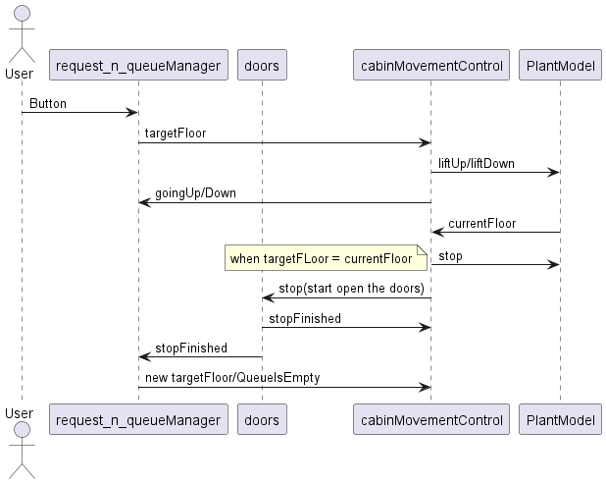
Figure 1 Sequence diagram
To define key states of cabin control, timing diagram was created:
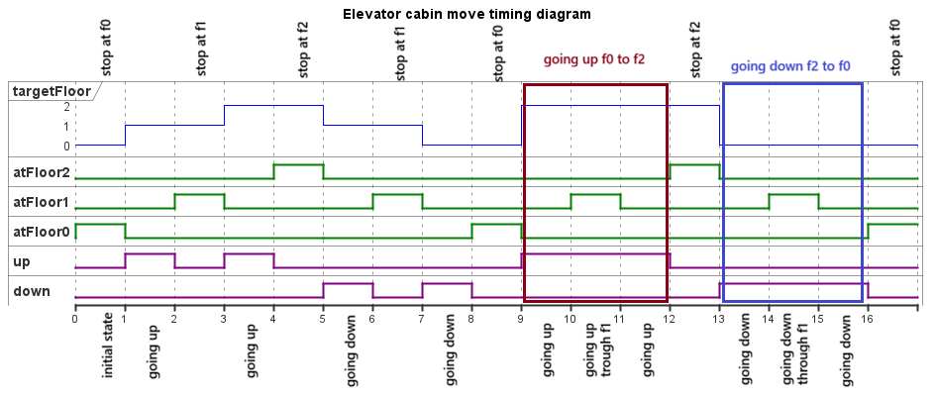
Figure 2 Timing diagram
Timing diagram shows all possible transitions. Elevator behaviour can be divided to 4 main states: going up, going down ,stop and wait
- Going up sends instruction to go UP
- Going down sends instruction to go DOWN
- Stop stops the cabin and communicates with door manager to start cycle of door opening
- Wait state appears when all requests are complete and elevator is waiting for new request

State diagram shows transitions between these states and door operating logic
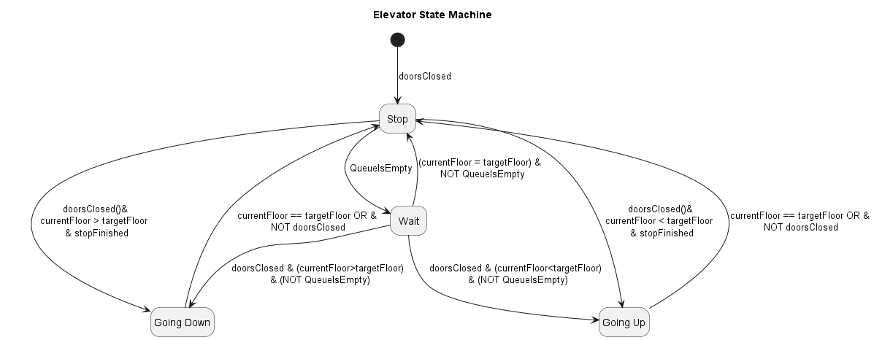
Figure 3 State diagram
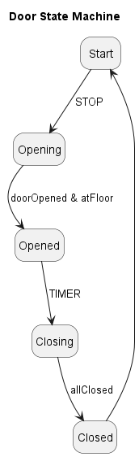
Figure 4 State diagram of STOP state
Implementation
Some helper blocks were created:
currentFloor
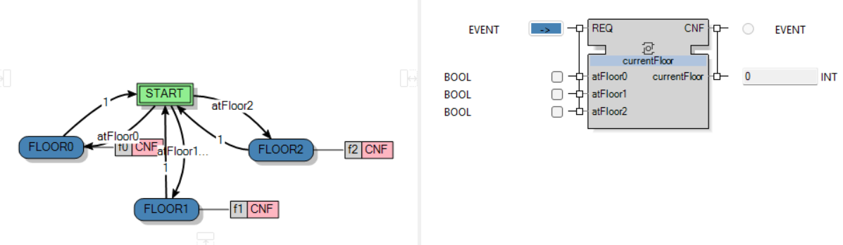
Algorithms set output to current floor value. For example for f0 :
currentFloor:=0;

allClosed
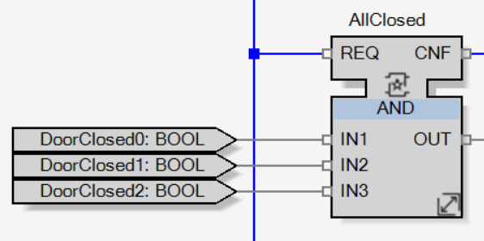

Request panel + Queue Manager
Request panel and Queue Manager are implemented in block LED_MANAGER
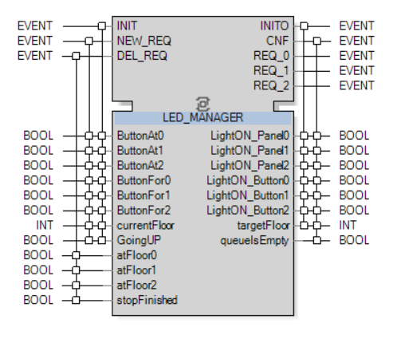
This composite function block consists of
3 RS_LED blocks
Queue_manager

RS_LED modules
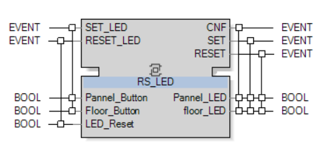
This block sets or resets LEDs
Queue Manager
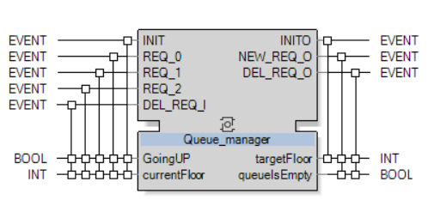
Queue_manager basic block creates queue. It stores internal value FloorsRequests in INT ARRAY[0..2]
TRUE in FloorsRequests[i] means that is request for floor i. Manager decides next floor (targetFloor) by the current direction elevator moves. It loocks through the FloorsRequests in direction of move. If it reaches edge floor, it starts looking in other direction. If there are no requests it sets queueIsEmpty to True.
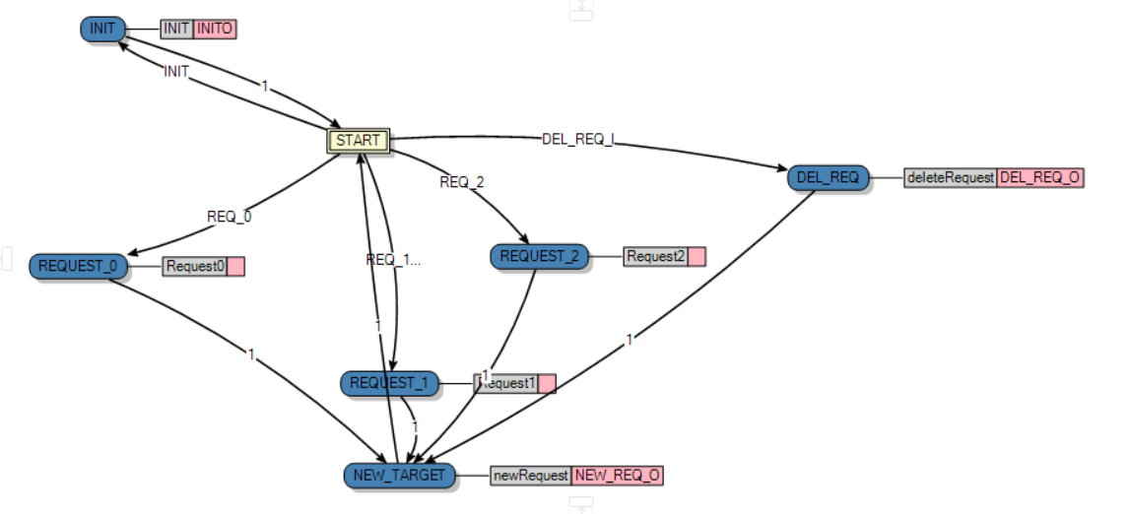
CabinMovementControl
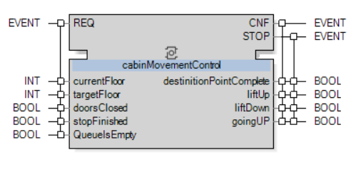
Is a basic function block that controls movement of cabin
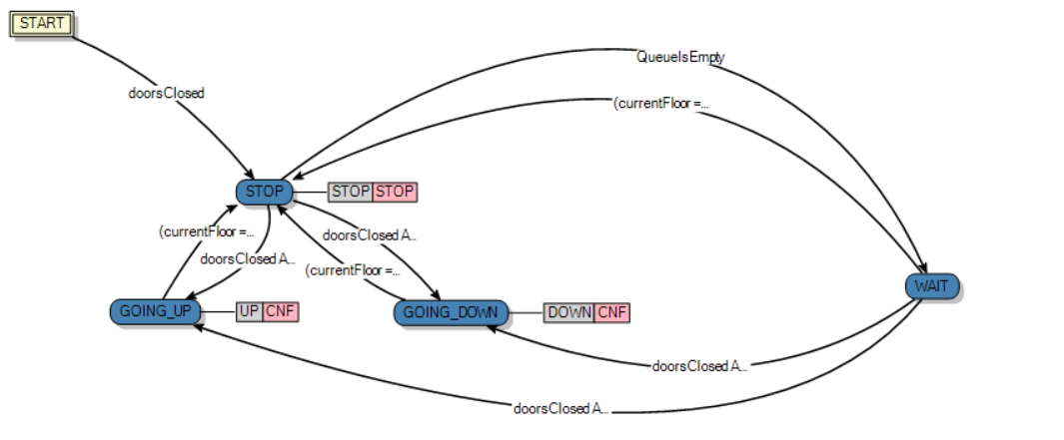
If block in GOING_UP or GOING_DOWN and door would open, elevator will go to state STOP

Door_manager
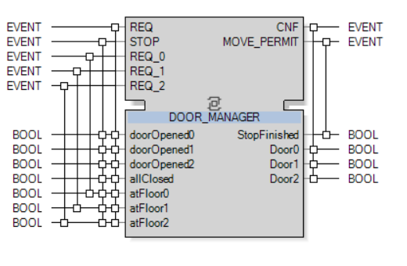
It consists of
door_control
STOP_SM
TIMER
Door_control
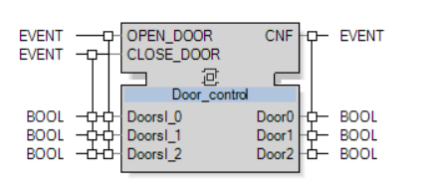
This composite block opens or closes the door. It consists of 3 RS_DOOR blocks
STOP_SM

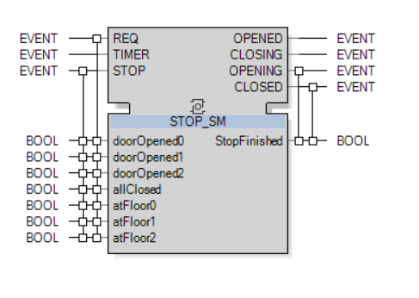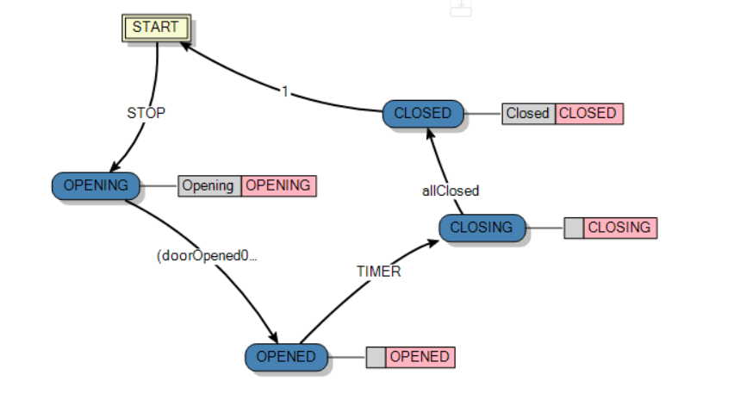
TIMER
it used to count 3 second and also resets counting if button was pushed on the same floor as elevator currently stays
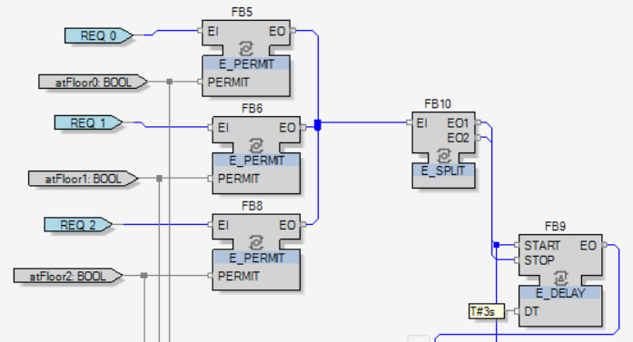
Requirement Coverage Table
Requirement ID | Requirement Summary | Design Evidence
TR-01 | Stop elevator at destination floor | State Diagram –Stopped state
TR-02 | Move to destination when doors safely closed | State Diagram –Stopped state
RH-01 | Register cabin button request | Sequence Diagram – addRequest()
RH-02 | Register floor button request | Sequence Diagram – addRequest()
RH-03 | Mark request as completed when stopped on floor | Sequence Diagram – destinationPointComplete()
RH-04 | Ignore duplicated requests (maintain order) | Sequence Diagram –TargetFloor()
DO-01 | Open doors when safely stopped at destination | State Diagram – Stopped state
DO-02 | Keep doors open for 3 seconds then close | State diagram – Stopped state
SO-01 | Move cabin only when all doors are closed | State diagram – Stopped state  Sequence Diagram –allClosed()
SO-02 | Open doors only when cabin is stopped on floor | State diagram – Stopped state  Sequence Diagram –openDoors()
OF-01 | Turn ON floor button indicator on request | Sequence Diagram –addRequest()
OF-02 | Turn ON cabin button indicator on request | Sequence Diagram –addRequest()
OF-03 | Turn OFF indicators when request is completed | Sequence Diagram – destinationPointComplete()
CI-01 | Clear all stored requests on initialization | State Diagram – init()
CI-02 | Start normal operation if no conflicting data | State Diagram – init()

