Requirements
Luggage Transport Controller
Initialization requirements:
IR-01 INITIAL POSITION for system is when all cylinders are in retracted state.
Transport requirement:
TR-01 WHEN luggage enters lift platform, Luggage Transport Controller shall extend vertical cylinder.
TR-02 WHEN luggage is lifted up, Luggage Transport Controller shall extend horizontal.
TR-03 WHEN luggage is pushed off the platform, Luggage Transport Controller shall retract horizontal and vertical cylinder.
TR-04 WHILE platform is empty and system is in initial state, Luggage Transport Controller should wait for next luggage
Safety:
SR-01 IF Horizontal cylinder is extracted, THEN Vertical cylinder should not extract

Master/Slave Distributed Architecture
Control system consists of 3 blocks. Two Slave blocks for Vertical and Horizontal cylinder . Master Luggage Transport Controller block.

Slave blocks
- Responsible to set model inputs LiftExt, LiftRet and PushExt and see data from model sensors
- Send confirmation to Master if cylinder is retracked or extended
Master block
- Receives information about luggage( LuggageLoaded and LuggageLifted)
- Sends commands to cylinders to retract or extend and receives confirmation from them

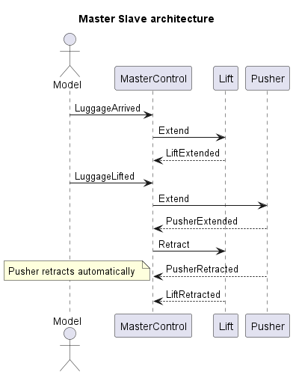
Figure 1 Sequence diagram

Requirements | Design Element | How the requirement adressed
IR-01 | Lift and Pusher Controller | Cylinders go to initial state only after sensor indicate they are retracted
TR-01 | Master Control | Lift luggage state
TR-02 | Master Control | Push luggage state
TR-03 | Master Control | Luggage pushed state
TR-04 | Master Control | Initial state
SR-01 | Master Control | Initial -> LiftLuggage state transition has check for Pusher cylinder status

OPC-UA
Model is a OPC-UA server that exposes luggage status data
Master Control and Cylinder controllers are Clients. Master control reads data from server about luggage status .
Cylinder controls are reading data from server about cylinder sensors states and sends to server values for actuators.
Mater reads data from cylinder control and sends them events to coordinate correct work cycle

