Requirements
- Transportation
Operation States: Move UP, move DOWN, STOP
TR-01 WHEN the destination floor sensor becomes active, the Elevator Controller shall stop the elevator.
TR-02 WHEN doors safely closed and next destination point is defined, the Elevator Controller shall move to that point.
- Request Handling
Multiple requests manager in Direction priority order
RH-01 WHEN a cabin button is pressed, the Elevator Controller shall register the requested floor.
RH-02 WHEN a floor button is pressed, the Elevator Controller shall register the requested floor.
RH-03 WHEN elevator stopped on the floor, the Elevator Controller shall mark as completed.
RH-04 IF request triggered multiple times(duplicated), request order should NOT be changed.

- Door Operation
DO-01 WHEN cabin safely stopped on destination point, doors shall be OPENED.
DO-02 WHEN the elevator door has opened, the Elevator Controller shall keep the door open for 3 seconds and then close the doors.
- Safe Operation
SO-01 The Elevator Controller can start move cabin only WHEN all doors are closed.
SO-02 The Elevator Controller can open the doors on each floor only WHEN cabin is stopped on that floor.
- Operator Feedback
OF-01 WHEN request is registered on the floor button, floor button indicator shall turn ON.
OF-02 WHEN request is registered on the cabin button, cabin button indicator shall turn ON.
OF-03 WHEN the request is completed, floor and cabin button indicator shall turn OFF.
- Controller Initialization
Initial condition: elevator is cabin on 2 floor and doors opened
CI-01 WHEN the controller is initialised, the Elevator Controller shall clear all stored requests.
CI-02 The Elevator Controller shall start normal operation, if the is no conflicting data (for example, two floors’ sensors are active)
Logical Design
Design divided to 4 modules:
Request panel (buttons inside elevator and on the floors, with indicators)
Queue manager for handling requests, setting queue and decide next target floor
Doors operator for safely opening and closing doors
Cabin Movement control to control elevator cabin
Communication between modules is showed on sequence diagram:
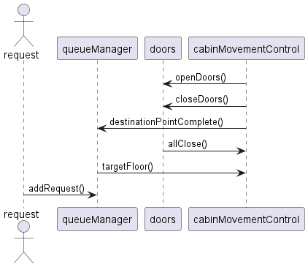
Figure 1Timing diagram
addRequest() -function that tells queue manager new floor request and turn on indicator on button(whether it in cabin or floor)
destinationPointComplete() - sets request as completed and turn off indication
targetFloor() - function that tells cabin what is the next floor to go
openDoors() - information to door operator to open doors
closeDoors() - information to door operator to close doors
allClosed() – information that all doors safely closed
To define key states of cabin control, timing diagram was created:
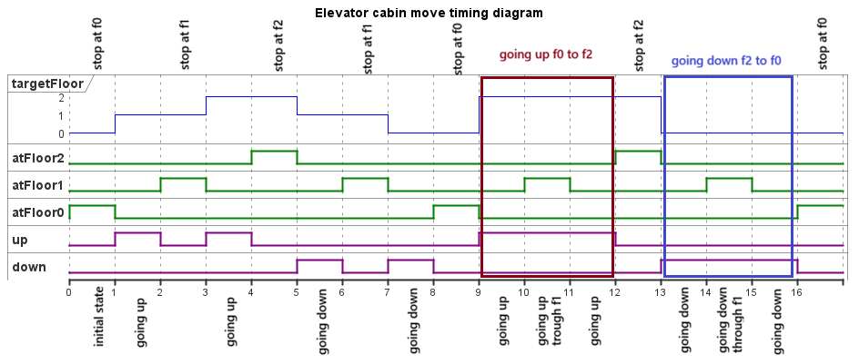
Figure 2Timing diagram
Timing diagram shows all possible transitions. Elevator behaviour can be divided to 3 main states: going up, going down and stop

State diagram shows transitions between these states and door operating logic
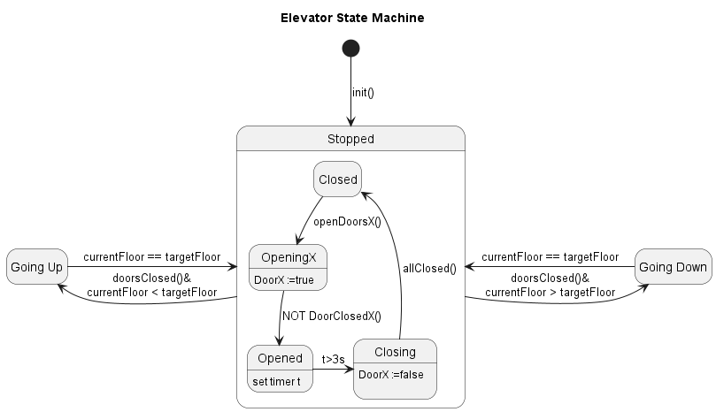
Figure 3 State diagram
Requirement Coverage Table
Requirement ID | Requirement Summary | Design Evidence
TR-01 | Stop elevator at destination floor | State Diagram –Stopped state
TR-02 | Move to destination when doors safely closed | State Diagram –Stopped state
RH-01 | Register cabin button request | Sequence Diagram – addRequest()
RH-02 | Register floor button request | Sequence Diagram – addRequest()
RH-03 | Mark request as completed when stopped on floor | Sequence Diagram – destinationPointComplete()
RH-04 | Ignore duplicated requests (maintain order) | Sequence Diagram –TargetFloor()
DO-01 | Open doors when safely stopped at destination | State Diagram – Stopped state
DO-02 | Keep doors open for 3 seconds then close | State diagram – Stopped state
SO-01 | Move cabin only when all doors are closed | State diagram – Stopped state  Sequence Diagram –allClosed()
SO-02 | Open doors only when cabin is stopped on floor | State diagram – Stopped state  Sequence Diagram –openDoors()
OF-01 | Turn ON floor button indicator on request | Sequence Diagram –addRequest()
OF-02 | Turn ON cabin button indicator on request | Sequence Diagram –addRequest()
OF-03 | Turn OFF indicators when request is completed | Sequence Diagram – destinationPointComplete()
CI-01 | Clear all stored requests on initialization | State Diagram – init()
CI-02 | Start normal operation if no conflicting data | State Diagram – init()

