# ***Blue Team Walk Through - Meta***

To view this file, I will be using a Kali Linux VM 😊

Downloaded the files.

Now let’s use the exif tool to get the Meta-data and answer the questions 😊

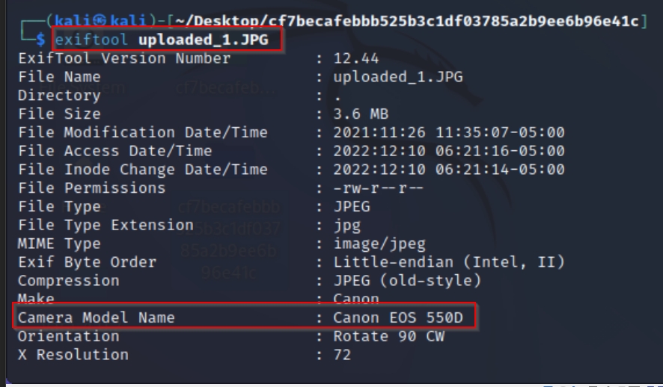

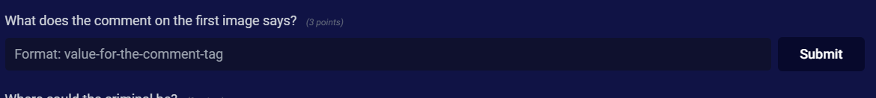

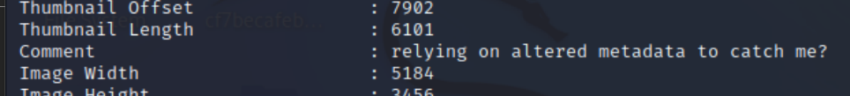

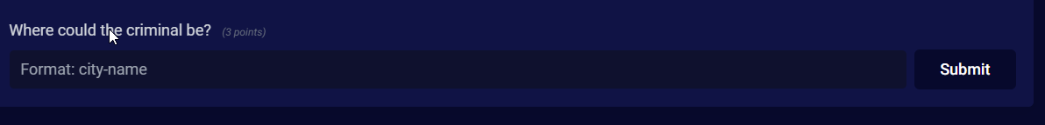

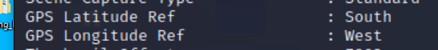

* Just might need to use Google Images.

By dragging and dropping the image into Google Images, I was able to get where the city is located. 😊

