**Computer Network 2020 HW1** B07902078 資工三 沈韋辰

01 Analysis of UDP packets

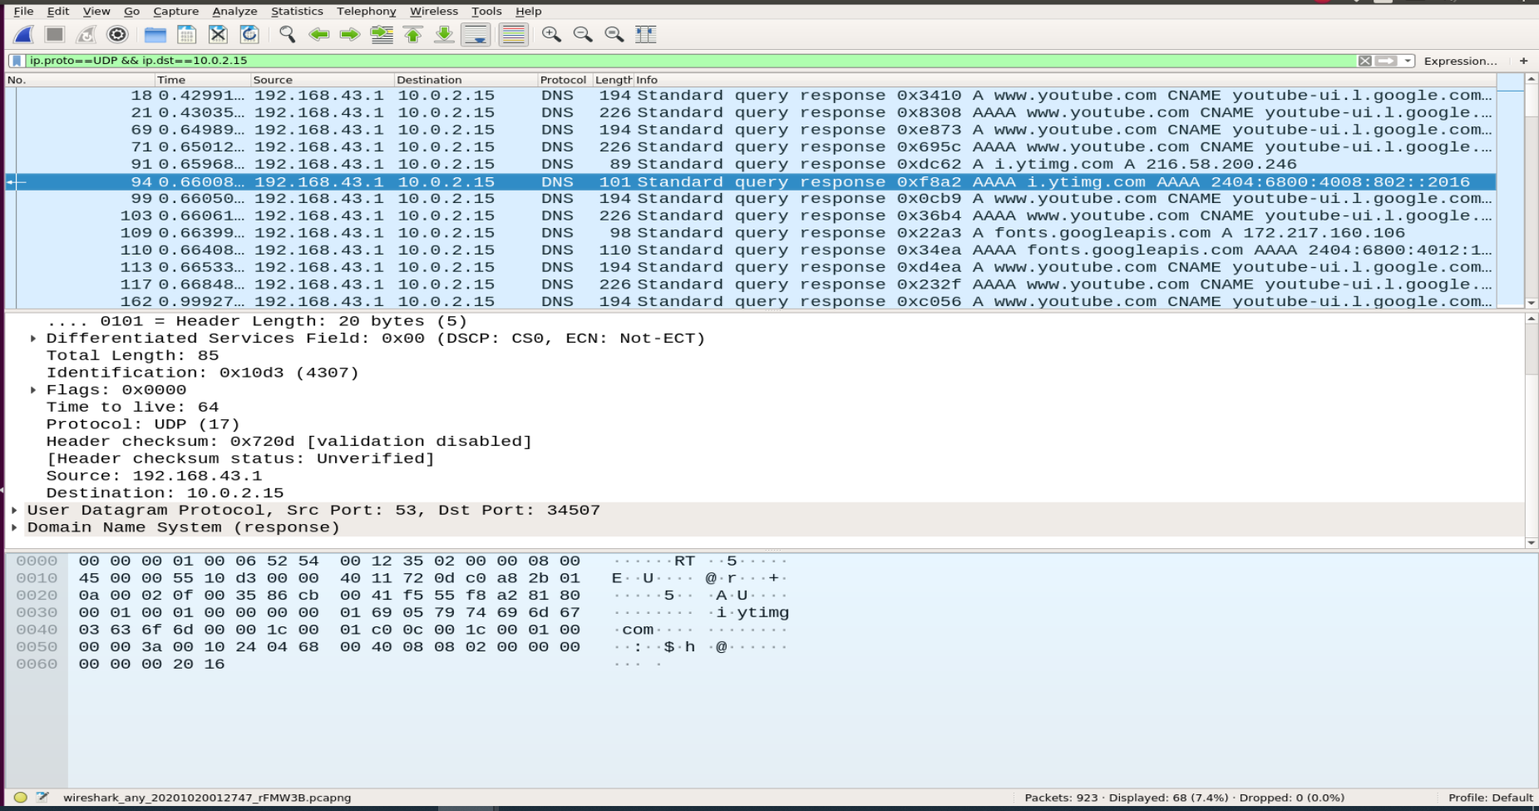

Webserver : DNS server (192.168.43.1)

Service: Mapping the domain name I requested (www.youtube.com) to IPv4 (216.58.200.238) address.

Why DNS prefer to use UDP? : UDP is faster and has less overhead than TCP. A DNS query is simple for the client. Therefore, if the request or response is not too large, using UDP is more economic. (Still exists a few cases use TCP for DNS.) Even though UDP is unreliable, it has good extensibility. We can add timeout or resend on the application layer to make it reliable.

02 Analysis of TCP packets

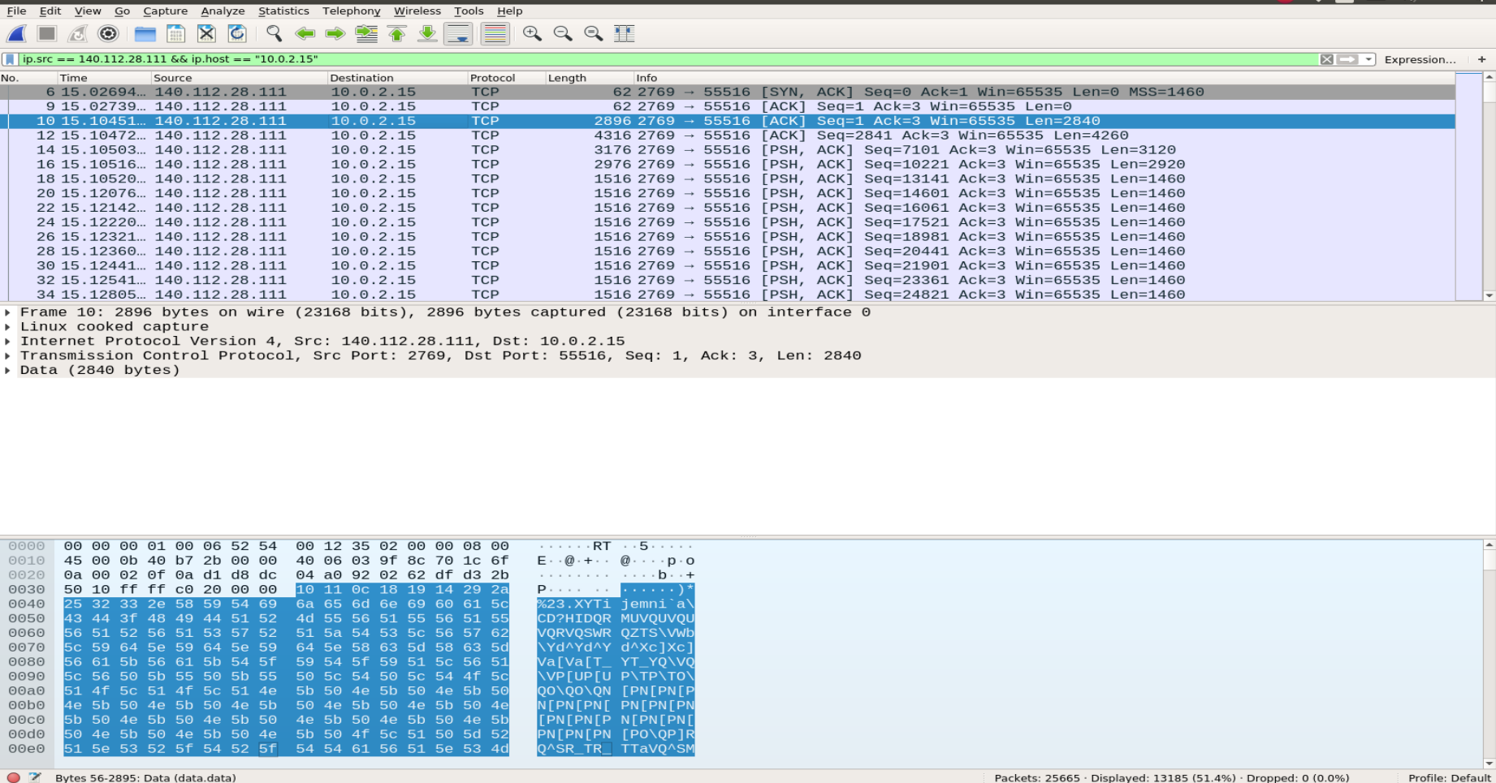

The server uses the port 2769.

03 Compare the headers of transport layer between TCP and UDP

* The average length of packet used TCP is larger than used UDP.
* TCP can transmit encrypted packets; while UDP usually transmit in plaintext.
* UDP only provides checksum; while TCP provides checksum, flags, sequence number, time stamp, etc.

04 Find out a plaintext password

* Screenshot of a packet

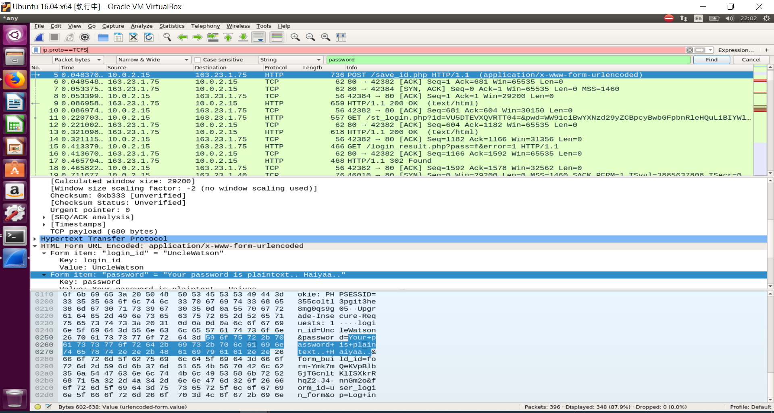

* website: 大葉大學學生資訊系統 http://sis.dyu.edu.tw/RWD/

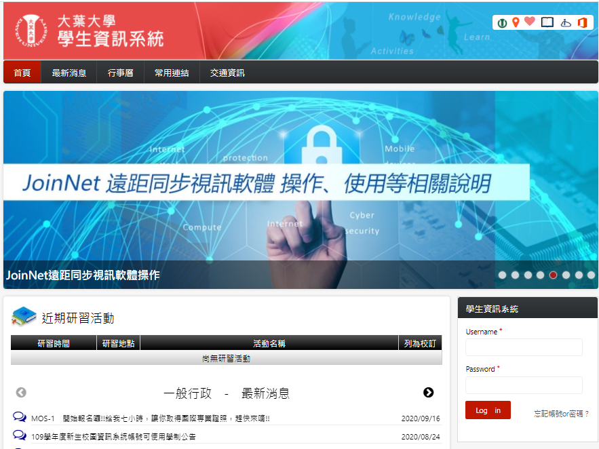

* Why is it not safe?

Transporting the packet may pass over many routers. If there is an attacker sniffer between the link of the user and server, he may get the plaintext of password and be able to access the user’s account.

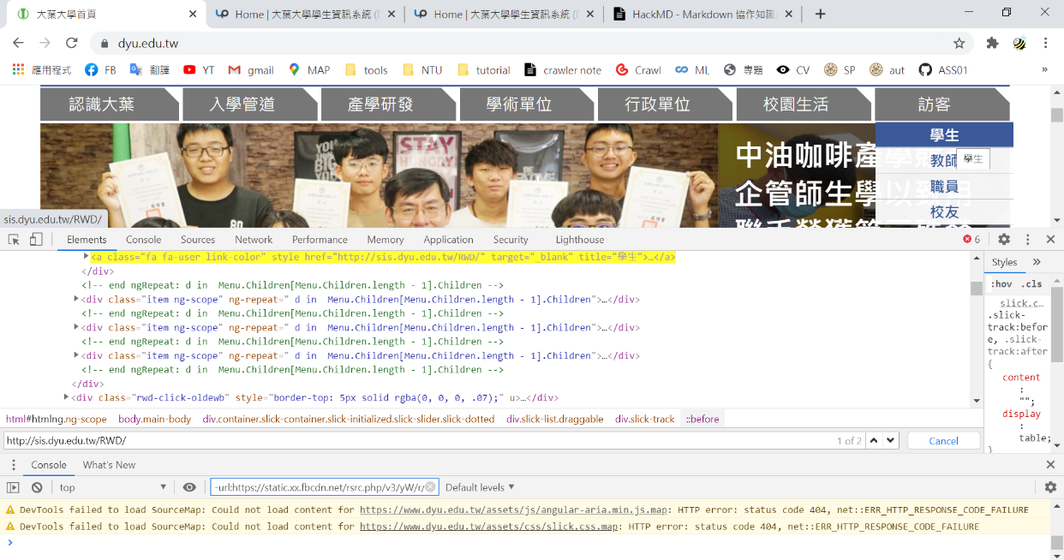Bonus

* I found that the student system is insecure due to the homepage which jumps to the student system has an insecure HTML code: the href attribute uses http rather than https. https will encrypt the packet while http won’t.