CN-2020 Homework3 Report B07902078 資工三 沈韋辰

***How to execute your program***

Makefile:

$make sender

$make receiver

$make agent

$make player

or

$make

Execute:

1. $./agent [sender IP] [receiver IP] [sender port] [agent port] [recv port] [loss_rate]
2. $./receiver [agent IP] [agent port] [receiver port]
3. $./sender [agent IP] [agent port] [sender port][video_name ]

***Explain your program structure***

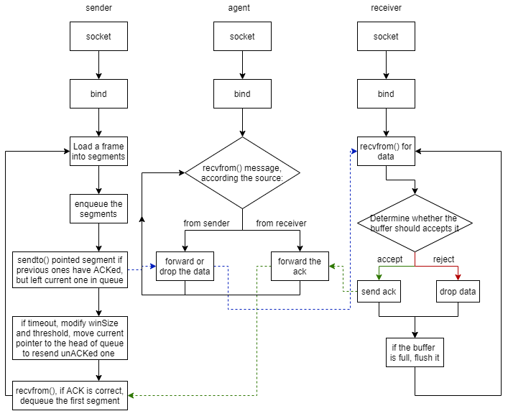

Github: https://github.com/SaintWatson/CN2020-hw3/tree/vers