**Computer Vision Homework 1** B07902078 資工三 沈韋辰

**Part.1**

Language: Python3.8.3 Modules: OpenCV(cv2)

1. upside-down lena.bmp

**一張含有 個人, 女性, 相片, 穿著 的圖片

描述是以非常高的可信度產生****Algorithm:** For each pixel, exchange it with the pixel in the same column but reverse row, so we can get the upside-down image.

1. right-side-left lena.bmp

**Algorithm:** For each pixel, exchange it with the pixel in the same row but reverse column, so we can get the right-side-left image 一張含有 個人, 女性, 建築物, 服飾 的圖片

描述是以非常高的可信度產生

1. diagonally flip lena.bmp

一張含有 桌, 坐, 盤, 女性 的圖片

描述是以非常高的可信度產生**Algorithm:** For each pixel, exchange it with the pixel that exchange its row and column coordinate, so we can realize “diagonally flipping” (Just like a transpose of matrix)

**Part.2**

Language: Python3.8.3 Modules: OpenCV(cv2), imutils

1. rotate lena.bmp 45 degrees clockwise

**Algorithm:** 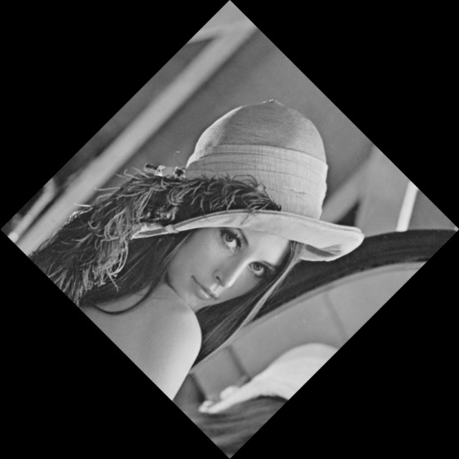We use the method “rotate_bound()” in the module “imutils” to rotate the image 45 degree clockwise.

1. shrink lena.bmp in half

一張含有 個人, 女性, 室外, 服飾 的圖片

描述是以非常高的可信度產生**Algorithm:** We use the method “resize()” in the module “imutils” to shrink the image in half.

1. binarize lena.bmp at 128 to get a binary image

**Algorithm:** We traverse all the pixel, if its value is higher than or equal to 128一張含有 文字 的圖片

描述是以非常高的可信度產生, then raise it to 255 (brightest). Otherwise, reduce it to 0 (darkest).