**Computer Vision Homework 3** B07902078 資工三 沈韋辰

Language: Python3.8.3

Modules: OpenCV(cv2), numPy, matplotlib.pyplot

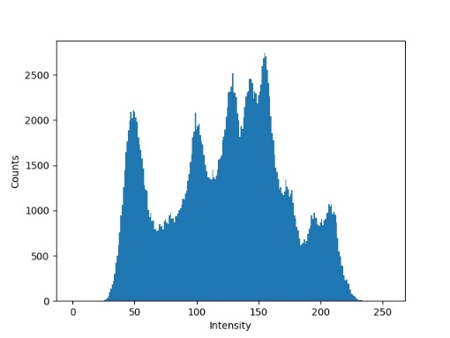**一張含有 個人, 女性, 室外, 服飾 的圖片

描述是以非常高的可信度產生**(a) Original image and its histogram:

**Algorithm:** Accumulating the pixels with the same intensity and draw it by the function *matplotlib.pyplot.bar.*

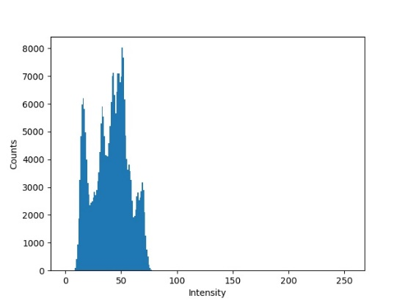(b) Image with intensity divided by 3 and its histogram:

**一張含有 個人, 女性, 室內, 握住 的圖片

描述是以非常高的可信度產生Algorithm:** Just traversing the image and divide the intensity by 3. After adjusting, the histogram will be steeper and assembled on the right side (dark side).

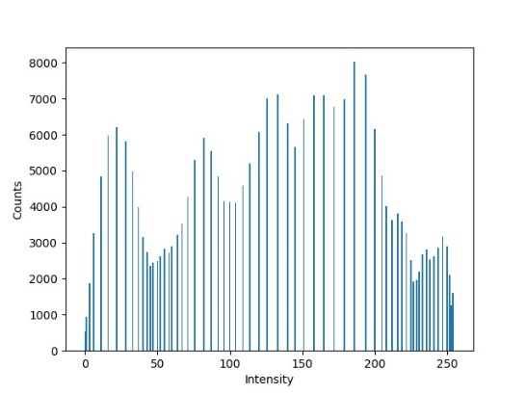一張含有 個人, 女性, 室外, 服飾 的圖片

描述是以非常高的可信度產生(c) image after applying histogram equalization to (b) and its histogram:

**Algorithm:** Counting the pixels with the same intensity and then computing the accumulation list. Mapping all the pixel to the new intensity, then the contrast will get higher.