**Computer Vision Homework 7** B07902078 資工三 沈韋辰

Language: Python3.8.3

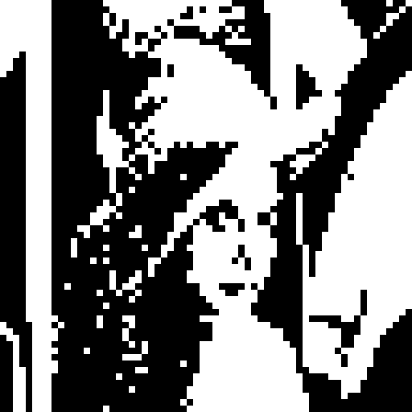Modules: OpenCV(cv2), numPy

Step.1  Binarize and downsample Lena

**Algorithm:**

Use 128 for threshold and take the topmost-left pixel as the downsampled data. (Duplicate the value to 8x8 block)

Step.2 Calculate the pair relationship

**Algorithm:**

First, compute the Yokoi value of all the pixels. Then, we follow the rule: if the Yokoi value of the pixel is 1 and there is at least one of its neighbors is also 1, we mark this pixel. Otherwise, we don’t mark it.

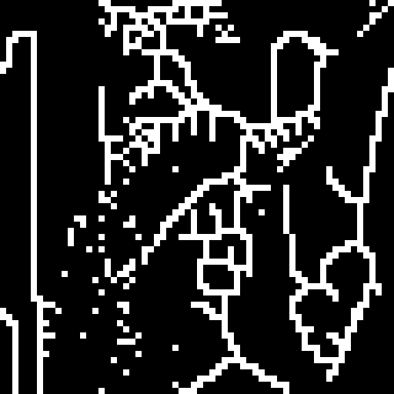Step.3 Thinning the image

**Algorithm:**

For all the marked pixels, if their Yokoi value is 1, we remove it. (Note: We have to compute the Yokoi value every time dynamically since some of pixels may be remove.) When we finish, check if the new image is same as the previous one. If they are different, repeat step.2 and 3 until the image doesn’t change anymore. (In this case, we repeat the step 7 times.)