INTEGRATION OF BARANGAY REQUISITION IN DIGITAL SERVICES

A Capstone Project Proposal Presented to the
Faculty of the College of Computer Studies Department
BENEDICTO COLLEGE – MANDAUE CAMPUS
A.S Fortuna St, Mandaue City, Cebu

In Partial Fulfillment of the Requirement for the Degree of
Bachelor of Science in Information Technology

Craig Lei Vayne Beduya
Crisline Marie G. Fajardo
Claire Danielle P. Apal
Ivhan C. Macrohon
Jobert P. Cabasa
John Marvin B. Salazar

January 2026
Chapter 1
THE PROBLEM AND ITS SCOPE
Rationale
Barangay services are an important part of everyday life because residents often need documents, information, and assistance from their local barangay. In Barangay Bakilid, some services still involve manual procedures, requiring residents to personally visit the barangay hall to make requests. This can be inconvenient for people who have work, school, or other responsibilities, especially when they need to wait in line or return to the barangay just to follow up on their requests. These situations show the need for a more convenient way of accessing barangay services.
One area that can be improved is service accessibility and information dissemination. Residents may need to know the requirements, available services, announcements, and changes in procedures before making a request. The proposed system can provide an online platform where residents of Barangay Bakilid can easily view important information in one place. It can also help the barangay share announcements and service updates more quickly, making it easier for residents to stay informed without always having to visit the barangay hall.
The system will also focus on making request processing more convenient. Residents can use the online platform to request commonly needed documents such as Barangay Clearance, Certificate of Residency, Certificate of Indigency, Business Permit, and other documents or certifications that are available through the barangay. Instead of starting the process through paper forms and an initial visit to the barangay hall, registered residents can submit their requests online. Barangay personnel can then review and manage the requests using digital forms and a centralized database, helping make the process more organized and reducing unnecessary manual work.
The proposed system will also provide request tracking, notifications, and a grievance or feedback mechanism. Residents can check the status of their requests and receive updates instead of repeatedly visiting the barangay hall to ask about their applications. If residents have concerns, questions, or complaints regarding a service or request, the grievance or feedback feature can provide another way for them to communicate with barangay personnel. This can help improve communication between the barangay office and residents while making the handling of requests and concerns more organized.
Overall, the Integration of Barangay Requisition in Digital Services through the Barangay Bakilid E-Service Management System aims to make barangay services more accessible, organized, and convenient for the community. By combining information dissemination, online request processing, request tracking, notifications, and resident feedback, the system can help address some of the difficulties caused by the current manual process. It is intended to benefit both residents and barangay personnel by making requests easier to submit and monitor while helping staff manage records and services more efficiently. This supports the study's goal of improving the efficiency, accessibility, transparency, and delivery of services in Barangay Bakilid.
Theoretical Background
As local government units in the Philippines continue to adopt digital technologies, the development of e-service management systems has become essential in improving public service delivery at the barangay level. The Digital Transformation in Local Governance Improving Barangay Service Accessibility is designed to enhance efficiency, accessibility, and transparency in providing services to residents. Understanding the theoretical foundations of technology adoption and system implementation is crucial in ensuring the effectiveness and sustainability of such systems. This section presents relevant theories that guide the design, development, and evaluation of e-service management systems within the context of barangay governance.
Digitalizing Governance: A Transformation on the Processes of One Community in the Philippines (Aliling et al., 2025). The study is anchored on the concept of Digital Governance, as presented by Aliling et al. (2025) in their study Digitalizing Governance: A Transformation on the Processes of One Community in the Philippines. The authors explain that digital governance refers to the integration of digital technologies into local government processes to improve the efficiency, transparency, and accessibility of public services. Their study highlights the implementation of an Electronic Barangay Information Management System (E-BIMS), which modernized traditional barangay operations by automating records management, document processing, and service delivery. This approach demonstrates how digital technologies can enhance the overall performance of local government units (LGUs) while promoting citizen-centered governance.
In relation to the present study, the theory provides a strong foundation for the Integration of Barangay Requisition in Digital Services. Similar to the E-BIMS, the proposed system seeks to replace the traditional paper-based requisition process with a digital platform that enables faster request processing, organized record management, and improved coordination among barangay personnel. By integrating requisition services into a digital system, the study aims to reduce delays, minimize manual errors, and enhance the efficiency of barangay operations, ultimately leading to better public service delivery.
Furthermore, Aliling et al. (2025) emphasize that digital governance is not only about adopting new technologies but also about transforming government processes to create more responsive, transparent, and efficient public services. This perspective is highly relevant to the present study because the success of a digital barangay requisition system depends on its ability to improve operational performance while meeting the needs of both barangay officials and the community. Guided by this theoretical framework, the study seeks to demonstrate how integrating requisition services into digital platforms can support effective governance, strengthen transparency, and contribute to the continuous digital transformation of barangay administration.
Digital Transformation in Public Administration (Elena Dobrolyubova, 2021). According to Dobrolyubova, digital transformation is more than simply adopting new technologies in government offices. It involves redesigning government processes and public services to improve efficiency, transparency, and the overall quality of service delivery. The theory emphasizes that digital transformation should create value not only for government institutions but also for citizens and businesses by making public services more accessible, responsive, and user-centered. This perspective supports the idea that technology should be integrated into government operations to improve administrative performance and meet the changing needs of the public.
In relation to this study, the theory provides a strong foundation for integrating the barangay requisition process into digital services. Traditional paper-based requisition systems often result in delays, misplaced documents, and inefficient processing. By applying the principles of digital transformation, the proposed system aims to streamline requisition requests, improve record management, and allow faster communication between barangay officials and concerned departments. The theory also highlights the importance of measuring the actual outcomes of digital initiatives, ensuring that the implementation of digital systems produces meaningful improvements in service quality, operational efficiency, and stakeholder satisfaction rather than simply replacing manual processes with electronic ones.
Furthermore, Dobrolyubova (2021) explains that successful digital transformation should be evaluated based on its impact on different stakeholders, including citizens, government employees, and the organization itself. This concept is highly relevant to the present study because the integration of a digital barangay requisition system is expected to benefit both barangay personnel and residents by reducing processing time, increasing transparency, minimizing paperwork, and improving the accessibility of public services. Guided by this theoretical framework, the study seeks to determine how integrating barangay requisition into digital services can contribute to a more efficient, reliable, and citizen-centered barangay administration while supporting the broader goals of digital governance.
Implementation of Electronic Services in Social Protection Systems (Zastelo et al., 2021). The rapid development of the information society and the integration of Information and Communication Technologies (ICT) into public administration have significantly transformed governance systems worldwide. The adoption of digital technologies has enabled governments to improve efficiency, transparency, accountability, and accessibility in the delivery of public services. Through e-government initiatives, administrative processes are modernized, information management is enhanced, and communication between government institutions and citizens is strengthened.
In this context, digital platforms play a crucial role in supporting data collection, processing, storage, and dissemination, ensuring that public services are delivered in a timely and organized manner. The continuous advancement of technology further emphasizes the need for structured systems that can adapt to evolving community requirements and governance standards User satisfaction remains one of the most widely recognized indicators of information system success. Early studies introduced validated measurement instruments to assess satisfaction levels among system users.
The User Information Satisfaction model developed by Ives, Olson, and Baroudi (1983) emphasized perceptions of information quality and system performance. Bailey and Pearson (1983) created a comprehensive measurement tool covering multiple dimensions of user experience, while Doll and Torkzadeh (1988) proposed the End-User Computing Satisfaction (EUCS) model, focusing on content, accuracy, format, ease of use, and timeliness. These foundational models demonstrate that user satisfaction is influenced by system performance and usability, making it a critical factor in evaluating digital service platforms, particularly in e-government environments where service quality and public trust are essential.
WeBarangay: A Local E-Government Services Web Application (Rey et al., 2024) explains how web-based platforms can improve the delivery of barangay services. Digital systems allow local governments to provide faster, more organized, and more accessible services to residents. Through a well-designed website interface, users can easily access announcements, community information, and available barangay services in one place. This helps residents stay informed about programs, activities, and services while conveniently accessing what they need online.
In many barangay web systems, the homepage serves as the main communication platform between the barangay officials and the residents. It usually displays announcements, updates, and important advisories to keep the community informed. The system also includes sections for requesting documents, accessing forms, and reserving barangay facilities. Additionally, the system contains an administrator dashboard that allows authorized staff to manage service requests, update announcements, monitor records, and maintain accurate information within the platform.
The effectiveness of web-based barangay systems can be explained using the Technology Acceptance Model (TAM) developed by Fred Davis (1989). This theory states that users accept and use a technology based on factors such as Perceived Usefulness, Attitude Toward Use, and Behavioral Intention to Use. These factors determine whether people find the system helpful, easy to use, and worth continuing to use. By applying this model, researchers can evaluate how residents respond to digital barangay systems and determine their effectiveness in improving public service delivery.
WebYu: A Barangay Web-Based Information Management System (Tosper et al., 2025) highlights the important role of barangays as the primary providers of public services in the Philippines. Guided by the Local Government Code of 1991, barangays are responsible for issuing essential documents such as business clearances, residence certificates (cedulas), certifications of residency, and certificates of indigency. These documents support various administrative, legal, and social needs of residents. However, the study points out that the delivery of these services is often affected by inefficient manual record-keeping systems, which lead to errors, delays, and difficulty in retrieving accurate information.
To address these challenges, the study emphasizes the use of a web-based information management system supported by several theoretical frameworks. Information Systems Theory explains how technology can improve the processing, storage, and management of data, making records more accurate and accessible. E-Governance Theory further supports the use of digital platforms to enhance transparency, efficiency, and citizen engagement in government services. In addition, Records Management Theory highlights the importance of properly organizing and maintaining records throughout their lifecycle to ensure reliability, security, and ease of retrieval.
The study also applies the Technology Acceptance Model (TAM) to explain how users adopt new technologies. It suggests that barangay personnel are more likely to use a system if they find it useful and easy to operate. By integrating these theories, the study provides a strong foundation for developing a web-based system that improves record management, reduces processing time, and enhances overall service delivery. Ultimately, the research supports the transition from manual to digital systems to achieve more efficient, accurate, and transparent barangay operations.

BARANGAY BAKILID E-SERVICE MANAGEMENT SYSTEM

WeBarangay: A Local E-Government Services Web Application for N.S. Amoranto in Quezon City, Philippines
by William P. Rey and colleagues (2024)
E-Government in the Philippines: Benchmarking Against Global Best Practices by Emmanuel C. Lallana, Patricia J. Pascual, and Edwin S. Soriano (2002)

A Web-Based Performance Monitoring System for E-Government Services” by Simon Fong and Ho Si Meng (2009)

Implementation of Electronic Services in the System of Population Social Protection
by Anna Zastelo, Tetiana Serha, Vladislav Koval, Yana Vikhliaieva, and Nataliya Shuberty (2021)

WebYu: A Barangay Yuson Web-Based Information Management System Initiatives by Rafael M. Tosper Jr. and colleagues (2025)

An integrated e-government service management system that enhances efficiency, accessibility, and transparency in barangay operations by leveraging web-based platforms, performance monitoring, and electronic service implementation.

Figure 1
Theoretical Framework

Statement of the Problem
Despite the availability of technology today, many barangays still use manual and paper-based processes when providing services to residents. In Barangay Bakilid, residents usually need to visit the barangay hall personally when requesting documents such as barangay clearances, certifications, and other services. This can be inconvenient, especially for residents who have work, school, or other responsibilities. It may also result in long waiting times when many people request services at the same time.
The use of manual records can also make it difficult for barangay staff to organize, find, and monitor requests. Documents may be misplaced, duplicated, or take longer to retrieve. Residents also have limited ways to check the progress of their requests unless they return to the barangay hall. These concerns show the need for a system that can make the requisition process more convenient, organized, and easier to monitor.
Specifically, this study aims to answer the following questions:
- How can the proposed system make the process of requesting barangay services easier and more convenient for residents?
- How can the system help reduce the time and effort needed to submit and process barangay requisition requests?
- How can the system help barangay staff organize and manage residents' records and service requests more efficiently?
- How can the system allow residents to check the status of their requests without having to visit the barangay hall repeatedly?
- How can the system improve the way barangay officials communicate announcements, updates, and information to residents?
- How can the system help minimize errors, misplaced records, and other problems associated with the current manual process?
- How acceptable is the proposed system to residents and barangay personnel in terms of its functionality, usability, accessibility, and efficiency?
General Problem of the Study
Many barangays still depend on manual and paper-based processes when providing services to their residents. In Barangay Bakilid, people usually need to visit the barangay hall personally to request documents such as barangay clearance, certifications, and other related services. This situation can sometimes lead to long waiting times, delays in processing requests, and inconvenience for residents who have work or other responsibilities during office hours. As the number of residents increases, managing requests through traditional methods becomes more difficult for both the residents and the barangay staff.
Because of these challenges, the current system of handling requests and records may not always be efficient or well organized. Documents can be harder to manage, and residents have limited ways to check the progress of their requests without going back to the barangay hall. These issues highlight the need for a more convenient and organized approach to service delivery. Therefore, this study focuses on developing a Barangay Bakilid E-Service Management System that can help improve the way services are requested, processed, and monitored within the barangay.
Specific Problems of the Study
- Manual processing of requests. Most transactions in Barangay Bakilid are still done using paper forms and manual procedures, which can slow down the processing of documents and sometimes result in long waiting times for residents.
- Limited access to barangay services. Residents usually need to visit the barangay hall during office hours to request documents or services, which can be inconvenient for those who have work, school, or other responsibilities.
- Unorganized record management. Since many records are stored as physical files, documents may become misplaced, duplicated, or difficult to locate when needed, which can delay verification and processing.
- Lack of request tracking. Residents currently have no convenient way to check the progress of their requests, which often leads them to return to the barangay hall just to ask for updates.
- Limited communication and service updates. Without an online platform, announcements, updates, and information about requests may not always reach residents quickly, which can affect transparency and communication between the barangay office and the community.
General Objective of the Study
The main objective of this study is to design and develop the Barangay Bakilid E-Service Management System that will help improve the delivery of barangay services to residents. The proposed system aims to provide an online platform where residents can conveniently submit requests for documents such as barangay clearances, certifications, and other related services without the need to personally visit the barangay hall.
In addition, the study aims to help barangay staff manage service requests and records more efficiently through the use of digital forms and a centralized database. By introducing this system, the study seeks to improve the organization of records, reduce delays in processing requests, and make it easier for residents to receive updates regarding their applications. Overall, the system is expected to support a more organized, accessible, and efficient way of delivering services in Barangay Bakilid.
Specific Objectives of the Study
- To Develop an Online Service Platform. Create an online platform where residents of Barangay Bakilid can request barangay services and submit applications without needing to go to the barangay hall in person.
- To Provide Request Tracking and Notifications. Enable residents to monitor the status of their requests and receive notifications or updates about their applications.
- To Improve Record Management. Establish a digital database where all documents and requests are stored securely and can be easily accessed, reducing the risk of lost or duplicated files.
- To Reduce Processing Time. Automate the processing of requests using digital forms to minimize manual handling, shorten waiting times, and reduce errors.
- To Enhance Communication and Transparency. Use the system to share announcements, updates, and important information, improving communication between the barangay office and its residents.
Scope and Limitation

Scope
This study focuses on the development of the Barangay Bakilid E-Service Management System, an online platform intended for the residents and authorized personnel of Barangay Bakilid. The system will focus on selected barangay processes that can reasonably be handled through a web-based platform.
The system will allow registered residents to create and access their accounts and view information about available barangay services, requirements, announcements, and updates. It will also allow residents to submit online requests for selected documents, which may include Barangay Clearance, Certificate of Residency, Certificate of Indigency, Business Permit, and other documents or certifications that are approved for online processing by Barangay Bakilid.
For request processing, the system will allow residents to submit the required information and supporting documents, while authorized barangay personnel can review submitted requests, update their status, and manage the corresponding records. Residents will also be able to monitor the progress of their requests and receive notifications or updates through the system.
The system will also include information dissemination through announcements and service updates. In addition, a grievance or feedback feature may be provided to allow residents to submit concerns, complaints, or feedback related to the services and requests handled through the system. Authorized barangay personnel will be responsible for reviewing and responding to these submissions.

Limitations
The system will be limited to Barangay Bakilid and will not cover services from other barangays, municipalities, or government offices. Only registered and authorized users will be able to access the appropriate system functions.
The system will focus only on selected barangay services and documents that can be processed through the online platform. Requests that require extensive physical verification, personal appearance, on-site inspection, or approval from offices outside Barangay Bakilid will remain subject to the existing procedures of the barangay.
The system will provide basic request tracking and status updates but will not automatically approve applications or make decisions on behalf of barangay officials. Final verification, approval, and release of documents will remain under the responsibility of authorized barangay personnel. The system will not include advanced automated approvals or integration with external government systems.
The effectiveness of the system may also depend on internet connection, device availability, and the user's familiarity with online platforms. Residents who do not have reliable internet access or appropriate devices may still need to visit the barangay hall.
Finally, the study will focus on the initial development and implementation of the system. Long-term maintenance, major future upgrades, integration with other government systems, and additional services outside the defined scope are not included in the present study.
Significance of the Study
For Barangay Officials and Staff - The system will help barangay personnel manage service requests more efficiently. By providing a centralized online platform, staff can review applications, track their progress, and update records in real-time. This reduces manual workload, minimizes errors, and allows employees to focus on providing faster and more organized service to residents.
For Residents - Residents of Barangay Bakilid will benefit from easier access to barangay services. They can submit requests, monitor the progress of their applications, and receive updates without having to physically visit the barangay hall. This convenience saves time, reduces long waiting lines, and ensures that requests are handled more systematically and transparently.
For Barangay Bakilid - Implementing the system supports a more modern and citizen-centered approach to local governance. By adopting technology to improve service delivery, the barangay can enhance transparency, accountability, and trust between officials and residents. It also shows that Barangay Bakilid is embracing digital solutions for community services.
For Future Researchers - This study provides a framework for developing web-based barangay service systems that improve efficiency and accessibility. Future researchers can use the findings as a reference for similar projects in other barangays, exploring ways to expand digital services, enhance user experience, improve record management, and strengthen system security.
For the Community - Ultimately, the system contributes to better communication, faster service delivery, and higher satisfaction among residents. The community benefits from a more organized, reliable, and accountable barangay office, creating a stronger connection between the local government and its constituents.

Chapter 2
REVIEW OF RELATED LITERATURE AND STUDIES
Related Literature
The role of technology in local government administration has become more and more important, especially when viewed in the context of local governance and service delivery. In the efforts of local government units to effectively implement innovative technologies such as e-service management systems, it is important to understand the various determinants that influence technology adoption among local residents and officials. This literature review will focus on recent studies that investigate the relationship between digital literacy, automated profiling and certification, data privacy protection, and e-inclusion in the context of local government in the Philippines.
Enhancing Barangay Household Registration with Google Maps by Reyna (2023) highlights how barangay systems integrate mapping technology to improve the accuracy and efficiency of household registration. According to the study, the system utilizes Google Maps to visualize resident locations, allowing barangay officials to better analyze and manage community data. The system enables staff to organize records systematically, making it easier to track households and generate reports. The author emphasized that traditional methods of registration are often inefficient and prone to errors due to manual processes. The implementation of a digital system enhances decision-making, improves service delivery, and ensures more accurate and accessible barangay records for both officials and residents

Development and Evaluation of Web-Based Barangay Profiling and Issuance System by Ballaran, Donaire, Singzon, Naz, Tanael, and Centeno (2023) highlights the importance of web-based systems in improving barangay service delivery. According to their study, the Barangay Profiling and Issuance System allows efficient management of resident data and faster processing of certificates and documents. The system helps barangay staff automate transactions, organize records, and monitor requests effectively. The authors stated that manual systems often result in delays, inefficiency, and data inconsistency. The use of a web-based system improves accuracy, reduces processing time, and enhances the overall efficiency of barangay operations and public service delivery.
Enhancing Barangay Information System with Chatbot and Geolocation by Cuevas, Gonzaga, Roque, Centeno, and Co (2024) highlights how barangay offices adopt digital systems to improve service delivery and community engagement. According to their study, the Barangay Information System integrates features such as resident data management, chatbot assistance, and geolocation technology to provide faster and more accessible services to citizens. The system allows barangay staff to efficiently manage records, process requests, and respond to inquiries in real-time. It also enhances transparency and reduces manual workload by automating transactions and organizing data. The authors emphasized that traditional barangay processes are often slow and inefficient due to manual handling of records, which can lead to delays and errors. The implementation of digital systems in barangays improves operational efficiency, user satisfaction, and overall public service delivery, making it easier for residents to access services quickly and conveniently.
Digitalizing Governance: A Transformation on the Processes of One Community in the Philippines by Aliling, Santa Ana, and Soberano (2025) highlights how the implementation of an Electronic Barangay Information Management System improves administrative processes. According to the study, the system transforms traditional barangay operations into a more efficient digital platform that enhances accessibility, accuracy, and speed of services. It enables barangay staff to manage records, process transactions, and provide services more effectively. The authors emphasized that manual systems limit efficiency and accessibility, while digital transformation improves transparency and service quality. The study concluded that adopting digital systems significantly enhances barangay governance and public service delivery.
An Academic Extension-Driven Solution for Enhancing Local Governance by Calibo-Senit (2026) highlights the role of digital barangay information systems in improving local governance. According to the study, the developed system addresses inefficiencies in barangay operations by automating processes and organizing data into a centralized platform. The system enables faster transaction processing, better record management, and improved accessibility of services for residents. The author emphasized that many barangays still face challenges due to limited digital adoption and manual processes. The implementation of digital systems enhances efficiency, supports decision-making, and improves the overall delivery of services in local communities.
Related Studies
In the development of the Barangay Bakilid E-Service Management System, various studies provide critical and essential ideas that play crucial roles in the development and implementation of the system in barangay settings. The studies usually cover essential factors that play crucial roles in the development and implementation of the system in barangay settings. The most common areas of study that will be crucial in the development of the barangay Bakilid e-Service Management System include.
Barangay Certificate Issuance and Record Management System with Descriptive Analytics by Pinon, Pornobi, and Mancenido (2021) highlights how barangay offices can improve efficiency through a digital certificate issuance and record management system. According to their study, the system allows barangay staff to encode resident information, process certificate requests, and generate reports with the help of descriptive analytics. The system enhances data organization and minimizes errors compared to manual processes. The authors emphasized that traditional record-keeping often leads to delays, data loss, and inefficiency. The implementation of a digital system enables faster processing and improves service delivery for residents.
Analytics-based Barangay Profiling System by Jacobe and associates (2021) highlights the importance of using analytics in managing barangay data. According to the study, the system provides tools for profiling residents and analyzing community information to support decision-making. It allows barangay officials to organize and interpret data more effectively. The authors stated that manual profiling systems are often inaccurate and time-consuming. The use of analytics-based systems improves data accuracy, enhances planning, and supports better governance in barangay operations.
An Open Data and Geo-based Information System by Mercurio and Hernandez (2022) highlights how integrating open data and geolocation technology improves information accessibility in local governance. According to their study, the system enables users to access location-based data and visualize information for better understanding and decision-making. The system allows efficient management of community data and improves transparency. The authors emphasized that traditional systems lack accessibility and real-time data capabilities. The implementation of a geo-based system enhances service delivery and supports informed decision-making in local government units.
Cloud-First Projects in Local Government in the Philippines by Dela Cruz and Santos (2022) highlights the adoption of cloud computing technologies in improving government services. According to their study, cloud-based systems allow secure data storage, real-time access, and efficient management of government operations. The system enables local government units, including barangays, to streamline processes and reduce infrastructure costs. The authors stated that traditional systems are limited by physical storage and accessibility issues. The adoption of cloud-first solutions improves scalability, efficiency, and overall service delivery in local governance.
UX Frameworks for Digital Inclusion at the Barangay Level by Villanueva (2024) highlights the importance of user experience design in developing digital government systems. According to the study, user-friendly interfaces and inclusive design improve accessibility and usability for all residents. The system ensures that services are easy to navigate and understand, even for users with limited technical skills. The author emphasized that poorly designed systems can limit adoption and effectiveness. The application of UX frameworks enhances user satisfaction, increases system usage, and improves the overall effectiveness of digital barangay services.

Chapter 3
TECHNICAL BACKGROUND
The proposed system will be developed using modern web development technologies and software tools to ensure efficiency, reliability, security, scalability, and maintainability. The researchers selected these technologies because of their capability to support dynamic web applications, improve development productivity, and provide a responsive and user-friendly experience for users. The combination of frontend frameworks, backend technologies, database management systems, security tools, and deployment platforms will contribute to the successful implementation of the proposed capstone project.
Frontend Technologies
React
React is a JavaScript library developed for building interactive and dynamic user interfaces, particularly for single-page applications. It allows developers to create reusable components, making the development process more organized, efficient, and maintainable. React improves application performance through the use of a virtual DOM (Document Object Model), which updates only the necessary parts of the webpage instead of reloading the entire page. In this study, React will be utilized to develop the user interface of the system, including dashboards, forms, navigation menus, and other interactive components that enhance the overall user experience.
Vite
Vite is a modern frontend build tool and development server designed to provide faster development and optimized application performance. Unlike traditional bundlers, Vite offers rapid startup times and instant updates during coding through Hot Module Replacement (HMR). This allows developers to immediately see changes made in the application without needing to refresh the browser manually. In the proposed system, Vite will be used to streamline frontend development, improve productivity, and optimize the performance of the React application during both development and deployment stages.
Tailwind CSS
Tailwind CSS is a utility-first CSS framework used for designing responsive and modern user interfaces. It provides pre-defined utility classes that simplify the process of styling webpages without the need to write extensive custom CSS code. Tailwind CSS enables developers to create clean, consistent, and mobile-friendly layouts efficiently. In this project, Tailwind CSS will be used to design the visual appearance of the system, ensuring responsive layouts, improved readability, and enhanced user interaction across different screen sizes and devices.
TypeScript
TypeScript is a modern programming language developed by Microsoft that builds on JavaScript by adding static typing and advanced development features. It helps developers create more organized, scalable, and error-free applications by allowing them to define data types for variables, functions, and objects. TypeScript is commonly used in web and software development because it improves code readability, detects errors during development, and makes large projects easier to maintain. Since it is a superset of JavaScript, any valid JavaScript code can also work in TypeScript, making it easier for developers to transition from JavaScript while gaining additional tools and features for efficient programming.

Axios
Axios is a promise-based HTTP client used to facilitate communication between the frontend and backend of the system. It allows developers to send and receive data through API requests efficiently and securely. Axios simplifies asynchronous operations such as retrieving records, submitting forms, updating information, and deleting data from the database. In this capstone project, Axios will be integrated into the frontend application to handle API requests and ensure smooth data exchange between the React frontend and the Express backend server.
Backend Technologies
Node.js
Node.js is a JavaScript runtime environment that enables developers to execute JavaScript code on the server side. It is designed to handle multiple requests efficiently through its non-blocking and event-driven architecture. Node.js is highly suitable for web applications that require fast performance and real-time processing. In the proposed system, Node.js will be used to manage server-side operations, process requests from users, handle database communication, and execute backend functionalities necessary for the application.
Express.js
Express.js is a lightweight and flexible web application framework built on top of Node.js. It simplifies backend development by providing tools for routing, middleware integration, API creation, and server management. Express.js enables developers to structure backend code more efficiently and maintain cleaner project architecture. In this study, Express.js will be used to create RESTful APIs, process client requests, manage authentication, and establish communication between the frontend and database systems.
REST API’s
REST (Representational State Transfer) is an architectural style used for designing web services and APIs. REST APIs allow different systems or components to communicate using standard HTTP methods such as GET, POST, PUT, and DELETE. This architecture improves the scalability, flexibility, and maintainability of web applications. In the proposed system, REST API architecture will be implemented to establish structured communication between the frontend application, backend server, and database management system.
JSON Web Token
JSON Web Token (JWT) is a secure authentication mechanism used for verifying and authorizing users within a system. JWT works by generating encrypted tokens after successful user login, allowing users to access protected routes and resources securely. This minimizes the risk of unauthorized access and improves overall system security. In this capstone project, JWT will be implemented to manage user authentication sessions and secure access to different system functionalities based on user roles and permissions.
Bcrypt
bcrypt is a password hashing library used to protect sensitive user credentials by encrypting passwords before storing them in the database. Instead of saving plain text passwords, bcrypt converts them into secure hashed values that are difficult to decode. This enhances data privacy and protects user accounts from security threats such as unauthorized access and database breaches. In the proposed system, bcrypt will be integrated into the authentication process to strengthen the security of user information.

CORS
CORS (Cross-Origin Resource Sharing) is a security mechanism that controls how resources are shared between different domains or servers. Since the frontend and backend of the system may operate on separate servers or ports during development and deployment, CORS is necessary to allow secure communication between them. In this study, CORS will be configured within the backend server to ensure proper and secure data exchange between the React frontend and Express backend application.
Database Management System
MySQL
MySQL is a relational database management system used for storing, organizing, and managing system data efficiently. It allows developers to create structured databases composed of tables, rows, and relationships that maintain data consistency and integrity. MySQL supports efficient querying, data retrieval, and secure record management, making it suitable for dynamic web applications. In the proposed capstone system, MySQL will serve as the primary database for storing user information, transaction records, authentication data, and other essential system data.
Development and Testing Tools
Visual Studio Code
Visual Studio Code (VS Code) is a lightweight yet powerful source-code editor developed for software and web development. It provides features such as syntax highlighting, debugging tools, integrated terminal support, and extensions that improve developer productivity. VS Code supports various programming languages and frameworks, making it suitable for full-stack web development. In this project, VS Code will be used as the primary integrated development environment (IDE) for writing, editing, testing, and debugging the system’s source code.
Git
Git is a distributed version control system used for tracking changes in source code during software development. It allows developers to manage revisions, restore previous versions of files, and collaborate effectively within a development team. Git helps maintain project organization and minimizes issues caused by code conflicts. In this study, Git will be used to monitor development progress and maintain proper version control throughout the implementation of the capstone project.
GitHub
GitHub is a cloud-based platform that hosts Git repositories and supports collaborative software development. It provides features such as repository management, code backup, issue tracking, and project collaboration. GitHub also enables developers to share projects online and manage updates efficiently. In the proposed system, GitHub will be utilized for storing the project repository, backing up source code, and facilitating collaboration among the researchers during development.
EchoAPI
EchoAPI is an API testing and debugging platform used for testing backend endpoints and monitoring API responses. It allows developers to simulate requests, inspect server responses, and identify potential issues in backend functionalities. EchoAPI helps ensure that APIs operate correctly before integration with the frontend application. In this capstone project, EchoAPI will be used during the development and testing phases to validate the functionality, reliability, and accuracy of the backend APIs.
Sequelize
Sequelize is a promise-based Object-Relational Mapping (ORM) library for Node.js that simplifies the interaction between applications and relational databases. It allows developers to manage databases using JavaScript or TypeScript instead of writing complex SQL queries manually. Sequelize supports several database systems, including MySQL, PostgreSQL, SQLite, and Microsoft SQL Server. Through Sequelize, developers can create models, define relationships between tables, perform CRUD operations, and manage database migrations more efficiently. It is widely used in web application development because it improves code organization, reduces manual database queries, and makes backend development faster and more maintainable.
Hardware Requirements (Laptop Support)
- Laptop: Acer Gaming Laptop – A high-performance laptop used for the development, testing, and deployment of the proposed system.
- Processor: 13th Generation Intel Processor – Ensures fast and efficient execution of frontend, backend, and database operations during system development.
- RAM: 6GB DDR4 RAM – Provides smooth multitasking and stable performance while running development tools, servers, and web applications simultaneously.
- Storage: 512GB SSD – Offers high-speed storage for faster boot times, quick application loading, and efficient file management.
- Operating System: Windows 11 – Provides a stable, secure, and optimized environment for modern web development technologies and applications.
- Graphics: NVIDIA GeForce RTX 5050 (6GB VRAM) – Supports graphical processing, browser rendering, and multitasking for development-related tasks.

Chapter 4
METHODOLOGY
Project Feasibility
The proposed Integration of Barangay Requisition in Digital Services underwent a comprehensive feasibility analysis to evaluate its practicality, sustainability, and readiness for implementation in Barangay Bakilid. The assessment examined the project's technical, economic, operational, legal and ethical, and schedule feasibility to determine whether the proposed system can effectively address the current challenges in the barangay's requisition process. This evaluation also considered the available resources, technological capabilities, organizational readiness, and implementation timeline to ensure that the project can be successfully developed and maintained while improving the efficiency, accessibility, and transparency of barangay services.
Technical Feasibility confirms that the proposed system can be successfully developed using available and reliable technologies. The Integration of Barangay Requisition in Digital Services will be implemented as a web-based application utilizing a modern technology stack consisting of React with Vite and Tailwind CSS for the frontend, Node.js with Express.js for the backend, and MySQL as the primary database management system. Additional technologies such as TypeScript, Axios, JWT, bcrypt, CORS, and Sequelize ORM will be integrated to ensure secure communication, efficient database management, and reliable authentication. These technologies are widely adopted in web application development, are supported by extensive documentation, and provide excellent scalability and maintainability.
The researchers possess the necessary knowledge and practical experience in full-stack web development acquired through academic coursework and software development projects. The required hardware and software resources, including Visual Studio Code, GitHub, and modern computing equipment, are readily available to support the development process. Furthermore, the system is designed to operate efficiently on desktop computers, laptops, tablets, and mobile devices with internet connectivity, making it accessible to both barangay personnel and residents without requiring specialized hardware or expensive infrastructure upgrades.
Economic Feasibility evaluates whether the proposed system is financially practical and beneficial for the barangay. Since the project is developed by student researchers as part of their academic requirements, development costs are significantly reduced because no commercial software development services are required. The system utilizes open-source technologies such as React, Node.js, Express.js, MySQL, and other freely available development tools, minimizing software licensing expenses.
The implementation of the system is expected to reduce operational costs associated with manual processing, excessive paper consumption, printing of forms, repetitive data entry, and physical record storage. By digitizing the requisition process, barangay personnel can process requests more efficiently while reducing administrative workload. The centralized database also minimizes document duplication and retrieval delays, resulting in long-term savings. The proposed system is designed for future maintenance and enhancement by succeeding Information Technology students or designated IT personnel, making it a sustainable digital solution with minimal recurring operational costs.
Operational Feasibility determines whether the proposed system can effectively support the daily operations of Barangay Bakilid and meet the needs of its intended users. The system is expected to be accepted by barangay officials, staff, and residents because it simplifies the requisition process through an intuitive and user-friendly interface. Residents will be able to submit requisition requests, monitor application status, and receive updates without the need to visit the barangay hall personally. This improves convenience while reducing long queues and waiting times.
For barangay personnel, the system provides centralized record management, digital processing of requests, and efficient monitoring of transactions. Authorized administrators can manage resident records, approve requisition requests, update announcements, and generate reports through an organized dashboard. The responsive design of the application ensures compatibility across different devices, allowing users to access the system anytime and anywhere with internet connectivity. Overall, the proposed system enhances operational efficiency, improves communication between the barangay and residents, and supports faster public service delivery.
Legal and Ethical Feasibility ensures that the proposed system complies with applicable laws, government regulations, and ethical standards concerning information management and public service. The Integration of Barangay Requisition in Digital Services is designed to comply with Republic Act No. 10173, otherwise known as the Data Privacy Act of 2012, by protecting the confidentiality, integrity, and security of personal information collected from residents.
The system implements secure authentication through encrypted passwords using bcrypt and user authentication using JSON Web Tokens (JWT). Access to system functions is controlled through role-based authorization, ensuring that only authorized barangay personnel can access confidential records and administrative features. Personal information is collected solely for legitimate barangay transactions and is stored securely within the system database. Ethical standards are also observed by ensuring transparency, accountability, fairness, and accuracy in processing requisition requests while preventing unauthorized access, data manipulation, and misuse of resident information.
Schedule Feasibility evaluates whether the project can be completed within the available academic timeframe. The development of the proposed system follows a structured software development schedule consisting of planning, requirements gathering, system design, database development, frontend and backend implementation, testing, documentation, revisions, and final deployment. A project timeline and Gantt chart will be utilized to monitor project progress and ensure that every development phase is completed according to schedule.
The researchers have allocated sufficient time for coding, system integration, debugging, user testing, documentation, and project presentation. Possible project risks, including software bugs, feature revisions, and integration challenges, will be managed through continuous testing, regular team meetings, proper task delegation, and version control using GitHub. These project management practices increase the likelihood of completing the system successfully within the prescribed academic semester.
Based on the comprehensive feasibility assessment, the proposed Integration of Barangay Requisition in Digital Services is considered technically achievable, economically sustainable, operationally practical, legally compliant, and capable of being completed within the planned project schedule. The implementation of the
system is expected to improve the efficiency, accessibility, transparency, and organization of barangay requisition services while supporting the continuing digital transformation of local government service delivery.

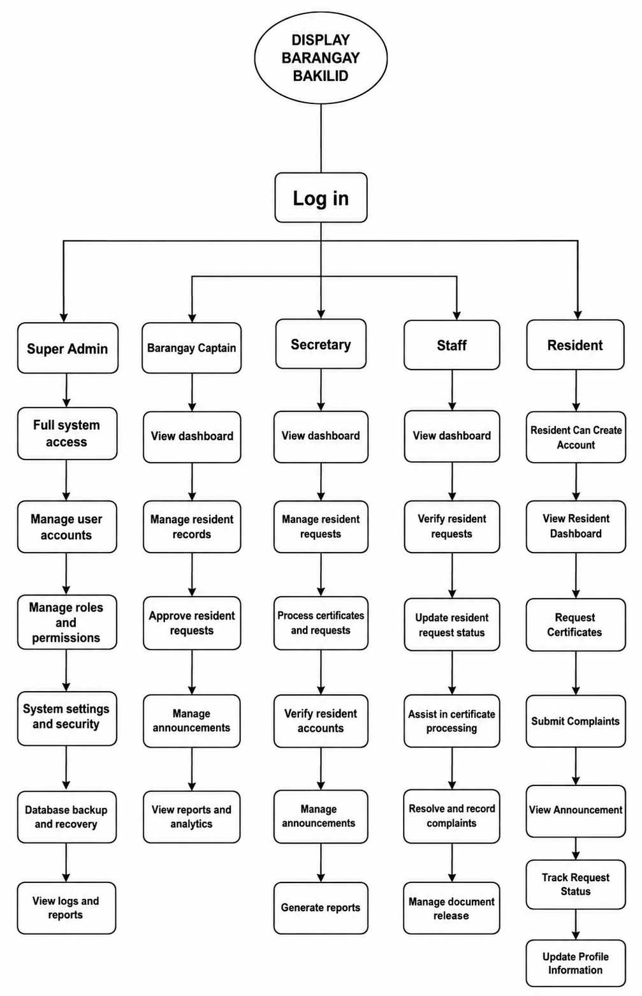
Work Breakdown Structure
Figure 2
Cost and Benefits Analysis
Providing fast, organized, and reliable barangay services is important in meeting the needs of the community. However, the current manual process for handling requisition requests still depends on paper forms and manual record-keeping, which can lead to delays, misplaced documents, duplicate records, and human errors. Residents also need to visit the barangay hall personally to submit requests or check the status of their applications, which can be inconvenient, especially for those with work or other responsibilities. These challenges show the need for a more efficient and accessible way of managing barangay services.
To improve the current process, a web-based digital requisition system is proposed to make service requests faster, more organized, and easier to manage. The system will allow residents to submit requests online, monitor the progress of their applications, and receive updates without making unnecessary trips to the barangay hall. For barangay personnel, the system will provide a centralized database that helps organize records, reduce paperwork, and simplify the processing of requests. Although developing and implementing the system requires an initial investment for development, testing, deployment, and maintenance, these costs are expected to provide long-term benefits by improving efficiency, reducing operational expenses, and enhancing the quality of public service.
The following financial analysis presents the estimated costs and benefits of moving from the existing manual process to the proposed digital system. Table 1 shows the current annual operating expenses of the manual system and serves as the basis for comparison. Table 2 presents the one-time costs needed to develop and implement the proposed system, while Table 3 shows the estimated annual operating costs after the system has been deployed. This analysis will serve as the basis for the Return on Investment (ROI) evaluation and help determine whether the proposed system is financially practical and beneficial for the barangay in the long run.
Table 1: Existing Annual Cost (Manual System)
Position / Expense | Monthly Cost (₱) | Annual Cost (₱)
Ballot Paper for Forms Requisition | 1,000.00 | 12,000.00
Printer Ink & Maintenance | 1,500.00 | 18,000.00
Photocopying of Documents | 800.00 | 9,600.00
Office Supplies (Folders, Pens, Staplers, etc.) | 700.00 | 8,400.00
Records Storage & Filing Materials | 500.00 | 6,000.00
Electricity (Printing & Office Equipment) | 1,500.00 | 18,000.00
Total Cost | 6,000.00 | 72,000.00

The total monthly expense for the existing manual system is ₱6,000.00, resulting in an annual cost of ₱72,000.00. These costs are mainly attributed to recurring operational expenses such as ballot paper for forms requisition, printer ink & maintenance, photocopying of documents, office supplies (folders, pens, staplers, etc.) records storage & filing materials and electricity (printing & office equipment) used for recording and managing requisition requests. These expenses represent the financial resources required to maintain the current paper-based process, where documents are manually prepared, recorded, and monitored. This cost serves as the financial baseline for evaluating the proposed digital system and determining its potential to reduce operational expenses, improve record management, and enhance the efficiency of processing barangay requisition requests.

Table 2: New System Development Cost (One-Time Investment)
Position / Expense | Monthly Cost (₱) | Total Cost (6 Months) (₱)
Developer Salary (2 Developers) | 30,000.00 | 180,000
Railway Pro (Backend Hosting) | 1,200.00 | 7,200.00
Vercel Pro (Frontend Hosting) | 1,100.00 | 6,600.00
Quality Assurance & Testing | 2,000.00 | 12,000.00
Development Tools & Licenses | 1,500.00 | 9,000.00
Bond Paper for Printing Results | 300.00 | 1,800.00
Total Development Cost | 36,100.00 | 216,600.00

The proposed system requires a monthly development cost of ₱36,100.00, which amounts to a total one-time investment of ₱216,600.00 for six months of development. These costs include the developers' salaries, backend and frontend hosting services, quality assurance and testing, development tools and software licenses, and printing expenses. This investment covers everything needed to build, test, and launch the system successfully. Although the initial cost is higher than the current manual process, it is expected to improve the overall efficiency of barangay operations by reducing manual work, organizing records more effectively, and providing faster and more reliable services to residents.

Table 3: Annual Operating Cost (New System)
Position / Expense | Monthly Cost (₱) | Annual Cost (₱)
Developer Salary (Frontend & Backend) | 30,000.00 | 360,000.00
Railway Pro | 1,200.00 | 14,400.00
Render Pro | 1,100.00 | 13,200.00
Quality Assurance & Testing | 2,000.00 | 24,000.00
Development Tools & Licenses | 1,500.00 | 18,000.00
Bond Paper for Printing the Results | 300.00 | 3,600.00
Total Annual Operating Cost | 36,100.00 | 433,200.00

Return on Investment (ROI) Analysis
The transition from the existing manual requisition process to the proposed Integration of Barangay Requisition in Digital Services changes the overall cost of operations. The current manual system has an annual operating cost of ₱72,000.00, while the proposed digital system has an annual operating cost of ₱433,200.00, as presented in Table 3.
The Return on Investment (ROI) is used to determine whether the benefits of implementing the proposed system outweigh its costs. The formula used is:
ROI = ((Net Profit from Investment) / Cost of Investment) × 100
First, the annual savings (or loss) are computed using the following formula:
Annual Savings = Old System Annual Cost − New System Annual Cost
Annual Savings = ₱72,000.00 − ₱433,200.00 = -₱361,200.00
This means that the proposed system will require an additional annual operating cost of ₱361,200.00 compared to the existing manual process. Since the result is negative, the initial one-time development cost of ₱216,600.00 cannot be recovered through annual operating savings alone.
However, the purpose of implementing the proposed system is not only to reduce expenses but also to improve the quality of barangay services. The digital system provides faster processing of requisition requests, better record management, improved data security, easier tracking of requests, and greater convenience for both residents and barangay personnel. These operational and service improvements provide long-term value that cannot be measured through financial savings alone. As a result, the proposed system should be viewed as a long-term investment that enhances efficiency, transparency, and the overall quality of public service rather than as a project focused solely on reducing operating costs.
MoSCow
INTEGRATION OF BARANGAY REQUISITION IN DIGITAL SERVICES
Must Have:
- Secure login and user authentication
- Resident account registration and management
- Online submission of barangay requisition requests
- Request status tracking for residents
- Different user roles (super admin, barangay captain, secretary, staff, resident)
- Centralized database for storing requisition records
- Responsive web design for both desktop and mobile devices
- Management of requisition request requests by barangay staff
- Announcement and notification feature
- Secure storage of resident information and documents
- Search and filter options for faster record retrieval
- Dashboard for monitoring requests and system activities
- User profile management
Should Have:
- Email notifications for request updates
- Reports and statistics for completed, pending, and rejected requests
- Data backup and recovery feature
- Activity logs for monitoring user transactions
Could Have:
- SMS notifications for request updates
- Online feedback and satisfaction survey
- Integration with other barangay information system in the future
Won’t Have:
- Biometric authentication
- AI-powered chatbot assistance
- Blockchain-based document verification
- Integration with national government database (e.g., PhilSysnor PSA)
- Online Payment gateway for barangay service fee

Gantt Chart
Figure 3

Critical Path
Figure 4

Data and Process Modeling
The Barangay Bakilid E-Service Management System uses data and process modeling to organize the information handled by the system and to make sure that each process works properly. The system is designed as a web-based application where residents and barangay personnel can access different services online. The frontend uses React with Vite and Tailwind CSS, while Node.js and Express.js are used for the backend. MySQL is used as the main database, with Sequelize helping the system communicate with the database.
The database is organized into different tables that store information needed by the system. These include user accounts, resident information, requisition requests, complaints, announcements, notifications, and other records needed for system operations. Each table has its own purpose and is connected to other tables when necessary. For example, user accounts are related to resident information, while requisition requests are associated with the residents who submitted them. This structure helps prevent unnecessary duplication of information and makes it easier to retrieve records when needed.
The process starts when a user visits the system and accesses the login or registration page. New users need to provide the required information and complete the verification process before their account can be used. Registered users can log in using their credentials. After the login information is checked, the system identifies the user's role and provides access to the appropriate dashboard. Different users have different responsibilities and access depending on whether they are residents or barangay personnel.
For residents, the system provides an easier way to request barangay services without having to personally visit the barangay office for every transaction. A resident can log in, select a service, complete the requisition form, and submit the required information and supporting documents when necessary. After submission, the request is stored in the database and can be monitored by the resident. Barangay personnel can then review the request and update its status as it moves through the processing stage.
The system also handles other activities such as complaints, announcements, and notifications. Residents can submit concerns through the system, while barangay personnel can post announcements and provide updates to the community. Notifications are used to inform users about important changes, especially updates related to their requests. These processes help improve communication between the residents and the barangay.
Data validation is performed before information is saved in the database. The frontend provides immediate feedback when users enter incomplete or incorrect information, while the backend performs additional validation before processing the request. This helps reduce incorrect records and prevents invalid information from being stored. The system uses RESTful APIs to allow the React frontend and Express backend to exchange information properly.
Overall, the data and process model connects the different functions of the system with the information stored in the database. The flow from user login, service selection, requisition submission, request processing, and notification is supported by the corresponding database records. This allows the system to keep information organized while making the barangay requisition process easier for both residents and barangay personnel.
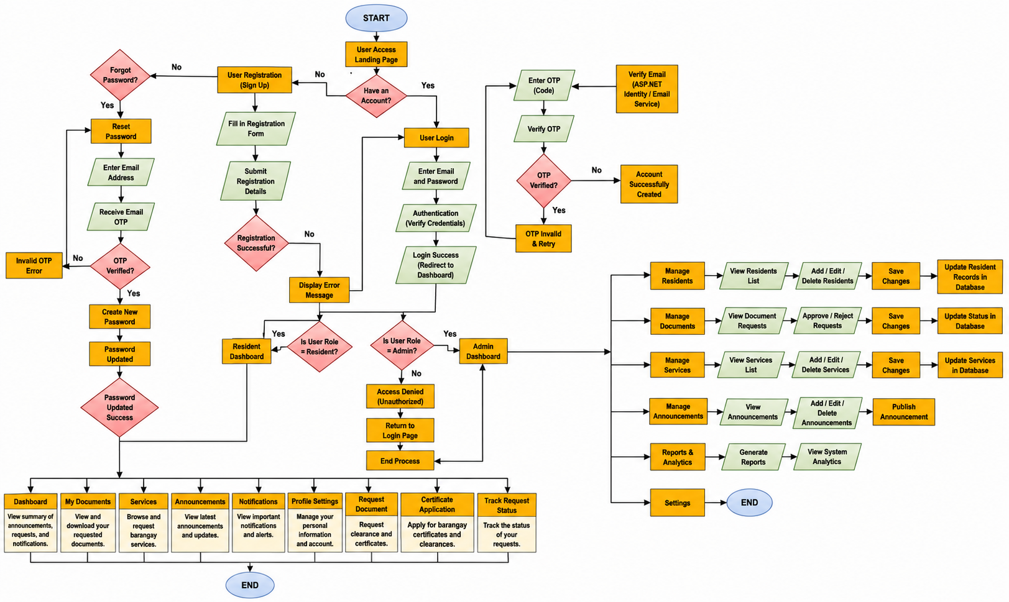
Existing Flow Chart
Figure 5
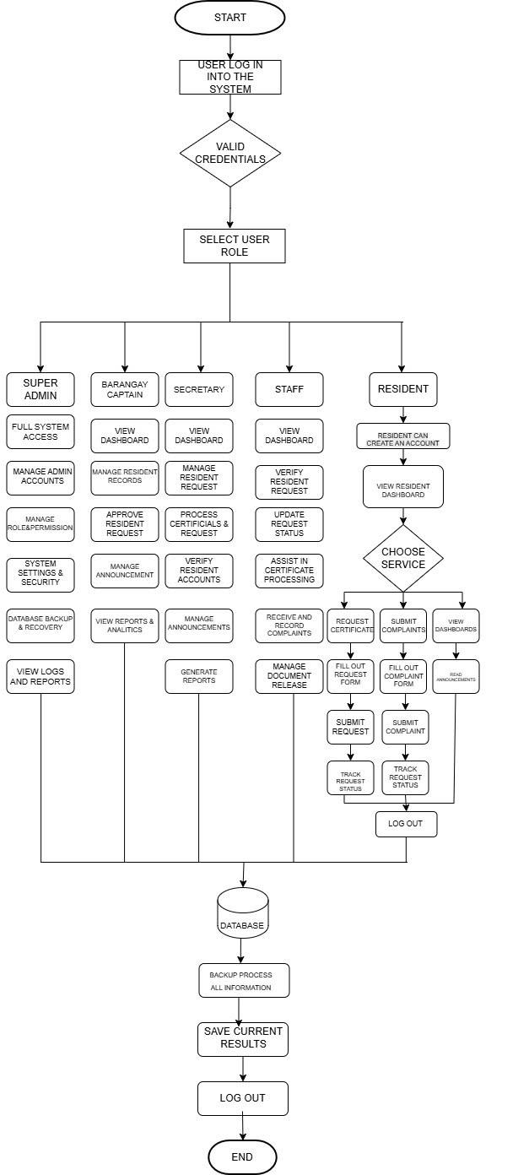
Proposed Flow Chart
Figure 6
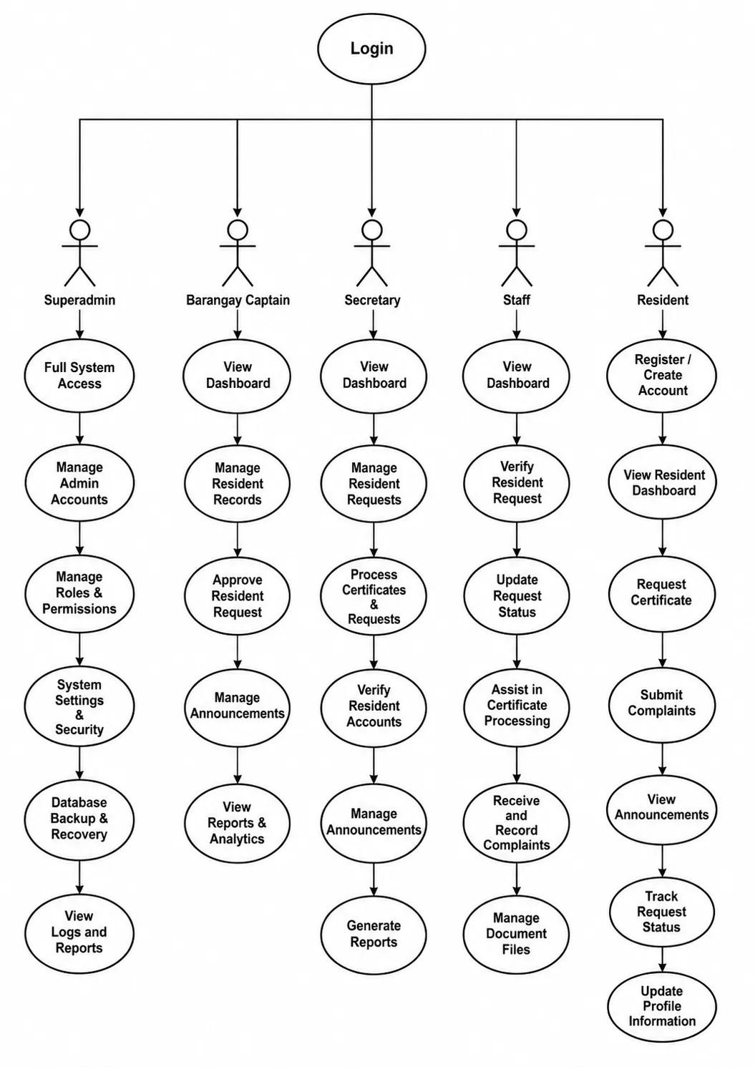
Use Case Diagram
Figure 7
Narrative
Table 4: Login Use Case
Field | Details
Use Case | Log in
Summary | Registered residents and authorized barangay personnel can log in to the system using their valid credentials to access the features and services available based on their assigned roles.
Actors | Resident, Barangay Staff, Secretary, Barangay Captain, SuperAdmin
Purpose | To provide secure access to the Barangay Requisition Digital Service System and protect user information from unauthorized access.
Pre-condition | The user must have a registered account and valid login credentials. The system must be available and connected to the internet.
Post-condition | The user is successfully authenticated and redirected to the appropriate dashboard according to their role.
Exception | Invalid username or password, empty login fields, inactive account, or network connection error.

Flow of Events
Actor Response | System Response
- User visits the Barangay Requisition website. | - The system displays the homepage.
- User clicks the Log in button. | - The system displays the login page.
- User enters their username/email and password, then clicks Log in. | - The system validates the credentials. If they are correct, the user is redirected to the appropriate dashboard based on their role.
Alternative Flow
Actor Response | System Response
5.1 User leaves the username or password blank. | 5.2 The system displays the message: “Username and Password are required.”
5.3 User enters incorrect login credentials. | 5.4 The system displays the message: “Invalid username or password.”
5.5 User attempts to log in with an inactive or unregistered account. | 5.6 The system displays the message: “Account not found or inactive. Please contact the barangay administration.”

Table 5: Manage Users Use Case
Field | Details
Use Case | Manage Users
Summary | The Super Admin can add, update, and manage user accounts, including residents and barangay personnel.
Actors | SuperAdmin
Purpose | To manage user accounts and assign appropriate roles and permissions within the system.
Pre-condition | The Super Admin is logged in and has access to the User Management module.
Post-condition | A new user account is successfully created, or an existing account is updated.
Exception | Missing required information, duplicate email/username, or invalid data.

Flow of Events
Actor Response | System Response
- The user visits the Barangay Requisition website. | - The system displays the homepage.
- The user clicks the Log In button. | - The system displays the login page.
- Users enter their username/email and password, then click Log in. | - The system validates the credentials. If they are correct, the user is redirected to the appropriate dashboard based on their role.
Alternative Flow
Actor Response | System Response
5.1 User leaves the username or password blank. | 5.2 The system displays the message “Username and password are required.”
5.3 User enters incorrect login credentials. | 5.3 The system displays the message. “Invalid username or password.”
5.5 User attempts to log in with an inactive or unregistered account. | 5.6 The system displays the message "Account not found or inactive. Please contact the Baranagy administration.”

Table 6: Use Case Description – Manage User
Field | Details
Use Case | Manage User
Summary | The SuperAdmin can add, update, and manage user accounts, including residents and baranagey personnel.
Actors | SuperAdmin
Purpose | To manage user accounts and assign appropriate roles and permissions with the system.
Pre-condition | The Super Admin is logged in and has access to the User Management module.
Post-condition | A new user account is successfully created, or an existing account is uploaded.
Exception | Missing required information, duplicate email/user name, or invalid data.

Flow of Events
Actor Response | System Response
- Log in to the system | - Display Resident Dashboard
- Select Request Service | - Display the list of available barangay services.
- Choose the type of document or service. | - Display the online requisition form.
- Fill out the required information and upload supporting documents (if required) | - Validate the submitted information.
- Click Submit Request | - Save the request, generate a reference number, and display a confirmation message.
Alternative Flow
Actor Response | System Response
7.1 Required fields are left blank. | 7.2 Error: “Please complete all required fields before submitting.”
7.3 Resident submits a duplicate | 7.4 Error: “A similar request is already pending.”
9.1 Internet connection is interrupted during submission. | 9.2 Error: “Request submission failed. Please try again later.”

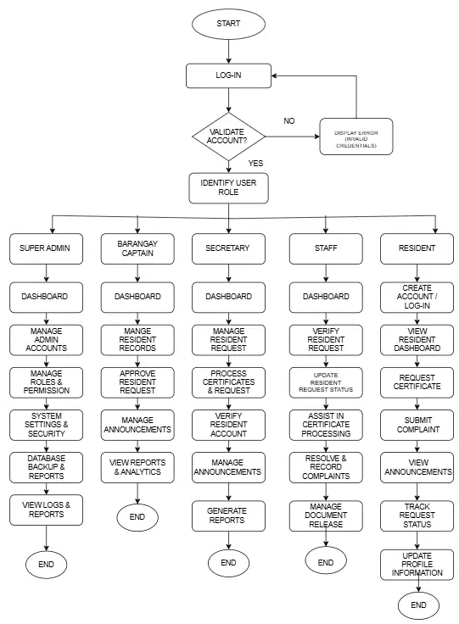
State Chart Diagram
Figure 9

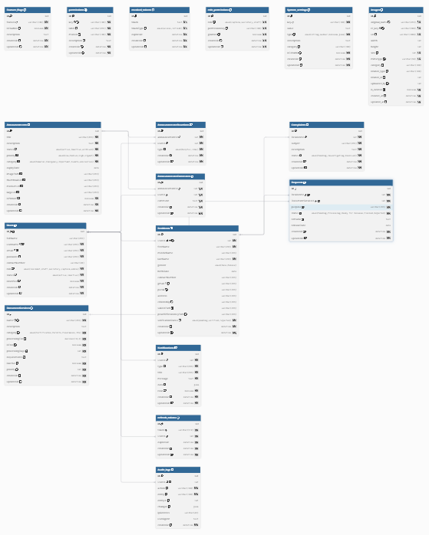
Entity Relationship Diagram
Figure 10
Link: https://dbdiagram.io/d/6a981f375450bea1becd71f2

System Architecture
Figure 11
Security Implementation
The Barangay Bakilid E-Service Management System includes several security measures to protect user accounts and the information stored in the system. Since the application handles personal information and barangay service requests, security is considered an important part of the system. The security implementation focuses mainly on authentication, authorization, password protection, data validation, and controlled access to system functions.
User authentication is handled through JSON Web Tokens (JWT). When a user logs in, the system checks the submitted credentials before allowing access to protected pages and functions. This prevents users who are not properly authenticated from accessing parts of the system that are intended only for registered users. The system also uses bcrypt to hash passwords before they are stored in the database. Because of this, the actual passwords are not directly stored as readable text.
The system also uses different user roles to control access to its features. The identified roles include Resident, Barangay Staff, Secretary, Barangay Captain, and SuperAdmin. Each role has its own responsibilities and level of access. For example, residents can submit and monitor their own requisition requests, while authorized barangay personnel can manage users and process requests. The SuperAdmin has access to administrative functions such as managing user accounts. This role-based approach helps prevent users from accessing functions that are not part of their responsibilities.
Input validation is another security measure used by the system. Information entered by users is checked before it is processed or stored. The React frontend can provide immediate feedback when required information is missing, while the Express backend performs additional checking. Server-side validation is important because information coming from the frontend should not automatically be considered safe or correct. This helps reduce the possibility of invalid or harmful information entering the database.
The system also uses CORS (Cross-Origin Resource Sharing) to control communication between the frontend and backend. Since the frontend and backend may run separately, CORS helps ensure that requests are coming from an allowed source. RESTful API endpoints are also organized according to the functions of the system, which makes it easier to manage and protect access to different operations.
Database security is supported by the use of MySQL and Sequelize. The database uses relationships between tables to keep records organized and consistent. User information, resident records, requisition requests, and other system data are stored in their appropriate tables. This structure also makes it easier to manage and retrieve information without unnecessarily repeating the same data.
The system also considers the protection of personal information in accordance with the Data Privacy Act of 2012 (Republic Act No. 10173). Only information needed for registration, authentication, requisition processing, and other legitimate system functions should be collected. Proper access restrictions are applied to help prevent unauthorized users from viewing or modifying information.
Overall, the security implementation provides several layers of protection instead of depending on only one security feature. Authentication protects user accounts, role-based access control systems function, and bcrypt protects passwords, validation checks submitted information, and database relationships help maintain the consistency of stored records. These measures help make the system safer and more reliable for both residents and barangay personnel.
Development Methodology and Implementation
The development of the Barangay Bakilid E-Service Management System follows an Agile development approach. This approach was chosen because it allows the researchers to work on the system in smaller parts, test each feature, identify problems, and make improvements throughout the development process. Instead of developing the entire system at once, the researchers can gradually build and improve its different functions.
The first part of the development process involved identifying the problems in the existing barangay requisition process. The researchers examined the difficulties experienced by residents and barangay personnel, particularly those related to manual processing, record keeping, request monitoring, and communication. The information gathered during this stage was used to identify the features that needed to be included in the proposed system.
After the requirements were identified, the researchers worked on the system design. This included preparing the flowcharts, use case diagram, state chart diagram, entity relationship diagram, and system architecture. These diagrams helped the researchers understand how users would interact with the system and how information would move between the frontend, backend, and database.
The database was designed using MySQL. Different tables were created to store the information required by the system, including user accounts, resident information, requisition requests, complaints, announcements, and notifications. Sequelize was used as the Object-Relational Mapping (ORM) tool to make communication between the Node.js application and MySQL database easier. The relationships between the tables were also considered during the database design to keep the records organized.
For the frontend, the system uses React, Vite, Tailwind CSS, and TypeScript. React is used to create the different pages and components of the application, while Vite helps during development and improves the speed of the frontend development process. Tailwind CSS is used to design the interface, while TypeScript helps organize the code and reduce possible programming errors.
The backend was developed using Node.js and Express.js. The backend is responsible for processing requests coming from the frontend, communicating with the MySQL database, handling authentication, and managing the different system functions. Axios is used on the frontend to send requests to the backend through the system's API. The use of RESTful APIs allows the frontend and backend to communicate in an organized manner.
The development process also included testing and debugging. Each major function was tested to determine whether it worked according to the requirements. For example, the researchers tested user registration, login, user management, requisition submission, and request processing. Errors found during testing were reviewed and corrected before moving to the next stage of development. API requests and responses can also be checked using testing tools such as EchoAPI.
Git and GitHub were used for version control during development. This allowed the researchers to keep track of changes made to the system and maintain different versions of the project. It also made collaboration easier because the members could work on the project while keeping the source code organized.
The final stage involves deployment and continuous improvement of the system. The researchers can review the results of testing and user feedback to identify areas that need improvement. Through the Agile approach, changes can be made when problems are discovered or when additional requirements are identified.
Overall, the development methodology allowed the researchers to build the system step by step while continuously checking its functionality. The combination of React, Vite, Node.js, Express.js, MySQL, Sequelize, JWT, bcrypt, Axios, and Git/GitHub provides the technical foundation of the system. The goal of the implementation is to produce a system that can make barangay requisition services more convenient, organized, and accessible for residents while also helping barangay personnel manage requests and records more efficiently.
Figure 12
Figure 13
Figure 14
Figure 15
Figure 16

Chapter 5
Summary, Conclusion, and Recommendations
Summary
Academic Validation and Assessment
Conclusion
Recommendations
For Educational Institutions
For System Enhancement and Researchers
DEFINITION OF TERMS
BIBLIOGRAPHY
Reference
Aliling, J. T., Santa Ana, B. B., & Soberano, K. T. (2025). Digitalizing governance: A transformation on the processes of one community in the Philippines. International Journal of Multidisciplinary Research and Analysis, 8(6), 3620–3625. https://doi.org/10.47191/IJMRA/v8-i06-68
Dobrolyubova, E. (2021). Measuring outcomes of digital transformation in public administration: Literature review and possible steps forward. NISPAcee Journal of Public Administration and Policy, 14(1), 61–86.
https://doi.org/10.2478/nispa-2021-0003
Anna Zastelo, Tetiana Serha, Vladislav Koval, Yana Vikhliaieva, Nataliya Shuberty (2021). Implementation of Electronic Services in the System of Population Social Protection. SHS Web of Conferences.
William P. Rey, John Daryl P. Aumentado, James Nathanael C. Delos Reyes, Mark Louie D. Dipad (2024). WeBarangay: A Local E-Government Services Web Application for N.S. Amoranto in Quezon City, Philippines. ACM Digital Library.
https://dl.acm.org › doi › fullHtml
Rafael M. Tosper Jr., Jayvee T. Mangalino, Katrina T. Obena, Marian C. Simon, Marjun A. Tayag, Kristine Joy Villano, Diosdado A. Reyes (2025). WebYu: A Barangay Yuson Web-Based Information Management System Initiatives.
https://scimatic.org › storage › journals › pdfs
Reyna (2023). Enhancing Barangay Household Registration with Google Maps.
https://ouci.dntb.gov.ua/en/works/4EV2Wp0l/
Ballaran, Donaire, Singzon, Naz, Tanael, and Centeno (2023). Development and Evaluation of Web-Based Barangay Profiling and Issuance System.
https://zenodo.org/records/12738879
Cuevas, Gonzaga, Roque, Centeno, and Co (2024). Enhancing Barangay Information System with Chatbot and Geolocation.
https://journal.esrgroups.org/jes/article/view/2426
Aliling, Santa Ana, and Soberano (2025). Digitalizing Governance: A Transformation on the Processes of One Community in the Philippines.
https://www.ijmra.ijpbms.com/v8i6/68.php
Calibo-Senit (2026). An Academic Extension-Driven Solution for Enhancing Local Governance.
https://ph02.tci-thaijo.org/index.php/tsujournal/article/view/261914
Pinon, K. A., Pornobi, L. J., and Mancenido, A. M. (2021). Barangay Certificate Issuance and Record Management System with Descriptive Analytics. Manuel S. Enverga University Foundation.
https://scholar.google.com/scholar?q=Barangay+Certificate+Issuance+and+Record+Management+System+Pinon+Pornobi+Mancenido+2021
Jacobe, B. and associates (2021). Analytics-based Barangay Profiling System. Advanced Trends in Computer Science and Engineering International Journal.
https://scholar.google.com/scholar?q=Analyticsbased+Barangay+Profiling+System+Jacobe+2021
Mercurio, D. I., and Hernandez, A. A. (2022). An Open Data and Geo-based Information System.
https://scholar.google.com/scholar?q=Open+Data+and+Geobased+Information+System+Mercurio+Hernandez+2022
Dela Cruz, M., and Santos, J. (2022). Cloud-First Projects in Local Government in the Philippines. ICT Development Journal, 14(2), 45–58.
https://www.google.com/search?q=https://scholar.google.com/scholar%3Fq%3DCloud-based%2Bbarangay%2Bmanagement%2Bsystem%2BPhilippines
Villanueva, K. (2024). UX frameworks for digital inclusion at the barangay level. Journal of Science and Technology in the Philippines, 30(1), 112–125.
https://www.google.com/search?q=https://www.researchgate.net/search%3Fq%3DUX%2Bdesign%2Bfor%2Be-governance%2BPhilippines
APPENDICES
CURRICULUM VITAE

