IMPLEMENTATION OF A SECURE AND SCALABLE AUTOMATED VOTING SYSTEM FOR THE SUPREME STUDENT COUNCIL ELECTION

A Capstone Project Proposal Presented to the
Faculty of College of Computer Studies Department
BENEDICTO COLLEGE - MANDAUE CAMPUS
A.S. Fortuna St., Mandaue City, Cebu

In Partial Fulfillment of the Requirement for the Degree of
Bachelor of Science in Information Technology

Eirick Kerbi D. Cabardo
Jhian Kyle R. Cinco
Kercson G. Didal
Kreshia Dian G. Epe
Milven John B. Hermosa
Charles Louie S. Tampos

October 2025
APPROVAL SHEET
The Capstone Project entitled “IMPLEMENTATION OF A SECURE AND SCALABLE AUTOMATED VOTING SYSTEM FOR THE SUPREME STUDENT COUNCIL ELECTION” prepared and presented by EIRICK KERBI D. CABARDO, JHIAN KYLE R. CINCO, KERCSON G. DIDAL, KRESHIA DIAN G. EPE, MILVEN JOHN B. HERMOSA, CHARLES LOUIE S. TAMPOS, in partial fulfillment of the requirements for subject - Capstone Project, has been examined and recommended for acceptance and approval for Oral Examination.
CAPSTONE PROJECT ADVISORY COMMITTEE

GENE PAUL R. CUEVA, MBA, MSIT
Chairman

LENY B. YAMILO, LPT, DPA _{(diss)} MA. OLGA DC. ALVAREZ, PhD, EdD WILSON A. GAYO, MSIT
Adviser Member Adviser

ALAN A. FELICANO, MSIT ROWELYN B. BAIS JINKY MALOLOY-ON
Member Grammarian Member

NIGEL DELA RIARTE ERIKA JANE QUITORIO KAYE VERNIETTE TOTOY
Member Member Member

Approved by the Committee on Project Presentation with a grade of ___________

GENE PAUL R. CUEVA, MBA, MSIT
Chairman

LENY B. YAMILO, LPT, DPA _{(diss)} MA. OLGA DC. ALVAREZ, PhD, EdD WILSON A. GAYO, MSIT
Adviser Member Adviser

ALAN A. FELICANO, MSIT ROWELYN B. BAIS JINKY MALOLOY-ON
Member Grammarian Member

NIGEL DELA RIARTE ERIKA JANE QUITORIO KAYE VERNIETTE TOTOY
Member Member Member

ACCEPTED AND APPROVED in partial fulfillment of the degree BACHELOR OF SCIENCE IN INFORMATION TECHNOLOGY.
Date of Project Presentation: October 25, 2025
PROF. GENE PAUL R. CUEVA
Dean, College of Computer Studies
ABSTRACT
TITLE | IMPLEMENTATION OF A SECURE AND SCALABLE AUTOMATED VOTING SYSTEM FOR THE SUPREME STUDENT COUNCIL ELECTION
RESEARCHERS | EIRICK KERBI D. CABARDO  JHIAN KYLE R. CINCO  KERCSON G. DIDAL  KRESHIA DIAN G. EPE  MILVEN JOHN B. HERMOSA  CHARLES LOUIE S. TAMPOS
DEGREE | BACHELOR OF SCIENCE IN INFORMATION TECHNOLOGY
ADVISER | PROF. LENY B. YAMILO
INSTITUTION AND ADDRESS | BENEDICTO COLLEGE, A.S. FORTUNA ST., BAKILID, MANDAUE CITY
NUMBER OF PAGES | 92
This capstone project details the successful implementation of a secure online voting system for the Supreme Student Council (SSC) elections at Benedicto College, designed to replace the institution's insecure and inefficient manual voting process. The primary objective was to enhance the integrity, security, and transparency of the electoral process by developing a robust platform for students to cast their votes. The project addresses the logistical challenges and security risks of traditional methods by delivering a streamlined, auditable, and accessible digital experience.
Developed using a modern technology stack, the system's viability was confirmed through a comprehensive feasibility study. The subsequent financial analysis concluded that the project represents a significant strategic investment in institutional modernization and security, with its value justified by enhanced transparency and data integrity rather than immediate operational cost savings. The successful deployment and academic validation of this system confirm that student-led initiatives can produce sustainable and secure digital assets that modernize institutional processes and uphold democratic principles within an academic environment.

Keywords: Online Voting System, Student Elections, Digital Voting, System Security, Strategic Investment, Electoral Process
ACKNOWLEDGEMENT
We are immensely grateful for the support and guidance we have received throughout our research project. This journey would not have been possible without the contributions of many individuals who have provided their resolute support.
First and foremost, we express our deepest gratitude to Almighty God for providing us with the strength, wisdom, and perseverance to complete this research project. Without His divine guidance and blessings, none of this would have been possible.
We extend our heartfelt gratitude to Ma’am Lilian B. Huan for the opportunity to be part of her esteemed school and institution. Her leadership and vision have been a constant source of inspiration.
To our Dean, Prof. Gene Paul R. Cueva, we are deeply grateful for his unwavering guidance and support throughout our research journey. His insights and encouragement have been invaluable to our success.
Our sincere appreciation goes to Prof. Leny B. Yamilo, who has been a pillar of support in ensuring the correctness of our research project. Her daily reminders, motivation, and dedication to our success have been instrumental in our progress. She is truly one of a kind in ensuring that we complete our tasks.
We owe a debt of gratitude to Prof. Wilson A. Gayo. His mentorship was pivotal in shaping our technical acumen and leadership capabilities. He not only guided us through the complexities of software development but also instilled in us the importance of teamwork and collaborative excellence, ensuring that we function not merely as individuals, but as a cohesive and effective team.
Our sincere thanks are also extended to Ma’am Ericka Jane Quitorio, who provided us with a crucial framework for architectural design and implementation, equipping us with the practical knowledge needed to translate theoretical concepts into a functional and robust application.
Special recognition is extended to Ma’am Kaye Verniette Totoy. Her dedication to our intellectual growth equipped us with the versatile and critical mindset necessary to navigate the complexities of this project and our future professional endeavors.
To our fellow researchers, we express our deep gratitude for their collaboration, shared ideas, and collective effort in building and advancing this project. This teamwork and dedication have been critical in bringing this project fruition.
Our heartfelt thanks go to our parents and guardians for their unwavering support in our daily lives. Their encouragement and belief in our abilities have been a source of constant motivation.
We also extend our gratitude to our classmates for sharing ideas and promoting a sense of camaraderie. Though we may not always have been fully aligned, our collaborative spirit and mutual support ensured that no one was left behind in the pursuit of our common goal.
Finally, to everyone who has been a part of this chapter of our lives, we offer our deepest thanks. As this academic journey reaches its conclusion, we look forward with hope and determination to the new paths we will forge, carrying with us the invaluable lessons learned, and the enduring relationships built.
- The Researchers

TABLE OF CONTENTS
Content |  |  | Page
TITLE PAGE |  | - - - - - - - - - - - - - - - - - - - - - - - - - - - | i
APPROVAL SHEET |  | - - - - - - - - - - - - - - - - - - - - - - - - - - - | ii
ABSTRACT |  | - - - - - - - - - - - - - - - - - - - - - - - - - - - | iii
ACKNOWLEDGEMENT |  | - - - - - - - - - - - - - - - - - - - - - - - - - - - | iv
TABLE OF CONTENTS |  | - - - - - - - - - - - - - - - - - - - - - - - - - - - | vi
LIST OF FIGURES |  | - - - - - - - - - - - - - - - - - - - - - - - - - - - | viii
LIST OF TABLES |  | - - - - - - - - - - - - - - - - - - - - - - - - - - - | ix
Chapter 1 THE PROBLEM AND ITS SCOPE
Rationale |  | - - - - - - - - - - - - - - - - - - - - - - - - - - - | 1
Theoretical Background |  | - - - - - - - - - - - - - - - - - - - - - - - - - - - | 2
Statement of the Problem |  | - - - - - - - - - - - - - - - - - - - - - - - - - - - | 8
 | General Problem of the Study | - - - - - - - - - - - - - - - - - - - - - - - - - - - | 8
 | Specific Problem of the Study | - - - - - - - - - - - - - - - - - - - - - - - - - - - | 8
Objectives of the Study |  | - - - - - - - - - - - - - - - - - - - - - - - - - - - | 9
 | General Objective of the Study | - - - - - - - - - - - - - - - - - - - - - - - - - - - | 9
 | Specific Objective of the Study | - - - - - - - - - - - - - - - - - - - - - - - - - - - | 10
Scope and Limitation |  | - - - - - - - - - - - - - - - - - - - - - - - - - - - | 10
 | Scope | - - - - - - - - - - - - - - - - - - - - - - - - - - - | 10
 | Limitation | - - - - - - - - - - - - - - - - - - - - - - - - - - - | 11
Significance of the Study |  | - - - - - - - - - - - - - - - - - - - - - - - - - - - | 13
Chapter 2 REVIEW OF RELATED LITERATURE AND STUDIES
Literature |  | - - - - - - - - - - - - - - - - - - - - - - - - - - - | 15
Studies |  | - - - - - - - - - - - - - - - - - - - - - - - - - - - | 18
Chapter 3 TECHNICAL BACKGROUND
Front End |  | - - - - - - - - - - - - - - - - - - - - - - - - - - - | 21
Back End |  | - - - - - - - - - - - - - - - - - - - - - - - - - - - | 24
Development and Database Management |  | - - - - - - - - - - - - - - - - - - - - - - - - - - - | 27
Deployment and Hosting |  | - - - - - - - - - - - - - - - - - - - - - - - - - - - | 30
Hardware Requirements |  | - - - - - - - - - - - - - - - - - - - - - - - - - - - | 31
Chapter 4 METHODOLOGY
Project Feasibility |  | - - - - - - - - - - - - - - - - - - - - - - - - - - - | 32
Cost and Benefit Analysis |  | - - - - - - - - - - - - - - - - - - - - - - - - - - - | 36
Return on Investment (ROI) Analysis |  | - - - - - - - - - - - - - - - - - - - - - - - - - - - | 39
MOSCoW |  | - - - - - - - - - - - - - - - - - - - - - - - - - - - | 40
Data and Process Modeling |  | - - - - - - - - - - - - - - - - - - - - - - - - - - - | 44
Security Implementation |  | - - - - - - - - - - - - - - - - - - - - - - - - - - - | 56
Development Methodology and Implementation |  | - - - - - - - - - - - - - - - - - - - - - - - - - - - | 57
Chapter 5 SUMMARY, CONCLUSION, & RECOMMENDATION
Summary |  | - - - - - - - - - - - - - - - - - - - - - - - - - - - | 60
Conclusion |  | - - - - - - - - - - - - - - - - - - - - - - - - - - - | 61
Recommendation |  | - - - - - - - - - - - - - - - - - - - - - - - - - - - | 62
DEFINITION OF TERMS |  | - - - - - - - - - - - - - - - - - - - - - - - - - - - | 64
BIBLIOGRAPHY |  | - - - - - - - - - - - - - - - - - - - - - - - - - - - | 68
APPENDICES
Appendix A |  | - - - - - - - - - - - - - - - - - - - - - - - - - - - | 72
Appendix B |  | - - - - - - - - - - - - - - - - - - - - - - - - - - - | 73
Appendix C |  | - - - - - - - - - - - - - - - - - - - - - - - - - - - | 75
CURRICULUM VITATE |  | - - - - - - - - - - - - - - - - - - - - - - - - - - - | 76
LIST OF FIGURES
No. | Title |  | Page
1 | Theoretical Framework | - - - - - - - - - - - - - - - - - - - - - - - - - - - - | 7
2 | Work Breakdown Structure | - - - - - - - - - - - - - - - - - - - - - - - - - - - - | 35
3 | Gantt Chart | - - - - - - - - - - - - - - - - - - - - - - - - - - - - | 42
4 | Critical Path | - - - - - - - - - - - - - - - - - - - - - - - - - - - - | 43
5 | Existing Flowchart | - - - - - - - - - - - - - - - - - - - - - - - - - - - - | 46
6 | Proposed Flowchart | - - - - - - - - - - - - - - - - - - - - - - - - - - - - | 47
7 | Use Case Diagram | - - - - - - - - - - - - - - - - - - - - - - - - - - - - | 48
8 | Activity Diagram | - - - - - - - - - - - - - - - - - - - - - - - - - - - - | 52
9 | State Chart Diagram | - - - - - - - - - - - - - - - - - - - - - - - - - - - - | 53
10 | Entity Relationship Diagram | - - - - - - - - - - - - - - - - - - - - - - - - - - - - | 54
11 | System Architecture | - - - - - - - - - - - - - - - - - - - - - - - - - - - - | 55

LIST OF TABLES
No. | Title |  | Page
1 | Existing Annual Cost (Manual System) | - - - - - - - - - - - - - - - - - - - - - - - - - - - - | 37
2 | New System Development Cost (One-Time Investment) | - - - - - - - - - - - - - - - - - - - - - - - - - - - - | 38
3 | Annual Operating Cost (New System) | - - - - - - - - - - - - - - - - - - - - - - - - - - - - | 39
4 | Log in Use Case | - - - - - - - - - - - - - - - - - - - - - - - - - - - - | 49
5 | Add Users Use Case | - - - - - - - - - - - - - - - - - - - - - - - - - - - - | 50
6 | Voting Process Use Case | - - - - - - - - - - - - - - - - - - - - - - - - - - - - | 51

Chapter 1
THE PROBLEM AND ITS SCOPE
Rationale
A voting system is a structured mechanism through which individuals formally express their choices in an electoral process. It serves as the foundation of democratic governance, ensuring fairness, transparency, and accountability in the selection of representatives. Over the years, electoral systems have evolved from traditional paper-based ballots to digitally integrated platforms that enhance accessibility, security, and efficiency. In contemporary settings, the integrity of an election is paramount, necessitating technological advancements that mitigate risks such as voter fraud, duplicate voting, and administrative inefficiencies.
In the academic domain, student elections hold significant importance in cultivating leadership, representation, and active participation. The Supreme Student Council (SSC) serves as the primary governing body representing the student body, making electoral integrity essential to maintaining student trust in governance. However, the prevailing election process is fraught with challenges that undermine its credibility and effectiveness.
Currently, Benedicto College employs a semi-automated voting process utilizing Google Forms. While this method offers a basic level of digitization, it lacks the robustness required for a secure and verifiable electoral process. The system collects votes digitally, but verification and validation are conducted manually. The lack of an authentication system allows unauthorized voting, posing risks such as former students and external parties’ casting votes. Additionally, the system does not inherently prevent multiple submissions, leading to an extensive and labor-intensive verification process that increases the likelihood of errors and delays in vote validation.
Logistical challenges further compound these inefficiencies. The current system requires students to vote within designated computer laboratories, which can accommodate only a limited number of voters at a time. As a result, students are subjected to long waiting periods, disrupting academic schedules and causing significant inconvenience, particularly for those who do not have classes on voting day but are still mandated to be physically present for the election. These inefficiencies contribute to reduced student engagement, weakened trust in electoral outcomes, and heightened concerns over the transparency of the voting process.
This research will focus on implementing a secure and scalable online voting system tailored specifically to the needs of the Supreme Student Council election. To enhance accessibility and electoral integrity, the system will be designed to allow students to securely cast their votes from any internet-enabled device, reducing logistical challenges and administrative burdens. Additionally, the system will incorporate mechanisms such as authentication protocols, encryption, and unique student IDs to mitigate risks associated with manual tallying discrepancies, delays in result dissemination, and unauthorized voting attempts. The goal aims to establish a democratic electoral process that upholds the highest standards of security and fairness, thereby ensuring the legitimacy of Supreme Student Council elections.
Theoretical Background
As educational institutions in the Philippines increasingly embrace digital solutions, the adoption of online voting systems has emerged as a significant advancement in student governance. Understanding the theoretical foundations that underpin technology adoption and implementation is crucial for developing effective online voting systems. This section presents a detailed exploration of relevant theories that can guide the design, implementation, and evaluation of online voting systems in educational settings, particularly within the Philippine context.
Rational Choice Theory of Voting (Anthony Downs, 1957). Downs introduced the Rational Choice Theory of Voting, which explains voter behavior through a cost-benefit analysis. According to this theory, individuals decide whether to vote based on a rational evaluation of potential benefits versus the costs of participation. In democratic elections, voters weigh factors such as the perceived impact of their vote, accessibility, and effort required to cast a ballot.
In the context of this study, the Rational Choice Theory of Voting provides a framework for understanding student voter participation in an online election system. The existing manual voting process in Benedicto College, which involves long wait times, verification procedures, and limited computer availability, creates barriers that may discourage voter turnout. By implementing an online voting system, these barriers can be minimized, reducing the "cost" of voting in terms of time and effort. This aligns with the theory, which suggests that when voting becomes more convenient and accessible, participation rates are likely to increase.
Furthermore, the theory highlights the role of perceived benefits in voter engagement. If students believe that an online system enhances election integrity, efficiency, and fairness, they are more likely to participate. Conversely, if they perceive security risks or lack confidence in the system’s transparency, trust in the voting process may decline. Thus, integrating this theory helps ensure that the system design prioritizes accessibility, security, and user confidence to promote higher voter engagement.
Systems Theory (Ludwig von Bertalanffy, 1968). Systems Theory provides a framework for understanding complex interactions within a system, emphasizing the interdependence of components. It postulates that a system’s effectiveness depends on the coordination and interaction of its subsystems. Originally applied in biological sciences, this theory has since been utilized in various fields, including organizational management, engineering, and technological system design.
In automated voting systems, Systems Theory aids in designing a cohesive infrastructure where technological components, user interfaces, and administrative procedures function seamlessly. A voting system must operate as an integrated network where hardware, software, and human processes are synchronized to ensure efficiency and security. Applying this theory to online voting in the Philippines, particularly in educational institutions, allows for a structured approach in managing the complexities associated with implementation, such as cybersecurity risks, database management, and accessibility across different regions. The interconnected nature of voting platforms, authentication processes, and result tabulation underscores the importance of a well-coordinated system, preventing operational failures and ensuring accuracy in elections.
Duggan–Schwartz Theorem (John Duggan & Thomas Schwartz, 2000). The Duggan–Schwartz Theorem addresses the strategic manipulability of voting rules, arguing that no voting system can be entirely free from strategic behavior. It states that every voting rule satisfying basic fairness criteria remains susceptible to manipulation by voters or administrators seeking to influence election outcomes in their favor.
Applying this theorem to an online voting system, it becomes crucial to design mechanisms that minimize opportunities for strategic manipulation. While traditional manual voting processes may be vulnerable to vote-buying or coercion, digital elections introduce new concerns such as algorithmic bias, hacking threats, and fraudulent registrations. In the Philippines, where electoral integrity has been a long-standing issue, understanding strategic vulnerabilities is vital to preventing undue influence over election results. Designing online voting systems with security protocols, voter authentication, and transparent ballot counting mechanisms aligns with the theorem’s implications, ensuring fair representation while mitigating risks associated with strategic voting.
Theory of Electoral Integrity (Pippa Norris, 2014). The Theory of Electoral Integrity emphasizes the adherence to international standards and principles that ensure elections are conducted fairly, transparently, and credibly. It identifies key elements such as impartial electoral management, voter education, secure voting technology, and mechanisms to prevent fraud.
In the Philippine context, the implementation of automated elections was intended to enhance electoral integrity by reducing human error and fraud. However, issues such as technical failures, system vulnerabilities, and concerns over vote-counting transparency have raised questions about the credibility of digital elections. Applying this theory to an online voting system requires a focus on establishing trust in technology, implementing stringent security measures, and promoting accountability in election administration. An online voting platform designed with electoral integrity principles can enhance public confidence and ensure that student elections in educational institutions remain free from manipulation.
E-Learning Technology Adoption in the Philippines (Manuel B. Garcia, 2017). This theory investigates factors affecting Filipino college students' acceptance of Learning Management Systems (LMS), applying models of technology adoption such as the Technology Acceptance Model (TAM) and Unified Theory of Acceptance and Use of Technology (UTAUT). Key factors include perceived usefulness, ease of use, and external influences, which shape individuals’ willingness to adopt digital platforms.
Applying this framework to an online voting system, the theory highlights that students are more likely to participate in digital elections if they perceive the system as efficient, transparent, and easy to navigate. Conversely, if students find the platform complex or unreliable, adoption rates may decline. To align with this theory, the system’s user interface must be intuitive, and accessibility must be ensured through proper support and design optimizations. Moreover, trust in the system is crucial, as voter confidence in digital platforms significantly impacts engagement in electoral processes.
The theoretical frameworks presented provide a comprehensive understanding of the factors influencing the adoption and implementation of online voting systems in educational settings. By leveraging these theories, alongside local research on technology adoption in Philippine institutions, this study aims to address the unique challenges and opportunities within the context of Benedicto College. Understanding these theories will guide the development of a user-friendly, secure, and effective online voting system that meets the needs of the student population and enhances the democratic processes within the school.

VOTING SYSTEM

Rational Choice Theory of Voting

By Anthony Downs
(1957)

Systems Theory

By Ludwig von Bertalanffy
1968)

Duggan–Schwartz Theorem

By John Duggan & Thomas Schwartz
2000

Theory of Electoral Integrity

By Pippa Norris
2014

E-Learning Technology Adoption in the Philippines

By Manuel B. Garcia
2017

A secure, scalable, and transparent automated voting system that enhances voter participation, strengthens election integrity, and improves the efficiency of student governance.

Figure 1
Theoretical Framework
Statement of the Problem
The central problem addressed by this study is the inefficiency and vulnerability of the current election process for the Supreme Student Council at Benedicto College. As student enrollment continues to grow, the semi-automated election methods have proven inadequate. Specific issues include the lack of security, the potential for duplicate voting, delays in vote tallying, and the absence of a robust system for managing election data.
General Problem of the Study
The current voting system for the Supreme Student Council elections at Benedicto College lacks security, efficiency, and accessibility. The use of Google Forms does not verify whether a voter is officially enrolled, posing risks of unauthorized voting. Additionally, the system does not automatically prevent duplicate votes, requiring manual validation that is time-consuming and prone to errors. The election process itself is inefficient, as students must physically line up due to limited computer availability, causing long waiting times and disruptions to academic schedules.
Furthermore, vote tallying is not automated, leading to delays in result processing and potential inaccuracies. These shortcomings undermine trust in the election process and call for a more secure, streamlined, and accessible voting system.
Specific Problems of the Study
- Lack of Enrollment Verification. The current voting process does not verify whether a student is officially enrolled before allowing them to cast a vote, increasing the risk of unauthorized participation and compromising the integrity of the election.
- Duplicate Voting Risk. The absence of strict authentication mechanisms in Google Forms allows students to submit multiple responses, requiring manual filtering to identify and remove duplicate votes, which increases administrative workload and the likelihood of errors.
- Vote Tallying Delays. The reliance on manual validation and verification of votes prolongs the process, delaying the announcement of results and reducing confidence in the election outcome.
- Disruptions and Inconvenience. The need for students to physically visit the computer laboratory, wait in long lines, and halt class schedules creates inefficiencies, discourages voter participation, and negatively impacts academic activities.
- Security and Reliability Issues. The current system lacks robust security measures, making it susceptible to unauthorized access, data manipulation, and potential election fraud, which threatens the credibility of the voting process.
General Objective of the Study
The primary objective of this study is to design, develop, and implement a secure, automated, and accessible voting system for the Supreme Student Council election at Benedicto College. This system aims to address the current security vulnerabilities by ensuring that only officially enrolled students can vote, preventing duplicate voting through strict authentication measures, and reducing inefficiencies by allowing students to cast votes remotely.
Additionally, it seeks to eliminate manual vote tallying by providing an automated counting mechanism, ensuring timely and accurate results. By enhancing security, efficiency, and accessibility, the system will improve trust and transparency in the electoral process, aligning with international standards and best practices.
Specific Objectives of the Study
- To Develop a Secure Voting Platform. The system will implement authentication mechanisms to ensure that only officially enrolled students can access and cast their votes, preventing unauthorized participation.
- To Prevent Duplicate Voting. This is to integrate a unique voter authentication system that automatically detects and prevents duplicate votes, ensuring the accuracy and fairness of the election results.
- To Automate Vote Tallying. Eliminate manual processing delays by implementing real-time result tracking and reporting, ensuring faster and more accurate election outcomes.
- To Improve Accessibility and Convenience. Develop a web-based voting platform that allows students to vote remotely from any internet-enabled device, reducing physical constraints and increasing voter participation.
- To Enhance Security and Reliability. Strengthening the security features of the voting system to prevent unauthorized access, data manipulation, and potential election fraud, ensuring the integrity of the electoral process.
Scope and Limitation
Scope
The system will provide secure voter authentication, allowing only officially enrolled students who meet the eligibility criteria to participate. A robust authentication mechanism requiring valid institutional credentials will prevent unauthorized access, multiple voting attempts, and electoral fraud. Designed as a web-based platform, the system will enable students to cast their votes remotely using any internet-enabled device, including computers, tablets, and smartphones, enhancing accessibility and inclusivity by eliminating logistical barriers that might hinder participation.
For election management and oversight, administrators will have full control over candidate registration, scheduling, and voter turnout monitoring. Real-time tracking mechanisms will ensure procedural integrity, allowing oversight of every phase of the election. Additionally, automated vote tallying and result generation will eliminate manual counting errors, ensuring accurate and real-time computation of election results, which will be accessible exclusively to authorized officials for verification before public release.
To safeguard electoral integrity, the system will integrate encryption protocols to protect the confidentiality of votes, while securely storing voter credentials and system logs to mitigate risks associated with data breaches or unauthorized access. Additionally, it will be designed for scalability and optimized performance, ensuring stable functionality even during peak voting periods through load balancing and server optimization techniques that prevent slowdowns or technical failures.
To address potential connectivity issues, the system will include an auto-save and session continuity feature, allowing students to resume their voting process without data loss in case of temporary internet disruptions. These functionalities will enhance electoral efficiency, increase voter engagement, and reinforce the integrity of student governance elections.
Limitation
Despite its technological capabilities, the Automated Voting System will have inherent limitations that define its scope, technical dependencies, and regulatory constraints. These limitations will manage user expectations, mitigate risks, and outline operational boundaries within the institutional framework.
The system will be exclusively designed for Supreme Student Council (SSC) elections and will not support other electoral processes, such as student organization elections, faculty votes, or administrative decision-making. Any modifications beyond SSC elections will require substantial reconfiguration and administrative approval, which falls outside the project’s scope.
As a web-based platform, the system will depend on a stable internet connection for functionality. While auto-save and reconnection features will help mitigate disruptions, prolonged connectivity issues may prevent some students from completing their votes.
To uphold electoral integrity and confidentiality, votes will be final upon submission, preventing modifications or reviews after confirmation. This measure will prevent coercion or tampering but will also require students to carefully finalize their selections.
To comply with data privacy regulations, general students will have limited access to election data beyond the officially declared results. Only designated election administrators will oversee real-time vote monitoring, system logs, and result verification. While this will protect sensitive data, voters will not have direct visibility into the internal audit process.
Despite being designed for scalability and performance, the system will remain susceptible to technical failures, including server downtimes, software vulnerabilities, or security threats. Continuous maintenance, security monitoring, and contingency planning will be required to ensure uninterrupted operation.
While these limitations impose certain constraints, they will ensure the integrity, security, and efficiency of SSC elections by minimizing risks and providing a streamlined voting experience within its defined parameters.
Significance of the Study
For the Supreme Student Council Adviser - The automated voting system will assist the Supreme Student Council Adviser in managing the election process more efficiently. By providing a platform that securely collects and compiles votes, the adviser can ensure that the elections are fair, transparent, and free from human error. The system will also generate results quickly, allowing the adviser to focus on other aspects of student governance and decision-making.
For the Supreme Student Councils/Officers - The system will benefit the Supreme Student Council (SSC) Officers by streamlining the electoral process, ensuring that their leadership roles are determined through an unbiased, accurate, and reliable voting method. This promotes trust in their election outcomes, increasing the legitimacy and credibility of their roles in the eyes of their peers.
For the Students - Students will have easier access to the voting process, allowing them to participate even if they are off-campus or unable to vote in person. The system will ensure that their votes are securely cast, giving them confidence that their voices are heard. Increased accessibility may also boost voter turnout, empowering students to engage in the democratic process.
For the School - The school stands to benefit from the implementation of an automated voting system by promoting a culture of transparency and integrity. By adopting modern technological solutions for student elections, Benedicto College will enhance its reputation as an institution that embraces innovation and supports student governance. Additionally, the system may serve as a model for future digital initiatives within the school.
For Future Researchers - This study will contribute to the body of knowledge on electronic voting systems in educational institutions, particularly in the Philippines. Future researchers can use this study as a reference when exploring similar topics, such as technology adoption in school elections or further improving the security and scalability of automated voting systems. The findings may inspire further research into the application of similar systems in other areas of governance.

Chapter 2
REVIEW OF RELATED LITERATURE AND STUDIES
Related Literature
The integration of technology in educational settings has become increasingly vital, particularly in the context of student governance and elections. As institutions strive to adopt innovative solutions like electronic voting systems, understanding the factors influencing technology adoption becomes paramount. This literature review examines recent studies that explore the interplay between digital literacy, mobile voting technologies, security measures, student engagement, and e-governance in Philippine higher education institutions.
Black Box Voting: Ballot-Tampering in the 21st Century by Beverly Harris (2003). Harris critically examined the vulnerabilities of electronic voting systems, arguing that their reliance on proprietary software creates significant security risks. The book detailed real-world cases in which electronic voting machines were compromised, demonstrating how a lack of transparency and independent verification can lead to potential election fraud. Harris advocated for voter-verified paper audit trails (VVPAT) as a safeguard to ensure accountability and election integrity. This work remains influential in discussions surrounding electronic voting security, as it underscores the necessity of transparency, auditability, and public oversight in any digital election system.
College Student Council Voting System for Pangasinan State University Bayambang - Campus by Cayabyab, J. (2008). Cayabyab developed the College Student Council Voting System, primarily aimed at simplifying the election process for the institution’s student council. This voting system was designed to be straightforward and secure, ensuring the confidentiality of ballots and facilitating the prompt counting of votes. The system’s user interface was specifically tailored for novice users, providing an intuitive and easily navigable environment. As such, users did not need to invest substantial time or effort in learning how to operate the software. By focusing on these elements, Cayabyab’s system aimed to make the election process more accessible and efficient while ensuring data security.
Lucky 3 Voting System, Mindanao State University by Echavez, A., et.al. (2010) implemented this system, which was specifically designed to enhance the reliability and transparency of the student council elections. The system was noted for its high level of security and user-friendliness, ensuring that students could easily cast their votes without encountering technical issues. Notably, this system strengthened a more equitable political environment, as it provided independent candidates with a viable platform to challenge established political parties. The development of the system not only improved election outcomes but also contributed to a more dynamic and competitive student political scene at the university, thus promoting democratic engagement among students.
Digital Literacy Skills, Digital Competence, and Digital Governance of Public Higher Educational Institutions (PHEIs) by Bucad, M. G. R., et.al. (2021) examines the level of digital literacy and competence among faculty and staff in public higher education institutions in Batangas, Philippines. The study highlights the necessity of strong digital governance frameworks to support emerging technologies such as online voting systems. It emphasizes that without adequate digital competence; institutions may struggle with implementing secure and efficient electronic systems. The findings underscore the role of digital governance in ensuring transparency, efficiency, and security, which are critical for the successful adoption of e-voting platforms in academic settings. The research serves as a foundation for developing ICT roadmaps that enhance digital literacy and governance in educational institutions.
Digital Transformation of Philippine Higher Education by World Bank. (2022) discusses the integration of digital technologies in higher education institutions across the Philippines. The report highlights how e-governance and digital competence contribute to administrative efficiency, student engagement, and security in online systems, including electronic voting. It outlines the challenges of transitioning to digital platforms, such as resistance to change, cybersecurity threats, and infrastructure limitations. The study provides insights into strategies for overcoming these barriers, advocating for policy reforms and investments in digital infrastructure. The recommendations in this report are highly relevant to institutions seeking to implement secure and scalable online voting systems.
For the Supreme Student Council voting system at Benedicto College, these insights imply that ensuring student trust and confidence in the system’s security will be critical to its success. The successful implementation of an automated voting system at Benedicto College depends on multiple factors that contribute to its efficiency and acceptance. The system must prioritize a user-friendly interface, ensuring that students can easily engage with the platform without requiring extensive training.
Moreover, offering mobile and remote access will enhance voter participation by allowing students to vote from various locations. Robust security measures are also crucial to maintain the integrity of the voting process and protect against potential vulnerabilities. Transparency in the system's operations is vital for building trust, as students need to feel confident in the fairness of the process. Finally, further communication with the student body and ensuring the system remains accessible, useful, and reliable are essential for securing trust and encouraging active participation. These factors collectively form the foundation for a successful, efficient, and widely adopted voting system.
Related Studies
In the development of an automated voting system, several studies provide valuable insights into the design, implementation, and challenges of electronic voting systems. These studies address crucial factors such as security, scalability, voter authentication, transparency, and the challenges of e-voting systems in university settings, which are pivotal to the proposed system’s successful development.
of E-Voting System by Chaum, D., et.al. (2004) highlight the significance of scalability in electronic voting systems. Their study emphasizes the importance of systems that can support multiple elections simultaneously while ensuring Scalability accurate vote tallying and preventing fraudulent voting. The scalability of such systems is particularly relevant to Benedicto College, where the proposed automated voting system must accommodate multiple student organizations’ elections concurrently.
A Mobile Web-Based Electronic Voting System of Strathmore University by Kamau, Samuel W. (2014) presents the development of a mobile-friendly, web-based electronic voting system designed for student council elections at Strathmore University. The study details the system’s architecture, including its security features, user authentication process, and real-time vote tallying mechanism. By leveraging mobile accessibility, the system significantly improved voter participation rates, ensuring that students could cast their votes conveniently from any location. The research highlights the advantages of transitioning from manual voting methods to digital platforms, including enhanced accuracy, reduced administrative burden, and minimized risks of electoral fraud.
The Evolution of End-to-End Verifiable Voting Systems by Ryan, P. Y. A. (2015) stresses the importance of end-to-end verifiability in electronic voting systems. This ensures votes are correctly recorded, stored, and counted without interference, providing transparency and security to the process. Ryan emphasizes the role of cryptographic protocols and secure encryption to safeguard the integrity and confidentiality of the voting process. These principles are crucial to securing the proposed automated voting system at Benedicto College, ensuring that it remains trustworthy and accurate.
Electronic Voting System for University Student Elections of Kabarak University, Kenya by Kibet, P., et.al. (2018) explores the design and implementation of an electronic voting system aimed at improving the efficiency of student elections at Kabarak University. The study addresses the challenges associated with traditional paper-based voting, such as ballot mismanagement, counting errors, and voter disenfranchisement. Through the integration of cryptographic security measures, biometric verification, and real-time result tabulation, the system ensures election integrity and transparency. The findings of this research demonstrate how electronic voting systems can enhance electoral processes in academic institutions by reducing the likelihood of fraud, increasing voter turnout, and streamlining vote counting.
Casting Votes in the Digital Age: Designing a Blockchain-Powered E-Voting System by Bamakhrama, M., et al. (2024). This study explores the feasibility of integrating blockchain technology into electronic voting systems to enhance security, transparency, and trust in the electoral process. The study outlines the critical design considerations involved in developing a blockchain-based voting platform, such as user authentication, vote encryption, and consensus mechanisms. The researchers propose a hybrid consensus model combining Proof of Work (PoW) and Proof of Stake (PoS) to balance security and energy efficiency. The study also addresses common challenges faced by e-voting systems, including voter coercion, double voting, and vote manipulation, and proposes solutions such as end-to-end encryption and real-time vote auditing. The authors emphasize the importance of designing an intuitive user interface to encourage voter participation and minimize the risk of errors during the voting process. Their findings suggest that blockchain-based systems can enhance voter confidence and streamline the electoral process by providing a tamper-proof and verifiable voting mechanism.
The overall studies on electronic voting systems collectively highlight the critical components necessary for the successful implementation of an automated voting system. They emphasize the importance of ensuring security, scalability, transparency, and effective voter authentication. These elements are essential not only to protect the integrity of the voting process but also to promote trust and engagement among voters. The research suggests that while technical challenges like infrastructure limitations and voter education need to be addressed, the benefits of an automated system, such as increased voter participation and reduced fraud, are significant.

Chapter 3
TECHNICAL BACKGROUND
This chapter provides a comprehensive overview of the technologies, tools, and platforms utilized in the development and deployment of the Online Voting System. The technical foundation encompasses frontend and backend frameworks, database management systems, development tools, and deployment platforms that collectively enable the creation of a secure, scalable, and user-friendly electoral system.
Frontend Technologies
Vite
Vite is a modern build tool and development server designed to provide an extremely fast development experience for modern web projects. Vite leverages native ES modules and modern JavaScript features to deliver lightning-fast hot module replacement and build times. Unlike traditional bundlers that process the entire application during development, Vite serves modules on-demand, dramatically reducing startup time and improving the development workflow.
Vite supports multiple frontend frameworks including React, Vue, Svelte, and vanilla JavaScript, making it highly versatile for different project requirements. Its plugin architecture allows developers to extend functionality seamlessly, while its optimized production builds ensure excellent performance.
React
React is a widely used JavaScript library for building dynamic and interactive user interfaces. It follows a component-based architecture, enabling developers to create reusable and modular UI components that enhance maintainability and scalability.
One of React's key advantages is its Virtual DOM, which efficiently updates only the necessary parts of a webpage, resulting in optimized performance and smooth user experiences. This makes React particularly effective for highly interactive applications, such as single-page applications (SPAs) and progressive web apps (PWAs).
React also boasts a rich ecosystem, including tools like React Router for navigation and Redux or Context API for state management. With its flexibility, strong community support, and seamless integration with backend technologies and other libraries, React remains a top choice for modern web development.
HTML
HTML (Hypertext Markup Language) is the building block of the web, providing the foundation for structuring and displaying content on websites. It is a markup language that uses a system of tags and elements to define different parts of a webpage, such as headings, paragraphs, images, links, tables, and forms.
With HTML, developers can create structured and well-organized web pages that can include multimedia elements like images, videos, and embedded content. It ensures cross-browser compatibility, allowing content to be displayed consistently across different devices and platforms. HTML is also essential for SEO (Search Engine Optimization), as properly structured markup helps search engines understand and rank web pages effectively.
As a core technology of the web, HTML continues to evolve, with the latest HTML5 version introducing powerful features like semantic elements, multimedia support, and improved accessibility. Whether for basic webpages or complex web applications, HTML remains an essential tool for developers in crafting the modern digital experience.
CSS
CSS is a fundamental technology in web development, used to define the visual presentation and layout of HTML elements. It enables developers to control colors, fonts, spacing, positioning, and animations, ensuring that web pages are both aesthetic and user-friendly. One of CSS's core advantages is its cascading nature, which allows styles to be applied hierarchically.
Styles can be defined inline, within a style tag, or in external stylesheets, making it easier to manage and maintain a consistent design across multiple web pages. CSS also plays a crucial role in responsive design, enabling websites to adapt seamlessly to different screen sizes and devices using features like media queries and flexible grids.
By separating content (HTML) from design (CSS), CSS ensures cleaner, more efficient code while enhancing the usability, accessibility, and performance of web applications. It is an essential tool for building modern, visually appealing, and highly functional websites.
TypeScript
TypeScript is a superset of JavaScript that introduces static typing, enabling developers to catch errors early and write more robust and maintainable code. Developed by Microsoft, it enhances JavaScript with strong type definitions, interfaces, and modern ES6+ features, making development more predictable and scalable. With better tooling support, TypeScript improves the developer experience by providing auto completion, code navigation, and intelligent refactoring.
Since it compiles down to standard JavaScript, it remains fully compatible with existing JavaScript libraries and frameworks, making it an excellent choice for both small and large-scale projects. By offering improved code reliability, scalability, and maintainability, TypeScript has become a preferred choice for modern web development, especially for enterprise applications and complex software architectures.
Backend Technologies
NestJS
NestJS is a progressive Node.js framework for building efficient, reliable, and scalable server-side applications. It uses modern JavaScript and is built with TypeScript, combining elements from Object-Oriented Programming, Functional Programming, and Functional Reactive Programming. NestJS provides a robust architecture that is heavily inspired by Angular, making it familiar for developers who have worked with Angular.
The framework leverages decorators, dependency injection, and modular architecture to create maintainable and testable applications. NestJS supports multiple databases through TypeORM, Mongoose, and Prisma integrations, and provides built-in support for validation, serialization, caching, and WebSocket communication. Its modular structure allows developers to organize code into feature modules, making large applications more manageable and promoting code reusability.
PostgreSQL
PostgreSQL is an advanced, open-source relational database management system that emphasizes extensibility and standards compliance. Known for its robustness, feature-richness, and performance, PostgreSQL supports both relational and non-relational data types, making it highly versatile for modern applications.
PostgreSQL offers advanced features such as complex queries, foreign keys, triggers, views, transactional integrity, and multiversion concurrency control. It supports JSON and JSONB data types for handling semi-structured data, full-text search capabilities, and custom data types. The database is highly scalable and provides excellent performance for both small applications and large enterprise systems.
As an open-source solution, PostgreSQL benefits from a strong community that continuously develops new features and improvements. Its compliance with SQL standards and support for advanced indexing, partitioning, and replication make it an excellent choice for applications requiring data integrity and complex analytical queries.
Prisma ORM
Prisma is a next-generation ORM (Object-Relational Mapping) tool that provides a type-safe database access layer for modern applications. It consists of three main components: Prisma Client, Prisma Migrate, and Prisma Studio. Prisma Client is an auto-generated query builder that provides type safety and auto-completion, making database operations both efficient and error-free.
Prisma supports multiple databases including PostgreSQL, MySQL, SQLite, and MongoDB, allowing developers to work with their preferred database system. The Prisma Schema serves as a single source of truth for the database structure and application models, enabling automatic generation of migrations and type-safe client code. Prisma Studio provides a visual database browser for easy data management and exploration.
The framework significantly improves developer productivity by eliminating the need to write raw SQL queries while maintaining full control over database operations. Its type safety features help prevent runtime errors and provide excellent developer experience with intelligent auto-completion and error detection.

API Development and Communication
REST APIs
REST (Representational State Transfer) is an architectural style for designing networked applications, particularly web services. RESTful APIs use standard HTTP methods (GET, POST, PUT, DELETE) to perform operations on resources identified by URLs. This approach provides a stateless, scalable, and platform-independent way to build web services that can be consumed by various client applications.
REST APIs are designed around resources and use HTTP status codes to communicate the outcome of operations. They support multiple data formats, with JSON being the most commonly used due to its lightweight nature and widespread support. RESTful design principles promote cacheable responses, uniform interfaces, and layered system architecture, making APIs more maintainable and scalable.
WebSockets
WebSockets provide full-duplex communication channels over a single TCP connection, enabling real-time, bidirectional communication between clients and servers. Unlike traditional HTTP requests, WebSockets maintain persistent connections, allowing servers to push data to clients instantly without the need for constant polling.
This technology is essential for applications requiring real-time updates, such as voting systems with live result displays, chat applications, live notifications, and collaborative tools. WebSockets significantly reduce latency and server overhead compared to traditional polling methods, making them ideal for applications that need instant data synchronization and real-time user interactions.

Development Tools and Database Management
Visual Studio Code (VS Code)
Visual Studio Code (VS Code) is a powerful and lightweight source code editor developed by Microsoft, designed to enhance the coding experience for developers across various programming languages. It provides an intuitive and efficient environment for writing, editing, and debugging code, making it a go-to tool for both beginners and experienced developers. One of VS Code's standout features is its rich extension ecosystem, allowing users to customize and extend functionality to suit their development needs.
With built-in support for syntax highlighting, intelligent code completion, and real-time debugging, it significantly improves productivity and code quality. Additionally, its integrated Git support makes version control seamless, enabling developers to commit, push, and track changes directly within the editor. VS Code is highly versatile, offering compatibility with multiple frameworks and technologies, from web development with JavaScript, TypeScript, and React, to backend development with Node.js, Python, and more.
PGAdmin4
PGAdmin4 is a comprehensive web-based administration and development platform for PostgreSQL databases. It provides a user-friendly graphical interface for managing PostgreSQL servers, databases, and database objects. The platform offers features for database design, query execution, server monitoring, and backup management.
PGAdmin4 supports multiple PostgreSQL servers and provides advanced features such as query optimization, data visualization, and database statistics. Its web-based interface makes it accessible from any modern browser while maintaining security through authentication and SSL connections. The tool is essential for database administrators and developers working with PostgreSQL systems.
Postman
Postman is a comprehensive platform for API development that simplifies the process of building, testing, and managing APIs. It provides an intuitive interface for creating and executing HTTP requests, allowing developers to test REST APIs, GraphQL endpoints, and WebSocket connections efficiently.
Postman offers advanced features including automated testing, mock servers, API documentation generation, and team collaboration tools. Its collection-based organization system helps developers manage complex API workflows, while its testing capabilities enable comprehensive validation of API responses and performance. The platform supports environment variables, pre-request scripts, and test scripts, making it invaluable for API development and quality assurance.
Swagger
Swagger is a framework for designing, building, and documenting REST APIs. It provides a specification format (OpenAPI) that allows developers to describe API endpoints, request/response schemas, authentication methods, and other API details in a standardized way. Swagger generates interactive API documentation that enables developers and stakeholders to understand and test API functionality directly from the documentation.
The framework includes tools for automatic code generation, API validation, and testing, significantly improving the API development workflow. Swagger's interactive documentation serves as both specification and testing interface, making it easier for frontend developers to integrate with backend APIs and for API consumers to understand available functionality.
Version Control and Collaboration
GitHub
GitHub is a widely used platform that enables developers, teams, and organizations to collaborate on software development projects efficiently. It provides a web-based Git version control system, allowing users to manage, store, and track changes in their code repositories. GitHub simplifies teamwork by offering tools such as pull requests, code reviews, and issue tracking, making it easier to propose, discuss, and implement updates seamlessly.
GitHub promotes global collaboration, allowing developers to contribute to existing projects, showcase their work, and learn from others. It also supports automation, project management, and integrations with various third-party services, streamlining software development workflows. With built-in features like branching, merging, and CI/CD pipeline support, GitHub enhances productivity and ensures smooth development cycles.
Git
Git is a distributed version control system designed to handle everything from small to very large projects with speed and efficiency. It allows developers to track changes in source code during software development, enabling multiple contributors to work on a project simultaneously without overwriting each other's work. Git manages code history through commits, branches, and merges, giving developers the flexibility to experiment and revert changes when necessary.
Git enables teams to create separate branches for new features, bug fixes, or experiments while keeping the main codebase stable. These branches can later be merged into the main branch once changes are reviewed and approved. Git also supports offline work, allowing developers to commit and review changes locally before syncing with a remote repository.
Deployment and Hosting
Railway
Railway is a modern cloud platform designed to simplify application deployment and infrastructure management. It provides seamless deployment for various programming languages and frameworks, including Node.js, Python, Go, and more. Railway automatically handles infrastructure provisioning, scaling, and monitoring, allowing developers to focus on building applications rather than managing servers.
The platform offers integrated database services, environment variable management, and automatic SSL certificates. Railway's Git-based deployment workflow enables continuous deployment directly from GitHub repositories, making it ideal for modern development practices.
Vercel
Vercel is a cloud platform optimized for frontend deployment and serverless functions. It provides exceptional performance for static sites and server-side rendered applications, with a global content delivery network (CDN) that ensures fast loading times worldwide. Vercel specializes in frameworks like Next.js, React, Vue.js, and other modern frontend technologies.
The platform offers features such as automatic HTTPS, custom domains, preview deployments for every pull request, and built-in analytics. Vercel's integration with Git repositories enables continuous deployment and collaboration, while its edge network ensures optimal performance and reliability for end users.
Hardware Requirements
Development Environment Specifications
- Laptop: ROG STRIX G15 (2022) G513RC-HN016W – A high-performance gaming laptop used for development.
- Processor: AMD Ryzen 7 6800H – Ensures fast and efficient execution of applications and development tools.
- RAM: 16GB DDR5-4800MHz – Provides smooth multitasking and fast data processing for development workflows.
- Storage: 512GB SSD + 1TB NVMe SSD – Offers high-speed storage for quick application loading, build processes, and data access.
- Operating System: Windows 11 Pro – Provides a stable and optimized environment for software development with support for modern development tools.
- Graphics: NVIDIA GeForce RTX 3050 – Supports graphical processing for UI development, testing, and other tasks requiring GPU acceleration.

Chapter 4
METHODOLOGY
Project Feasibility
The proposed development of an Online Voting System for Benedicto College, specifically designed for the conduct of the Supreme Student Council (SSC) elections, underwent a comprehensive feasibility analysis to determine its viability and sustainability. The assessment covered multiple domains, including technical, economic, operational, legal, and schedule feasibility. The objective of this evaluation is to ensure that the project can be successfully implemented within the defined timeframe, considering resource limitations and institutional requirements, while addressing foreseeable risks and constraints.
Technical Feasibility confirms that the system has been developed using available and proven technologies. The platform is a web-based application built on a robust technology stack, including a Node.js (Express) backend and a React (Vite) frontend, with PostgreSQL serving as the database. These technologies are well-documented, benefit from strong community support, and are suitable for building secure, scalable, and interactive platforms. The institution possesses the necessary computer laboratories, internet infrastructure, and network capabilities to host and support the system. The development team has demonstrated the requisite expertise through academic coursework and practical application to execute the software development lifecycle, including design, implementation, and testing. Furthermore, the system's minimal hardware requirements ensure it can operate effectively on standard desktop computers and mobile devices without necessitating additional institutional expenditure.
Economic Feasibility was evaluated in terms of cost-effectiveness and long-term institutional value. As the project was developed internally by students under academic supervision, direct labor and outsourcing expenses were mitigated. The development leveraged open-source and pre-licensed software, minimizing capital expenditure. The implementation of this system yields substantial operational savings by eliminating the costs associated with manual ballots, printing, physical polling stations, and the administrative labor required for traditional elections. These cost reductions are foundational to the project's financial sustainability. Moreover, the system is designed for future enhancements and maintenance, allowing it to be managed by succeeding batches of IT students, thereby transforming the platform into a long-term institutional asset with minimal recurring costs.
Operational Feasibility indicates that the system will be accepted and effectively utilized by its intended stakeholders, including students, election officers (COMELEC), and school administrators. The user interface is designed to be intuitive, allowing voters to navigate the authentication and voting process with minimal training. For administrative users, comprehensive training and user guides will be provided to manage account generation, vote verification, and result tabulation. The system is engineered to accommodate all eligible student voters while enforcing security protocols to prevent duplicate votes and unauthorized access, thereby preserving the integrity of the electoral process. Its responsive design ensures accessibility across mobile phones, tablets, and desktops, promoting wide participation and potentially increasing voter turnout.
Legal and Ethical Feasibility ensures the system's compliance with relevant national laws and institutional policies, most notably the Republic Act No. 10173, the Data Privacy Act of 2012. The system is designed to collect and process student information strictly for authentication and auditing purposes during the election period. All personal data is stored in an encrypted format, and voting records are anonymized upon submission to protect voter privacy. No sensitive data is stored beyond the necessary retention period as defined by institutional policy. The platform's implementation is governed by role-based access controls, ensuring that election results are transparent, accurate, and auditable, while upholding ethical standards by preventing fraud, vote manipulation, and unauthorized access to administrative functions.
Schedule Feasibility was assessed based on the academic timeline and the development team's resource allocation. A detailed Gantt chart was utilized to monitor progress and ensure that all deliverables were completed within the academic semester. Key milestones, including system design, prototype development, testing, deployment, and final presentation, were successfully met. Project risks, such as system bugs or feature revisions, were managed through proactive task delegation and agile time management, enabling the system to be fully developed and deployed in time for the next scheduled SSC election.
Based on this multifaceted feasibility analysis, the Online Voting System for Benedicto College is deemed technically achievable, economically viable, operationally practical, legally compliant, and timely executed. The system represents a strategic advancement in promoting digital governance within academic institutions and serves as a model for secure, inclusive, and efficient electoral processes.

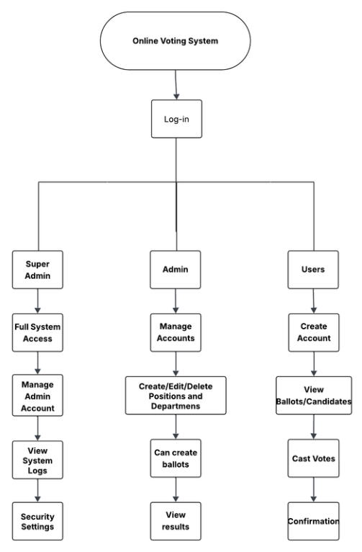
Work Breakdown Structure
Figure 2
Cost and Benefits Analysis
The integrity, security, and efficiency of an electoral process are fundamental to upholding the democratic principles of any educational institution. The existing manual voting system, while functional, presents significant operational and legal risks in the modern digital landscape. Its reliance on paper-based processes and manual data handling introduces vulnerabilities related to data accuracy, potential for human error, and a lack of transparent, auditable records. From a legal and compliance standpoint, this manual system falls short of contemporary standards for data privacy and security, creating an imperative for modernization to mitigate risk and ensure institutional accountability.
In response to these challenges, the development of a new, automated voting system was undertaken as a strategic initiative. This project was not merely a technological upgrade but a necessary investment in institutional integrity. The new platform is designed to enhance security through robust authentication measures, ensure data accuracy via automated processing, and provide a fully auditable trail for all electoral activities, thereby aligning with best practices in digital governance. The transition to this platform required a one-time capital expenditure to cover the development, testing, and deployment of a secure, scalable, and user-friendly system.
The following financial analysis provides a transparent and comprehensive breakdown of the costs and benefits associated with this transition. It is presented in three parts: Table 1 details the recurring operational costs of the outdated manual system, establishing a financial baseline. Table 2 outlines the one-time development costs required to build the new platform. Finally, Table 3 presents the new annual operating costs for the automated system. This analysis will serve as the foundation for the subsequent Return on Investment (ROI) evaluation, which will articulate the long-term financial implications and strategic value of this critical project.
Table 1: Existing Annual Cost (Manual System)
Position / Expense | Monthly Cost (₱) | Annual Cost (₱)
Ballot Paper for Printing | 800.00 | 9,600.00
Printer Expenses | 1,500.00 | 18,000.00
Results Printing | 100.00 | 1,200.00
Electricity | 1,500.00 | 18,000.00
Google Sheets/Excel | 2,000.00 | 24,000.00
Total Cost | 5,900.00 | 70,800.00
The total monthly expense for the existing manual system is ₱5,900.00, leading to an annual cost of ₱70,800.00. These costs are primarily driven by recurring needs such as ballot paper, printer expenses, electricity, and software subscriptions for manual data entry. This figure represents the financial baseline required to maintain the old, labor-intensive process and serves as the benchmark for evaluating the new system's financial impact.

Table 2: New System Development Cost (One-Time Investment)
Position / Expense | Monthly Cost (₱) | Total Cost (6 Months) (₱)
Developer Salary (2 Developers) | 60,000.00 | 360,000.00
Railway Pro (Backend Hosting) | 1,163.41 | 6,980.46
Render Pro (Frontend Hosting) | 1,163.41 | 6,980.46
Quality Assurance & Testing | 2,000.00 | 12,000.00
Development Tools & Licenses | 1,500.00 | 9,000.00
Bond Paper for Printing Results | 50.00 | 300.00
Total Development Cost | 65,876.82 | 395,260.92
The total one-time investment required to develop the new automated system over a six-month period is ₱395,260.92. The majority of this cost, ₱360,000.00, is allocated to developer salaries, reflecting the skilled labor needed to build, test, and deploy the software. The remaining expenses cover essential hosting, testing, and licensing during the development phase. This figure represents the total capital expenditure needed to transition to a modern, efficient platform.

Table 3: Annual Operating Cost (New System)
Position / Expense | Monthly Cost (₱) | Annual Cost (₱)
Developer Salary (Frontend & Backend) | 60,000.00 | 720,000.00
Railway Pro | 1,163.41 | 13,960.92
Render Pro | 1,163.41 | 13,960.92
Quality Assurance & Testing | 2,000.00 | 24,000.00
Development Tools & Licenses | 1,500.00 | 18,000.00
Bond Paper for Printing the Results | 50.00 | 600.00
Total Annual Operating Cost | 65,876.82 | 790,521.84
Return on Investment (ROI) Analysis
The transition from the existing manual voting system to the new automated platform involves a shift in cost structure. The previous manual process incurred an annual cost of ₱70,800.00, while the new automated system has a recurring annual operating cost of ₱790,521.84, as detailed in Table 3.
The Return on Investment (ROI) is calculated to determine the financial gain or loss relative to the cost. The formula is:
ROI = ((Net Profit from Investment) / Cost of Investment) * 100
First, we determine the net profit (or loss) from the investment by calculating the annual savings:
Annual Savings = Old System Annual Cost - New System Annual Cost
Annual Savings = ₱70,800.00 - ₱790,521.84 = -₱719,721.84
This results in an increased annual expenditure of ₱719,721.84. Because the annual savings are negative, the initial one-time development cost of ₱395,260.92 is not recovered through operational savings.
Based on this financial structure, the project represents a strategic investment in modernization and technological capability rather than immediate operational cost savings. The value is realized through improved efficiency, security, and accuracy, justifying the increased annual expenditure.
MoSCoW
IMPLEMENTATION OF A SECURE AND SCALABLE AUTOMATED VOTING SYSTEM FOR THE SUPREME STUDENT COUNCIL ELECTION
Must Have:
- Secure user authentication system
- User registration with student verification
- Email-based password reset functionality
- One-vote-per-student restriction
- Multi-role access control (Super Admin, Admin, User)
- Department and course-based voter categorization
- Responsive web design for desktops and mobile
- Candidate profiles with information display
- File upload functionality for candidate photos
- Automated vote confirmation receipts
- Real-time voting statistics dashboard
- Comprehensive audit trail for system activities
- Export functionality for election results (e.g., CSV)
Should Have:
- Election scheduling and time management
- Voter eligibility verification tools
- System backup and recovery capabilities
Could Have:
- Multi-language support
- Advanced analytics and reporting
- Integration with student information systems
- Mobile application for enhanced accessibility
- Automated voter reminder notifications
Won't Have:
- Biometric verification systems
- Blockchain-based vote ledger
- Social media platform integration
- Physical ballot backup systems
- Advanced AI-powered fraud detection

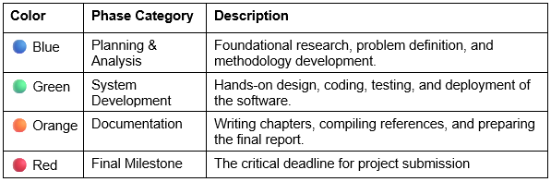
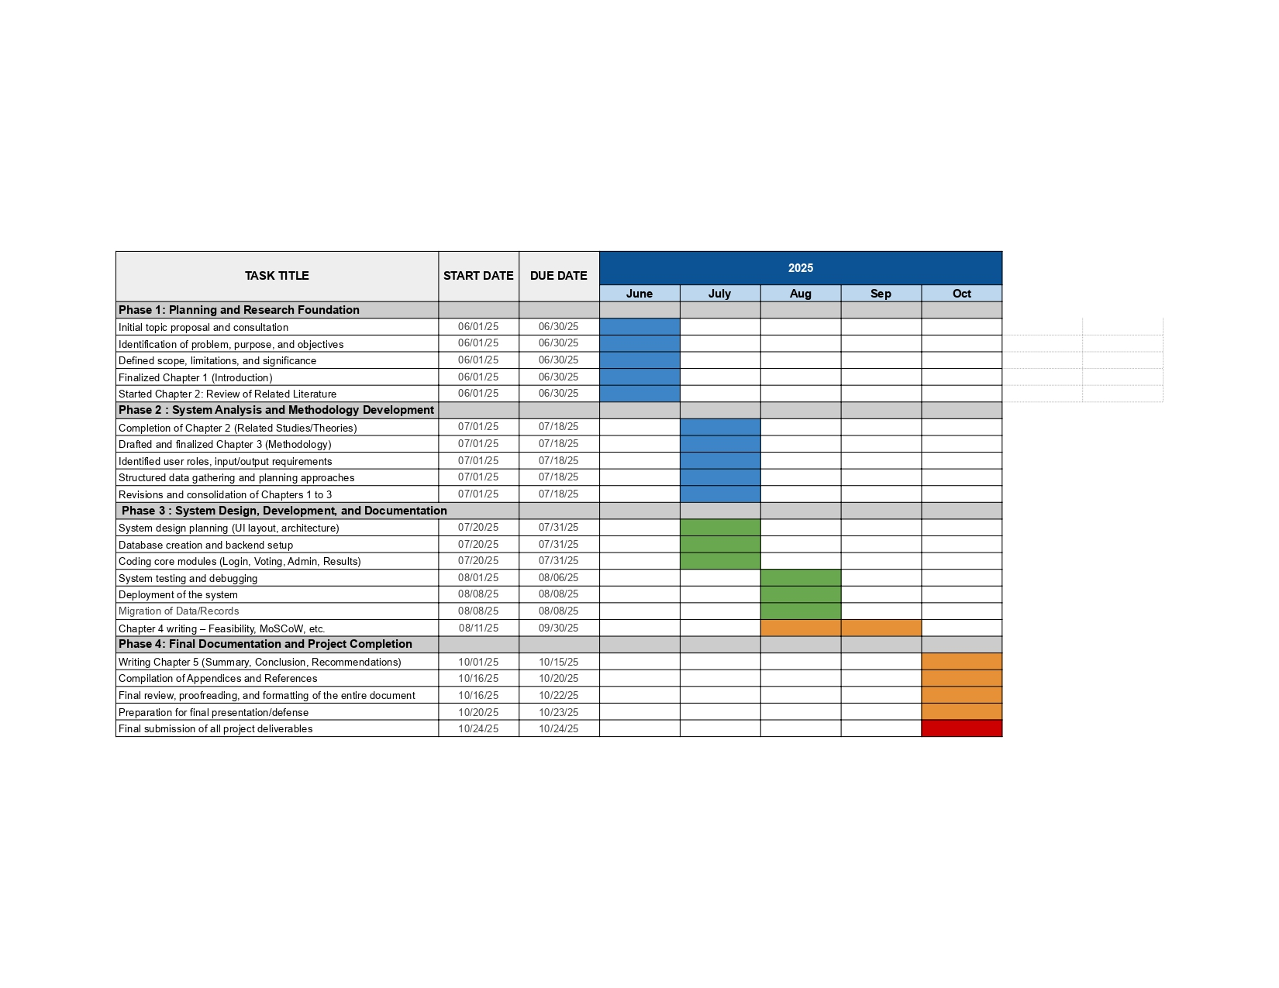
Gantt Chart
Figure 3

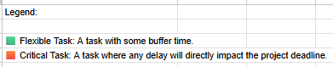
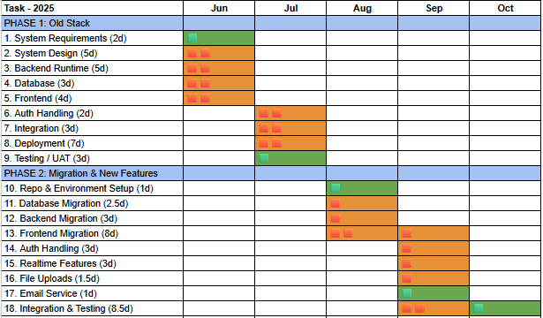

Critical Path
Figure 4
Data and Process Modeling
The Online Voting System employs a comprehensive data and process modeling approach to ensure efficient data management, seamless workflow execution, and reliable system performance. The data modeling framework utilizes PostgreSQL as the primary relational database management system, with a backend built on Node.js and the Express framework to handle data logic and API requests.
The database architecture follows a relational model with carefully designed entities to support the complete election workflow. The core entities include User, Election, Candidate, Vote, and History tables, each with well-defined relationships and constraints to maintain data integrity. The User entity stores essential authentication information, including student ID, hashed passwords using bcrypt encryption, user roles (voter, admin, superadmin), and account status. The Election entity manages election metadata, while the Candidate entity maintains candidate profiles. The Vote entity securely records voting transactions, and the History table serves as an audit log by capturing all critical system activities for security monitoring.
The process modeling incorporates both synchronous and asynchronous workflows. The voting process follows a strict sequential workflow, beginning with user authentication via JSON Web Tokens (JWTs) stored in localStorage. This is followed by voter eligibility verification, ballot presentation, vote selection, and secure submission to the backend. Administrative processes include election setup, candidate management, user account administration, and real-time monitoring of election progress through the dashboard.
The system ensures data integrity and transaction reliability. Each vote submission is handled as an atomic transaction by the Express backend, ensuring that a vote is either recorded completely or not at all, which prevents partial or corrupt data. Database constraints and foreign key relationships in PostgreSQL maintain referential integrity across all related tables, ensuring that the data remains consistent and reliable throughout the election cycle.
Data flow modeling ensures secure and efficient information processing. Input data is validated on both the React frontend to provide immediate user feedback and on the Express backend to protect the system from invalid data. All sensitive data, particularly user passwords, undergoes industry-standard hashing before being stored. The system's API is designed following RESTful principles, providing clear and organized endpoints for all CRUD (Create, Read, Update, Delete) operations related to authentication, elections, candidates, and voting.
Performance and deployment strategies were chosen for reliability and scalability. The backend, built with Node.js and Express, is deployed on Railway, a platform known for its ease of use and robust infrastructure. The frontend, a dynamic single-page application built with React, is deployed on Render, ensuring fast load times and a smooth user experience. This decoupled architecture allows the frontend and backend to be scaled independently, ensuring the system remains responsive and available even during peak voting periods.

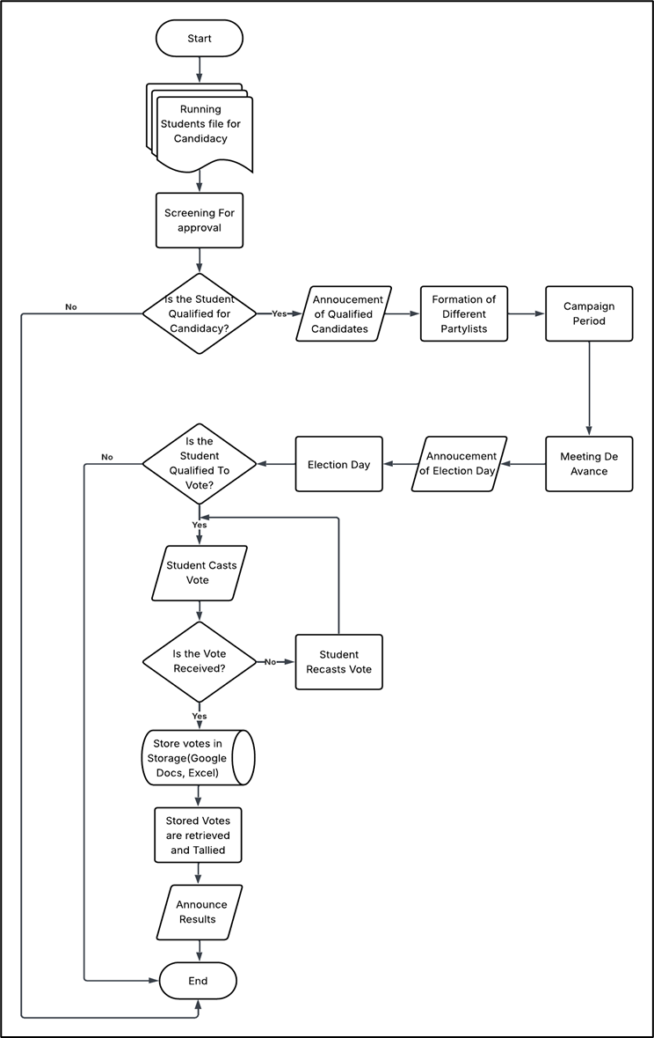
Existing Flow Chart
Figure 5
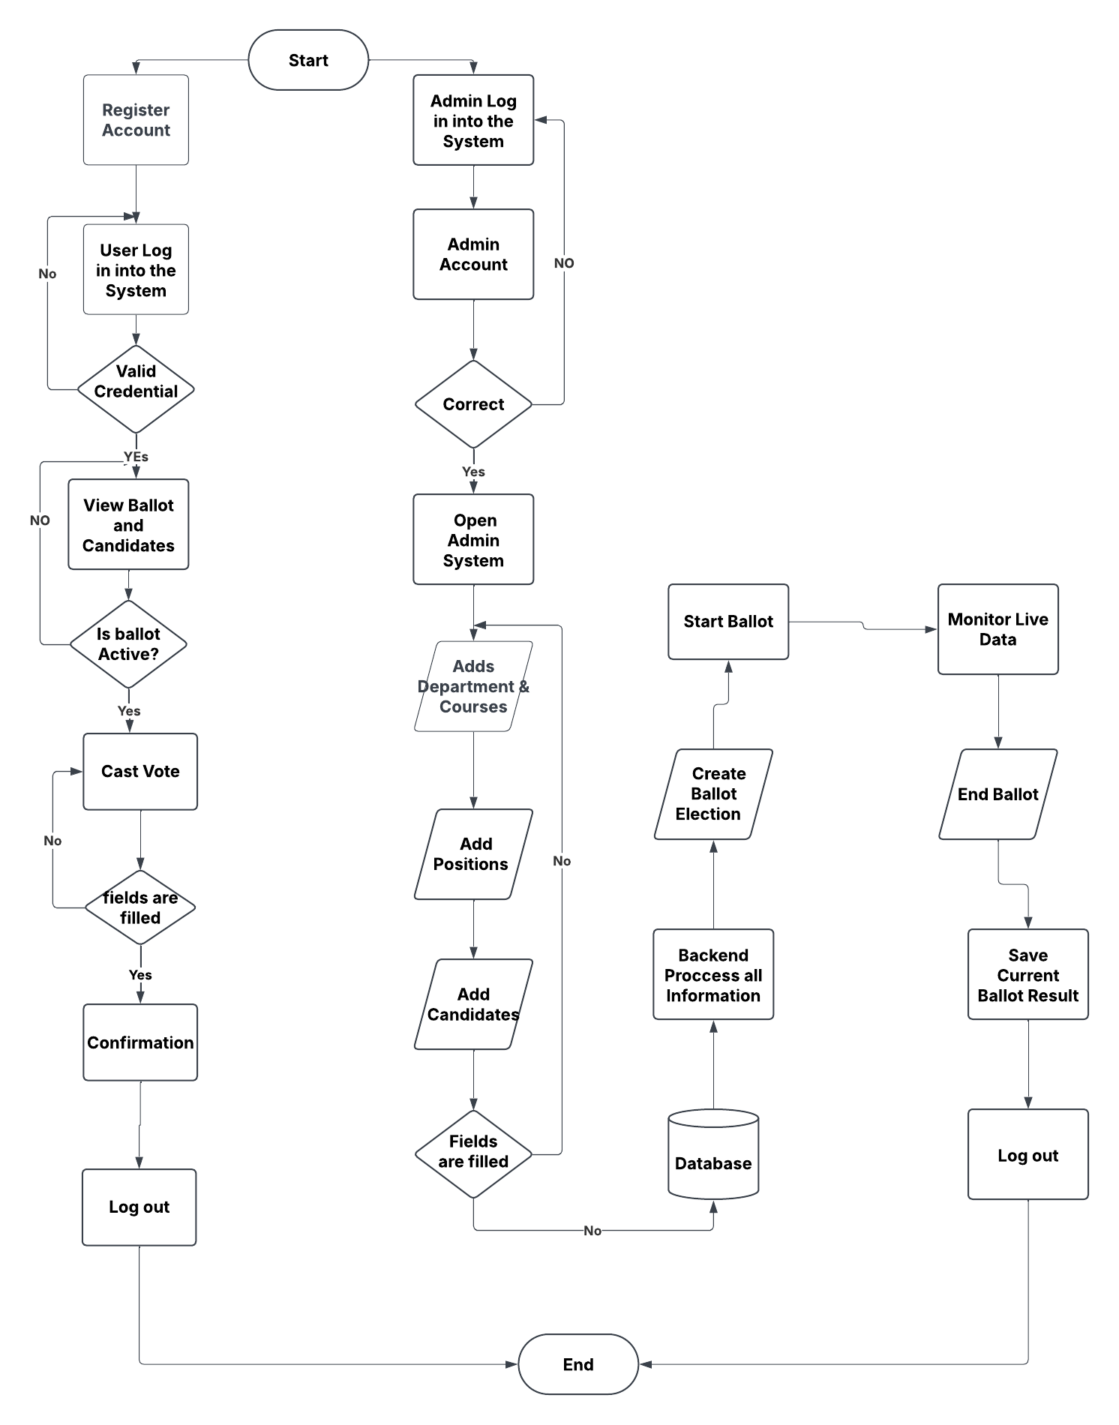
Proposed Flowchart
Figure 6
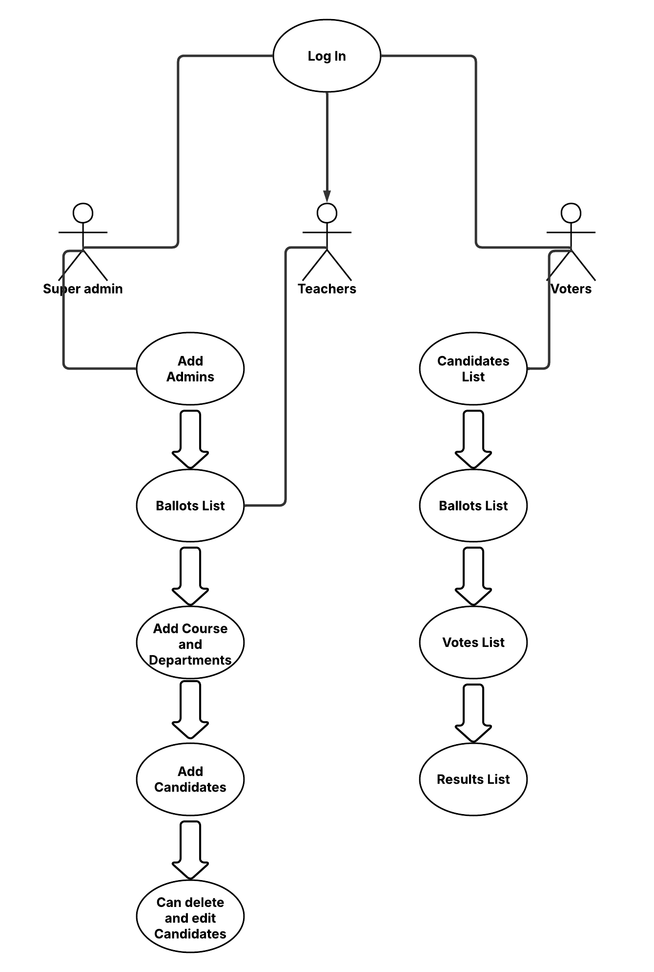
Use Case Diagram
Figure 7
Narrative
Table 4: Login Use Case
Field | Details
Use Case | Log In
Summary | Students can log in and cast their votes for SSC candidates. Each student is allowed to vote once.
Actors | Students, Admins, Super Admin
Purpose | To provide a secure and efficient way for students to vote online
Pre-condition | Students have access to the website and valid login credentials
Post-condition | The vote is successfully recorded and stored in the database
Exception | Duplicate voting attempt, network failure, invalid login credentials

Flow of Events
Actor Response | System Response
1. Visit Website | 2. Display Website
3. Click Login | 4. Display Login Page
5. Enter Student ID & Password | 6. Successful login → Redirect to dashboard
Alternative Flow
Actor Response | System Response
5.1 ID/Password blank | 5.2 Error: "Fields cannot be empty"
5.3 ID/Password invalid | 5.4 Error: "Incorrect Student ID or Password"

Table 5: Add Users Use Case
Field | Details
Use Case | Manage Users
Summary | Add new voters to the election system
Actors | Super Admin, Admin
Purpose | To register eligible voters in the voting system
Pre-condition | Admin logged in with access to user management
Post-condition | User successfully added to the system
Exception | Duplicate student ID, invalid data format

Flow of Events
Actor Response | System Response
1. Visit Website | 2. Display Website
3. Click Login | 4. Display Login Form
5. Enter Username & Password | 6. Successful login
7. Navigate to User Management | 8. Display User Registration Form
9. Enter User Details | 10. Save & Confirm user registration
Alternative Flow
Actor Response | System Response
9.1 Missing required fields | 9.2 Error: "Please complete all required fields."
9.3 Duplicate Student ID | 9.4 Error: "Student ID already exists"

Table 6: Voting Process Use Case
Field | Details
Use Case | Cast Vote
Summary | Students can vote for their preferred candidates during the election period
Actors | Voters
Purpose | To allow eligible students to cast their votes securely
Pre-condition | The voter is logged in and eligible to vote
Post-condition | Vote successfully recorded in the system
Exception | Duplicate voting attempt, no selection made

Flow of Events
Actor Response | System Response
1. Visit Website | 2. Display Website
3. Click Login | 4. Display Login Form
5. Enter Student ID & Password | 6. Successful login
7. Access Voting Page | 8. Display List of Candidates with Photos
9. Select Candidates | 10. Confirm Vote Submission
11. Vote Submitted | 12. Display Confirmation Message
Alternative Flow
Actor Response | System Response
9.1 No selection made | 9.2 Error: "Please select a candidate before submitting."
10.1 Duplicate voting attempt | 10.2 Error: "You have already voted."

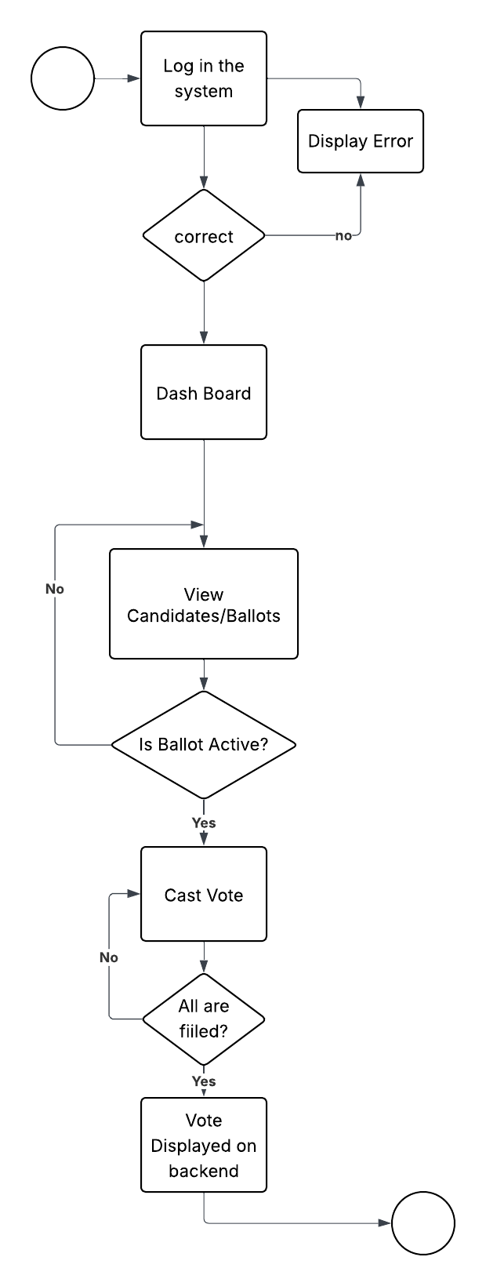

State Chart Diagram
Figure 9
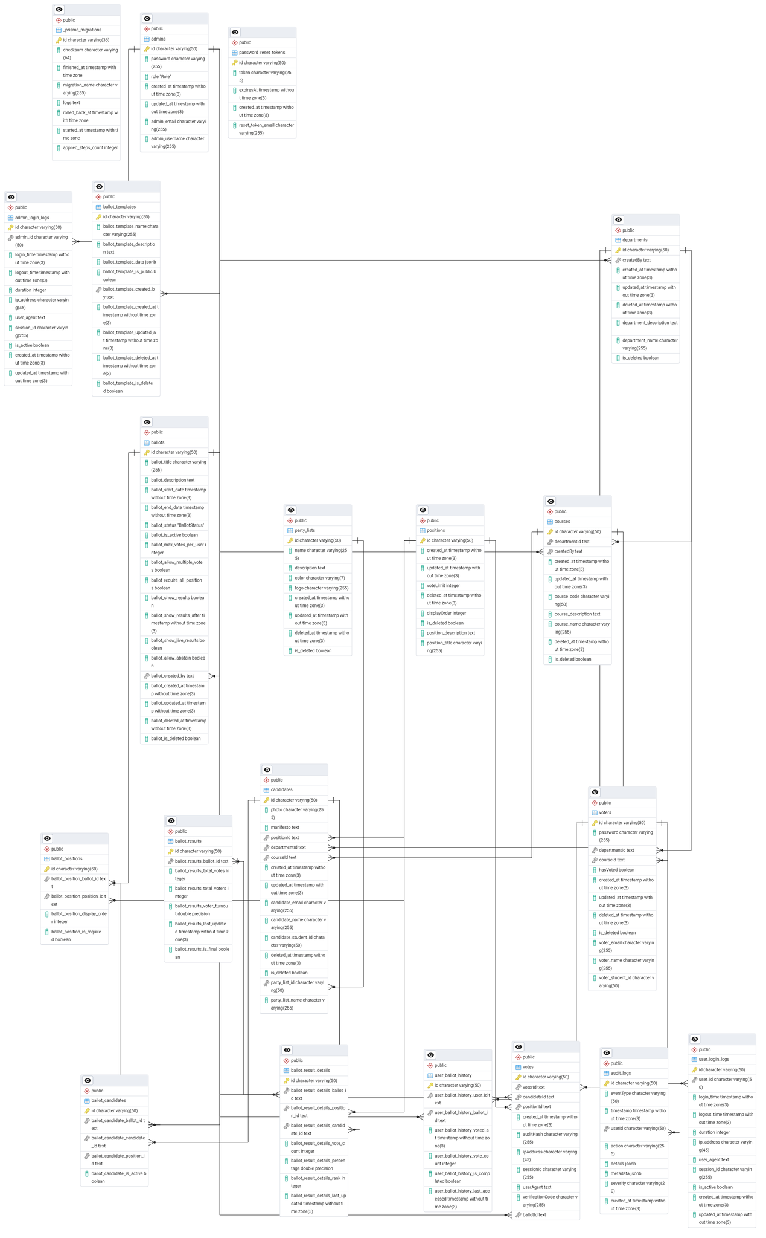

Entity Relationship Diagram
Figure 10
Link: https://printed-magenta-tssvman6pz.edgeone.app/ERD.png

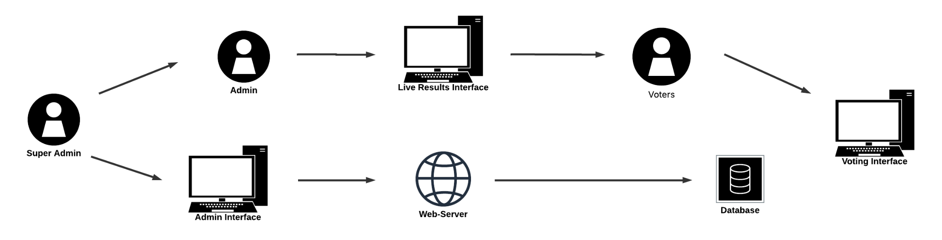

System Architecture
Figure 11
Security Implementation
The Online Voting System implements a multi-layered security architecture designed to protect against common web threats while maintaining the integrity, confidentiality, and availability of the election process. The security framework addresses authentication, authorization, data protection, and network security requirements.
Authentication and Authorization security is centered on a JSON Web Token (JWT) implementation, which manages secure user sessions. User passwords undergo industry-standard bcrypt hashing with salt rounds before being stored in the database, which prevents direct password exposure even in the event of a data breach. The system enforces a strict Role-Based Access Control (RBAC) model, with distinct permission levels for Voters, Admins, and Super Admins. Authorization checks are performed on the backend for every sensitive API request, ensuring users can only access data and perform actions appropriate for their role.
Data Protection mechanisms are enforced at multiple levels. All data transmission between the client and the server is secured over HTTPS using TLS encryption. Database connections are similarly protected to secure data in transit. To protect voter privacy, the system is designed to anonymize vote data upon submission, separating the voter's identity from their cast ballot to ensure the integrity of the secret ballot principle.
To prevent common web vulnerabilities, the system implements comprehensive input validation and sanitization. All user-submitted data is validated on both the React frontend for immediate feedback and, more critically, on the Express backend using middleware before being processed or stored. This server-side validation is crucial for protecting against threats such as SQL injection and Cross-Site Scripting (XSS).
Network Security is bolstered through several standard practices. The application is deployed on modern cloud infrastructure (Railway and Render), which provides foundational security features like firewalls. The Express backend implements security headers via middleware (like helmet) to protect against common browser-based attacks. Furthermore, a Cross-Origin Resource Sharing (CORS) policy is configured to restrict which domains can access the API, preventing unauthorized cross-site requests.
Audit and Monitoring capabilities provide comprehensive tracking of system activities. The History table functions as an audit log, capturing user authentication events (logins/logouts), administrative actions, and other critical changes with immutable timestamps. This log is essential for security analysis and ensuring the transparency and verifiability of the election process.
Finally, the system is designed in compliance with data privacy principles, particularly those outlined in the Philippines Data Privacy Act of 2012. It follows data minimization by collecting only the information necessary for authentication and election integrity, ensuring that student data is handled responsibly and ethically.
Development Methodology and Implementation
The development of the Online Voting System was executed in accordance with a formal Agile methodology, adapted to the rigorous constraints of an academic calendar and the stringent legal and ethical requirements of managing electoral processes. This framework prioritized iterative development, continuous integration, and stakeholder validation to ensure the final system achieved the highest standards of functionality, security, and legal compliance.
The project lifecycle was structured into distinct, auditable phases, beginning with comprehensive requirements analysis and system design, followed by the meticulous design of the PostgreSQL database schema and RESTful API architecture. The technical implementation phase involved constructing the backend infrastructure using the Node.js and Express.js framework and developing the client-side interface with Vite and React, adhering to contemporary software engineering principles.
Central to this process was the use of Git and GitHub for version control, providing a complete and transparent history of all code contributions and changes. The system’s architecture was guided by industry-standard design patterns to ensure scalability and maintainability. The Express.js backend was organized into a modular structure to handle authentication, election management, and voting operations with clarity and separation of concerns, while the PostgreSQL database employed a normalized relational model to guarantee data integrity and referential consistency.
The React frontend was built upon component-based architecture, promoting reusability and efficient state management. The API was developed in strict adherence to RESTful principles, featuring robust input validation and sanitization to mitigate common security vulnerabilities and protect against unauthorized data manipulation.
Quality assurance was embedded throughout the lifecycle, with a primary focus on securing authentication and authorization mechanisms to uphold the principle of one person, one vote. The deployment strategy utilized professional-grade cloud services, with the backend hosted on Railway’s Pro-tier plan and the frontend on Render’s Pro-tier plan, leveraging their advanced security, scaling, and monitoring capabilities.
All sensitive configurations were managed securely through environment variables, and the system was designed with comprehensive error handling and logging to support ongoing maintenance and troubleshooting. This disciplined approach ensures that the system is not only a successful academic endeavor but also a secure, reliable, and sustainable asset designed for long-term institutional value and potential use by future student developers.
Chapter 5
Summary, Conclusion, and Recommendations
Summary
This capstone project successfully developed and deployed a secure online voting system for the Supreme Student Council elections at Benedicto College. The system replaced the existing manual process with a comprehensive web application featuring secure authentication, real-time vote counting, and automated result tabulation. Built using a modern technology stack including a Vite + React frontend, a Node.js/Express.js backend, and a PostgreSQL database, the system ensured election integrity through JWT authentication, vote anonymization, and comprehensive audit trails.
The implementation demonstrated that student-developed electoral systems can effectively modernize institutional voting processes. The financial analysis concluded that the project represented a strategic investment in technological capability and security. With a one-time development cost of ₱395,260.92 and new annual operating costs of ₱790,521.84, the system's value was realized through critical intangible benefits such as enhanced security, transparency, and voter trust, justifying the increased expenditure. The deployed system successfully handled concurrent voting, prevented duplicate submissions, and provided real-time monitoring capabilities that significantly improved upon manual electoral processes.
Academic Validation and Assessment
The academic evaluation process provided comprehensive validation of the project's technical merit and institutional value. The examining committee recognized the technical competence demonstrated in the system implementation and acknowledged the project's significant contribution to modernizing electoral processes within educational institutions. The evaluation highlighted the comprehensive approach to security implementation and the practical consideration of economic constraints typical in academic environments.
The assessment emphasized the importance of the cost-benefit analysis, which transparently framed the project as a strategic investment in institutional modernization rather than one of operational cost savings. The academic validation confirmed that the project met rigorous standards for comprehensive capstone work while demonstrating both functional effectiveness and meaningful contribution to the field of electoral technology in educational settings.
Conclusion
The Online Voting System for Benedicto College's Supreme Student Council elections has been successfully developed, deployed, and academically validated. The system effectively addressed the limitations of the previous manual processes by providing secure authentication, real-time vote counting, and comprehensive audit capabilities. The financial analysis confirmed that the project was a strategic investment in the institution's technological infrastructure, security, and democratic process, with value delivered through operational improvements that justified the increased annual costs.
Academic evaluation confirmed that the project met comprehensive capstone standards while demonstrating practical value for institutional electoral modernization. The successful deployment proved that student-led technology initiatives can deliver functional solutions when properly planned and executed. This project established a foundation for future electoral system development and provided a sustainable digital asset for the institution's ongoing democratic processes.
Recommendations
For Educational Institutions
Educational institutions consider implementation should proceed with system deployment through a structured pilot program, recognizing it as a strategic investment. Piloting with low-stakes elections before official use allows for the identification of operational issues while building user confidence. Institutions must establish clear technical support protocols, including trained personnel, troubleshooting procedures, and backup plans for technical failures. Reliable internet connectivity is critical, and backup options should be evaluated.
Budget planning must account for the significant ongoing operational costs of ₱790,521.84 annually, in addition to domain registration and periodic system updates. Institutions must establish dedicated funding streams to ensure system continuity. Legal compliance requires comprehensive policies governing data management in accordance with Republic Act No. 10173 (Data Privacy Act of 2012), with legal consultation to ensure all procedures meet regulatory standards.
Strategic expansion opportunities should be evaluated to leverage the platform for additional institutional voting needs, as this can help justify the significant investment by maximizing the technology's utility. Long-term sustainability requires addressing the challenge of maintaining technical expertise as student developers graduate, potentially through partnerships with IT service providers or by creating structured knowledge-transfer programs for subsequent student cohorts. Regular system reviews should be conducted annually to assess security, performance, and user satisfaction.
For System Enhancement and Research
Developers implementing similar systems should understand that modern web development frameworks introduce complexity requiring careful management, as dependency conflicts between React, Express.js, and supporting libraries can consume significant development time. Database design decisions have long-term implications, and the PostgreSQL schema may require modification for larger or more complex election scenarios.
Authentication and security implementation require a thorough understanding of web security principles. While the JWT token approach provides adequate security, future implementations should consider additional measures like rate limiting and more sophisticated encryption. Testing strategies should emphasize realistic usage scenarios, including peak load conditions.
Comparative analysis of voting system implementations across different educational institutions would provide valuable insights. Research into integration with existing student information systems could significantly improve operational efficiency by automating voter eligibility verification.
The economic analysis, technical challenges, and operational requirements documented through this project provide realistic guidance for institutions considering similar initiatives. Future success will depend on careful planning, realistic expectations, and a sustained institutional commitment to the operation and maintenance of digital voting systems.
DEFINITION OF TERMS
The following definitions provide clarity on key terminology essential for understanding the intersection of technology, psychology, economics, and environmental sciences.
Agile Methodology - An iterative approach to project management and software development that emphasizes flexibility, collaboration, and frequent releases. In this project, it allowed for continuous adaptation to academic timelines and stakeholder feedback.
API (Application Programming Interface) - A set of rules and protocols that allows different software applications to communicate with each other. In this system, the API enables the React frontend to interact with the Node.js backend.
Authentication - The process of verifying the identity of a user to grant them access to the system. This is primarily handled through student IDs and hashed passwords.
Authorization - The process of determining the level of access or permissions a verified user has within the system, such as differentiating between a voter, an Admin, and a Super Admin.
Audit Trail - A chronological record of system activities that allows for the monitoring and review of all actions, such as logins, votes cast, and administrative changes. It is crucial for ensuring transparency and security.
Backend - The server-side of the application that handles logic, database interactions, and API requests. In this project, it was built using Node.js and the Express.js framework.
bcrypt - A widely used and secure password-hashing function designed to protect user credentials by converting them into a non-reversible format before storage.
Cost-Benefit Analysis - An economic evaluation used to compare the costs of a project against its benefits to determine its financial viability and strategic value.
Cross-Origin Resource Sharing (CORS) - A security mechanism that controls which external websites or domains are permitted to request resources from the application's backend, preventing unauthorized cross-site requests.
Data Encryption - A method of protecting sensitive data by converting it into an unreadable format, ensuring that only authorized parties can decode and access the information.
Database Management System (DMS) - Software that allows the storage, retrieval, and management of data, including voter information and election results.
Deployment - The process of making the application live and accessible to end-users on a production server. The backend was deployed on Railway and the frontend on Render.
Electoral Process - The structured procedures followed during an election, including nomination, campaigning, voting, and the declaration of results.
Express.js - A minimal and flexible web application framework for Node.js that provides a robust set of features for building the backend API.
Feasibility Study - A comprehensive analysis conducted to determine the viability of a project across technical, economic, operational, legal, and schedule-related dimensions.
Frontend - The client-side of the application that users interact with directly. In this project, it was built using React and Vite.
JSON Web Token (JWT) - A compact and secure standard for creating access tokens that are used to authenticate users and manage their sessions after they log in.
MoSCoW Method - A prioritization technique used to categorize project requirements into four categories: Must-have, Should-have, Could-have, and Won't-have.
PostgreSQL - An open-source relational database management system used to store, manage, and retrieve all project data, including user information, election details, and votes.
Node.js - A JavaScript runtime environment that allows for the execution of JavaScript code on the server-side, forming the foundation of the project's backend.
Online Voting System - A digital platform that allows voters to cast their ballots electronically, replacing traditional paper-based voting methods. This system ensures convenience and accessibility in the election process.
Relational Database - A type of database that stores and provides access to data points that are related to one another, organized into tables with rows and columns. MySQL is the relational database used in this project.
Return on Investment (ROI) - A performance measure used to evaluate the profitability of an investment. In this project, it is calculated based on the financial costs and strategic benefits of the new system versus the old one.
Role-Based Access Control (RBAC) - A security model that restricts system access based on a user's assigned role (e.g., Voter, Admin, Super Admin), ensuring users can only perform actions permitted for their role.
Scalability - The ability of a system to handle a growing amount of work or its potential to be enlarged to accommodate that growth. The system was designed to be scalable for future needs.
Schema - The structure or blueprint of a database that defines how data is organized, including the tables, fields, and the relationships between them.
SQL Injection - A type of cyberattack where malicious SQL code is inserted into a system's queries to manipulate the database. The system is protected against this via input sanitization.
Strategic Investment - An expenditure that is made with the primary goal of achieving long-term strategic objectives, such as modernization and improved security, rather than immediate financial profit.
Supreme Student Council (SSC) - The governing student body responsible for representing the student population in various activities and decisions within the institution.
System Security - Refers to the measures put in place to protect the voting system from unauthorized access, data breaches, and manipulation of results, ensuring the integrity of the election.
System Vulnerability - Weaknesses or flaws in the online voting system that could potentially be exploited, leading to security breaches or errors in the electoral process.
User Interface (UI) - The part of the online voting system that users interact with, designed for ease of use and efficiency in navigating the voting process.
Vite - A modern frontend build tool that provides a faster and more efficient development experience for web projects, used here with React.
Voter Turnout - The proportion of eligible students who participate in the voting process, typically used as a measure of engagement or interest in the elections.

BIBLIOGRAPHY

REFERENCE
Anthony Downs (1957). An Economic Theory of Democracy. Harper & Row.
Ludwig von Bertalanffy (1968). General System Theory: Foundations, Development, Applications. George Braziller.
John Duggan & Thomas Schwartz (2000). Strategic Manipulability of Voting Rules. Social Choice and Welfare, 17(3), 289–316.
Pippa Norris (2014). Why Electoral Integrity Matters. Cambridge University Press.
Manuel B. Garcia (2017). E-Learning Technology Adoption in the Philippines. The International Journal of E-Learning and Educational Technologies in the Digital Media, 3(3), 118-130.

Bev Harris (2003). Black Box Voting: Ballot Tampering in the 21st Century. Plan Nine Publishing.
Cayabyab, J. (2008). College Student Council Voting System for Pangasinan State University Bayambang-Campus.
Echavez, A., Garay, J., & Ratunil, M. (2010). Lucky 3 Voting System, Mindanao State University.
Bucad, M. G. R., & Galicia, L. S. (2021). Digital Literacy Skills, Digital Competence, and Digital Governance of Public Higher Educational Institutions (PHEIs) in the Province of Batangas: A Basis for ICT Roadmap Development. Retrieved from https://multidisciplinaryjournals.com/wp-content/uploads/2021/05/FULL-PAPER-DIGITAL-LITERACY-SKILLS-DIGITAL-COMPETENCE-AND-DIGITAL-GOVERNANCE-OF-PUBLIC-HIGHER-EDUCATIONAL-INSTITUTIONS.pdf
World Bank. (2022). Digital Transformation of Philippine Higher Education. https://documents1.worldbank.org/curated/en/099925001062333685/pdf/P17757402843a10c90b3e30308406a38304.pdf
Chaum, D., Rivest, R. L., and Sherman, A. T. (2004). Scalability of E-Voting System
Ryan, P. Y. A. (2015). The Evolution of End-to-End Verifiable Voting Systems
Dr. Magdi Amer and Dr. Hazem El-Gendy (2013). Towards a Fraud Prevention E-Voting System
Kamau, S. W. (2014). A Mobile Web-Based Electronic Voting System: A Case Study of Strathmore University.
https://su-plus.strathmore.edu/server/api/core/bitstreams/471cbc2f-7891-4b2e-8ff3-da4538b9a959/content
Kibet, P., Rono, J. K., & Serem, D. K. (2018). Electronic Voting System for University Student Elections: The Case of Kabarak University, Kenya. Retrieved from https://ieeexplore.ieee.org/document/8417298

APPENDICES
Appendix A
Relevant Source Code
The source code for this study can only be downloadable by the assigned people and researchers. Thank you so much for understanding.

Appendix B
Election Module
- Ability to add, edit, delete, and retrieve election details.
- The system automatically manages election status (Pending, Ongoing, Finished) based on the scheduled start and end times.
- The dashboard displays a real-time count of votes as they are submitted.
Department & Course Module
- Ability to add, edit, and retrieve department and course details.
- Voters are categorized by departments and courses to ensure they receive the correct ballot.
- The database must be populated with department and course data before users can be properly assigned.
User Module (Voters & Admins)
- Ability to add, edit, and delete users.
- The system supports distinct roles (Voter, Admin, and Super Admin) with different permissions.
- Voters are restricted to casting only one vote per election.
- Admins can manage candidates and view election results.
- Super Admins have full system oversight, including user and election management.
To-Do
- Ensure the database is normalized and all relevant details are stored properly.
- Note: The core features for the election process have been implemented as per the MoSCoW analysis in Chapter 4.
Error Testing
- Authentication:
  - Ensure login fails if the Student ID or Password is incorrect.
  - Ensure login form fields cannot be submitted if empty.
- Voting Process:
  - Ensure a user who has already voted cannot access the ballot a second time.
  - Ensure a voter cannot submit a ballot without making a selection.
- Data Integrity:
  - Ensure text fields for names do not accept numbers.
  - Ensure email fields follow a valid format.
Ensure an administrator cannot create a new user with a Student ID that already exists in the database.

Appendix C
Grammarian’s Certificate
CERTIFICATE OF GRAMMATICAL REVIEW
This is to certify that the undersigned has conducted a comprehensive grammatical and stylistic review of the capstone project manuscript entitled:
"IMPLEMENTATION OF A SECURE AND SCALABLE AUTOMATED VOTING SYSTEM FOR THE SUPREME STUDENT COUNCIL ELECTION"
The review was performed to ensure the document adheres to the linguistic standards required for academic and technical writing. The examination focused on correcting errors in grammar, syntax, punctuation, and spelling, as well as improving the overall clarity, coherence, and professional tone of the text.
This certification attests that the documentation has been reviewed to a high standard of linguistic quality, rendering it ready for final submission. The technical accuracy and validity of the subject matter remain the sole responsibility of the authors.
Issued on this ___ day of ___________, 2025.

Rowelyn B. Bais
Grammarian

CURRICULUM VITAE

EIRICK KERBI D. CABARDO
Bachelor of Science in Information Technology
Tayud, Liloan, Cebu |+63 927 746 3330 | kerbi2600@gmail.com | github.com/AdeptEagle
TECHNICAL SKILLS
Languages: C, C#, C++, JavaScript, TypeScript, HTML, CSS
Frontend Frameworks: React, Angular, Nest.js, Bootstrap
Backend Frameworks: Node.js, Next.js, Websockets, REST APIs
Databases/ORM: MySQL, PostgreSQL, Prisma ORM
Tools/Technologies: Git, GitHub, Postman, Arduino
PROFESSIONAL SKILLS

- Problem solving skills
- Communication skills
- Critical thinking
- Efficient under pressure
- Ability to multitask
- English Fluency

PROJECTS
Online Voting School System | June 2025 - November 2025
- Role: Team Leader & Lead Full stack Developer
- An Undergraduate study that aims to improve the manual voting process of the school using mobile phones and school desktops.
- Developed full stack features using NestJS, Prisma ORM, and PostgreSQL, including backend APIs and frontend interfaces.
LEADERSHIP and EXTRACURRICULAR ACTIVITES
- Supreme Student Council | Benedicto College | 2023-2024
- Department President (College of Computer Studies) | Benedicto College | 2024-2025
- Honor’s List | Benedicto College | 2023
- Director’s List | Benedicto College |2024
- President’s List | Benedicto College | 2025
- 2nd Multidisciplinary Research Congress | Benedicto College |2025
  - Best Podium Presenter
  - Best Research Paper
SEMINARS and WORKSHOPS
- March 21, 2023: Philippine Society of Information Technology Educators – Central Visayas Region, Fortifying IT Education through Disruptive Innovation, CTU Gym, Cebu City
- March 15, 2024: Philippine Society of Information Technology Educators – Central Visayas Region, Navigating the Digital Frontier: Trust, Twins and Wellness in the Digital Age, CITU, Cebu City
- May 7, 2025: Philippine Society of Information Technology Educators – Central Visayas Region, Empowering and Future Proofing Students through Cybersecurity and Research, Recoletos Coliseum, USJ-R Basak Campus
- May 15, 2025: ORACLE: Redefine Best in a World of Change, NUSTAR Resort Cebu
- June 10, 2025: Lig-Ong Apps, Protektadong Endpoint | Beyond Firewall: App & Endpoint Security, Seda Central Bloc Cebu
- July 17, 2025: Can You hackIT Challenge: IBPAP Hackathon, Cebu Institute of Technology – University
EDUCATION
Benedicto College – Mandaue Campus | A. S. Fortuna St
Bachelor of Science in Information Technology - (2022- 2026)

Jhian Kyle R. Cinco
☎ +63 969 188 5757
✉ cincojhian@gmail.com
Zone 3 Upper Tingub, Mandaue City, Cebu
Gender  Date of Birth  Nationality  Marital Status |  | Male  October 22, 2003  Filipino  Single
Objective |  | I am looking for an opportunity to leverage my academic knowledge from the BSIT program to drive measurable improvements in process efficiency and aid in digital transition projects. My goal is to join a supportive IT team that provides a clear trajectory for skill development and practical application within a relevant IT domain.
Education |  | 2022 - 2026 | Benedicto College | College  A.S. Fortuna St., Mandaue City
 |  | 2020 - 2022 | Benedicto College | Senior High  A.S. Fortuna St., Mandaue City
 |  | 2016 - 2020 | Mabolo National High School | Junior High  Juan Lune Ave., Cebu City
 |  | 2009 - 2016 | Subangdaku Elementary School  Subangdaku, Mandaue City
Seminars |  | 03.21.2023 | Philippine Society of Information Technology  Educators – Central Visayas Region  CTU Gym, Main Campus, M.J. Cuenco Ave., Corner  R. Palma St., Cebu City  Fortifying IT Education through Disruptive Innovation Tools and Technologies
 |  | 03.15.2024 | Philippine Society of Information Technology  Educators – Central Visayas Region  Cebu Institute of Technology - University (CITU), Cebu City  Navigating the Digital Frontier: Trust, Twins and Wellness in the Digital Age
 |  | 05.07.2025 | Philippine Society of Information Technology  Educators – Central Visayas Region  Venue: Recoletos Coliseum, USJ-R Basak Campus  Theme: Empowering and Future Proofing Students through Cybersecurity and Research

TECHNICAL SKILLS

Front End: HTML, CSS, JS
Frameworks: Laravel
Back End: Express.js, MYSQL, Node,js
Developer Tools: VS Code, Git, GIthu
PROJECTS and AWARDS

- Capstone Project | Voting System (React / Next.js / PostgreSQL + Prisma)
- 2nd Multidisciplinary Research Congress, Best Research Paper | Benedicto College | December 2025

Kercson G. Didal
☎ 0921 963 9200
✉ kercsondidal@gmail.com | kercson.netlify.app
Zone Sili 195, Paknaan, Mandaue City
Gender  Nationality  Marital Status |  | Male  Filipino  Single
Objective |  | I am a 21-year-old IT student who loves learning new things about technology. I always do my best in everything I do and make sure to finish tasks responsibly. I’m a hardworking and easy-to-approach person who enjoys working with others and learning from them. I believe that every experience is a chance to grow and improve myself.
Education |  | 2022 - 2026 | Benedicto College | College  A.S. Fortuna St., Mandaue City
 |  | 2006 - 2012 | University of Cebu, Lapu-Lapu and Mandaue | Senior High  A.C. Cortes Avenue, Mandaue City
 |  | 2000 - 2006 | Pakna-an National High School | Junior High  Pakna-an, Mandaue City
TECHNICAL SKILLS

- Backend | Node.js, Express.js
- Database & Data | SQL (MySQL/MariaDB, PostgreSQL)
- DevOps & Tools | Git, GitHub, Frontend Architecture
- Web Development | JavaScript, TypeScript, Angular, Vite+React.js
- Cloud & Services | Vercel, Railway
- Foundational CS | Object-Oriented Programming (OOP), Data Structures & Algorithms (DSA), C, C++, C#

PROJECTS and AWARDS

- Director’s List | Benedicto College | 2023
- Capstone Project | Voting System (React / Next.js / PostgreSQL + Prisma)
- 2nd Multidisciplinary Research Congress, Best Research Paper | Benedicto College | December 2025

Kreshia Dian G. Epe
✉ kdianepe@gmail.com
Bayanihan, Barangay Buaya, Lapu-Lapu City, Cebu
Gender  Date of Birth  Nationality  Marital Status |  | Female  June 24, 2002  Filipino  Single
Objective |  | Motivated BSIT student aiming to leverage a strong academic foundation and technical proficiency to conduct thorough, data-driven research that contributes innovative solutions to current industry challenges
Education |  | 2022 - 2026 | Benedicto College | College  A.S. Fortuna St., Mandaue City
 |  | 2019 - 2020 | Benthel Asia School of Technology | Senior High  Peninsula Place, Sudtunggan Road, Basak, Lapu-Lapu City
 |  | 2015 - 2016 | Bankal National High School | Junior High  Bankal, Lapu-Lapu City
 |  | 2010 - 2011 | Bankal Elementary School  Bankal, Lapu-Lapu City
Seminars |  | 03.21.2023 | Philippine Society of Information Technology  Educators – Central Visayas Region  CTU Gym, Main Campus, M.J. Cuenco Ave., Corner  R. Palma St., Cebu City  Fortifying IT Education through Disruptive Innovation Tools and Technologies
 |  | 05.07.2025 | Philippine Society of Information Technology  Educators – Central Visayas Region  Venue: Recoletos Coliseum, USJ-R Basak Campus  Theme: Empowering and Future Proofing Students through Cybersecurity and Research

PROJECTS and AWARDS

- Dean’s List
- Capstone Project | Voting System (React / Next.js / PostgreSQL + Prisma)
- 2nd Multidisciplinary Research Congress, Best Research Paper | Benedicto College | December 2025


Milven John Hermosa
✉ mhermosa895@gmail.com
Lower Hermag Village, Basak, Mandaue City
Gender  Date of Birth  Nationality  Marital Status |  | Male  May 25, 1995  Filipino  Single
Objective |  | With over a decade of experience in various roles, I am a dedicated professional with honed critical thinking skills and a strong work ethic. As a working student excelling as a Quality Analyst - Data Collector while pursuing my education, I am driven by passion, hard work, and sincerity to achieve excellence. I am eager to continue my personal and professional growth.
Education |  | 2022 - 2026 | Benedicto College  A.S. Fortuna St., Mandaue City
 |  | 2006 - 2012 | Mandaue City Comprehensive National High School  Plaridel St., Reclamation Area, Mandaue City
 |  | 2000 - 2006 | Basak Elementary School  Basak, Mandaue City
Seminars |  | 03.21.2023 | Philippine Society of Information Technology  Educators – Central Visayas Region  CTU Gym, Main Campus, M.J. Cuenco Ave., Corner  R. Palma St., Cebu City  Fortifying IT Education through Disruptive Innovation Tools and Technologies
 |  | 03.15.2024 | Philippine Society of Information Technology  Educators – Central Visayas Region  Cebu Institute of Technology - University (CITU), Cebu City  Navigating the Digital Frontier: Trust, Twins and Wellness in the Digital Age
 |  | 03.21.2024 | VST ECS Phils., Inc.  Marina Seaview Restaurant  Fortifying IT Education through Disruptive Innovation
 |  | 06.27.2024 | N2N Solutions, Inc  NuStar Fili Hotel, Ballroom 3  DELL: Discover the Future of Storage is happening tomorrow!
 |  | 11.08.2024 | N2N Solutions, Inc  Venue: BAI Hotel, Cebu | Zula 1 Room  Theme: Cyber Security Awareness
 |  | 05.07.2025 | Philippine Society of Information Technology  Educators – Central Visayas Region  Venue: Recoletos Coliseum, USJ-R Basak Campus  Theme: Empowering and Future Proofing Students through Cybersecurity and Research

EXPERIENCE
Hackathon Participant | CIB.O (Cebu IT/BPM Organization) | May 25, 2023
- Collaborated with a team to ideate and develop an application under time-bound project constraints
- Contributed to system design, feature planning, and final product presentation
- Applied practical problem-solving using selected technologies for the project
- Participated in the final demo following industry standards for pitching and presentation
SKILLS
- Can do the work and deliver exceptional results
- Can be fit in beautifully and be a great addition to the team
- Good in both oral and written communication
- Interact people with confidence
- Ability to learn quickly, follow instruction, and willing to take new duties

LEADERSHIP and EXTRACURRICULAR ACTIVITES
- BC Choir | A.Y. 2022-2024
- Supreme Student Council – Vice President | Benedicto College | A.Y. 2023-2024
- Department President (College of Computer Studies) | Benedicto College | A.Y. 2023-2024
- Supreme Student Council – Senator | Benedicto College | A.Y. 2025-2026
- Capstone Project | Voting System | Project Manager
PROJECTS and AWARDS
- Director’s List | Benedicto College | 2023
- Director’s List | Benedicto College | 2025
- Capstone Project | Voting System (React / Next.js / PostgreSQL + Prisma)
- 2nd Multidisciplinary Research Congress, Best Research Paper | Benedicto College | December 2025

Charles Louie S. Tampos
☎ (+63) 928011336
✉ charlestampos17@gmail.com
Gk Urban, Maguikay, Mandaue City
Gender  Nationality  Marital Status |  | Male  Filipino  Single
Objective |  | I am seeking an on-the-job training opportunity where I can apply my knowledge, develop valuable new skills, gain hands-on experience, and connect with professionals who can guide me in unlocking my full potential in the field of Information Technology.
Education |  | 2022 - 2026 | Benedicto College | College  A.S. Fortuna St., Mandaue City
 |  | 2018 - 2020 | Benedicto College | Senior High  A.S. Fortuna St., Mandaue City
 |  | 2014 - 2018 | Cabancalan, National High School | Junior High  Cabancalan, Mandaue City
 |  | 2008 - 2014 | Maguikay, Elementary School  Maguikay, Mandaue City
Seminars |  | 03.15.2024 | Philippine Society of Information Technology  Educators – Central Visayas Region  Cebu Institute of Technology - University (CITU), Cebu City  Navigating the Digital Frontier: Trust, Twins and Wellness in the Digital Age
 |  | 05.07.2025 | Philippine Society of Information Technology  Educators – Central Visayas Region  Venue: Recoletos Coliseum, USJ-R Basak Campus  Theme: Empowering and Future Proofing Students through Cybersecurity and Research
SKILLS
- Adaptable, hardworking, and creative, with a strong work ethic and a desire to learn and perform well under pressure.
- Advanced computer abilities.
- Capable in Microsoft Office software - Excel, and have experience with organizing data, analysis, and presentation

PROJECTS and AWARDS
- Capstone Project | Voting System (React / Next.js /PostgreSQL + Prisma)
- 2nd Multidisciplinary Research Congress, Best Research Paper | Benedicto College | December 2025

