Practice

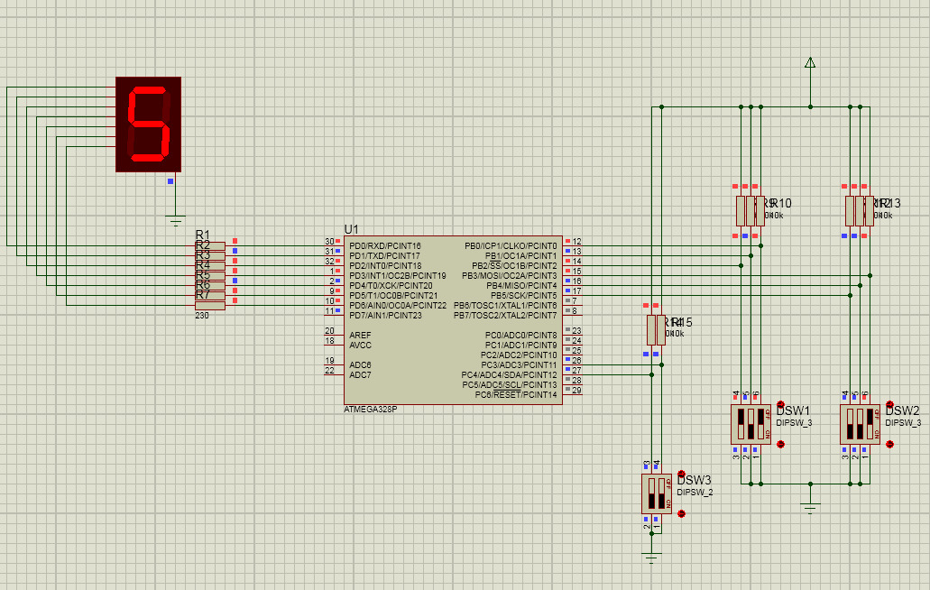

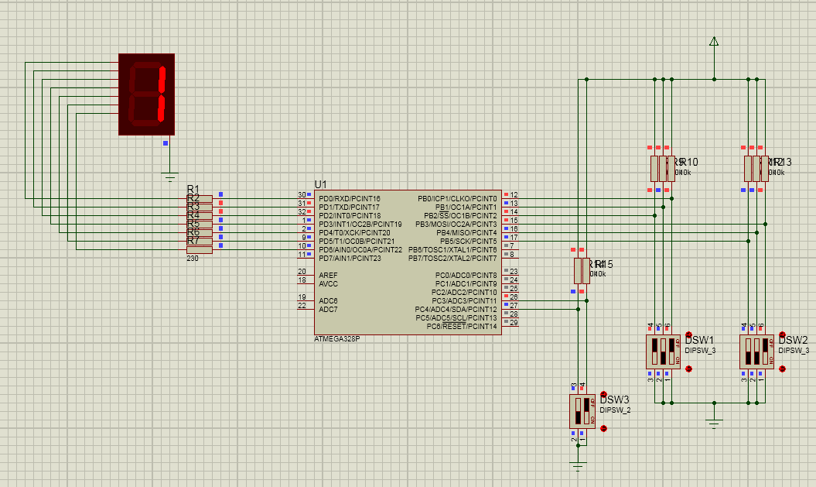

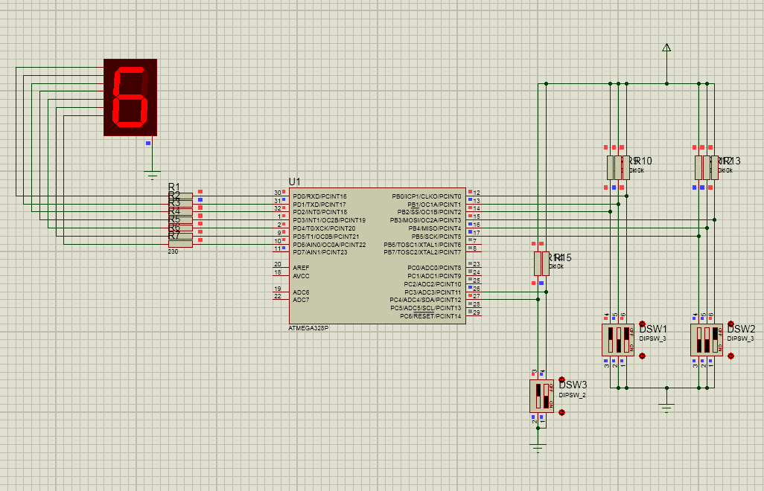

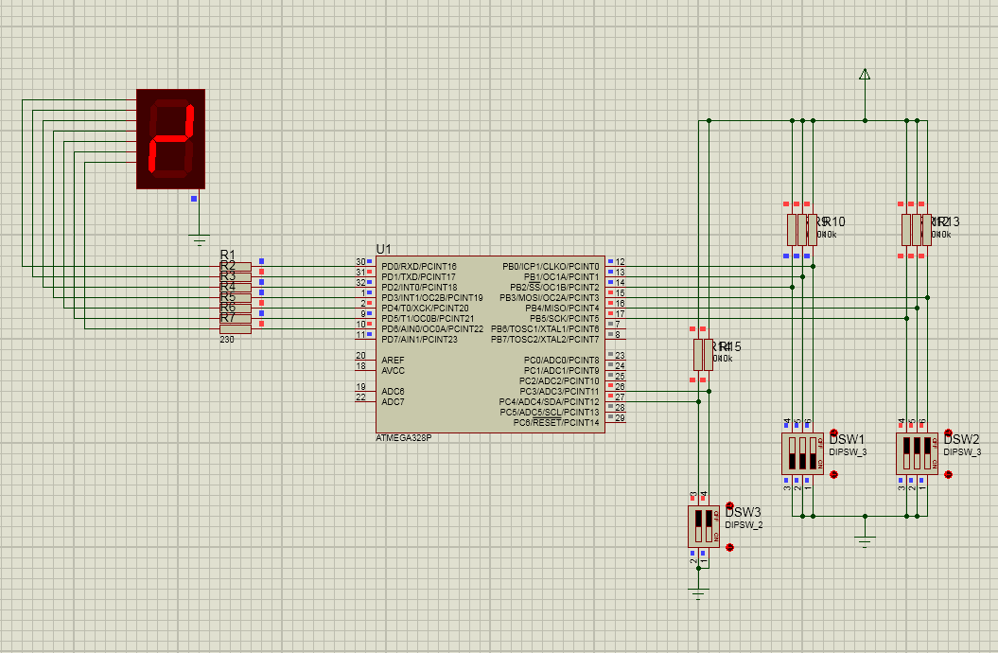

#include <avr/io.h>

int main(void)

{

unsigned char TB7SEG[] = {

0b00111111, 0b00000110, 0b01011011, 0b01001111,

0b01100110, 0b01101101, 0b01111101, 0b00000111,

0b01111111, 0b01101111, 0b01110111, 0b01111100,

0b00111001, 0b01011110, 0b01111001, 0b01110001,

0b01010010};

signed char DISPLY;

signed char SWITCH,MODE,x1,x2,y;

DDRD = 0xFF; //output D

DDRC = 0x00; //input C

DDRB = 0x00; //input B

while(1)

{

SWITCH = PINB;

x1 = SWITCH & 0b00000111;

x2 = SWITCH & 0b00111000;

x2 = x2 >> 3;

MODE = PINC;

MODE = MODE & 0b00011000;

MODE = MODE >> 3;

if(MODE == 0)

{

y = x1;

}

else if(MODE == 1)

{

y = x2;

}

else if(MODE == 2)

{

y = x1+x2;

}

else

{

y = x1-x2;

if(y < 0)

y = 16;

}

DISPLY = TB7SEG[y];

PORTD = ~DISPLY;

}

}