Program 1

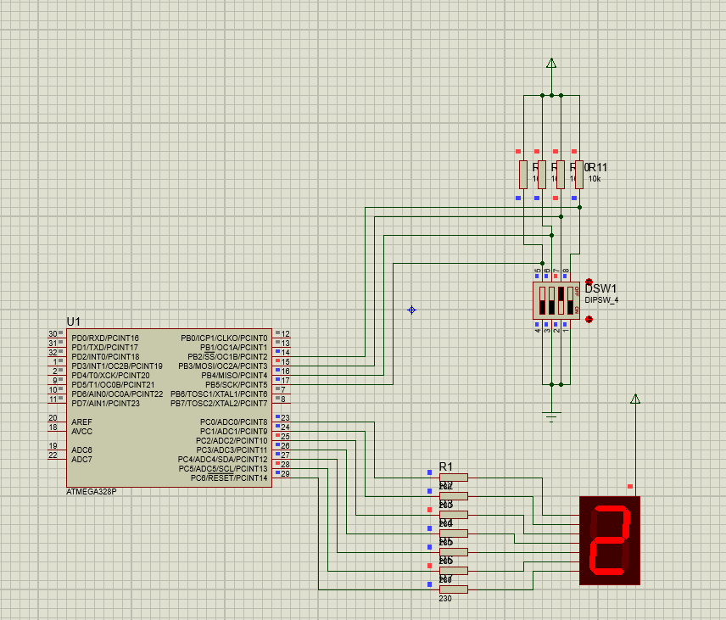

Code

#include <avr/io.h>

int main()

{

unsigned char TB7SEG[] = {

0b00111111, 0b00000110, 0b01011011, 0b01001111,

0b01100110, 0b01101101, 0b01111101, 0b00000111,

0b01111111, 0b01101111, 0b01110111, 0b01111100,

0b00111001, 0b01011110, 0b01111001, 0b01110001};

unsigned char display, sw;

DDRB = 0x00;

DDRC = 0xFF;

while (1)

{

sw = PINB;

sw &= 0b00111100;

sw = sw >> 2;

display = TB7SEG[sw];

PORTC = ~display;

}

return 0;

}

Program 2

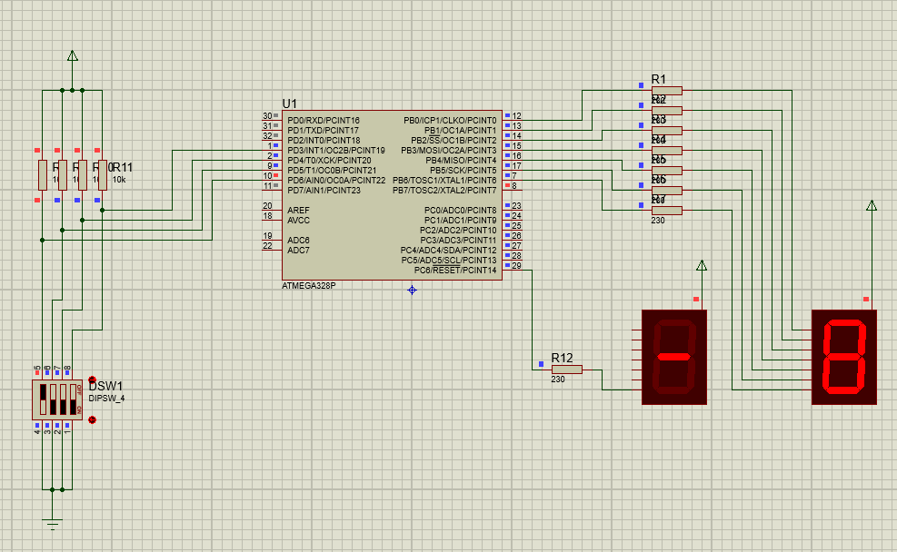

Code

#include <avr/io.h>

int main()

{

unsigned char TB7SEG[] = {

0b00111111, 0b00000110, 0b01011011, 0b01001111,

0b01100110, 0b01101101, 0b01111101, 0b00000111,

0b01111111, 0b01101111, 0b01110111, 0b01111100,

0b00111001, 0b01011110, 0b01111001, 0b01110001};

unsigned char display, sw;

DDRC = 0xFF;

DDRD = 0x00;

DDRB = 0xFF;

while (1)

{

sw = PIND;

sw &= 0b01111000;

sw = sw >> 3;

if(sw<8){

PORTC = 0xFF;

}

else

{

PORTC = 0x00;

sw = 16-sw;

}

display = TB7SEG[sw];

PORTB = ~display;

}

return 0;

}

Program 3

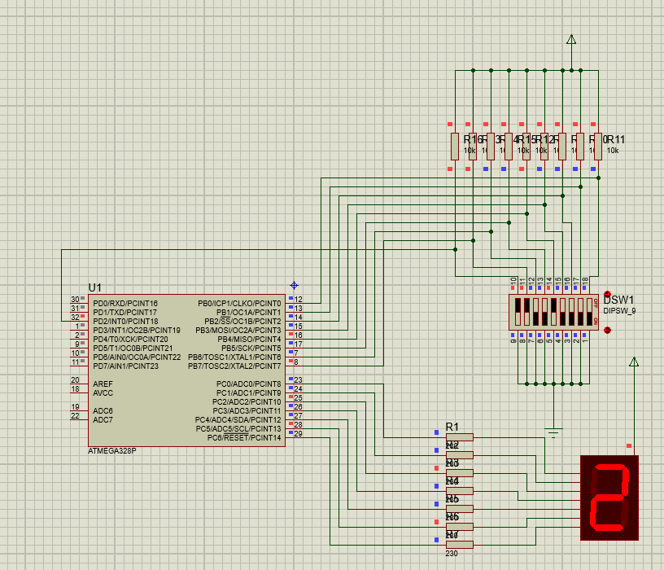

Code

#include <avr/io.h>

int main(void)

{

unsigned char TB7SEG[] = {

0b00111111, 0b00000110, 0b01011011, 0b01001111,

0b01100110, 0b01101101, 0b01111101, 0b00000111,

0b01111111, 0b01101111, 0b01110111, 0b01111100,

0b00111001, 0b01011110, 0b01111001, 0b01110001};

unsigned char DISPLY, mask, count, i;

unsigned char SWITCH, HL, temp;

DDRD = 0x00;

DDRC = 0xFF;

DDRB = 0x00;

while(1)

{

SWITCH = PINB;

HL = PIND;

HL &= 0b00000100;

HL = HL >> 2;

mask = 0b00000001;

count = 0;

for(i=0;i<8;i++)

{

temp = SWITCH & (mask<<i);

if(temp)

count++;

}

if(HL == 0)

count = 8 - count;

DISPLY = TB7SEG[count];

PORTC = ~DISPLY;

}

}

Program 4

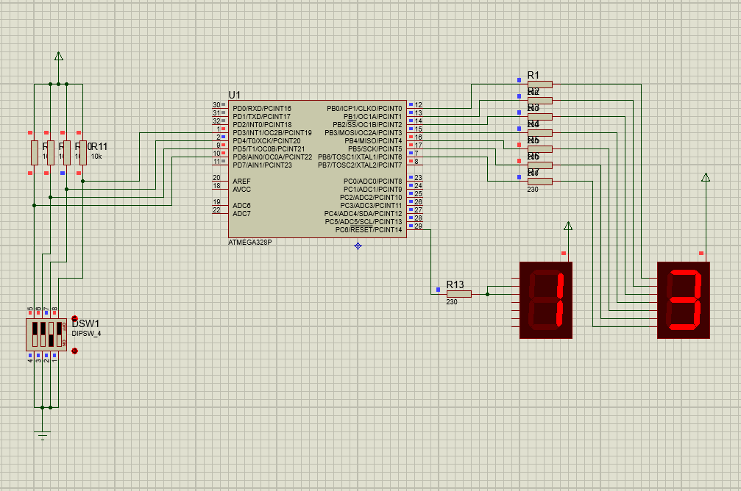

Code

#include <avr/io.h>

int main()

{

unsigned char TB7SEG[] = {

0b00111111, 0b00000110, 0b01011011, 0b01001111,

0b01100110, 0b01101101, 0b01111101, 0b00000111,

0b01111111, 0b01101111, 0b01110111, 0b01111100,

0b00111001, 0b01011110, 0b01111001, 0b01110001};

unsigned char display, sw;

DDRC = 0xFF;

DDRD = 0x00;

DDRB = 0xFF;

while (1)

{

sw = PIND;

sw &= 0b01111000;

sw = sw >> 3;

if(sw<10){

PORTC = 0xFF;

}

else

{

PORTC = 0x00;

sw = sw-10;

}

display = TB7SEG[sw];

PORTB = ~display;

}

return 0;

}