**Lab 5: Inheritance**

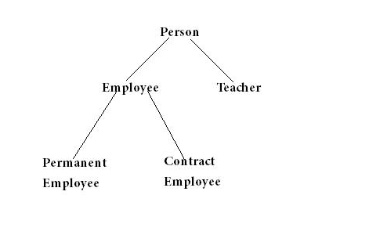

public class Person {  
    String name;  
    int age;  
    public Person(String n, int a) {  
        name = n;  
        age = a;  
    }  
    public void printDetails() {  
        System.out.println("Name: " + name);  
        System.out.println("Age: " + age);  
    }  
}

Teacher:name, age, faculty

Employee:name, age, employeeId,

PermanentEmployee:name, age, employeeId, salary

ContractEmployee: name, age, employeeId, payment

Write test program to

1 create object and call every methods

2 create an ArrayList to keep every object that created in 1.

**Class Diagram**

**Person**

//Attribute

- name : String

- age : int

//Method

+ Person(String name, int age)

+ String getName()

+ int getAge()

+ void setName(String name)

+ void setAge(int age)

+ void printDetails()

**Teacher**

//Attribute

- faculty : String

+ Teacher(String name, int age,

String faculty)

//Method

+ String getFaculty()

+ void setFaculty(String faculty)

+ void printDetails()

**Employee**

//Attribute

- employeeId : String

+ Employee(String name, int age,

String employeeId)

//Method

+ String getEmployeeId()

+ void setEmployeeId(String Id)

+ void printDetails()

**Class Diagram (Cont.)**

**Person**

**Teacher**

**Employee**

**ContractEmployee**

//Attribute

- payment : int

//Method

+ ContractEmployee(

String name, int age,

String employeeId,

int payment

)

+ int getPayment()

+ void setPayment(int payment)

+ void printDetails()

**PermanentEmployee**

//Attribute

- salary : int

//Method

+ PermanentEmployee(

String name, int age,

String employeeId,

int salary

)

+ int getSalary()

+ void setSalary(int salary)

+ void printDetails()

**โค๊ด**

**Class Person**

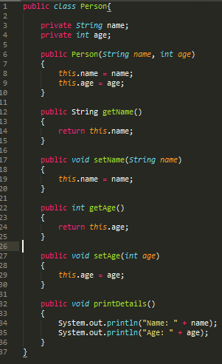

**Class Teacher**

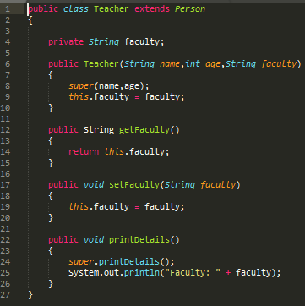

**Class Employee**

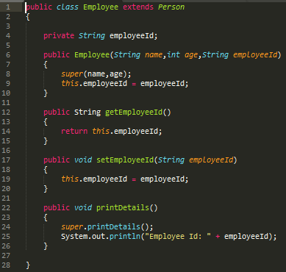

**Class Permanent**

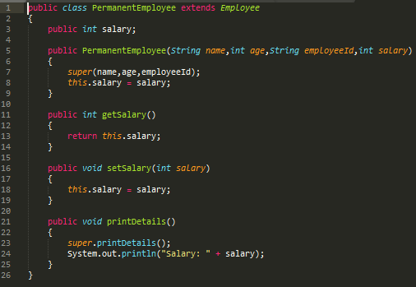

**Class ContractEmployee**

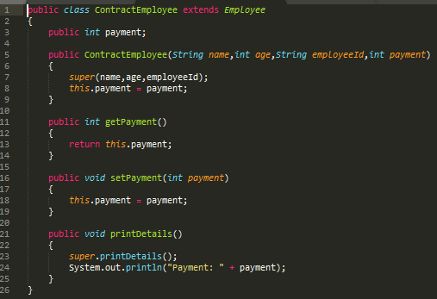

**Program 1**

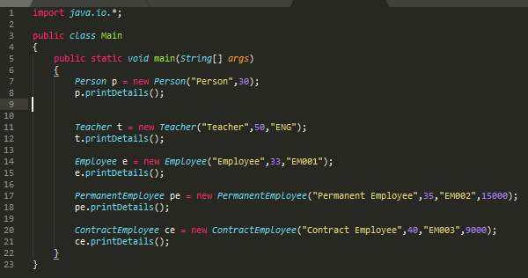

**ผลการรัน**

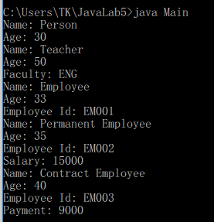

**Program 2**

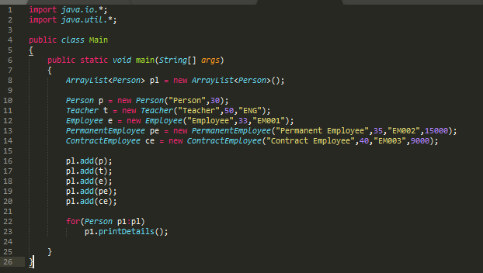

**ผลการรัน**

