Claims Triage Assistant

1. What I built
A small web app that goes through health insurance claims and decides, for each one, whether it can be approved, should be denied, or needs a person to look at it. You upload the claim files (PDF or TXT), the policy document and the reference workbook, press Run, and get a table of decisions with a short reason for each. The results can be downloaded as decisions.csv.
Everything is decided by plain rules and the data in the workbook. I did not use an LLM anywhere, including the explanations, which are written from simple templates and quote the relevant section of the uploaded policy.

2. How it works
- 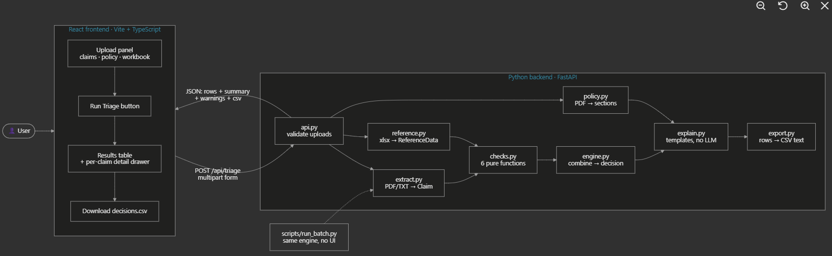
Read the claim. The PDF and TXT files look different, so I wrote one reader for both and checked that they give exactly the same details for all 10 claims. If something is blank or unreadable, it stays missing. Nothing is guessed or corrected.
- Run six checks. Required details and a valid diagnosis code, member covered on the date of service, not a duplicate of a paid claim, prior authorization if needed, provider in-network, and a total of $10,000 or less.
- Pick the decision. If required details are missing it goes to a human. Otherwise a deny wins, then anything that needs a human, and if nothing came up it is approved.
- Explain it. Each reason points to the policy section it comes from, and denials mention the 180-day appeal right.
If a file is broken or the wrong type, it shows up as a 'needs human' row and the rest of the batch carries on. The backend is Python and the interface is React.

3. The app
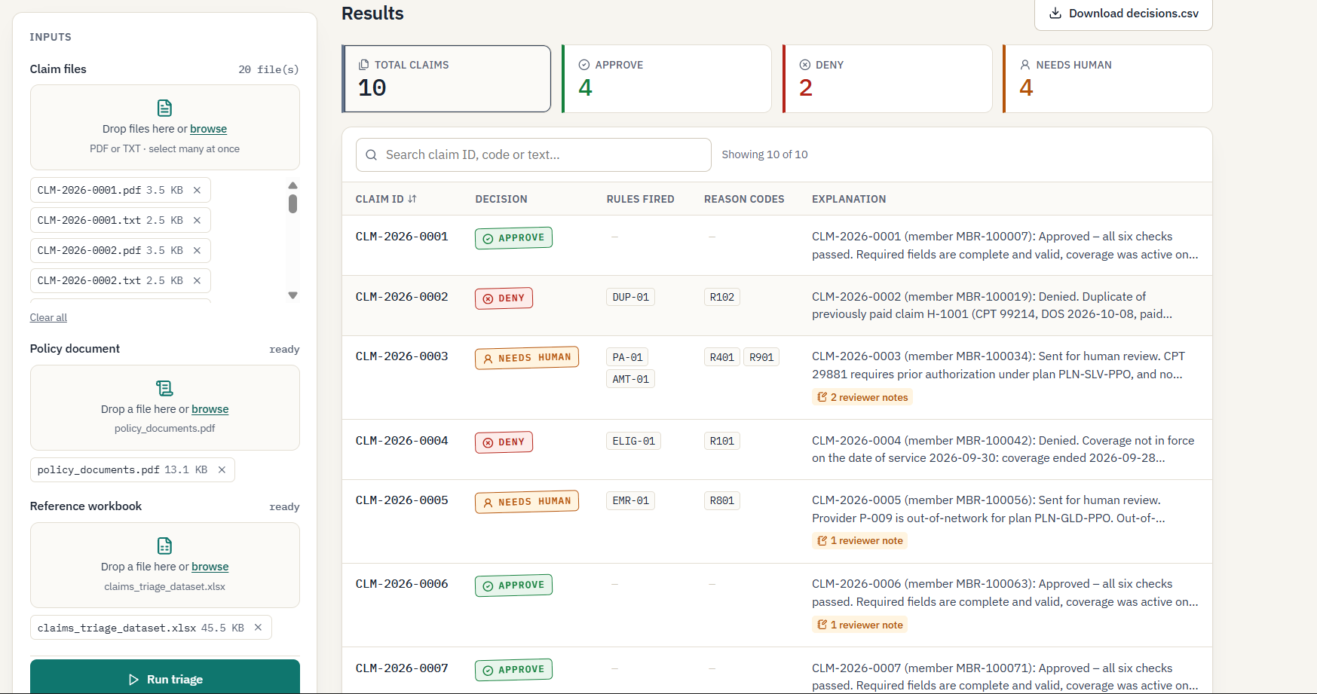

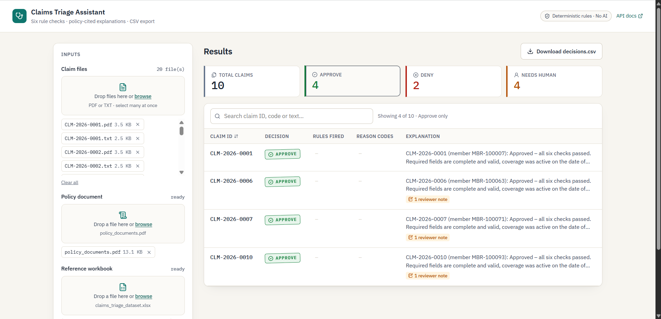

4. Results
Claim | Decision | Why
CLM-2026-0001 | Approve | All checks passed
CLM-2026-0002 | Deny | Duplicate of a claim that was already paid
CLM-2026-0003 | Needs human | No approved prior authorization, and $18,500 is over the limit
CLM-2026-0004 | Deny | Coverage ended two days before the service date
CLM-2026-0005 | Needs human | Emergency room visit at an out-of-network hospital
CLM-2026-0006 | Approve | All checks passed
CLM-2026-0007 | Approve | All checks passed
CLM-2026-0008 | Needs human | Needs prior authorization and none is on file
CLM-2026-0009 | Needs human | Rendering NPI missing and the diagnosis code is not valid
CLM-2026-0010 | Approve | All checks passed

In total: 4 approved, 2 denied and 4 sent to a human.

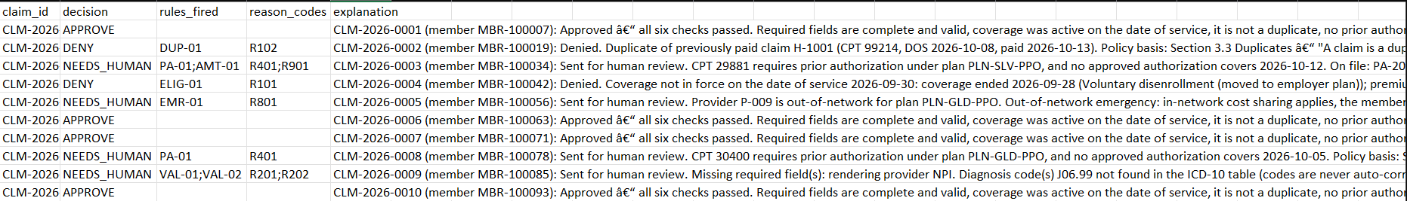

5. Testing
I tested reading both file formats, each check on its own, the decision order, the expected result for every claim, the explanations, and a lot of messy cases like empty files, wrong file types, missing details and a broken workbook. All tests pass.


