**TOPIC:**

**SQL Project**

**CREATED BY**: MATTA SAI PRAKASH

**CREATED DATE**: 02-02-2024.

**APPROVED BY**:

**Project:**

Spotify top songs analysis

1. Which artist has the most songs in the top streamed list of 2023?
2. What is the average number of streams for songs released in each month of 2023?
3. Are songs with higher danceability percentages generally more popular (i.e. have more streams)?
4. What percentage of songs in the 'Top Spotify Songs 2023' were released in 2023?

**Solution:**

For Loading data to OLEDB (database) I have used SSIS (SQL SERVER INTEGRATION SERVICES)

Deleting old records using Execute SQL task

Data flow task used to set up for loading data from source file (XL) to target file (OLEDB)

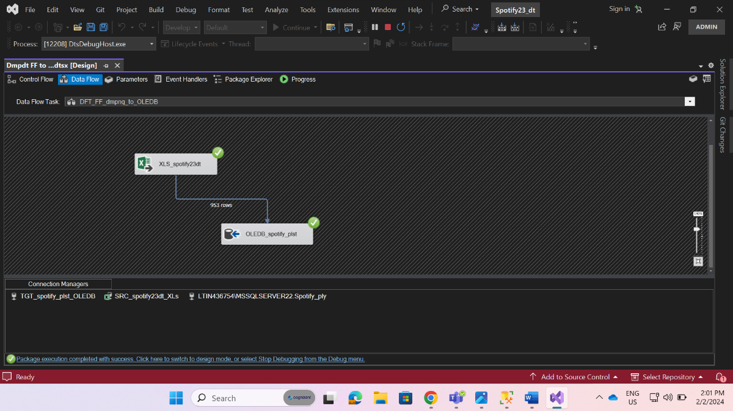

Select * from Spotify_plst

Select top 10

[artist(s)_name],

count(*) as most_played

from Spotify_plst

where released_year=2023

group by [artist(s)_name]

order by most_played desc

Select round(avg(streams),2) as avg_streams,

released_month

from Spotify_plst

where released_year=2023

group by released_month

order by released_month

Select

CASE WHEN [danceability_%] <= 25 THEN '0-25%'

WHEN [danceability_%] <= 50 THEN '26-50%'

WHEN [danceability_%] <= 75 THEN '51-75%'

ELSE '76-100%' END AS danceability_group,

avg(streams)as avg_streams

FROM Spotify_plst

group by CASE WHEN [danceability_%] <= 25 THEN '0-25%'

WHEN [danceability_%] <= 50 THEN '26-50%'

WHEN [danceability_%] <= 75 THEN '51-75%'

ELSE '76-100%' END

order by avg_streams desc

/*

select danceability_group,

avg(streams) as avg_streams from

(Select CASE WHEN [danceability_%] <= 25 THEN '0-25%'

WHEN [danceability_%] <= 50 THEN '26-50%'

WHEN [danceability_%] <= 75 THEN '51-75%'

ELSE '76-100%' END AS danceability_group,

streams

FROM Spotify_plst ) group by 1 */

; with percent2023release as

(select count (*) as total_songs, sum(case when released_year=2023 then 1 ELSE 0 END) as songs2023

from Spotify_plst)

Select ((songs2023*100)/total_songs) as percent23

from percent2023release

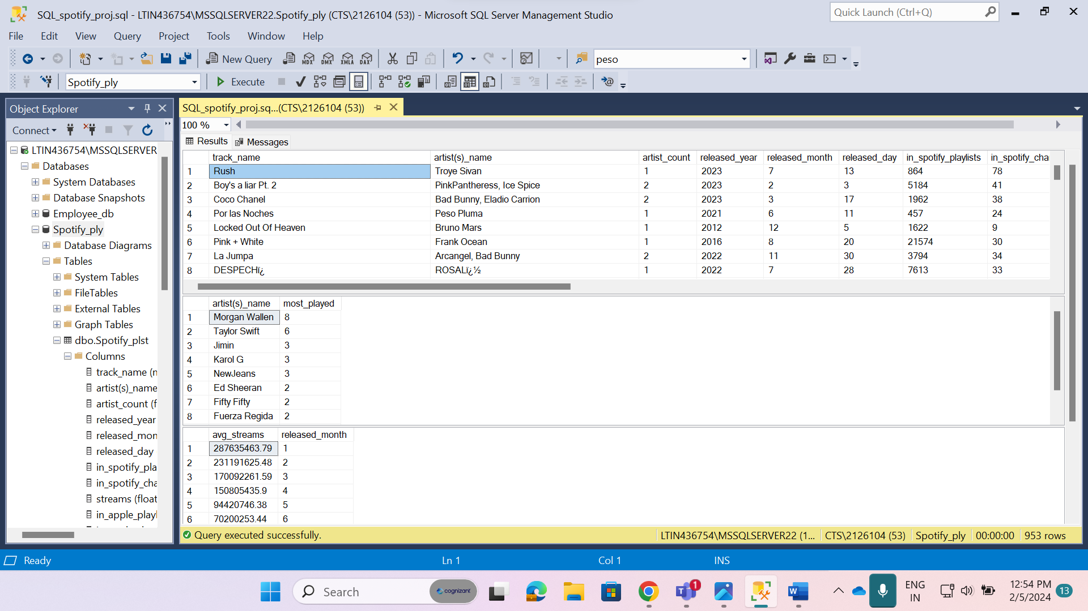

* First result set depicts that whole data present in Spotify_plst table.
* Second result depicts that the artist who has the most songs in the top streamed list in the year 2023

At the top – Morgan Wallen with 8 songs

* Third result depicts that average number of streams that has released in each month of year 2023

* Fourth result depicts that the (26-50%) danceability_% group has more popular streams.
* Fifth result depicts that Top Spotify songs released in 2023 was 18% of songs released every year.