Waterflood injection recommendation
streak_5x4 sample · asset SAMPLE · unit system field
Confidence: HIGH
Objective: maximum NPV · posture: balanced · horizon: 24 months · generated 2026-09-04 08:22 UTC by admin

Sector S1 — summary
item | value
confidence | HIGH — blind R² 1.00; parameter spread 0%; no gate warnings
method | CRMP (producer)
blind-test R² / MAPE | 1.000 / 0.0 %
gain vs hold-current | +1.1 %
gain vs equal split | +1.3 %
plan value (P10 / P50 / P90) | 24,393 / 24,393 / 24,393 bbl
hold-current (P10 / P50 / P90) | 23,925 / 23,925 / 23,925 bbl
changes this week | 5
posture | balanced

Change list
well | from [bbl/d] | to [bbl/d] | step this week | target date | setting hint | expected oil [bbl] | revert if
I-3 | 1,841 | 0 | -276 | 2023-01-15 | target 0; set choke / pump frequency to reach it, field to confirm the setting | 124 | water cut of any connected producer rises by more than 5%
I-4 | 1,646 | 0 | -247 | 2023-01-08 | target 0; set choke / pump frequency to reach it, field to confirm the setting | 111 | water cut of any connected producer rises by more than 5%
I-1 | 2,310 | 3,612 | 346 | 2019-12-29 | target 3612; set choke / pump frequency to reach it, field to confirm the setting | 87 | water cut of any connected producer rises by more than 5%
I-5 | 1,450 | 2,695 | 217 | 2020-01-05 | target 2695; set choke / pump frequency to reach it, field to confirm the setting | 84 | water cut of any connected producer rises by more than 5%
I-2 | 1,782 | 2,722 | 267 | 2019-12-29 | target 2722; set choke / pump frequency to reach it, field to confirm the setting | 63 | water cut of any connected producer rises by more than 5%

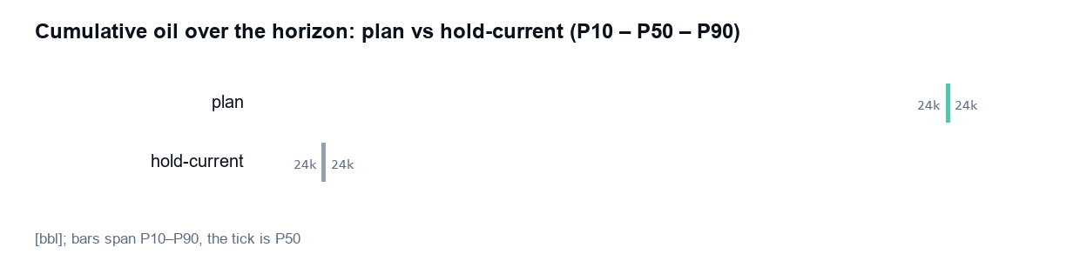
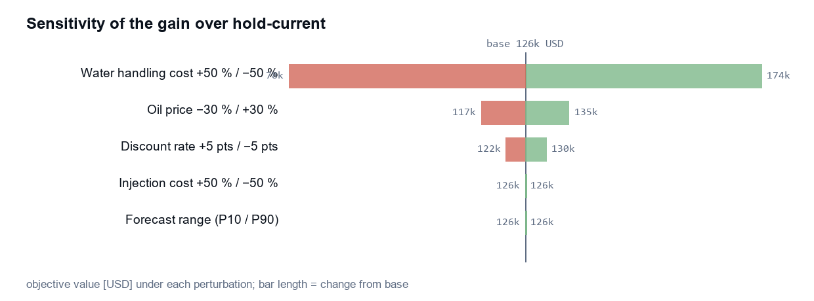

Connectivity
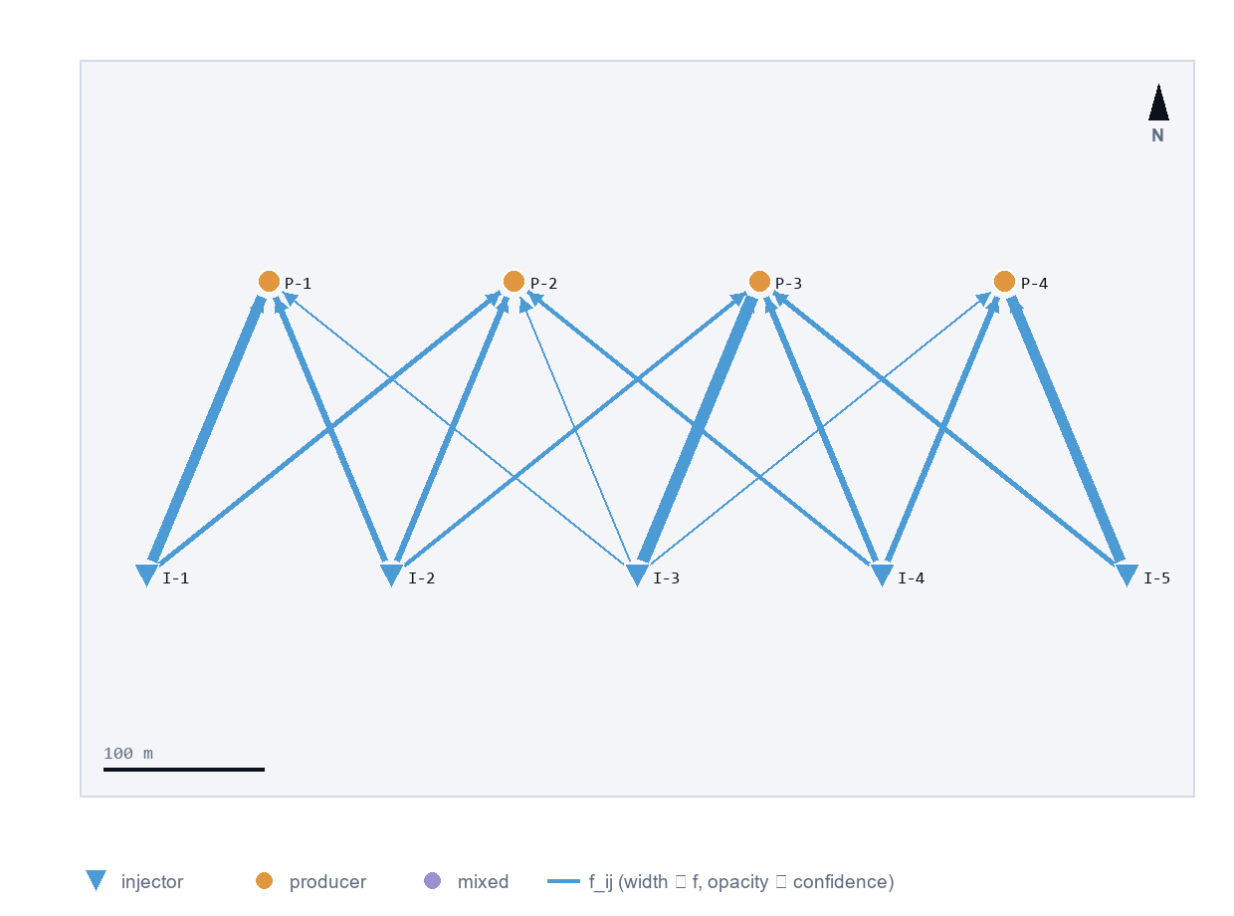
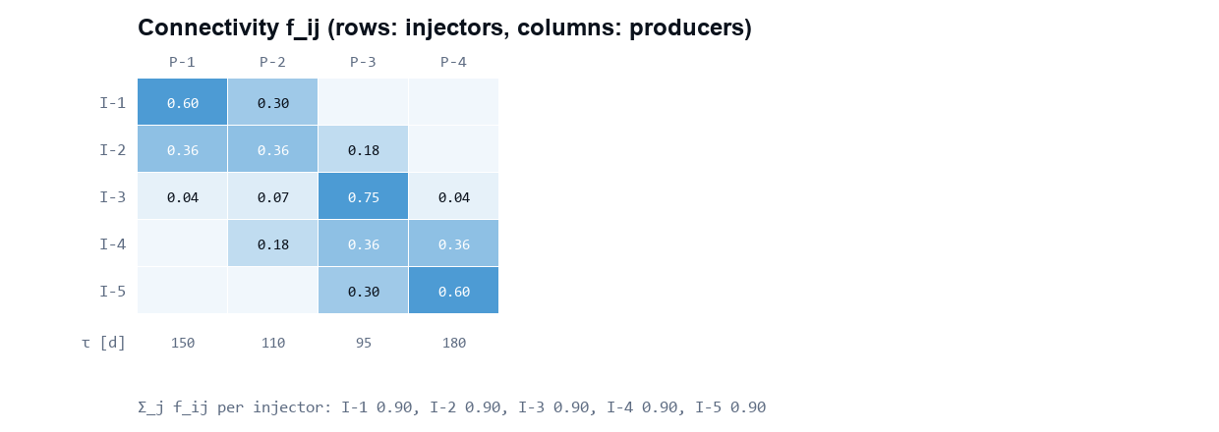

Forecast and injector efficiency
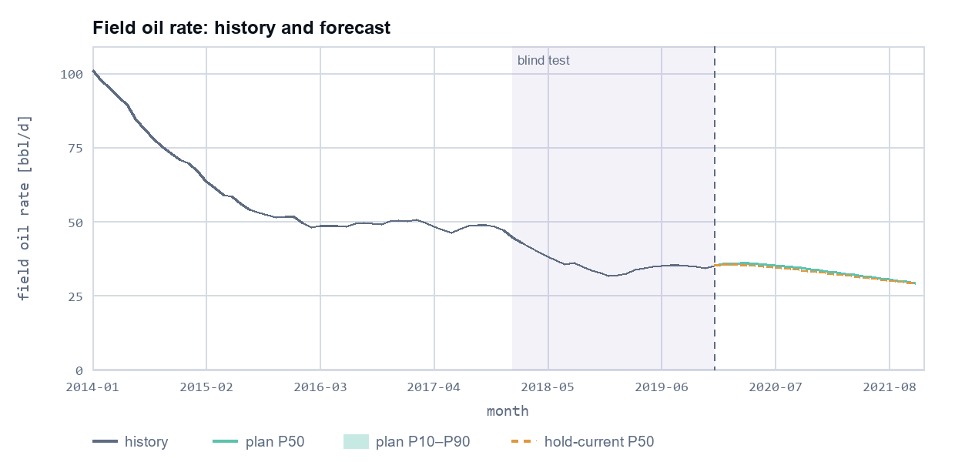
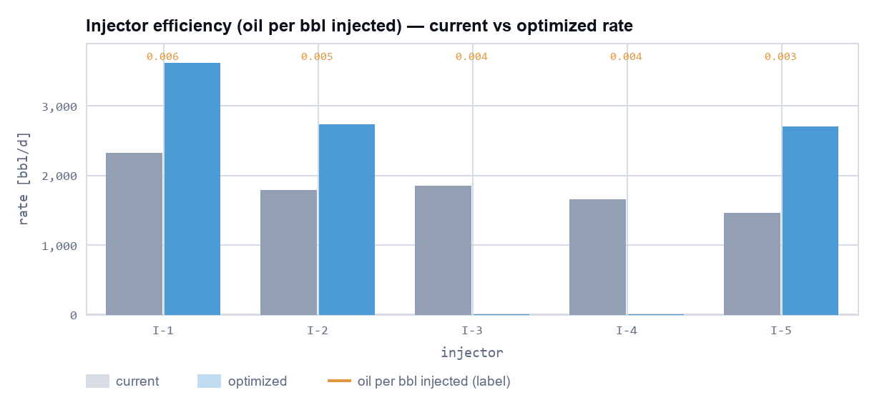

Which method won
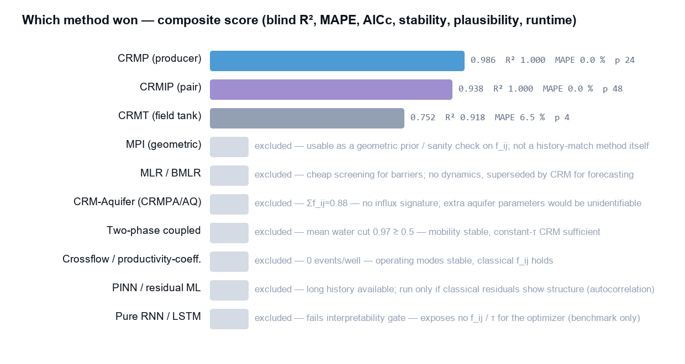
gate | result
history_min | pass
od | pass
points_per_param | pass
crmip_data | pass
inj_cv | pass
tau_dt | pass
influx | fail / not applicable
event_heavy | fail / not applicable
mature | pass
long_history | pass
has_xy | pass
has_bhp | fail / not applicable
has_relperm | fail / not applicable

History match per well
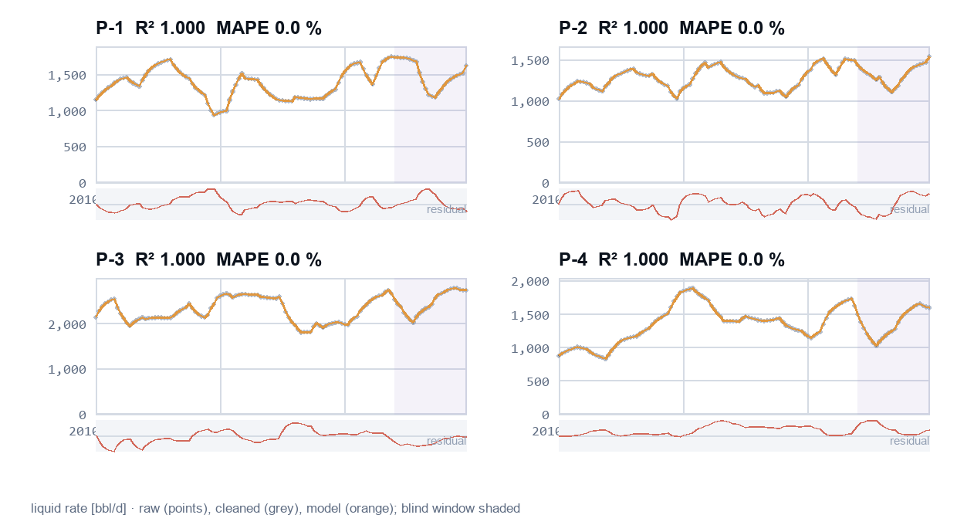

Sampling and pressure
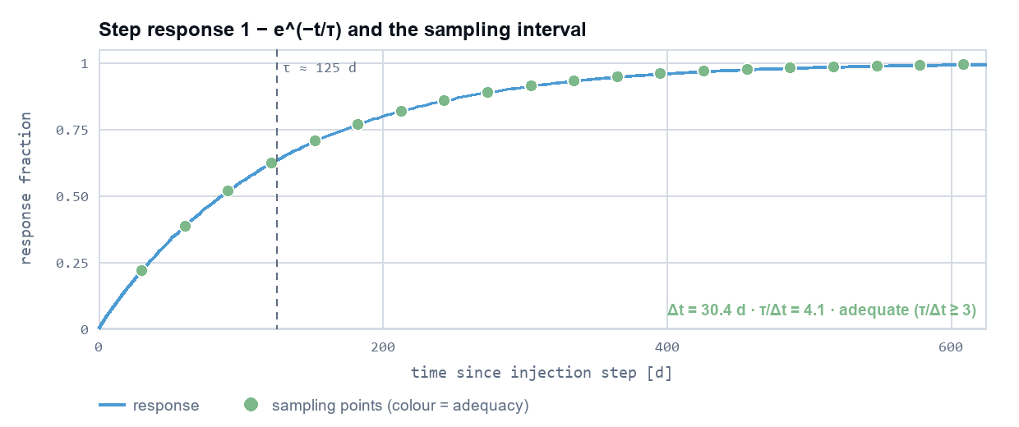
Δt = 30 d · τ estimate = 125 d · τ/Δt = 4.1 · O_d = 20.0 · pressure source: none

Data quality
Traffic light: green · steps: 120 · outliers removed: 0 · simultaneous P+I steps: 0 · unmatched IDs: 0 · warnings: 0 · errors: 0
well | type | coverage % | pressure | conversions
I-1 | INJ | 100
I-2 | INJ | 100
I-3 | INJ | 100
I-4 | INJ | 100
I-5 | INJ | 100
P-1 | PROD | 100 | none
P-2 | PROD | 100 | none
P-3 | PROD | 100 | none
P-4 | PROD | 100 | none

Conditions (plain language)
severity | what it means | suggested action | scope
info | Reservoir-volume conversion uses constant formation-volume factors (Bo = 1.0, Bw = 1.0). | Load a PVT table if formation volume factors change with pressure. | field
info | No flowing pressure data; lift or choke changes must be in the events table. | Load ESP/gauge pressure or an events log if lift settings changed during the history. | field
info | The MPI (geometric) model would suit this data but is not available in this release. | None needed; the next best available model was used. | field
info | The MLR / BMLR model would suit this data but is not available in this release. | None needed; the next best available model was used. | field
info | The PINN / residual ML model would suit this data but is not available in this release. | None needed; the next best available model was used. | field
info | The model misses some slow trends for P-1; forecasts may drift. | None needed for screening; a residual correction is considered when history exceeds 120 months. | well:P-1
info | The model misses some slow trends for P-2; forecasts may drift. | None needed for screening; a residual correction is considered when history exceeds 120 months. | well:P-2
info | The model misses some slow trends for P-3; forecasts may drift. | None needed for screening; a residual correction is considered when history exceeds 120 months. | well:P-3
info | The model misses some slow trends for P-4; forecasts may drift. | None needed for screening; a residual correction is considered when history exceeds 120 months. | well:P-4

Workflow
item | value
recommendation | 422b38fb649a
state | APPROVED
originator | admin
approved by originator | YES — same person ran and approved
override reason | —
advanced overrides | none
snapshot digest | 6a0b517bad5e5f2fa974da02b1b8e8ce338281d5c7e683826a350295d6d61cc6
implemented at | —

when | action | actor | acting role | from → to | note
2026-09-04 08:22 | review | admin | reviewer | DRAFT → REVIEWED | sample review
2026-09-04 08:22 | approve | admin | approver | REVIEWED → APPROVED | sample approval

injector | recommended [bbl/d] | implemented [bbl/d]
I-1 | 3,612 | —
I-2 | 2,722 | —
I-3 | 0 | —
I-4 | 0 | —
I-5 | 2,695 | —

Reproducibility
item | value
run id | f1f43bbedd07
data snapshot hash | f7fda78b31f7813fabf5d9e653ed8508b3f642bb382c1ebbbf405b4a1ddc592e
config hash | 7f90028e1dc16a82f17887a8f06f66883030895f1fc53860299672b9c6576ee0
code version | cbb7eec
seed | 232413243
engine runtime | 22.3 s
windows | 2010-01-01 → 2019-12-01 (full history)
application | Waterflood Optimizer 0.5.0

