Assignment-2

import 'package:flutter/material.dart';

void main() {

runApp(MyApp());

}

class MyApp extends StatelessWidget {

@override

Widget build(BuildContext context) {

return MaterialApp(

home: Scaffold(

appBar: AppBar(

title: Text('Sai Pranav'), // Title of the AppBar

backgroundColor: const Color.fromARGB(255, 243, 45, 111), // Pink background color for the AppBar

),

body: Container(

color: const Color.fromARGB(143, 245, 220, 2), // Yellow background color for the body

child: Center(

child: Text(

'Hello World', // Text to be displayed on the screen

style: TextStyle(

fontSize: 40, // Font size of the text

fontWeight: FontWeight.bold, // Making the text bold

fontStyle: FontStyle.italic, // Making the text italic

color: Colors.black, // Black color for the text

),

),

),

),

),

);

}

}

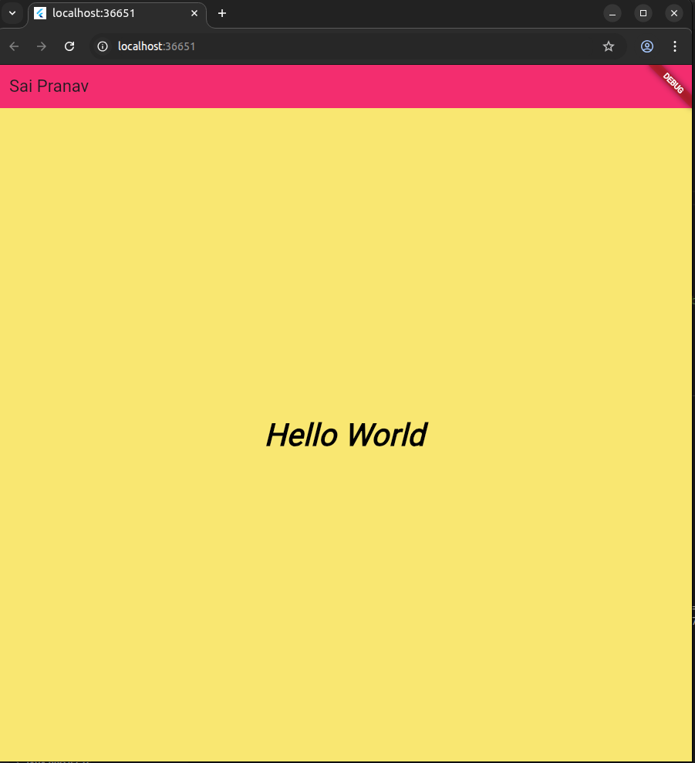

Problem 2

import 'package:flutter/material.dart';

void main() {

runApp(MyApp());

}

class MyApp extends StatelessWidget {

@override

Widget build(BuildContext context) {

return MaterialApp(

home: MyDetailsPage(),

);

}

}

class MyDetailsPage extends StatelessWidget {

@override

Widget build(BuildContext context) {

return Scaffold(

appBar: AppBar(

title: Text('V Sai Pranav'), // Title of the AppBar

backgroundColor: Colors.blue, // Blue background for the AppBar

actions: [

Padding(

padding: EdgeInsets.all(8.0),

child: Text(

'DEBUG', // DEBUG label on the top right

style: TextStyle(fontWeight: FontWeight.bold),

),

),

],

),

body: Center(

child: Padding(

padding: const EdgeInsets.all(20.0),

child: Column(

mainAxisSize: MainAxisSize.min,

crossAxisAlignment: CrossAxisAlignment.start,

children: [

Text(

'Name: V Sai Pranav!',

style: TextStyle(fontSize: 20),

),

SizedBox(height: 10),

Text(

'USN: 1MS24CS220',

style: TextStyle(fontSize: 20),

),

SizedBox(height: 10),

Text(

'Department: Computer Science and Engineering',

style: TextStyle(fontSize: 20),

),

],

),

),

),

);

}

}

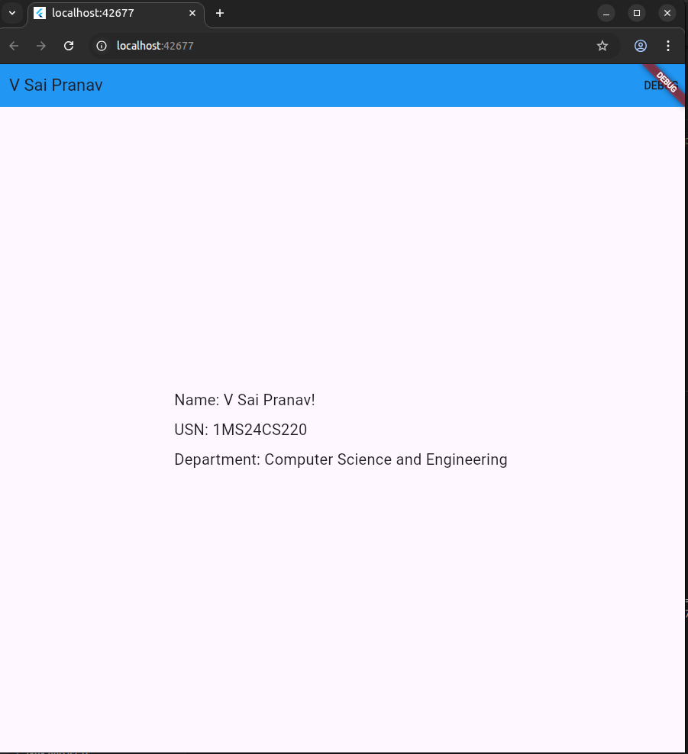

Problem 3

import 'package:flutter/material.dart';

void main() {

runApp(MyApp());

}

class MyApp extends StatelessWidget {

@override

Widget build(BuildContext context) {

return MaterialApp(

home: FontExample(),

);

}

}

class FontExample extends StatelessWidget {

@override

Widget build(BuildContext context) {

return Scaffold(

appBar: AppBar(

title: Text('Different Font Types Example'),

backgroundColor: Colors.blue,

actions: [

Padding(

padding: EdgeInsets.all(8.0),

child: Text(

'DEBUG', // 'DEBUG' label on the right side

style: TextStyle(fontWeight: FontWeight.bold),

),

),

],

),

body: Center( // Center the body content

child: Padding(

padding: const EdgeInsets.all(20.0),

child: Column(

mainAxisSize: MainAxisSize.min, // Minimize the column's size to fit the content

crossAxisAlignment: CrossAxisAlignment.center, // Align content to the center horizontally

children: [

Text(

'Text with TimesNew Roman',

style: TextStyle(fontFamily: 'Times New Roman', fontSize: 20),

),

SizedBox(height: 10),

Text(

'Text with Calibri',

style: TextStyle(fontFamily: 'Calibri', fontSize: 20),

),

SizedBox(height: 10),

Text(

'TEXT WITH STENCIL',

style: TextStyle(fontFamily: 'Stencil', fontSize: 30, fontWeight: FontWeight.bold),

),

SizedBox(height: 10),

Text(

'TEXT WITH ALGERIAN',

style: TextStyle(fontFamily: 'Algerian', fontSize: 30, fontWeight: FontWeight.bold),

),

SizedBox(height: 10),

Text(

'Text with Edwardian Script ITC',

style: TextStyle(fontFamily: 'Edwardian Script ITC', fontSize: 20),

),

],

),

),

),

);

}

}

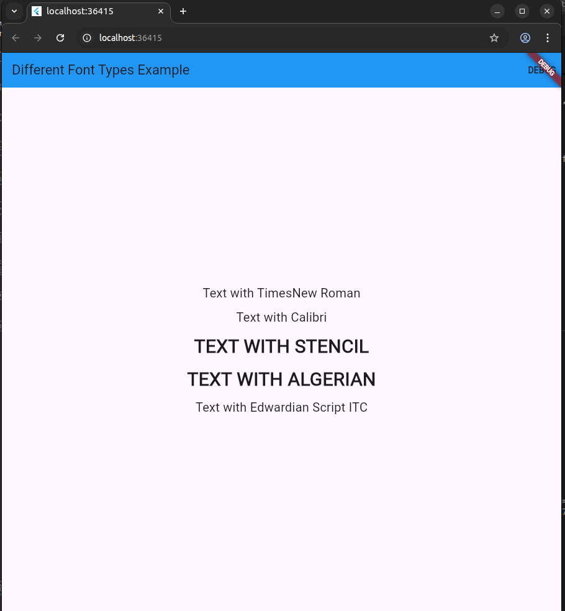

Problem 4

import 'package:flutter/material.dart';

void main() {

runApp(MyApp());

}

class MyApp extends StatelessWidget {

@override

Widget build(BuildContext context) {

return MaterialApp(

home: RichTextExample(),

);

}

}

class RichTextExample extends StatelessWidget {

@override

Widget build(BuildContext context) {

return Scaffold(

appBar: AppBar(

title: Text('RichText Example'), // AppBar title

backgroundColor: Colors.blue, // Blue background for the AppBar

actions: [

Padding(

padding: EdgeInsets.all(8.0),

child: Text(

'DEBUG', // DEBUG label

style: TextStyle(fontWeight: FontWeight.bold),

),

),

],

),

body: Center(

child: Padding(

padding: const EdgeInsets.all(20.0),

child: RichText(

text: TextSpan(

style: TextStyle(fontSize: 20, color: Colors.black), // Default style

children: <TextSpan>[

TextSpan(text: 'Hello '),

TextSpan(

text: 'bold',

style: TextStyle(

fontWeight: FontWeight.bold, // Bold text

color: const Color.fromARGB(206, 30, 162, 228), // Blue color

),

),

TextSpan(text: ' world! '),

TextSpan(

text: 'This is a ',

style: TextStyle(color: const Color.fromARGB(255, 18, 212, 60)), // Green color

),

TextSpan(

text: 'different color',

style: TextStyle(color: Colors.red), // Red colored text

),

],

),

),

),

),

);

}

}

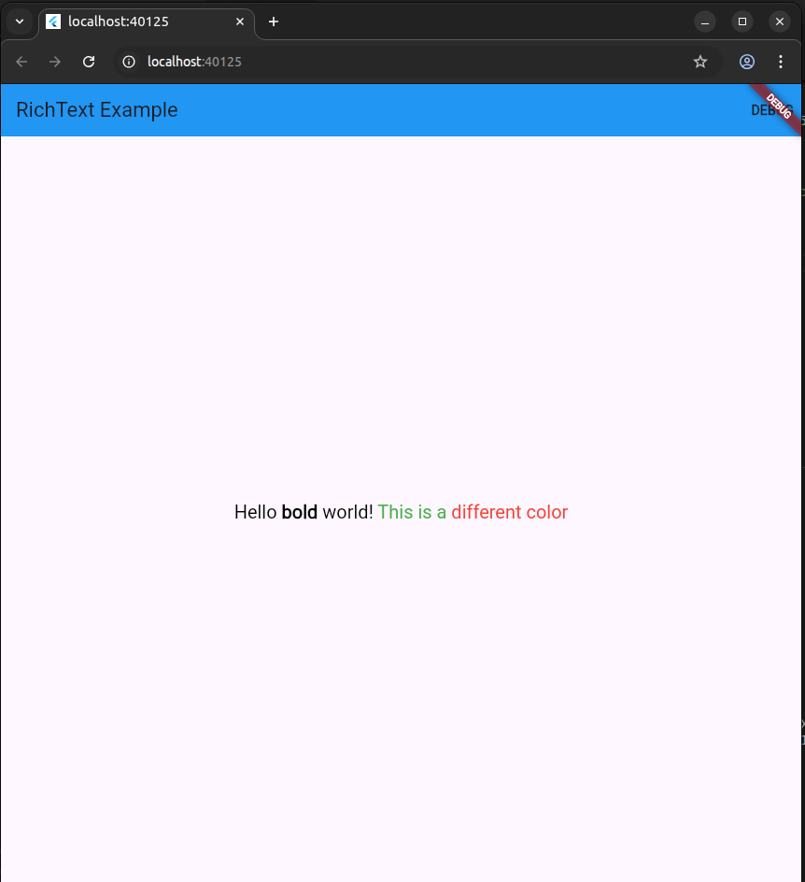

Problem 5

import 'package:flutter/material.dart';

void main() {

runApp(MyApp());

}

class MyApp extends StatelessWidget {

@override

Widget build(BuildContext context) {

return MaterialApp(

home: TextPositionExample(),

);

}

}

class TextPositionExample extends StatelessWidget {

@override

Widget build(BuildContext context) {

return Scaffold(

appBar: AppBar(

title: Text('Text Positions in Flutter', style: TextStyle(color: Colors.black)), // Black text for AppBar

backgroundColor: const Color.fromARGB(255, 120, 125, 129), // Blue background for AppBar

actions: [

Padding(

padding: EdgeInsets.all(8.0),

child: Text(

'DEBUG', // "DEBUG" label in the AppBar

style: TextStyle(fontWeight: FontWeight.bold, color: Colors.black),

),

),

],

),

body: Container(

color: Colors.blue, // Blue background for the body

child: Stack(

children: [

// Grey background for "Text Positions in Flutter" text part

Positioned(

top: 20,

left: 20,

child: Container(

color: Colors.grey, // Grey background

padding: EdgeInsets.all(8.0),

),

),

// Blue background with black text for other parts

Positioned(

top: 100,

left: 20,

child: Text(

'Top Left Corner',

style: TextStyle(fontSize: 20, color: Colors.black), // Black text

),

),

Positioned(

top: 200,

left: 100,

child: Text(

'Specific Position (100, 200)',

style: TextStyle(fontSize: 20, color: Colors.black), // Black text

),

),

Center(

child: Text(

'Centered Text',

style: TextStyle(fontSize: 20, color: Colors.black), // Black text

),

),

Positioned(

bottom: 20,

right: 20,

child: Text(

'Bottom Right Corner',

style: TextStyle(fontSize: 20, color: Colors.black), // Black text

),

),

],

),

),

);

}

}

