Assignment-3

import 'package:flutter/material.dart';

void main() => runApp(MyApp());

class MyApp extends StatelessWidget {

@override

Widget build(BuildContext context) {

return MaterialApp(

home: Scaffold(

appBar: AppBar(

title: Text('Row Widget Example'),

),

body: Center(

child: Row(

mainAxisAlignment: MainAxisAlignment.center,

children: <Widget>[

Container(

width: 30,

height: 30,

color: Colors.red,

),

SizedBox(width: 10),

Container(

width: 30,

height: 30,

color: Colors.green,

),

SizedBox(width: 10),

Container(

width: 30,

height: 30,

color: Colors.blue,

),

SizedBox(width: 10),

Container(

width: 30,

height: 30,

color: Colors.cyan,

),

],

),

),

),

);

}

}

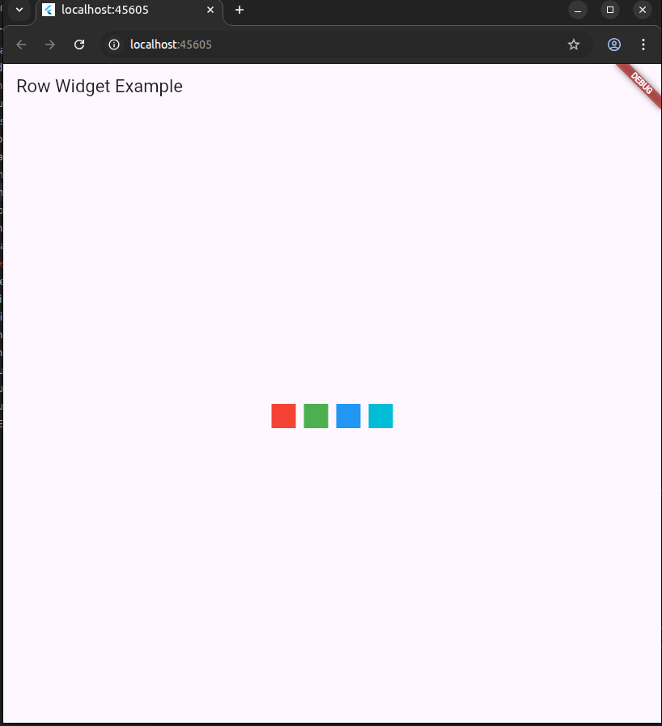

Problem 2

import 'package:flutter/material.dart';

void main() {

runApp(RamaiahProfileApp());

}

class RamaiahProfileApp extends StatelessWidget {

@override

Widget build(BuildContext context) {

return MaterialApp(

title: 'Chairman Profile',

home: RamaiahProfileScreen(),

debugShowCheckedModeBanner: false,

);

}

}

class RamaiahProfileScreen extends StatelessWidget {

@override

Widget build(BuildContext context) {

return Scaffold(

appBar: AppBar(

title: Text('Ramaiah Chairman Profile'),

backgroundColor: Colors.blue[800],

),

body: Padding(

padding: const EdgeInsets.all(16.0),

child: Card(

elevation: 8,

shape: RoundedRectangleBorder(

borderRadius: BorderRadius.circular(16),

),

child: Column(

mainAxisSize: MainAxisSize.min,

crossAxisAlignment: CrossAxisAlignment.center, // centers content horizontally

children: [

SizedBox(height: 20),

CircleAvatar(

radius: 50,

backgroundImage: AssetImage('/home/cselab3/ramaiah1.jpg'), // Replace with your image path

),

SizedBox(height: 12),

Text(

'Dr. M.S. Ramaiah',

style: TextStyle(

fontSize: 22,

fontWeight: FontWeight.bold,

),

textAlign: TextAlign.center,

),

Text(

'Founder Chairman',

style: TextStyle(

fontSize: 16,

color: Colors.grey[600],

),

textAlign: TextAlign.center,

),

SizedBox(height: 16),

Padding(

padding: const EdgeInsets.symmetric(horizontal: 20.0),

child: Text(

'Mathikere Sampangi Ramaiah was born on 20 April 1922, in Madhugiri to Sampangiappa and Narasamma.',

textAlign: TextAlign.center,

style: TextStyle(fontSize: 16),

),

),

SizedBox(height: 20),

],

),

),

),

);

}

}

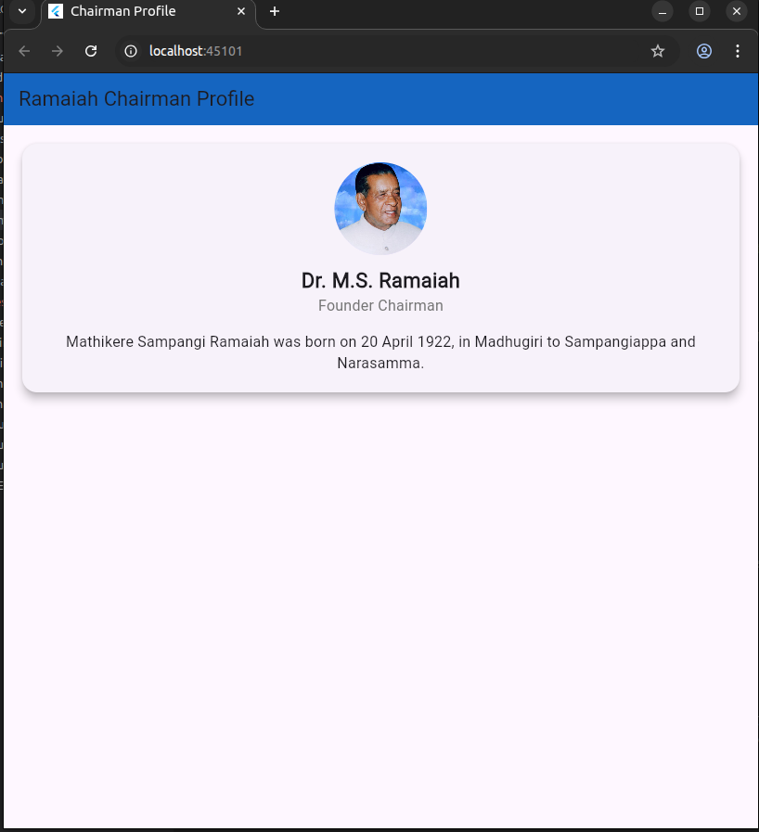

Problem 3

import 'package:flutter/material.dart';

void main() {

runApp(TextButtonApp());

}

class TextButtonApp extends StatelessWidget {

@override

Widget build(BuildContext context) {

return MaterialApp(

title: 'TextButton Example',

home: TextButtonScreen(),

debugShowCheckedModeBanner: false,

);

}

}

class TextButtonScreen extends StatelessWidget {

void _handleClick() {

print('Performing hot restart...');

Future.delayed(Duration(milliseconds: 100), () {

print('Restarted application in 653ms.');

});

Future.delayed(Duration(milliseconds: 300), () {

print('Button Clicked!');

});

}

@override

Widget build(BuildContext context) {

return Scaffold(

appBar: AppBar(

title: Text('TextButton Example'),

backgroundColor: Colors.blue[800],

),

body: Center(

child: TextButton(

onPressed: _handleClick,

child: Text(

'Click Me',

style: TextStyle(fontSize: 18),

),

),

),

);

}

}

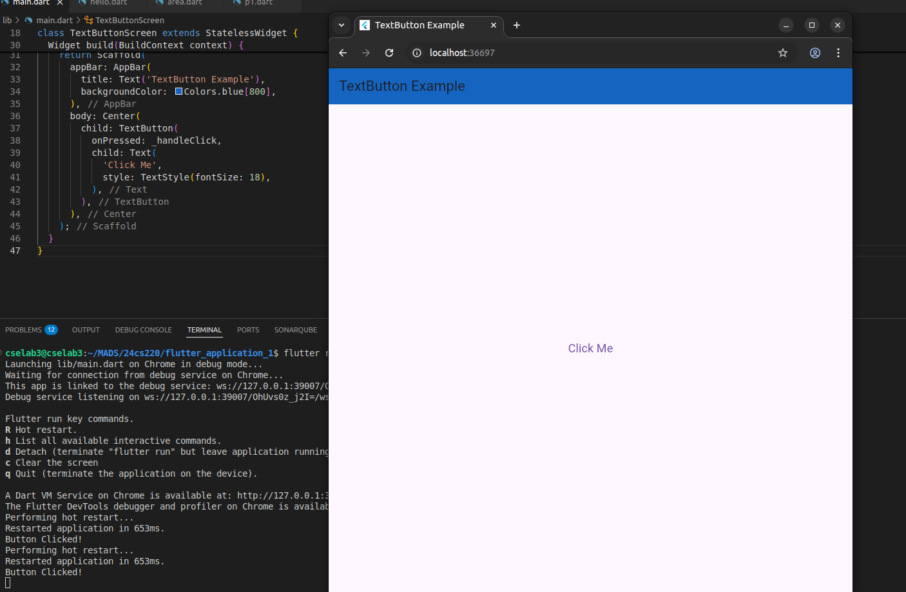

Problem 4

import 'package:flutter/material.dart';

void main() {

runApp(MyApp());

}

class MyApp extends StatelessWidget {

@override

Widget build(BuildContext context) {

return MaterialApp(

title: 'ElevatedButton with Hamburger Icon',

home: Scaffold(

appBar: AppBar(

leading: ElevatedButton(

style: ElevatedButton.styleFrom(

padding: EdgeInsets.all(8),

shape: RoundedRectangleBorder(

borderRadius: BorderRadius.circular(8),

),

backgroundColor: Colors.blueAccent, // Match AppBar color or choose your own

elevation: 4,

),

onPressed: () {

print('Hamburger button clicked!');

},

child: Icon(

Icons.menu, // Hamburger menu icon: 3 horizontal lines

color: Colors.white,

),

),

title: Text('ElevatedButton Example'),

),

body: Center(

child: ElevatedButton(

onPressed: () {

print('Button clicked!');

},

child: Text('Click Me'),

),

),

),

);

}

}

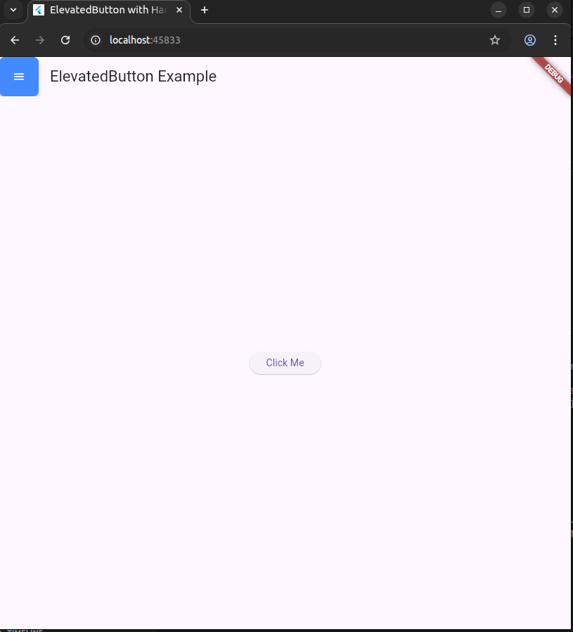



Problem 5:

import 'package:flutter/material.dart';

void main() => runApp(MyApp());

class MyApp extends StatelessWidget {

@override

Widget build(BuildContext context) {

return MaterialApp(

home: MyHomePage(),

);

}

}

class MyHomePage extends StatelessWidget {

void _showAlertDialog(BuildContext context) {

showDialog(

context: context,

builder: (BuildContext context) {

return AlertDialog(

title: Text("Alert Dialog"),

content: Text("This is a basic alert dialog."),

actions: <Widget>[

TextButton(

child: Text("Close"),

onPressed: () {

Navigator.of(context).pop();

},

),

],

);

},

);

}

@override

Widget build(BuildContext context) {

return Scaffold(

appBar: AppBar(

title: Text("Flutter Alert Dialog Example"),

),

body: Center(

child: ElevatedButton(

onPressed: () {

_showAlertDialog(context);

},

child: Text("Show Alert Dialog"),

),

),

);

}

}

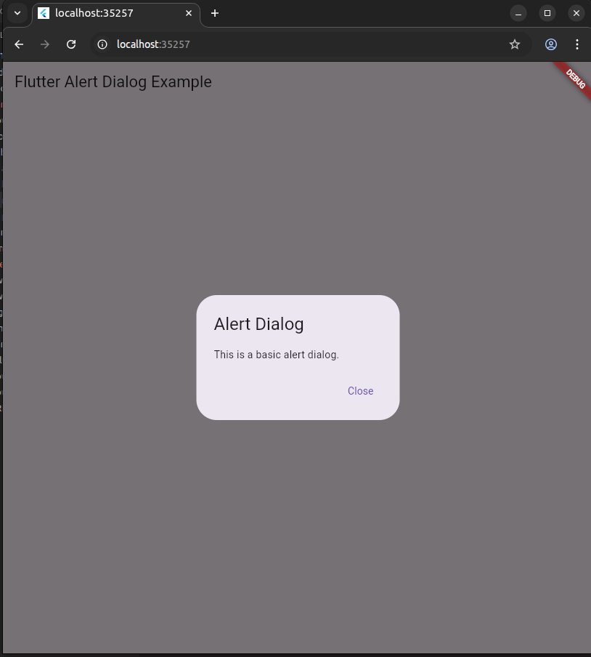

Problem 6:

import 'package:flutter/material.dart';

void main() => runApp(MyApp());

class MyApp extends StatelessWidget {

@override

Widget build(BuildContext context) {

return MaterialApp(

home: MyHomePage(),

);

}

}

class MyHomePage extends StatelessWidget {

@override

Widget build(BuildContext context) {

return Scaffold(

appBar: AppBar(

title: Text("Flutter Icons Example"),

),

body: Center(

child: Column(

mainAxisAlignment: MainAxisAlignment.center,

children: <Widget>[

Icon(

Icons.star,

size: 100.0,

color: Colors.yellow,

),

Text("Star Icon", style: TextStyle(fontSize: 20.0)),

SizedBox(height: 20.0),

Icon(

Icons.favorite,

size: 100.0,

color: Colors.red,

),

Text("Favorite Icon", style: TextStyle(fontSize: 20.0)),

SizedBox(height: 20.0),

Icon(

Icons.local_florist,

size: 100.0,

color: Colors.green,

),

Text("Florist Icon", style: TextStyle(fontSize: 20.0)),

],

),

),

);

}

}

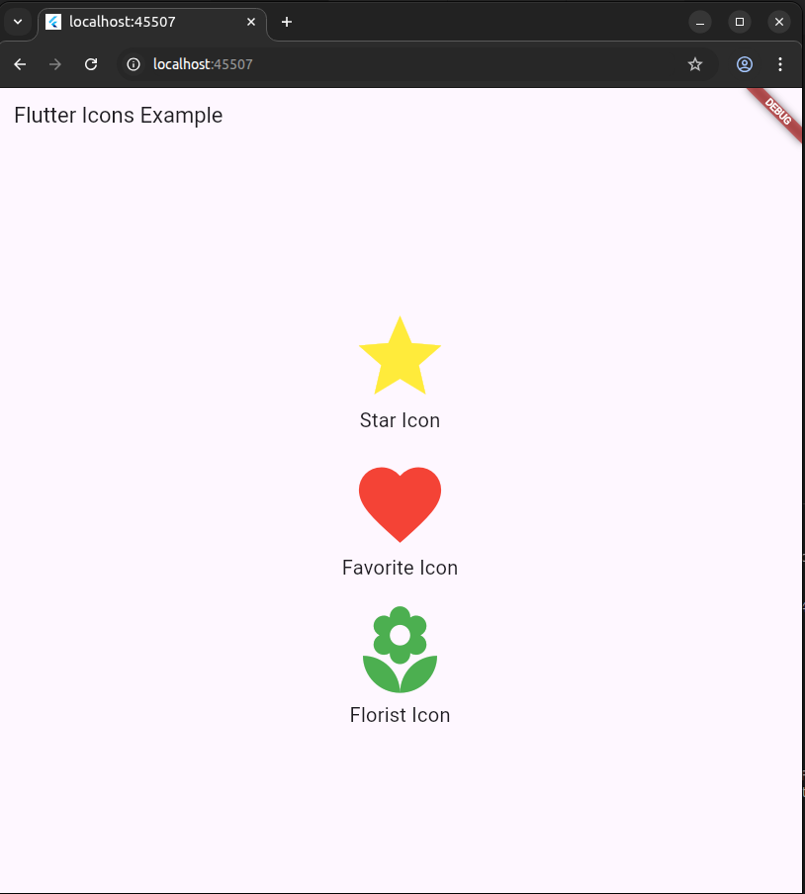

Problem 7:

import 'package:flutter/material.dart';

void main() => runApp(MyApp());

class MyApp extends StatelessWidget {

@override

Widget build(BuildContext context) {

return MaterialApp(

home: MyHomePage(),

);

}

}

class MyHomePage extends StatelessWidget {

final List<String> items = [

'Item 1',

'Item 2',

'Item 3',

'Item 4',

'Item 5',

];

@override

Widget build(BuildContext context) {

return Scaffold(

appBar: AppBar(

title: Text("Flutter List Example"),

),

body: ListView.builder(

itemCount: items.length,

itemBuilder: (BuildContext context, int index) {

return ListTile(

title: Text(items[index]),

);

},

),

);

}

}

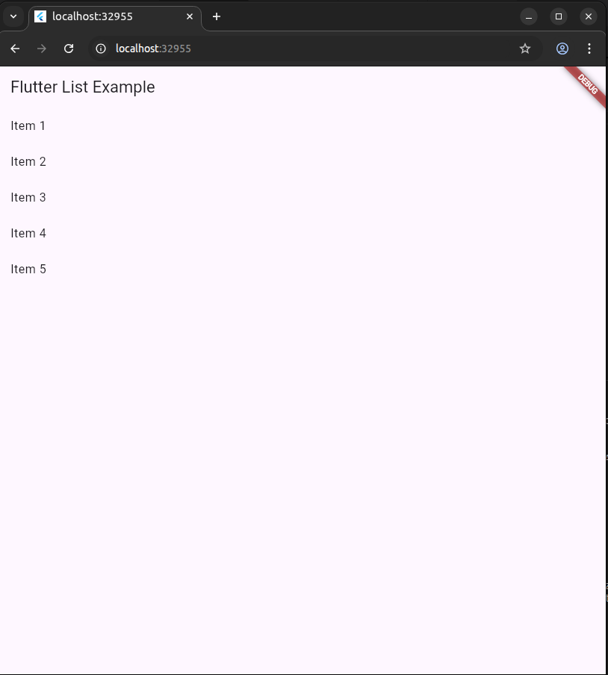

Problem 8:

import 'package:flutter/material.dart';

void main() {

runApp(MyApp());

}

class MyApp extends StatelessWidget {

@override

Widget build(BuildContext context) {

return MaterialApp(

home: MyHomePage(),

);

}

}

class MyHomePage extends StatelessWidget {

void showToast(BuildContext context) {

ScaffoldMessenger.of(context).showSnackBar(

SnackBar(

content: Text('Hello, Flutter Toast!'),

duration: Duration(seconds: 2),

),

);

}

@override

Widget build(BuildContext context) {

return Scaffold(

appBar: AppBar(

title: Text('Flutter Toast Example'),

),

body: Center(

child: ElevatedButton(

onPressed: () => showToast(context),

child: Text('Show Toast'),

),

),

);

}

}

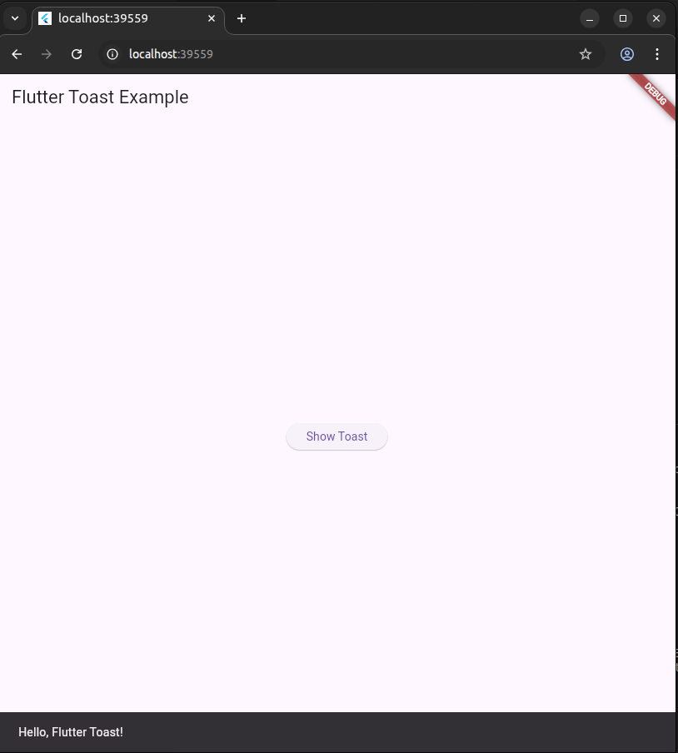

Problem 8:

import 'package:flutter/material.dart';

void main() {

runApp(MyApp());

}

class MyApp extends StatelessWidget {

@override

Widget build(BuildContext context) {

return MaterialApp(

theme: ThemeData(

scaffoldBackgroundColor: Colors.black, // Set background color to black

primaryColor: Colors.yellow, // Set text color to yellow

),

home: MyHomePage(),

);

}

}

class MyHomePage extends StatelessWidget {

@override

Widget build(BuildContext context) {

return Scaffold(

appBar: AppBar(

title: Text('Flutter Theme Example'),

),

body: Center(

child: Text(

'Welcome to Flutter Themes',

style: TextStyle(

fontSize: 24,

color: Colors.yellow, // Set text color explicitly

),

),

),

);

}

}

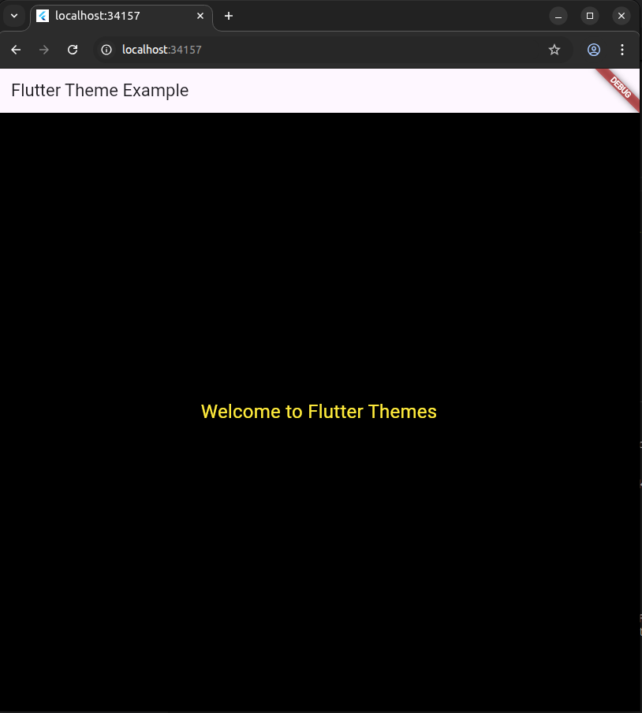

Problem 9:

import 'package:flutter/material.dart';

import 'package:fl_chart/fl_chart.dart';

void main() {

runApp(MyApp());

}

class MyApp extends StatelessWidget {

@override

Widget build(BuildContext context) {

return MaterialApp(

home: MyHomePage(),

);

}

}

class MyHomePage extends StatelessWidget {

@override

Widget build(BuildContext context) {

return Scaffold(

appBar: AppBar(

title: Text('Flutter Pie Chart Demo'),

),

body: Center(

child: PieChart(

PieChartData(

sections: [

PieChartSectionData(

color: Colors.blue,

value: 30,

title: 'Category A',

),

PieChartSectionData(

color: Colors.green,

value: 40,

title: 'Category B',

),

PieChartSectionData(

color: Colors.orange,

value: 20,

title: 'Category C',

),

PieChartSectionData(

color: Colors.red,

value: 10,

title: 'Category D',

),

],

),

),

),

);

}

}

