1. Remember me not working as expected

Login to Application with Rememeber me? checkedin

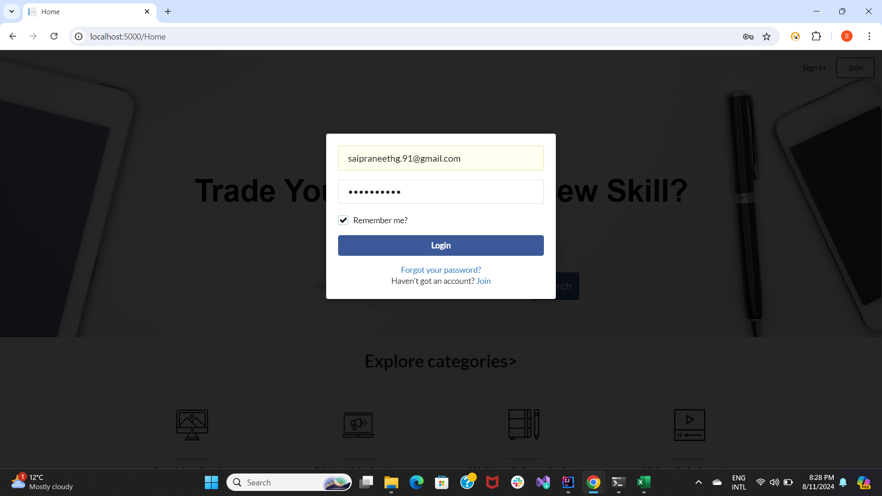

Logout

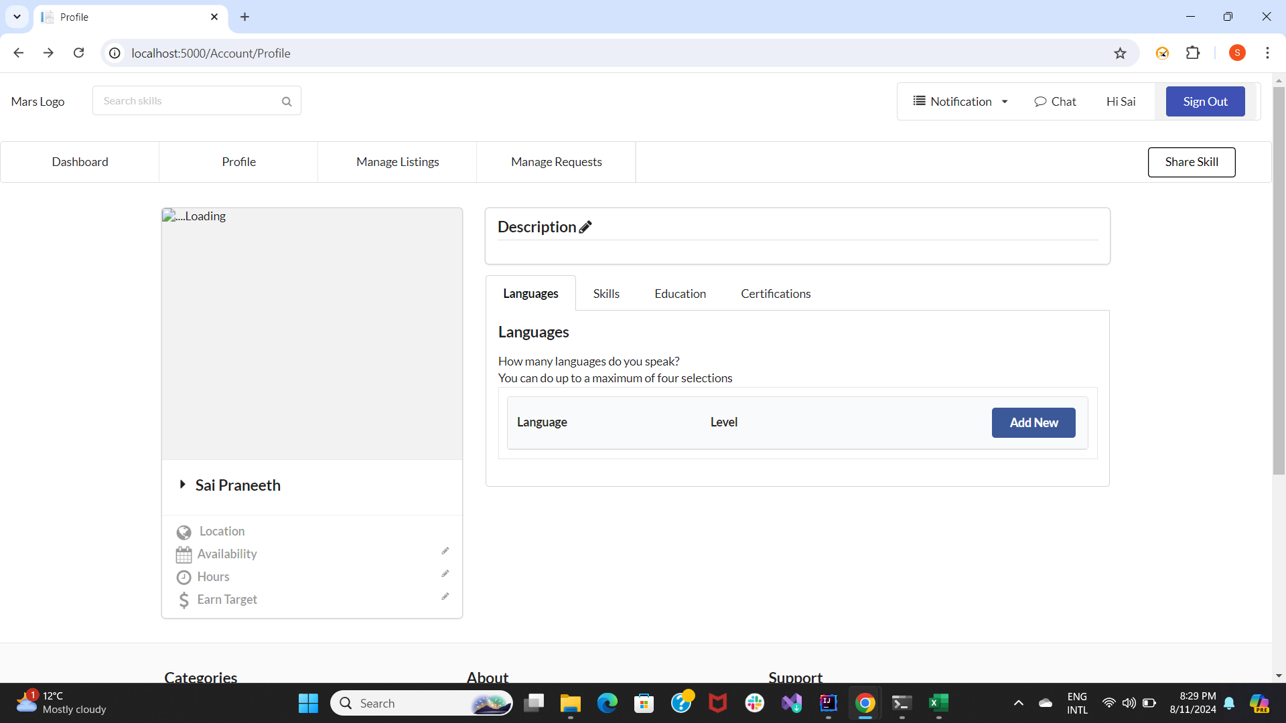

Credentials are not remembered

1. Mandatory field missing error not displayed

Open Register page and register without giving Email address, no error is displayed

