Pre-requisistes to create EKS cluster in windows 11
Step -1 : install AWS-CLI
1. Install AWS CLI (If Not Installed)
Try installing AWS CLI using the following steps:
- Download the AWS CLI installer for Windows from https://awscli.amazonaws.com/AWSCLIV2.msi .
- Run the .msi installer and follow the installation steps.
- Once installed, verify it using in command promt:
aws --version
Confirm AWS CLI Installation
Run this in PowerShell or Command Prompt:
sh
where aws
- If it doesn’t return a path, AWS CLI isn’t installed.
- If installed, it should return something like:
C:\Program Files\Amazon\AWSCLIV2\aws.exe
If AWS CLI isn’t installed, you can download it from here and install it.
2. Verify Your System’s PATH Variable
If AWS CLI is installed, but not recognized, follow these steps:
- Open Run (Win + R), type sysdm.cpl, and press Enter.
- Go to Advanced > Environment Variables.
- Under System Variables, find Path, click Edit.
- Add this AWS CLI path: C:\Program Files\Amazon\AWSCLIV2\aws.exe
- Click OK, then Restart PowerShell/Command Prompt.
now open vscode in terminal section and check now
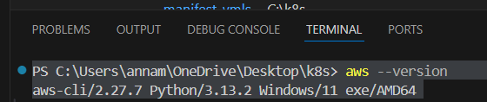
Step-2: install kubectl
1) You have two options for installing kubectl on your Windows device
- Direct download:
Download the latest 1.33 patch release binary directly for your specific architecture by visiting the Kubernetes release page. Be sure to select the correct binary for your architecture (e.g., amd64, arm64, etc.).
- Using curl:
If you have curl installed, use this command:
curl.exe -LO https://dl.k8s.io/release/v1.33.0/bin/windows/amd64/kubectl.exe
2) Validate the binary (optional)
Download the kubectl checksum file:
- curl.exe -LO https://dl.k8s.io/v1.33.0/bin/windows/amd64/kubectl.exe.sha256
3) verify
Test to ensure the version of kubectl is the same as downloaded:
kubectl version --client
Or use this for detailed view of version:
kubectl version --client --output=yaml

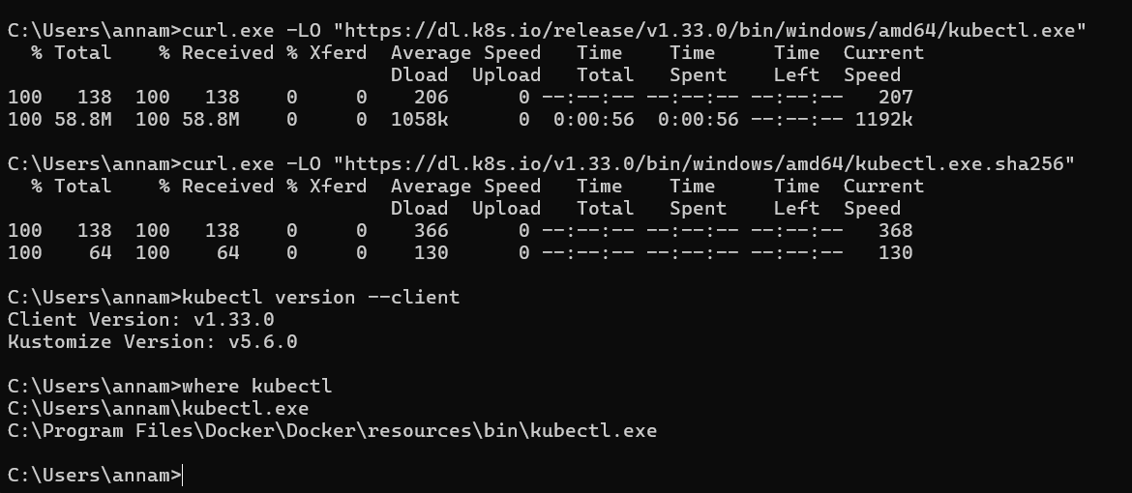

Step 3 : install eksctl
choco install -y eksctl
make sure that download the choco pacage manager
check form here : Chocolatey Software | Installing Chocolatey
and now download eksctl with choco
choco install -y eksctl
C:\Users\annam>eksctl version
0.207.0
step 4 : check the locations of eksctl, kubectl, aws-cli
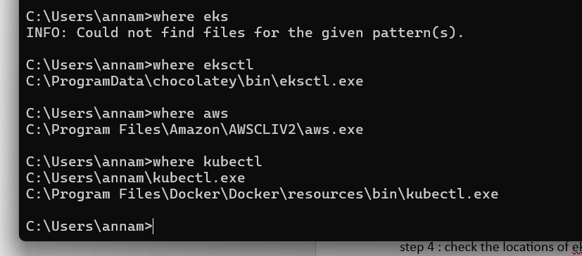

And add those exe files in environmental variables to access from vs code
goto windows > type “edit the system environmental variables” and click environmental variables
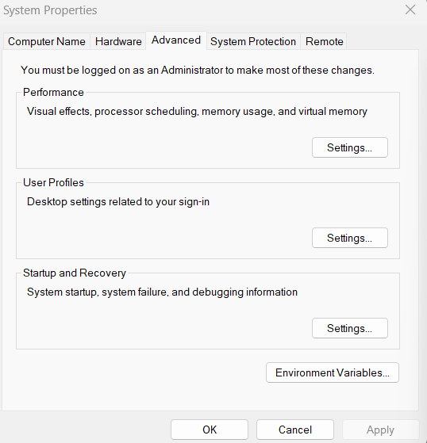
click on path and edit
