**Data-set-for-Hepatitis-C-Virus-HCV-for-Egyptian-patients**

Data set consists symptoms of the patients and their test report values for Hepatitis C virus in the body. Purpose of the repository is to explore and find some insights.

## **Attribute Information of the data set**

## Age

## Gender

## BMI (Body Mass Index)

## Fever

## Nausea/Vomting

## Headache

## Diarrhea

## Fatigue & generalized bone ache

## Jaundice

## Epigastric pain

## WBC (White blood cell)

## RBC (Red blood cells)

## HGB (Hemoglobin)

## Plat (Platelets)

## AST 1 (Aspartate transaminase ratio)

## ALT 1 (Alanine transaminase ratio 1 week)

## ALT 4 (Alanine transaminase ratio 4 weeks)

## ALT 12 (Alanine transaminase ratio 12 weeks)

## ALT 24 (Alanine transaminase ratio 24 weeks)

## ALT 36 (Alanine transaminase ratio 36 weeks)

## ALT 48 (Alanine transaminase ratio 48 weeks)

## ALT after 24w (Alanine transaminase ratio after 24 weeks)

## RNA Base

## RNA 4 (4th week Reading)

## RNA 12 (12th Week reading)

## RNA EOT (RNA end-of-treatment)

## RNA EF (RNA Elongation Factor)

## Baseline histological Grading

## Baselinehistological staging

# PROBLEM STATEMENT

1. To find out whether the patients are still affected by HCV (Hepatitis C Virus) after undertaking the treatment for 12 months ?

* We can determine the patients who are still affected by HCV after undertaking the treatment for 12 months by logistic regression performed on RNA.12 factor

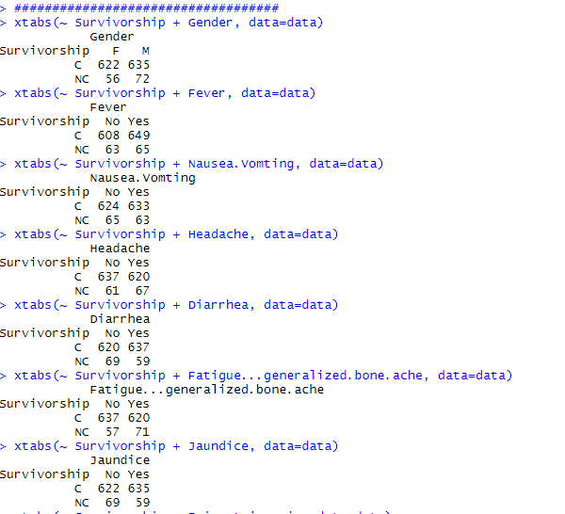

1. To find out what factors of the patients are responsible for the failure/success of treatment?

* We can’t determine which factors are responsible for the failure/success of the treatment because factors such as BMI, Fever, Nausea, Headache, Diarrhea, Fatigue, Jaundice, Epigastric pain, WBC, RBC, HGB, platelet were taken initially in to the account before starting the treatment.
* Only ‘age’ is a parameter where we can judge the failure/success of the treatment but the data is totally scattered when we looked for the insights.

1. To find out how many patients were positively responding to the doses reported on 24th week and the features influencing the recovery?

* We can determine the patients who were positively responding to the doses by analyzing and comparing RNA.Base with RNA.4, RNA.8, RNA.12 to look for a decline in the value set

1. To find out how many patients showed no symptoms but were still affected by HCV virus?

* From Logistic regression we concluded who were affected by the HCV after keeping threshold of 7,00,000 on RNA.Base

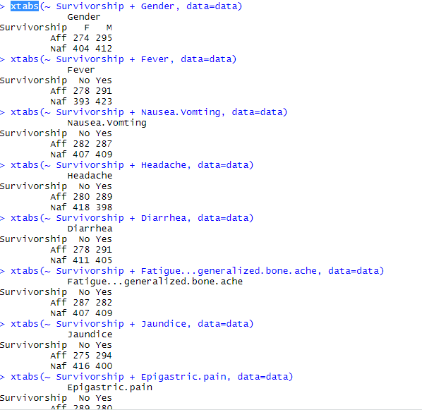

1. To find out highly correlated features that are accountable for the treatment?

* After performing PCA and Factor Analysis on the dataset we concluded features such as RNA.EF, RNA.EOT, RNA.12 were highly corelated that are accountable for the treatment.

2019-11-15

# Factor Analysis  
HCV<- read.csv("HCV-Egy-Data.csv")  
  
View(HCV)  
attach(HCV)  
library(dplyr)

##   
## Attaching package: 'dplyr'

## The following objects are masked from 'package:stats':  
##   
## filter, lag

## The following objects are masked from 'package:base':  
##   
## intersect, setdiff, setequal, union

Survivorship = HCV$Survivorship <- if_else( RNA.EOT>= 400000 , 'NC','C')  
cbind(data.frame(Survivorship),HCV)

## Survivorship Age Gender BMI Fever Nausea.Vomting Headache Diarrhea  
## 1 C 56 1 35 2 1 1 1  
## 2 C 46 1 29 1 2 2 1  
## 3 NC 57 1 33 2 2 2 2  
## 4 NC 49 2 33 1 2 1 2  
## 5 C 59 1 32 1 1 2 1  
## 6 C 58 2 22 2 2 2 1  
## 7 C 42 2 26 1 1 2 2  
## 8 C 48 2 30 1 1 2 2  
## 9 C 44 1 23 1 1 2 2  
## 10 C 45 1 30 2 1 2 2  
## 11 NC 37 2 24 2 1 2 1  
## 12 C 36 1 22 2 2 1 1  
## 13 C 45 2 25 2 1 1 1  
## 14 C 34 1 22 1 2 1

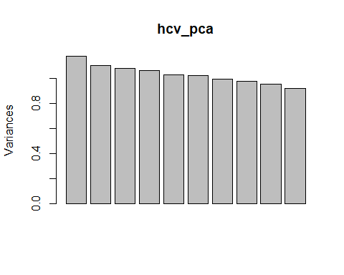

fit.pc <- principal(HCV[1:29], nfactors=4, rotate="varimax")  
fit.pc

## Principal Components Analysis  
## Call: principal(r = HCV[1:29], nfactors = 4, rotate = "varimax")  
## Standardized loadings (pattern matrix) based upon correlation matrix  
## RC1 RC2 RC3 RC4 h2 u2 com  
## Age -0.10 0.06 -0.05 0.27 0.091 0.91 1.4  
## Gender -0.01 0.05 0.08 -0.09 0.017 0.98 2.6  
## BMI -0.02 -0.04 0.15 -0.51 0.287 0.71 1.2  
## Fever 0.02 0.09 0.18 0.01 0.043 0.96 1.5  
## Nausea.Vomting 0.05 -0.52 0.26 0.08 0.346 0.65 1.5  
## Headache -0.02 -0.08 0.05 0.35 0.129 0.87 1.1  
## Diarrhea 0.03 0.03 0.35 0.16 0.148 0.85 1.5  
## Fatigue...generalized.bone.ache 0.05 0.13 0.00 -0.02 0.021 0.98 1.3  
## Jaundice 0.04 0.07 -0.09 0.34 0.133 0.87 1.3  
## Epigastric.pain 0.11 0.39 0.03 -0.09 0.169 0.83 1.3  
## WBC -0.10 0.18 -0.09 -0.18 0.084 0.92 3.1  
## RBC -0.06 -0.32 -0.04 -0.03 0.109 0.89 1.1  
## HGB 0.04 -0.17 -0.17 -0.41 0.227 0.77 1.7  
## Plat 0.11 -0.34 0.36 -0.15 0.281 0.72 2.6  
## AST.1 -0.04 0.01 0.07 0.00 0.007 0.99 1.6  
## ALT.1 -0.04 -0.08 0.58 0.11 0.356 0.64 1.1  
## ALT4 0.05 -0.10 -0.24 0.17 0.101 0.90 2.3  
## ALT.12 -0.08 0.04 -0.46 0.16 0.242 0.76 1.3  
## ALT.24 0.06 -0.38 -0.33 0.02 0.260 0.74 2.0  
## ALT.36 0.06 -0.07 0.01 0.19 0.044 0.96 1.5  
## ALT.48 -0.01 0.40 0.19 0.13 0.212 0.79 1.6  
## ALT.after.24.w 0.00 0.22 0.09 0.09 0.066 0.93 1.6  
## RNA.Base -0.02 0.11 0.15 0.31 0.131 0.87 1.8  
## RNA.4 -0.07 0.19 0.01 -0.21 0.083 0.92 2.2  
## RNA.12 0.76 0.05 0.01 0.04 0.581 0.42 1.0  
## RNA.EOT 0.78 0.08 -0.04 0.00 0.613 0.39 1.0  
## RNA.EF 0.78 0.06 -0.03 0.05 0.620 0.38 1.0  
## Baseline.histological.Grading -0.07 0.16 0.04 -0.14 0.050 0.95 2.5  
## Baselinehistological.staging 0.03 -0.20 0.03 0.28 0.118 0.88 1.9  
##   
## RC1 RC2 RC3 RC4  
## SS loadings 1.88 1.25 1.22 1.22  
## Proportion Var 0.06 0.04 0.04 0.04  
## Cumulative Var 0.06 0.11 0.15 0.19  
## Proportion Explained 0.34 0.22 0.22 0.22  
## Cumulative Proportion 0.34 0.56 0.78 1.00

# Play with FA utilities  
  
fa.parallel(HCV[1:29]) # See factor recommendation

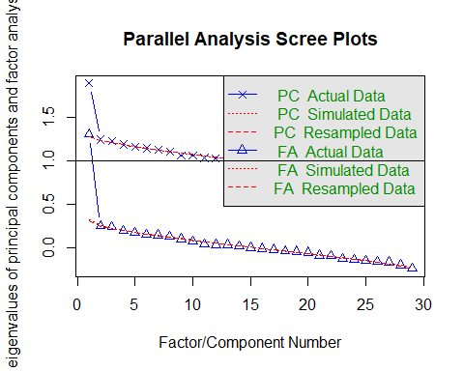

## Parallel analysis suggests that the number of factors = 1 and the number of components = 1

fa.plot(fit.pc) # See Correlations within Factors

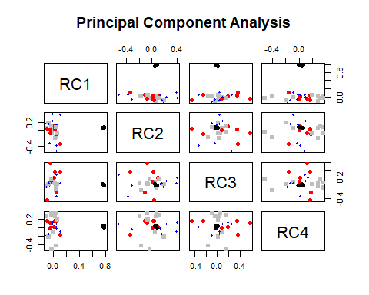

fa.diagram(fit.pc) # Visualize the relationship

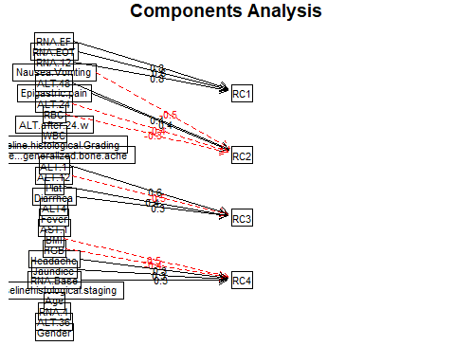

vss(HCV[1:29]) # See Factor recommendations for a simple structure

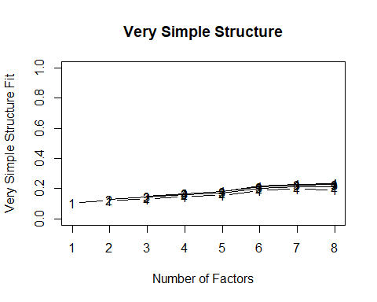

##   
## Very Simple Structure  
## Call: vss(x = HCV[1:29])  
## VSS complexity 1 achieves a maximimum of 0.2 with 7 factors  
## VSS complexity 2 achieves a maximimum of 0.22 with 7 factors  
##   
## The Velicer MAP achieves a minimum of 0 with 1 factors   
## BIC achieves a minimum of -2353.19 with 1 factors  
## Sample Size adjusted BIC achieves a minimum of -1155.61 with 1 factors  
##

#Importing the Hepatatis c Dataset

> HCV <- read.csv("C:/Users/Kaustubh Chalke/Documents/Multivariate Analysis/Project/HCV-Egy-Data.csv")

> library(dplyr)

> attach(HCV)

> Survivorship =HCV$Survivorship <- if_else( RNA.EOT>= 400000 , 0,1)

> cbind(data.frame(Survivorship),HCV)

Survivorship Age Gender BMI Fever Nausea.Vomting Headache Diarrhea Fatigue...generalized.bone.ache Jaundice Epigastric.pain

1 1 56 1 35 2 1 1 1 2 2 2

2 1 46 1 29 1 2 2 1 2 2 1

3 0 57 1 33 2 2 2 2 1 1 1

4 0 49 2 33 1 2 1 2 1 2 1

5 1 59 1 32 1 1 2 1 2 2 2

6 1 58 2 22 2 2 2 1 2 2 1

7 1 42 2 26 1 1 2 2 2 2 2

8 1 48 2 30 1 1 2 2 1 1 2

9 1 44 1 23 1 1 2 2 2 1 2

10 1 45 1 30 2 1 2 2 1 1 2

11 0 37 2 24 2 1 2 1 2 2 1

12 1 36 1 22 2 2 1 1 1 1 1

13 1 45 2 25 2 1 1 1 2 1 2

14 1 34 1 22 1 2 1 1 2 2 1

15 0 40 2 32 2 2 2 1 2 1 1

16 0 58 1 34 2 1 1 1 2 1 1

17 1 61 1 35 1 2 2 2 1 1 2

18 1 55 2 24 2 1 2 2 2 2 2

19 0 56 1 27 1 2 2 2 2 2 2

20 0 35 2 23 2 2 1 1 1 1 2

21 0 57 2 23 1 1 2 2 1 1 1

22 1 33 1 25 2 1 2 2 2 2 2

23 1 41 1 23 1 2 2 2 2 1 2

24 1 39 2 29 1 2 1 2 1 1 2

25 1 33 2 24 1 2 2 2 2 1 2

26 1 43 2 34 2 2 2 1 1 1 1

27 0 51 1 34 2 1 2 2 1 1 2

28 0 39 2 33 2 1 2 1 1 1 2

29 1 57 2 26 1 2 2 1 1 1 2

30 1 47 2 29 1 1 2 1 2 1 2

31 1 55 2 33 1 2 2 1 2 1 2

32 1 58 2 35 2 2 2 2 1 1 1

WBC RBC HGB Plat AST.1 ALT.1 ALT4 ALT.12 ALT.24 ALT.36 ALT.48 ALT.after.24.w RNA.Base RNA.4 RNA.12 RNA.EOT RNA.EF

1 7425 4248807 14 112132 99 84 52 109 81 5 5 5 655330 634536 288194 5 5

2 12101 4429425 10 129367 91 123 95 75 113 57 123 44 40620 538635 637056 336804 31085

3 4178 4621191 12 151522 113 49 95 107 116 5 5 5 571148 661346 5 735945 558829

4 6490 4794631 10 146457 43 64 109 80 88 48 77 33 1041941 449939 585688 744463 582301

5 3661 4606375 11 187684 99 104 67 48 120 94 90 30 660410 738756 3731527 338946 242861

6 11785 3882456 15 131228 66 104 121 96 65 73 114 29 1157452 1086852 5 5 5

7 11620 4747333 12 177261 78 57 113 118 107 84 80 28 325694 1034008 275095 214566 635157

8 7335 4405941 11 216176 119 112 80 127 45 96 53 39 641129 72050 787295 370605 506296

9 10480 4608464 12 148889 93 83 55 102 97 122 39 45 591441 757361 5 371090 203042

10 6681 4455329 12 98200 55 68 72 127 81 125 43 30 1151206 230488 267320 275295 555516

11 4437 4265042 12 166027 103 124 111 74 53 123 101 33 1023123 103190 731929 448466 59998

12 6052 4130219 13 144266 75 49 93 52 46 46 59 45 137712 1122999 561438 63145 806204

13 9279 4116937 13 203003 97 101 66 53 95 55 104 26 936444 536969 5 5 5

14 5638 4321603 14 141110 120 61 64 51 78 90 113 23 392976 884322 586834 182775 782154

15 11507 4165603 14 222874 127 122 106 105 88 111 111 36 1133727 1111871 421304 437544 124609

16 8035 4896464 11 149506 117 53 50 80 120 66 86 34 614951 314296 83690 671490 135145

17 10843 4165219 10 197640 86 105 70 86 83 87 47 33 900099 721460 5 5 5

18 8476 4466885 14 163276 53 101 50 95 112 97 68 27 1145310 230993 457882 318363 256415

19 6599 4448466 15 190642 53 124 62 76 57 46 93 26 506756 359181 743399 405175 162983

20 4845 4436025 10 111819 115 121 63 127 95 124 93 42 1080499 76404 717159 404314 477719

21 5925 4031637 15 116558 86 109 118 119 55 103 84 32 169624 786017 669076 531187 282524

22 9952 4994729 10 109023 84 77 67 81 117 68 42 32 1135200 572747 5 5 5

23 7961 4595487 14 94733 45 92 103 104 40 115 93 33 293380 440576 53098 18292 187341

24 7136 4625248 10 211363 70 102 76 58 111 95 58 25 993940 992652 96482 334897 762760

25 6057 4300774 11 222135 62 91 116 128 41 70 106 43 243433 981370 12504 360015 753383

26 6648 4529290 15 109871 48 112 99 85 59 87 78 35 955296 540654 5 5 5

27 11032 4052583 15 94503 41 54 128 64 71 89 87 34 766355 531269 737603 734863 372837

28 5234 4906158 12 190314 61 120 113 75 88 114 99 43 486467 45990 45578 733292 19572

29 6038 4763261 13 126721 51 118 98 42 93 53 83 45 285374 186657 5 5 5

30 5846 4753531 15 104729 120 72 117 126 45 95 49 38 426136 247777 767015 377123 315150

31 5383 3999388 15 182262 96 49 59 88 62 58 81 41 1194301 928679 29778 124250 244049

32 7378 3998925 10 201114 57 110 128 96 69 105 72 26 557708 287714 623587 66891 35044

> HCV_lr = select(HCV,RNA.12,RNA.EF,RNA.EOT,RNA.Base)

> #Multiple Regression

> View(HCV)

> # Performing multiple regression on HCV dataset

> fit <- lm(Survivorship~RNA.EF+RNA.EOT+RNA.Base+RNA.12,data=HCV)

> #show the results

> summary(fit)

Call:

lm(formula = Survivorship ~ RNA.EF + RNA.EOT + RNA.Base + RNA.12,

data = HCV)

Residuals:

Min 1Q Median 3Q Max

-0.55458 -0.08468 -0.05481 0.13407 0.59337

Coefficients:

Estimate Std. Error t value Pr(>|t|)

(Intercept) 1.068e+00 1.453e-02 73.482 < 2e-16 ***

RNA.EF 1.451e-07 2.682e-08 5.409 7.47e-08 ***

RNA.EOT -1.687e-06 2.697e-08 -62.531 < 2e-16 ***

RNA.Base -1.384e-08 1.737e-08 -0.797 0.426

RNA.12 1.224e-07 2.467e-08 4.963 7.80e-07 ***

---

Signif. codes: 0 ‘***’ 0.001 ‘**’ 0.01 ‘*’ 0.05 ‘.’ 0.1 ‘ ’ 1

Residual standard error: 0.2287 on 1380 degrees of freedom

Multiple R-squared: 0.7703, Adjusted R-squared: 0.7696

F-statistic: 1157 on 4 and 1380 DF, p-value: < 2.2e-16

> #Summary has three sections. Section1: How well does the model fit the data (before Coefficients). Section2: Is the hypothesis supported? (until sifnif codes). Section3: How well does data fit the model (again).

> # Useful Helper Functions

> coefficients(fit)

(Intercept) RNA.EF RNA.EOT RNA.Base RNA.12

1.067746e+00 1.450885e-07 -1.686741e-06 -1.383850e-08 1.224221e-07

> #install.packages("GGally", lib="/Library/Frameworks/R.framework/Versions/3.5/Resources/library")

> library(GGally)

> ggpairs(data=HCV_lr, title="HCV Data")

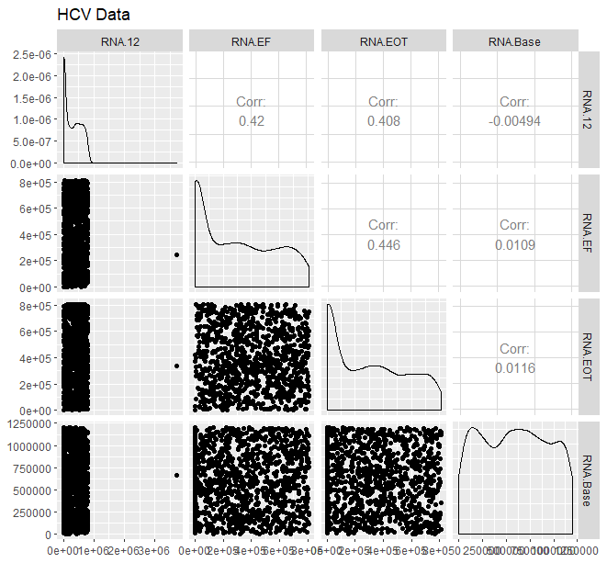

> confint(fit,level=0.95)

2.5 % 97.5 %

(Intercept) 1.039242e+00 1.096251e+00

RNA.EF 9.246772e-08 1.977093e-07

RNA.EOT -1.739656e-06 -1.633825e-06

RNA.Base -4.791802e-08 2.024102e-08

RNA.12 7.403556e-08 1.708087e-07

> # Predicted Values

> fitted(fit)

1 2 3 4 5 6 7 8 9

1.093951141 0.581583066 -0.100425497 -0.046202140 0.978951116 1.051721814 0.827153724 0.603599640 0.463088785

10 11 12 13 14 15 16 17 18

0.700788986 0.395451379 1.145034724 1.054780232 0.939337139 0.383690303 -0.043539588 1.055283193 0.608158926

19 20 21 22 23 24 25 26 27

0.491963928 0.527928690 0.292325027 1.052029748 1.066513908 0.611586573 0.567963654 1.054519349 -0.037988796

28 29 30 31 32 33 34 35 36

-0.167439567 1.063790063 0.565364837 0.880695657 1.028626040 -0.011389086 0.506226136 0.011654539 0.213029450

37 38 39 40 41 42 43 44 45

0.597629258 0.737527908 1.005760078 0.793516211 0.267095793 0.588765861 0.794159304 -0.016029038 1.009401378

> residuals(fit)

1 2 3 4 5 6 7 8 9

-0.093951141 0.418416934 0.100425497 0.046202140 0.021048884 -0.051721814 0.172846276 0.396400360 0.536911215

10 11 12 13 14 15 16 17 18

0.299211014 -0.395451379 -0.145034724 -0.054780232 0.060662861 -0.383690303 0.043539588 -0.055283193 0.391841074

19 20 21 22 23 24 25 26 27

-0.491963928 -0.527928690 -0.292325027 -0.052029748 -0.066513908 0.388413427 0.432036346 -0.054519349 0.037988796

28 29 30 31 32 33 34 35 36

0.167439567 -0.063790063 0.434635163 0.119304343 -0.028626040 0.011389086 0.493773864 -0.011654539 -0.213029450

37 38 39 40 41 42 43 44 45

0.402370742 0.262472092 -0.005760078 0.206483789 -0.267095793 0.411234139 0.205840696 0.016029038 -0.009401378

46 47 48 49 50 51 52 53 54

0.356215266 -0.022662356 -0.237126633 0.073368272 0.087265310 0.113395942 0.427698389 -0.145781416 -0.032229682

55 56 57 58 59 60 61 62 63

-0.058694243 -0.077549428 0.193079578 -0.201812452 -0.020263805 0.004195303 0.353194003 0.241011417 -0.389892131

64 65 66 67 68 69 70 71 72

0.058767072 0.048147108 0.170029600 0.452182189 -0.010218911 0.199892619 -0.483167144 0.429041016 0.265917721

73 74 75 76 77 78 79 80 81

0.478695135 -0.498119095 -0.377537795 0.147279156 0.341947206 -0.416317016 0.203756691 0.515857719 0.178512111

82 83 84 85 86 87 88 89 90

0.157948751 -0.439036477 0.224930967 -0.412856208 0.349722377 -0.047544726 -0.443753655 -0.294019820 0.399434327

91 92 93 94 95 96 97 98 99

0.511166604 -0.202967827 -0.058981268 0.128043944 -0.279917451 -0.061377944 0.100981119 0.090908069 -0.057401881

> #Anova Table

> anova(fit)

Analysis of Variance Table

Response: Survivorship

Df Sum Sq Mean Sq F value Pr(>F)

RNA.EF 1 29.323 29.323 560.5988 < 2.2e-16 ***

RNA.EOT 1 211.422 211.422 4041.9169 < 2.2e-16 ***

RNA.Base 1 0.039 0.039 0.7417 0.3893

RNA.12 1 1.289 1.289 24.6336 7.796e-07 ***

Residuals 1380 72.184 0.052

---

Signif. codes: 0 ‘***’ 0.001 ‘**’ 0.01 ‘*’ 0.05 ‘.’ 0.1 ‘ ’ 1

> vcov(fit)

(Intercept) RNA.EF RNA.EOT RNA.Base RNA.12

(Intercept) 2.111404e-04 -8.223385e-11 -8.432992e-11 -1.771662e-10 -7.084659e-11

RNA.EF -8.223385e-11 7.195422e-16 -2.398368e-16 -4.605975e-18 -1.929385e-16

RNA.EOT -8.432992e-11 -2.398368e-16 7.276145e-16 -5.055297e-18 -1.804488e-16

RNA.Base -1.771662e-10 -4.605975e-18 -5.055297e-18 3.018065e-16 5.574184e-18

RNA.12 -7.084659e-11 -1.929385e-16 -1.804488e-16 5.574184e-18 6.084031e-16

> cov2cor(vcov(fit))

(Intercept) RNA.EF RNA.EOT RNA.Base RNA.12

(Intercept) 1.0000000 -0.210977843 -0.21515200 -0.701828333 -0.19766857

RNA.EF -0.2109778 1.000000000 -0.33146446 -0.009883919 -0.29160511

RNA.EOT -0.2151520 -0.331464455 1.00000000 -0.010787772 -0.27121123

RNA.Base -0.7018283 -0.009883919 -0.01078777 1.000000000 0.01300832

RNA.12 -0.1976686 -0.291605109 -0.27121123 0.013008324 1.00000000

> temp <- influence.measures(fit)

> temp

Influence measures of

lm(formula = Survivorship ~ RNA.EF + RNA.EOT + RNA.Base + RNA.12, data = HCV) :

dfb.1_ dfb.RNA.EF dfb.RNA.EO dfb.RNA.B dfb.RNA.1 dffit cov.r cook.d hat inf

1 -0.009242 9.45e-03 0.009317 -2.30e-03 -7.89e-03 -0.01974 1.005 7.80e-05 0.00230

2 0.070830 -7.91e-02 0.011375 -7.56e-02 8.17e-02 0.13596 0.997 3.69e-03 0.00545

3 0.000257 1.01e-02 0.022491 -1.23e-03 -2.41e-02 0.03375 1.009 2.28e-04 0.00584

4 -0.007665 1.34e-03 0.006796 6.85e-03 1.60e-03 0.01308 1.008 3.43e-05 0.00416

5 -0.007033 -1.24e-02 -0.009916 1.08e-03 3.97e-02 0.03979 1.165 3.17e-04 0.13877 *

6 -0.000415 3.24e-03 0.003318 -9.83e-03 2.59e-03 -0.01422 1.007 4.05e-05 0.00393

7 0.014511 3.32e-02 -0.016197 -1.55e-02 -8.46e-03 0.04221 1.005 3.56e-04 0.00310

8 -0.016288 1.09e-02 -0.022960 7.23e-03 7.62e-02 0.09722 0.996 1.89e-03 0.00312

9 0.041378 -1.07e-02 0.051171 -8.76e-04 -7.25e-02 0.10381 0.986 2.15e-03 0.00194 *

10 -0.031871 4.17e-02 -0.015180 5.55e-02 -1.37e-02 0.07817 1.001 1.22e-03 0.00354

11 0.033901 8.30e-02 -0.025488 -5.83e-02 -8.88e-02 -0.13291 0.999 3.53e-03 0.00583

12 -0.014484 -3.89e-02 0.034561 2.19e-02 -1.18e-02 -0.05555 1.010 6.17e-04 0.00756

13 -0.003268 3.39e-03 0.003466 -6.37e-03 2.79e-03 -0.01260 1.006 3.18e-05 0.00275

14 0.001621 1.40e-02 -0.010662 -4.01e-03 4.94e-03 0.01895 1.008 7.19e-05 0.00506

15 0.033820 5.05e-02 -0.033425 -6.98e-02 -2.65e-02 -0.10098 0.997 2.04e-03 0.00359

16 0.001641 -5.14e-03 0.010957 2.35e-04 -5.55e-03 0.01276 1.008 3.26e-05 0.00445

17 -0.003767 3.41e-03 0.003490 -5.76e-03 2.83e-03 -0.01239 1.006 3.07e-05 0.00261

18 -0.037327 -1.90e-02 -0.000724 7.28e-02 3.27e-02 0.09253 0.996 1.71e-03 0.00290

19 -0.013742 7.33e-02 -0.012156 1.24e-02 -1.07e-01 -0.13290 0.991 3.52e-03 0.00378

20 0.072959 -8.02e-03 0.014894 -8.68e-02 -8.49e-02 -0.14289 0.988 4.07e-03 0.00379 *

99 -0.005962 3.51e-03 0.003591 -3.06e-03 2.97e-03 -0.01178 1.006 2.78e-05 0.00220

100 0.033978 -8.45e-03 -0.003932 -2.74e-02 3.14e-04 0.03582 1.004 2.57e-04 0.00253

[ reached 'max' / getOption("max.print") -- omitted 1285 rows ]

> View(temp)

> #diagnostic plots

> plot(fit)

Hit <Return> to see next plot:

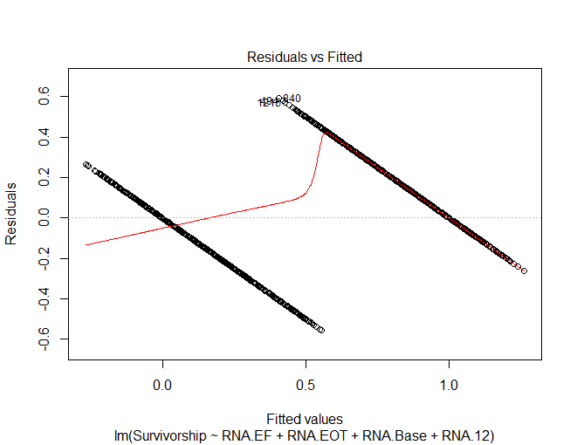

Hit <Return> to see next plot:

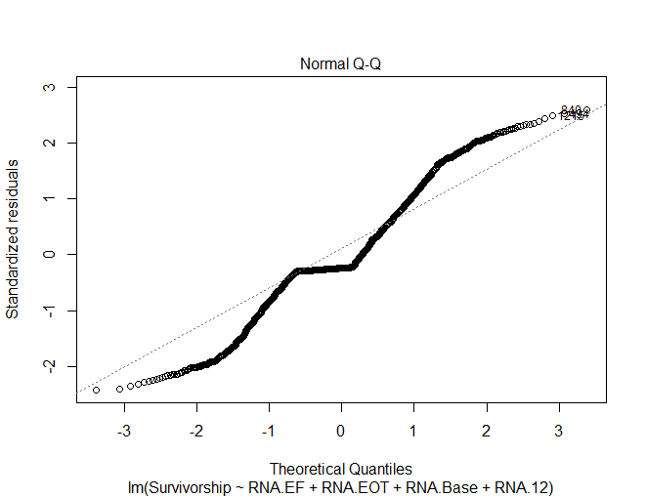

Hit <Return> to see next plot:

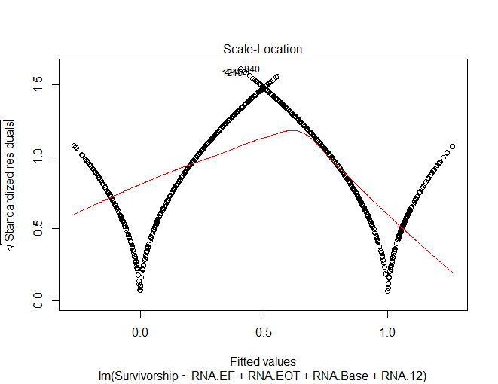

Hit <Return> to see next plot:

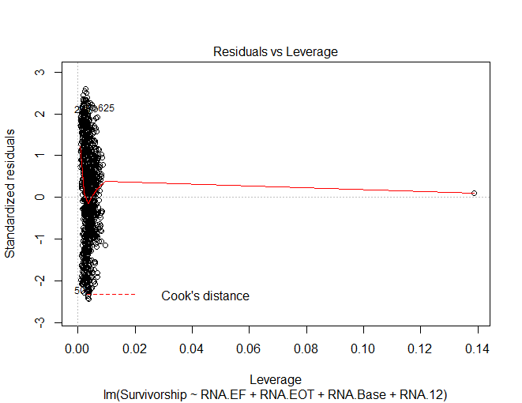

> library(car)

> # Assessing Outliers

> outlierTest(fit)

No Studentized residuals with Bonferroni p < 0.05

Largest |rstudent|:

rstudent unadjusted p-value Bonferroni p

840 2.603482 0.0093273 NA

> qqPlot(fit, main="QQ Plot")

[1] 494 840

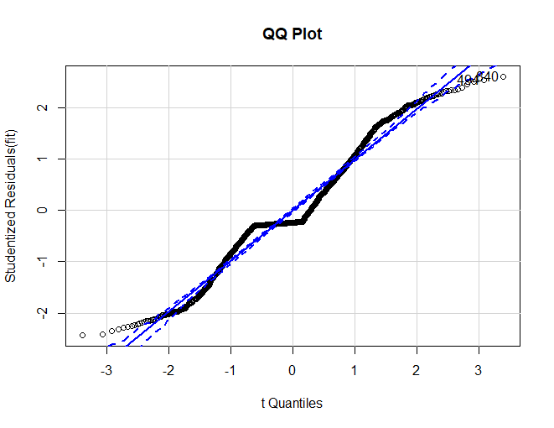

> leveragePlots(fit) # leverage plots

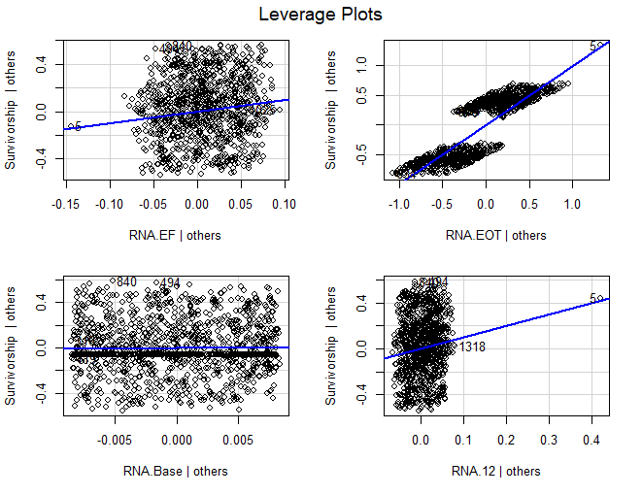

> # Influential Observations

> # Cook's D plot

> # identify D values > 4/(n-k-1)

> cutoff <- 4/((nrow(HCV_lr)-length(fit$coefficients)-2))

> plot(fit, which=4, cook.levels=cutoff)

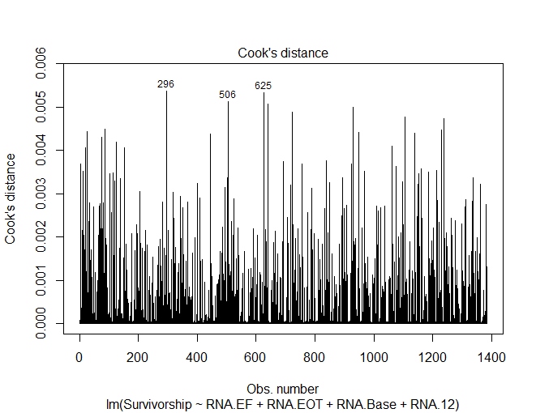

> # Influence Plot

> influencePlot(fit, id.method="identify", main="Influence Plot", sub="Circle size is proportial to Cook's Distance" )

StudRes Hat CookD

5 0.0991361 0.138768759 0.0003169402

296 2.1047833 0.006039832 0.0053705967

494 2.5371963 0.002452653 0.0031530644

625 2.1441686 0.005779939 0.0053316046

838 -1.1507095 0.009669033 0.0025850093

840 2.6034820 0.002786195 0.0037717929

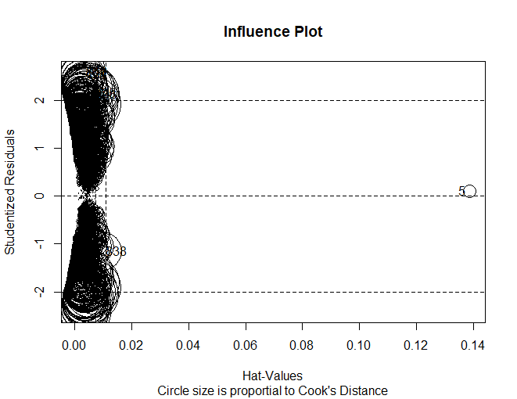

> # Normality of Residuals

> # qq plot for studentized resid

> qqPlot(fit, main="QQ Plot")

[1] 494 840

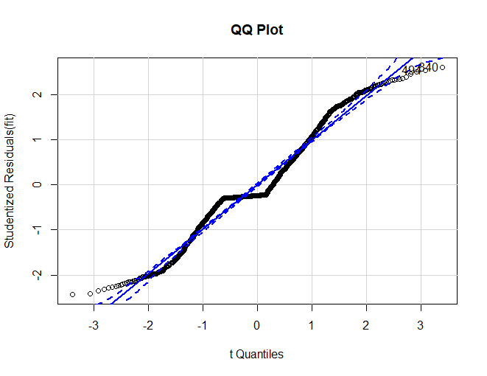

> # distribution of studentized residuals

> library(MASS)

> sresid <- studres(fit)

> hist(sresid, freq=FALSE,

+ main="Distribution of Studentized Residuals")

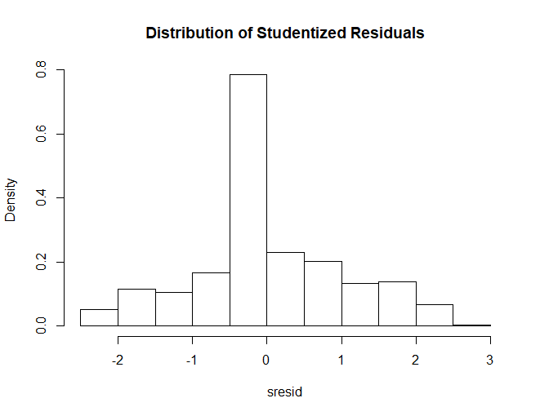

> xfit<-seq(min(sresid),max(sresid),length=40)

> yfit<-dnorm(xfit)

> lines(xfit, yfit)

> #Non-constant Error Variance

> # Evaluate homoscedasticity

> # non-constant error variance test

> ncvTest(fit)

Non-constant Variance Score Test

Variance formula: ~ fitted.values

Chisquare = 79.34254, Df = 1, p = < 2.22e-16

> # plot studentized residuals vs. fitted values

> spreadLevelPlot(fit)

Suggested power transformation: 1.305065

Warning message:

In spreadLevelPlot.lm(fit) :

145 negative fitted values removed

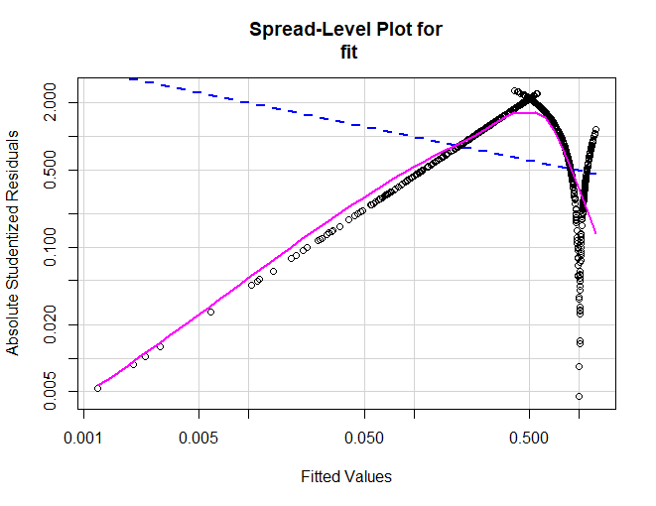

> #Multi-collinearity

> # Evaluate Collinearity

> vif(fit) # variance inflation factors

RNA.EF RNA.EOT RNA.Base RNA.12

1.364358 1.347477 1.000344 1.310757

> sqrt(vif(fit)) > 2 # problem?

RNA.EF RNA.EOT RNA.Base RNA.12

FALSE FALSE FALSE FALSE

> #Nonlinearity

> # component + residual plot

> crPlots(fit)

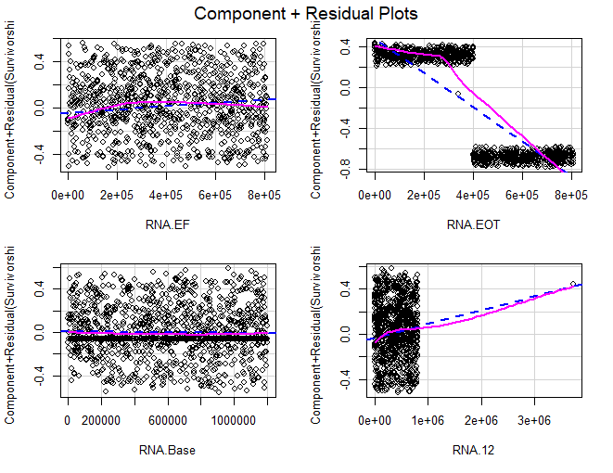

> # Ceres plots

> ceresPlots(fit)

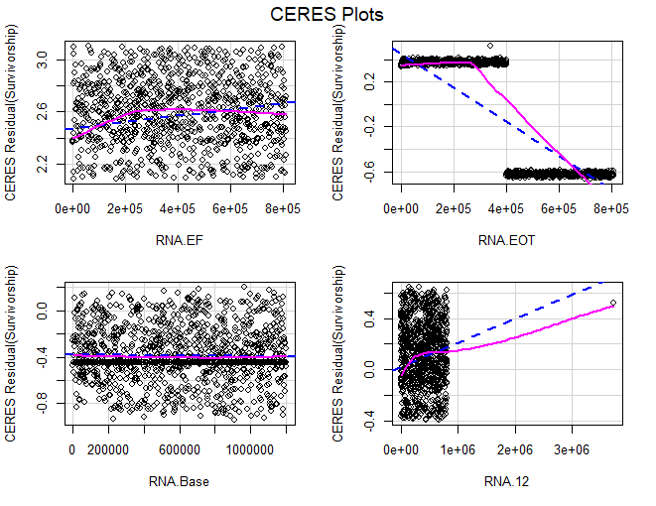

> #Non-independence of Errors

> # Test for Autocorrelated Errors

> durbinWatsonTest(fit)

lag Autocorrelation D-W Statistic p-value

1 0.05058114 1.898679 0.07

Alternative hypothesis: rho != 0

> # Global test of model assumptions

> install.packages("gvlma", lib="/Library/Frameworks/R.framework/Versions/3.5/Resources/library")

> library(gvlma)

> gvmodel <- gvlma(fit)

> summary(gvmodel)

Call:

lm(formula = Survivorship ~ RNA.EF + RNA.EOT + RNA.Base + RNA.12,

data = HCV)

Residuals:

Min 1Q Median 3Q Max

-0.55458 -0.08468 -0.05481 0.13407 0.59337

Coefficients:

Estimate Std. Error t value Pr(>|t|)

(Intercept) 1.068e+00 1.453e-02 73.482 < 2e-16 ***

RNA.EF 1.451e-07 2.682e-08 5.409 7.47e-08 ***

RNA.EOT -1.687e-06 2.697e-08 -62.531 < 2e-16 ***

RNA.Base -1.384e-08 1.737e-08 -0.797 0.426

RNA.12 1.224e-07 2.467e-08 4.963 7.80e-07 ***

---

Signif. codes: 0 ‘***’ 0.001 ‘**’ 0.01 ‘*’ 0.05 ‘.’ 0.1 ‘ ’ 1

Residual standard error: 0.2287 on 1380 degrees of freedom

Multiple R-squared: 0.7703, Adjusted R-squared: 0.7696

F-statistic: 1157 on 4 and 1380 DF, p-value: < 2.2e-16

ASSESSMENT OF THE LINEAR MODEL ASSUMPTIONS

USING THE GLOBAL TEST ON 4 DEGREES-OF-FREEDOM:

Level of Significance = 0.05

Call:

gvlma(x = fit)

Value p-value Decision

Global Stat 27.0771 1.918e-05 Assumptions NOT satisfied!

Skewness 8.7671 3.067e-03 Assumptions NOT satisfied!

Kurtosis 0.1197 7.294e-01 Assumptions acceptable.

Link Function 18.0083 2.199e-05 Assumptions NOT satisfied!

Heteroscedasticity 0.1820 6.696e-01 Assumptions acceptable.

> fit

Call:

lm(formula = Survivorship ~ RNA.EF + RNA.EOT + RNA.Base + RNA.12,

data = HCV)

Coefficients:

(Intercept) RNA.EF RNA.EOT RNA.Base RNA.12

1.068e+00 1.451e-07 -1.687e-06 -1.384e-08 1.224e-07

> summary(fit)

Call:

lm(formula = Survivorship ~ RNA.EF + RNA.EOT + RNA.Base + RNA.12,

data = HCV)

Residuals:

Min 1Q Median 3Q Max

-0.55458 -0.08468 -0.05481 0.13407 0.59337

Coefficients:

Estimate Std. Error t value Pr(>|t|)

(Intercept) 1.068e+00 1.453e-02 73.482 < 2e-16 ***

RNA.EF 1.451e-07 2.682e-08 5.409 7.47e-08 ***

RNA.EOT -1.687e-06 2.697e-08 -62.531 < 2e-16 ***

RNA.Base -1.384e-08 1.737e-08 -0.797 0.426

RNA.12 1.224e-07 2.467e-08 4.963 7.80e-07 ***

---

Signif. codes: 0 ‘***’ 0.001 ‘**’ 0.01 ‘*’ 0.05 ‘.’ 0.1 ‘ ’ 1

Residual standard error: 0.2287 on 1380 degrees of freedom

Multiple R-squared: 0.7703, Adjusted R-squared: 0.7696

F-statistic: 1157 on 4 and 1380 DF, p-value: < 2.2e-16

> fit1 <- fit

> fit2 <- lm(Survivorship~RNA.EF+RNA.EOT+RNA.12, data=HCV)

> # compare models

> anova(fit1, fit2)

Analysis of Variance Table

Model 1: Survivorship ~ RNA.EF + RNA.EOT + RNA.Base + RNA.12

Model 2: Survivorship ~ RNA.EF + RNA.EOT + RNA.12

Res.Df RSS Df Sum of Sq F Pr(>F)

1 1380 72.184

2 1381 72.217 -1 -0.03319 0.6345 0.4258

> step <- stepAIC(fit, direction="both")

Start: AIC=-4081.61

Survivorship ~ RNA.EF + RNA.EOT + RNA.Base + RNA.12

Df Sum of Sq RSS AIC

- RNA.Base 1 0.033 72.217 -4083.0

<none> 72.184 -4081.6

- RNA.12 1 1.289 73.473 -4059.1

- RNA.EF 1 1.530 73.714 -4054.6

- RNA.EOT 1 204.531 276.715 -2222.5

Step: AIC=-4082.98

Survivorship ~ RNA.EF + RNA.EOT + RNA.12

Df Sum of Sq RSS AIC

<none> 72.217 -4083.0

+ RNA.Base 1 0.033 72.184 -4081.6

- RNA.12 1 1.294 73.512 -4060.4

- RNA.EF 1 1.526 73.743 -4056.0

- RNA.EOT 1 204.611 276.828 -2223.9

> step$anova # display results

Stepwise Model Path

Analysis of Deviance Table

Initial Model:

Survivorship ~ RNA.EF + RNA.EOT + RNA.Base + RNA.12

Final Model:

Survivorship ~ RNA.EF + RNA.EOT + RNA.12

Step Df Deviance Resid. Df Resid. Dev AIC

1 1380 72.18418 -4081.615

2 - RNA.Base 1 0.03319039 1381 72.21738 -4082.978

> install.packages("leaps", lib="/Library/Frameworks/R.framework/Versions/3.5/Resources/library")

> library(leaps)

> leaps<-regsubsets(Survivorship~RNA.EF+RNA.EOT+RNA.Base+RNA.12, data=HCV_lr,nbest=10)

> # view results

> summary(leaps)

Subset selection object

Call: regsubsets.formula(Survivorship ~ RNA.EF + RNA.EOT + RNA.Base +

RNA.12, data = HCV_lr, nbest = 10)

4 Variables (and intercept)

Forced in Forced out

RNA.EF FALSE FALSE

RNA.EOT FALSE FALSE

RNA.Base FALSE FALSE

RNA.12 FALSE FALSE

10 subsets of each size up to 4

Selection Algorithm: exhaustive

RNA.EF RNA.EOT RNA.Base RNA.12

1 ( 1 ) " " "*" " " " "

1 ( 2 ) "*" " " " " " "

1 ( 3 ) " " " " " " "*"

1 ( 4 ) " " " " "*" " "

2 ( 1 ) "*" "*" " " " "

2 ( 2 ) " " "*" " " "*"

2 ( 3 ) " " "*" "*" " "

2 ( 4 ) "*" " " " " "*"

2 ( 5 ) "*" " " "*" " "

2 ( 6 ) " " " " "*" "*"

3 ( 1 ) "*" "*" " " "*"

3 ( 2 ) "*" "*" "*" " "

3 ( 3 ) " " "*" "*" "*"

3 ( 4 ) "*" " " "*" "*"

4 ( 1 ) "*" "*" "*" "*"

> # plot a table of models showing variables in each model.

> # models are ordered by the selection statistic.

> plot(leaps)

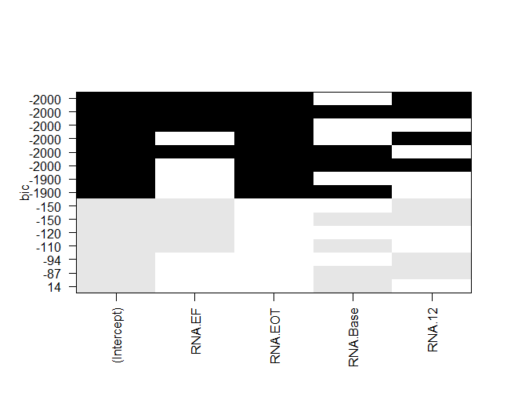

> plot(leaps,scale="r2")

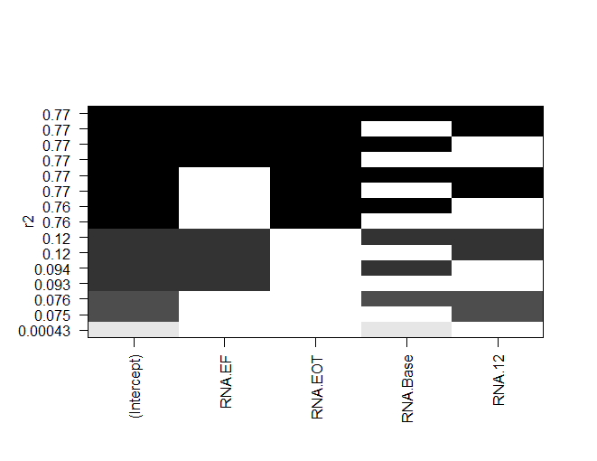

> subsets(leaps, statistic="rsq")

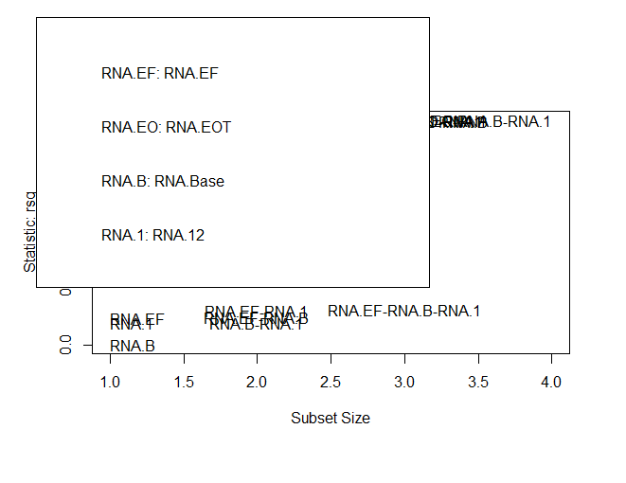

> # All Subsets Regression

> plot(leaps,scale="bic")



> summary(leaps)

Subset selection object

Call: regsubsets.formula(Survivorship ~ RNA.EF + RNA.EOT + RNA.Base +

RNA.12, data = HCV_lr, nbest = 10)

4 Variables (and intercept)

Forced in Forced out

RNA.EF FALSE FALSE

RNA.EOT FALSE FALSE

RNA.Base FALSE FALSE

RNA.12 FALSE FALSE

10 subsets of each size up to 4

Selection Algorithm: exhaustive

RNA.EF RNA.EOT RNA.Base RNA.12

1 ( 1 ) " " "*" " " " "

1 ( 2 ) "*" " " " " " "

1 ( 3 ) " " " " " " "*"

1 ( 4 ) " " " " "*" " "

2 ( 1 ) "*" "*" " " " "

2 ( 2 ) " " "*" " " "*"

2 ( 3 ) " " "*" "*" " "

2 ( 4 ) "*" " " " " "*"

2 ( 5 ) "*" " " "*" " "

2 ( 6 ) " " " " "*" "*"

3 ( 1 ) "*" "*" " " "*"

3 ( 2 ) "*" "*" "*" " "

3 ( 3 ) " " "*" "*" "*"

3 ( 4 ) "*" " " "*" "*"

4 ( 1 ) "*" "*" "*" "*"

> View(leaps)

> leaps

Subset selection object

Call: regsubsets.formula(Survivorship ~ RNA.EF + RNA.EOT + RNA.Base +

RNA.12, data = HCV_lr, nbest = 10)

4 Variables (and intercept)

Forced in Forced out

RNA.EF FALSE FALSE

RNA.EOT FALSE FALSE

RNA.Base FALSE FALSE

RNA.12 FALSE FALSE

10 subsets of each size up to 4

Selection Algorithm: exhaustive

> coef(leaps,1:4)

[[1]]

(Intercept) RNA.EOT

1.102941e+00 -1.567667e-06

[[2]]

(Intercept) RNA.EF

8.104191e-01 -5.437384e-07

[[3]]

(Intercept) RNA.12

7.841322e-01 -4.576448e-07

[[4]]

(Intercept) RNA.Base

6.683893e-01 -2.775824e-08

> #prediction of the cured

> predict.lm(fit, data.frame(RNA.12 =585688 ,RNA.EF=582301,RNA.EOT= 744463,RNA.Base=1041941) )

1

-0.04620214

roc.df <- data.frame(tpp=roc.info$sensitivities*100, ## tpp = true positive percentage  
 fpp=(1 - roc.info$specificities)*100, ## fpp = false positive precentage  
 thresholds=roc.info$thresholds)  
roc.df

## tpp fpp thresholds  
## 1 100.00000 100.0000000 -Inf  
## 2 100.00000 3.4330011 5.323833e-14  
## 3 100.00000 3.3222591 1.709546e-13  
## 4 100.00000 3.2115172 2.867293e-13  
## 5 100.00000 3.1007752 7.822429e-13  
## 6 100.00000 2.9900332 3.212620e-12  
## 7 100.00000 2.8792913 1.332148e-11  
## 8 100.00000 2.7685493 6.246558e-11  
## 9 100.00000 2.6578073 1.065926e-10  
## 10 100.00000 2.5470653 1.514639e-10  
## 11 100.00000 2.4363234 2.243080e-10

head(roc.df) ## head() will show us the values for the upper right-hand corner of the ROC graph, when the threshold is so low

## tpp fpp thresholds  
## 1 100 100.000000 -Inf  
## 2 100 3.433001 5.323833e-14  
## 3 100 3.322259 1.709546e-13  
## 4 100 3.211517 2.867293e-13  
## 5 100 3.100775 7.822429e-13  
## 6 100 2.990033 3.212620e-12

## (negative infinity) that every single sample is called "obese".  
## Thus TPP = 100% and FPP = 100%  
tail(roc.df) ## tail() will show us the values for the lower left-hand corner

## tpp fpp thresholds  
## 66 93.15353 0 1  
## 67 92.94606 0 1  
## 68 92.73859 0 1  
## 69 92.53112 0 1  
## 70 92.32365 0 1  
## 71 0.00000 0 Inf

## of the ROC graph, when the threshold is so high (infinity)  
## that every single sample is called "not obese".  
## Thus, TPP = 0% and FPP = 0%  
## now let's look at the thresholds between TPP 60% and 80%  
roc.df[roc.df$tpp > 60 & roc.df$tpp < 80,]

## [1] tpp fpp thresholds  
## <0 rows> (or 0-length row.names)

roc(data$Survivorship,logistic$fitted.values,plot=TRUE, legacy.axes=TRUE, xlab="False Positive Percentage", ylab="True Postive Percentage", col="#377eb8", lwd=4, percent=TRUE)

## Setting levels: control = C, case = NC  
## Setting direction: controls < cases

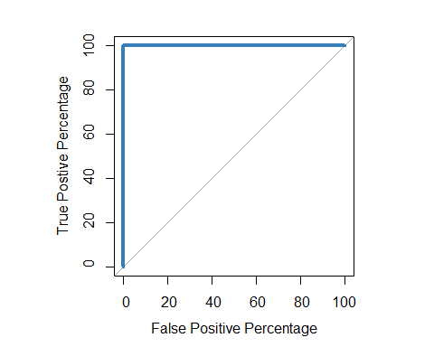

##   
## Call:  
## roc.default(response = data$Survivorship, predictor = logistic$fitted.values, percent = TRUE, plot = TRUE, legacy.axes = TRUE, xlab = "False Positive Percentage", ylab = "True Postive Percentage", col = "#377eb8", lwd = 4)  
##   
## Data: logistic$fitted.values in 903 controls (data$Survivorship C) < 482 cases (data$Survivorship NC).  
## Area under the curve: 100%

roc(data$Survivorship,logistic$fitted.values,plot=TRUE, legacy.axes=TRUE, xlab="False Positive Percentage", ylab="True Postive Percentage", col="#377eb8", lwd=4, percent=TRUE, print.auc=TRUE)

## Setting levels: control = C, case = NC  
## Setting direction: controls < cases

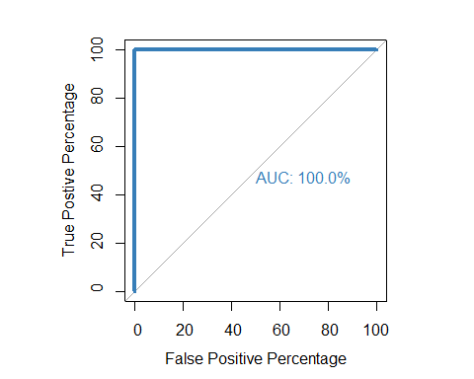

##   
## Call:  
## roc.default(response = data$Survivorship, predictor = logistic$fitted.values, percent = TRUE, plot = TRUE, legacy.axes = TRUE, xlab = "False Positive Percentage", ylab = "True Postive Percentage", col = "#377eb8", lwd = 4, print.auc = TRUE)  
##   
## Data: logistic$fitted.values in 903 controls (data$Survivorship C) < 482 cases (data$Survivorship NC).  
## Area under the curve: 100%

roc(data$Survivorship,logistic$fitted.values,plot=TRUE, legacy.axes=TRUE, xlab="False Positive Percentage", ylab="True Postive Percentage", col="#377eb8", lwd=4, percent=TRUE, print.auc=TRUE, partial.auc=c(100, 90), auc.polygon = TRUE, auc.polygon.col = "#377eb822", print.auc.x=45)

## Setting levels: control = C, case = NC  
## Setting direction: controls < cases

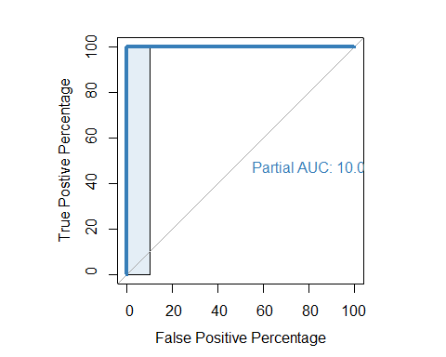

##   
## Call:  
## roc.default(response = data$Survivorship, predictor = logistic$fitted.values, percent = TRUE, plot = TRUE, legacy.axes = TRUE, xlab = "False Positive Percentage", ylab = "True Postive Percentage", col = "#377eb8", lwd = 4, print.auc = TRUE, partial.auc = c(100, 90), auc.polygon = TRUE, auc.polygon.col = "#377eb822", print.auc.x = 45)  
##   
## Data: logistic$fitted.values in 903 controls (data$Survivorship C) < 482 cases (data$Survivorship NC).  
## Partial area under the curve (specificity 100%-90%): 10%

# Lets do two roc plots to understand which model is better  
roc(data$Survivorship, logistic_simple$fitted.values, plot=TRUE, legacy.axes=TRUE, percent=TRUE, xlab="False Positive Percentage", ylab="True Postive Percentage", col="#377eb8", lwd=4, print.auc=TRUE)

## Setting levels: control = C, case = NC  
## Setting direction: controls < cases

##   
## Call:  
## roc.default(response = data$Survivorship, predictor = logistic_simple$fitted.values, percent = TRUE, plot = TRUE, legacy.axes = TRUE, xlab = "False Positive Percentage", ylab = "True Postive Percentage", col = "#377eb8", lwd = 4, print.auc = TRUE)  
##   
## Data: logistic_simple$fitted.values in 903 controls (data$Survivorship C) < 482 cases (data$Survivorship NC).  
## Area under the curve: 52.71%

# Lets add the other graph  
plot.roc(data$Survivorship, logistic$fitted.values, percent=TRUE, col="#4daf4a", lwd=4, print.auc=TRUE, add=TRUE, print.auc.y=40)

## Setting levels: control = C, case = NC  
## Setting direction: controls < cases

legend("bottomright", legend=c("Simple", "Non Simple"), col=c("#377eb8", "#4daf4a"), lwd=4) # Make it user friendly

