QUESTIONS MUST ANSWRER
1. What is sentiment analysis?
Sentiment analysis is a Natural Language Processing (NLP) technique used to identify the opinion or emotion expressed in text. In this project, customer reviews are classified into three categories: Positive, Negative, and Neutral.
2. Why is sentiment analysis useful for companies?
Sentiment analysis helps companies understand customer opinions from a large number of reviews. It can be used to identify customer satisfaction, find complaints, understand feedback, and improve products and services.
3. What is NLP and why is it needed for this task?
NLP stands for Natural Language Processing. It is a branch of Artificial Intelligence that helps computers process and understand human language. NLP is needed in this project because customer reviews are written in text, which must be processed and converted into numerical features before the machine learning model can classify them.
4. What is TF-IDF?
TF-IDF stands for Term Frequency–Inverse Document Frequency. It is a technique used to convert text into numerical features that a machine learning model can understand. It gives more importance to words that are useful for distinguishing between different reviews.
5. Which machine learning model did you use and why?
I used Logistic Regression for sentiment classification. It is a simple, fast, and effective machine learning algorithm for text classification when combined with TF-IDF features. It can classify customer reviews into Positive, Negative, and Neutral categories.
6. What accuracy did your model achieve?
My Logistic Regression model achieved an accuracy of 77.8% on the test dataset.
Note: If you improve your model and get a different accuracy, replace 77.8% with your final actual accuracy.
7. Give one example where the model may produce an incorrect prediction.
The model may make an incorrect prediction when a review contains mixed opinions or sarcasm.
For example:
"The delivery was fast, but the product quality was terrible."
The model might predict this as Positive because it sees the positive word "fast", even though the overall review is negative.

CONCLUSION
This project demonstrated how Natural Language Processing and Machine Learning can be used to perform customer review sentiment analysis. The customer reviews were cleaned using basic text preprocessing techniques and converted into numerical features using TF-IDF. A Logistic Regression model was trained to classify reviews into Positive, Negative, and Neutral categories. The model achieved an accuracy of 77.8% on the test dataset. The performance was evaluated using accuracy, classification report, and a confusion matrix. The model was also tested on new customer reviews to demonstrate its prediction capability. The project shows that TF-IDF and Logistic Regression can be effectively used for basic sentiment classification. However, the model may make incorrect predictions for sarcasm, mixed opinions, or unfamiliar words. Overall, this project helped demonstrate the basic workflow of an NLP-based sentiment analysis system.

SCREENSHOTS/OUTPUTS:
1.DATASET/PREPROCESSING:
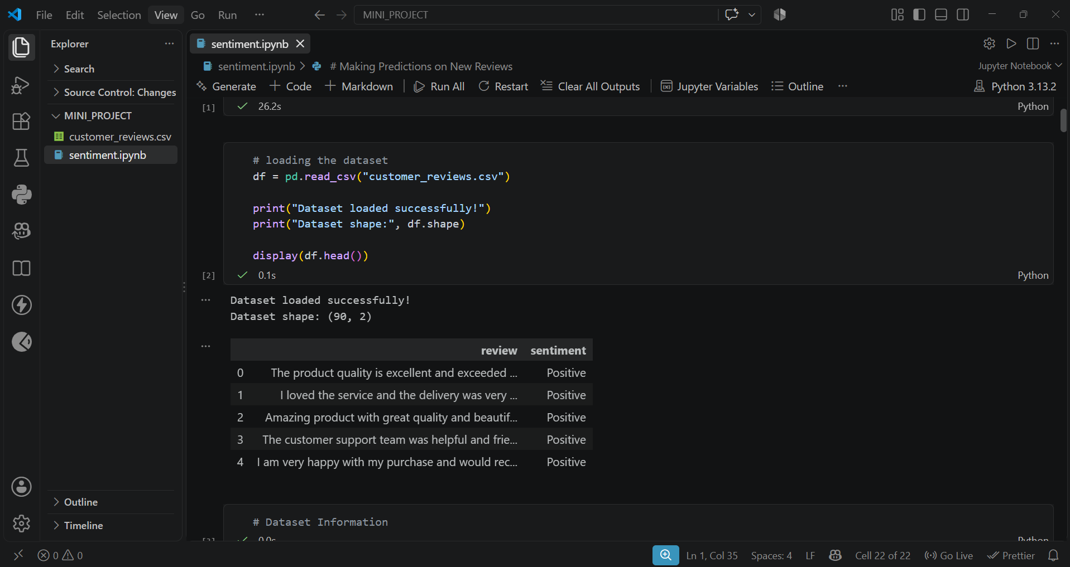
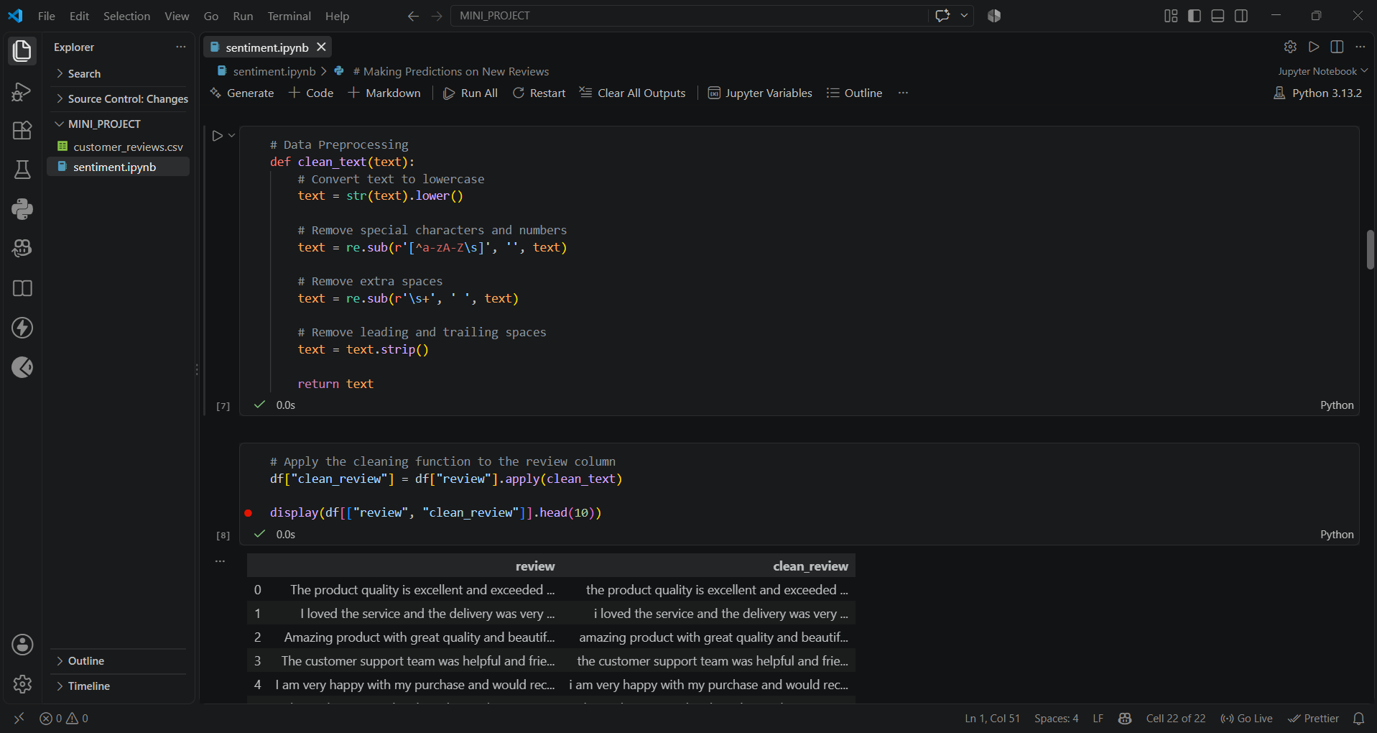
TF-IDF / feature extraction:
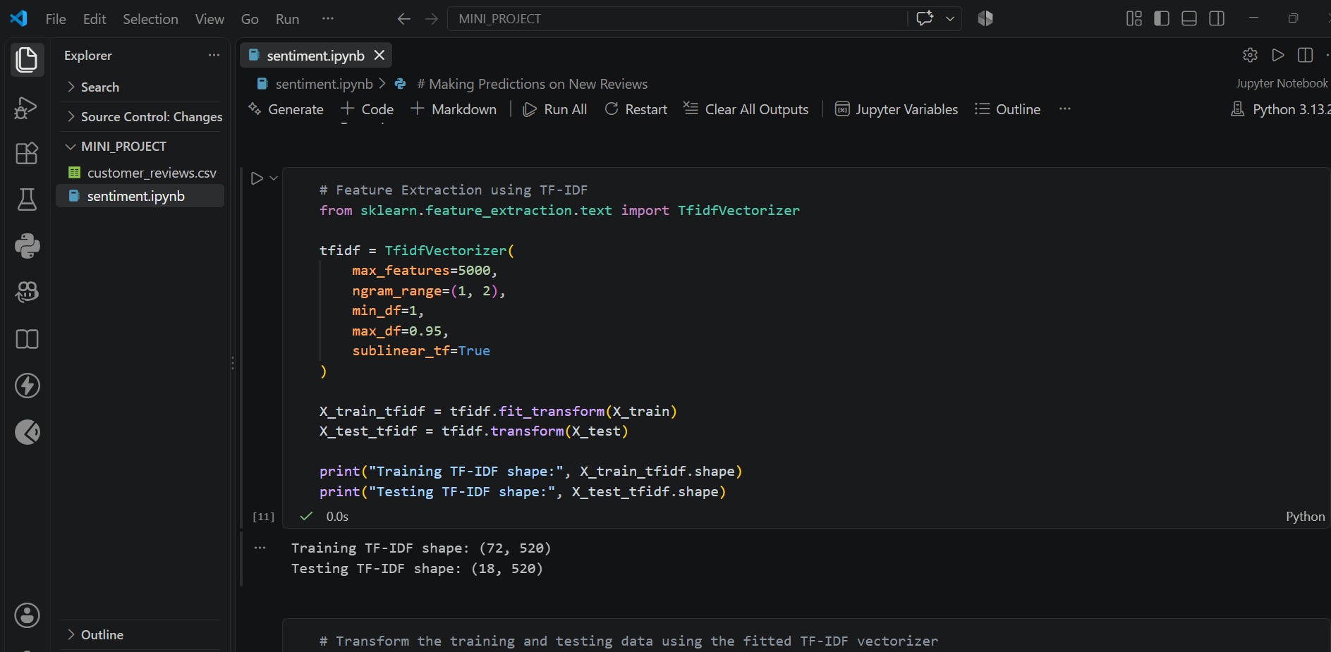
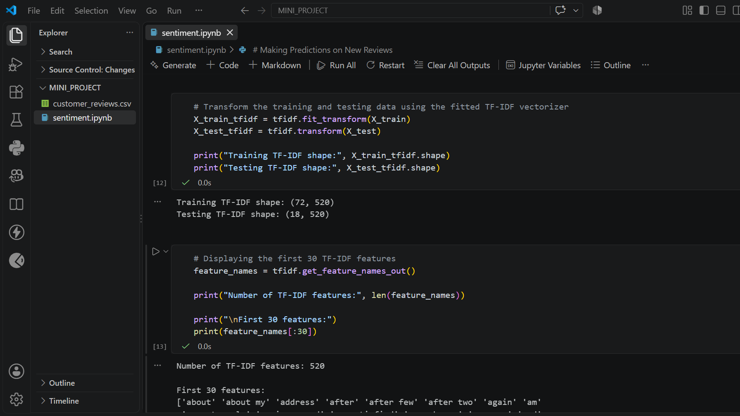
ML model and prediction:
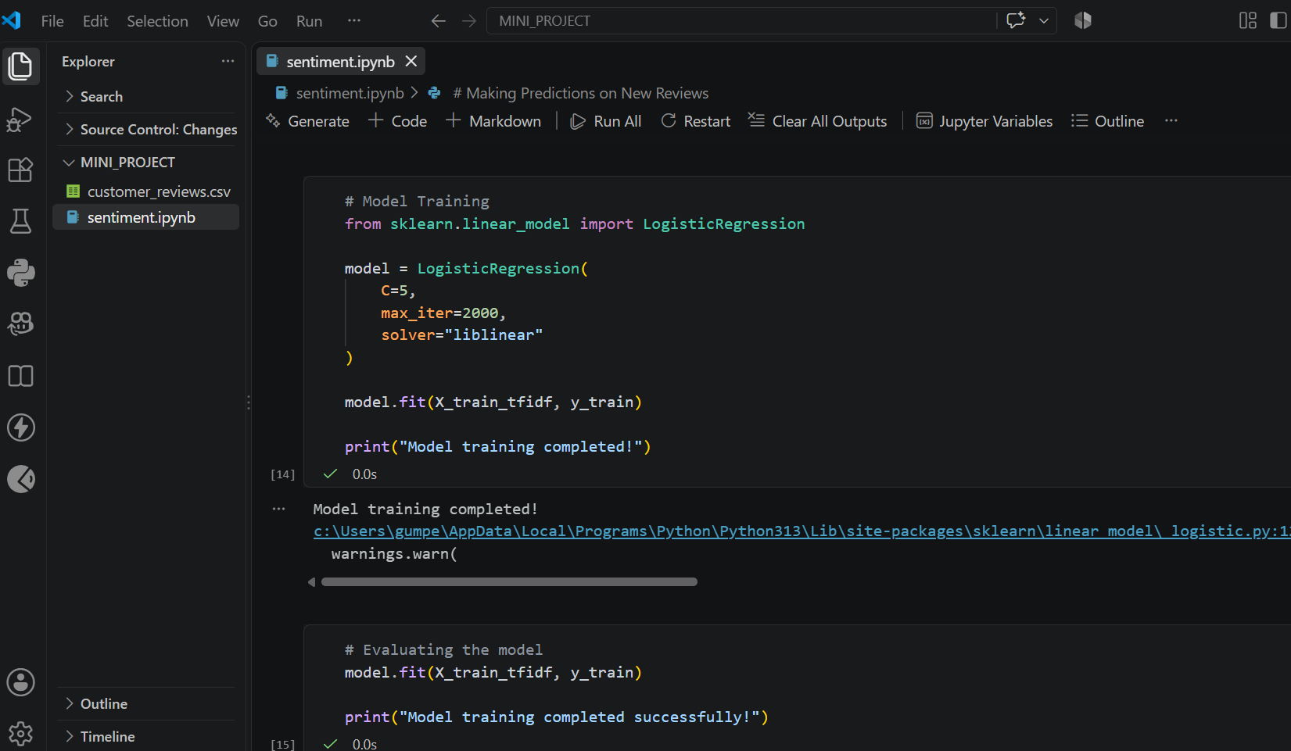
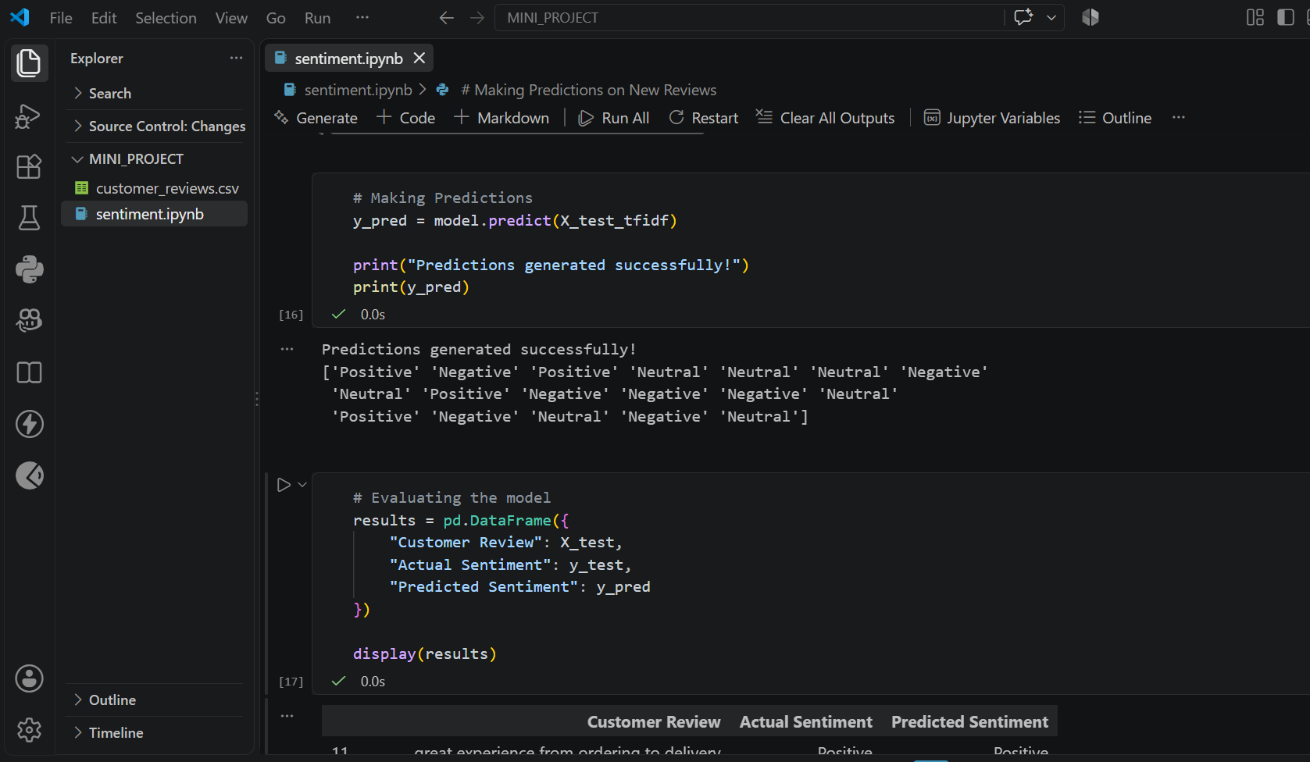
Evaluation and results:
