Assignment

1. **Documentation for following screenshots**

* Report View

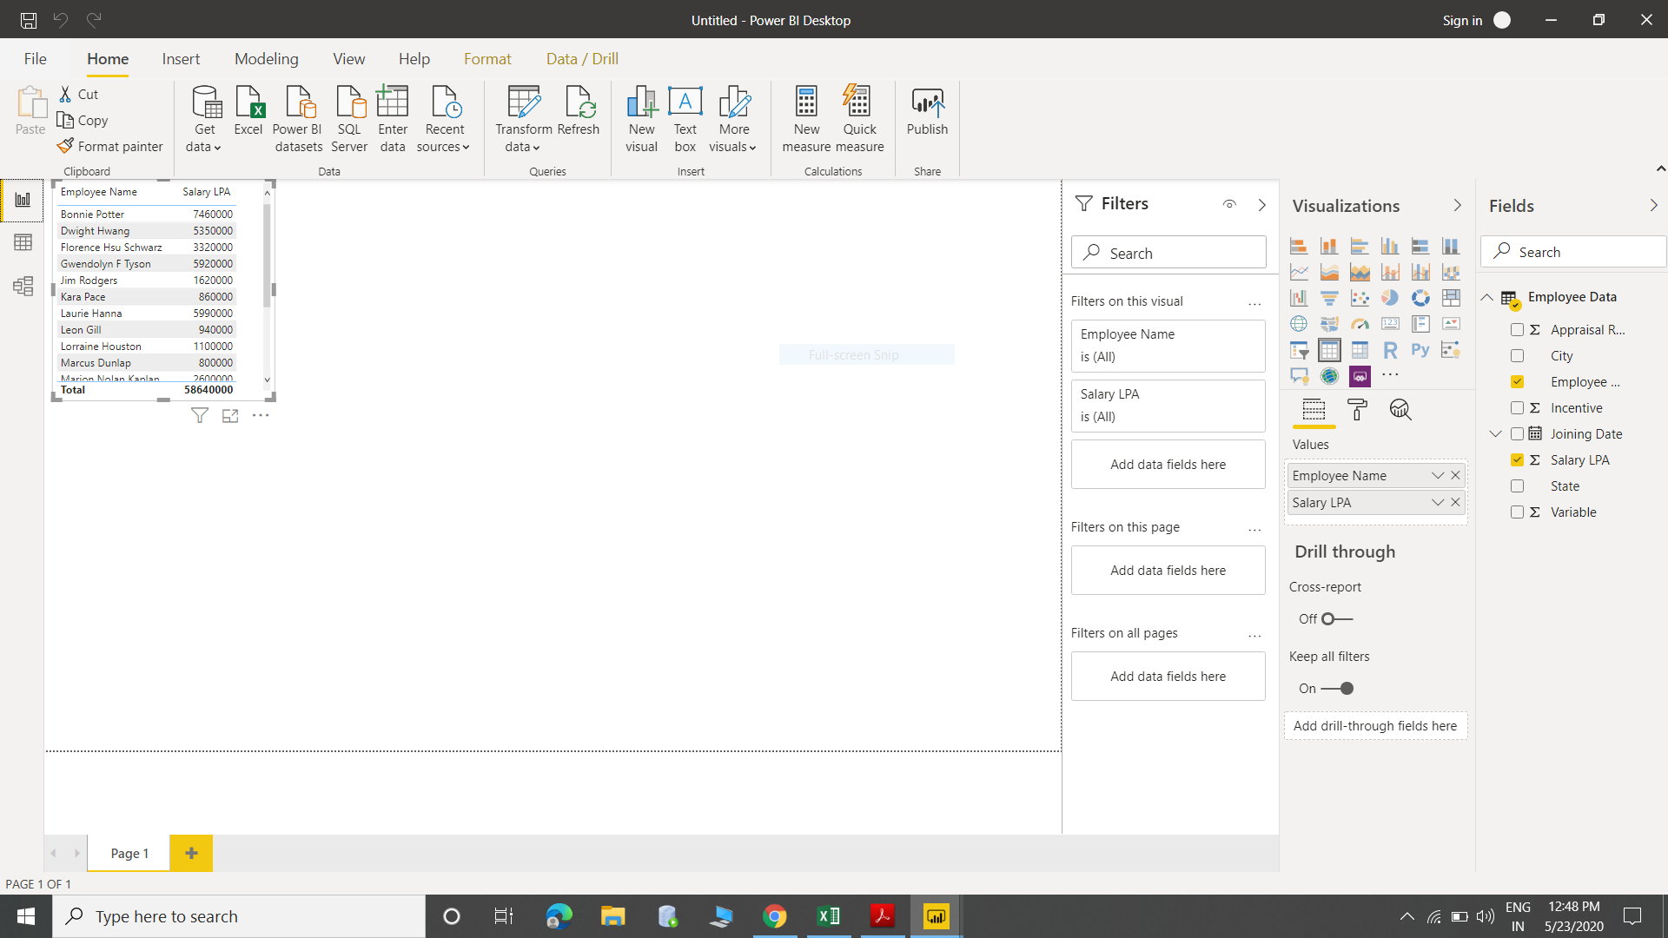

* Data View
* 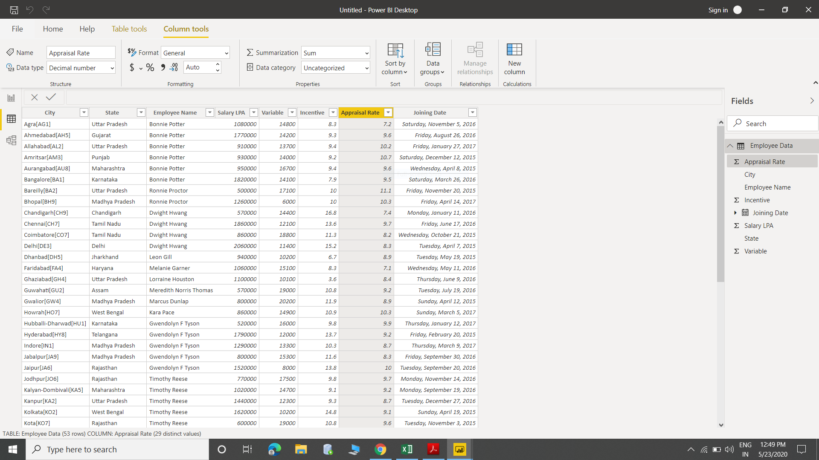
* Model View

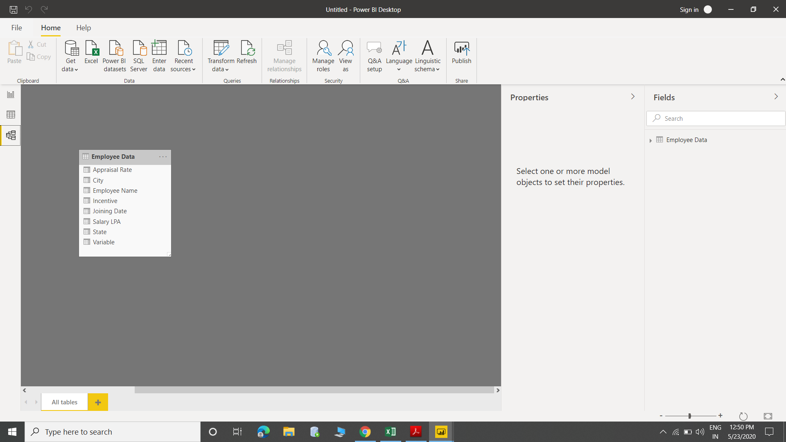

* Power Query Editor View

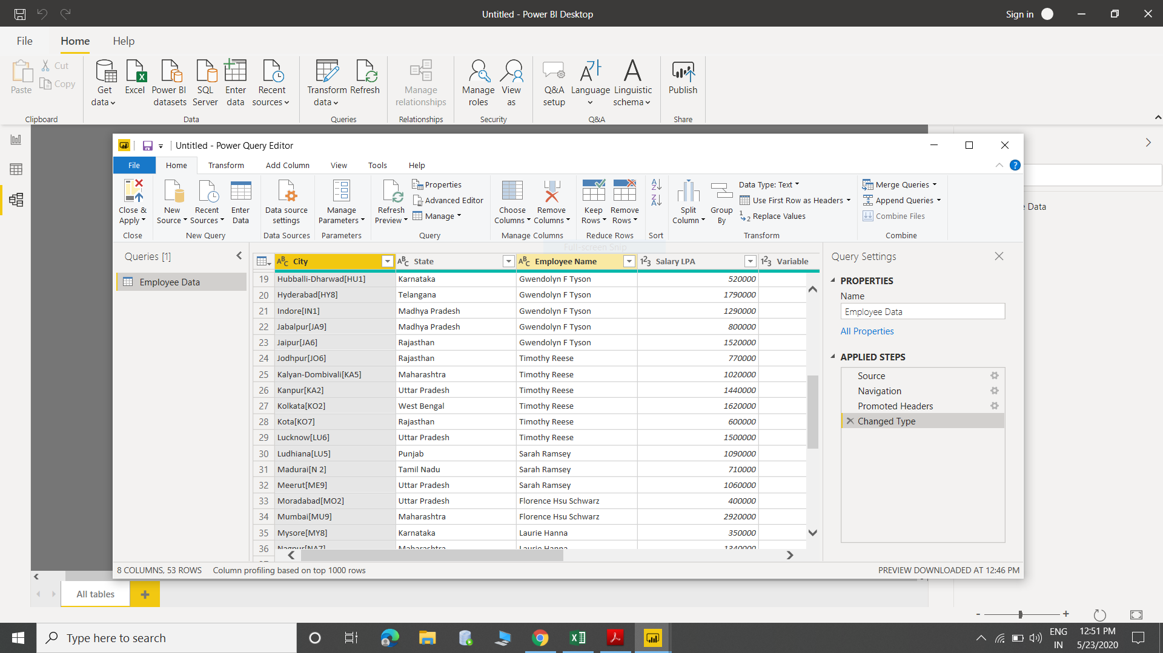

* Advance Editor View

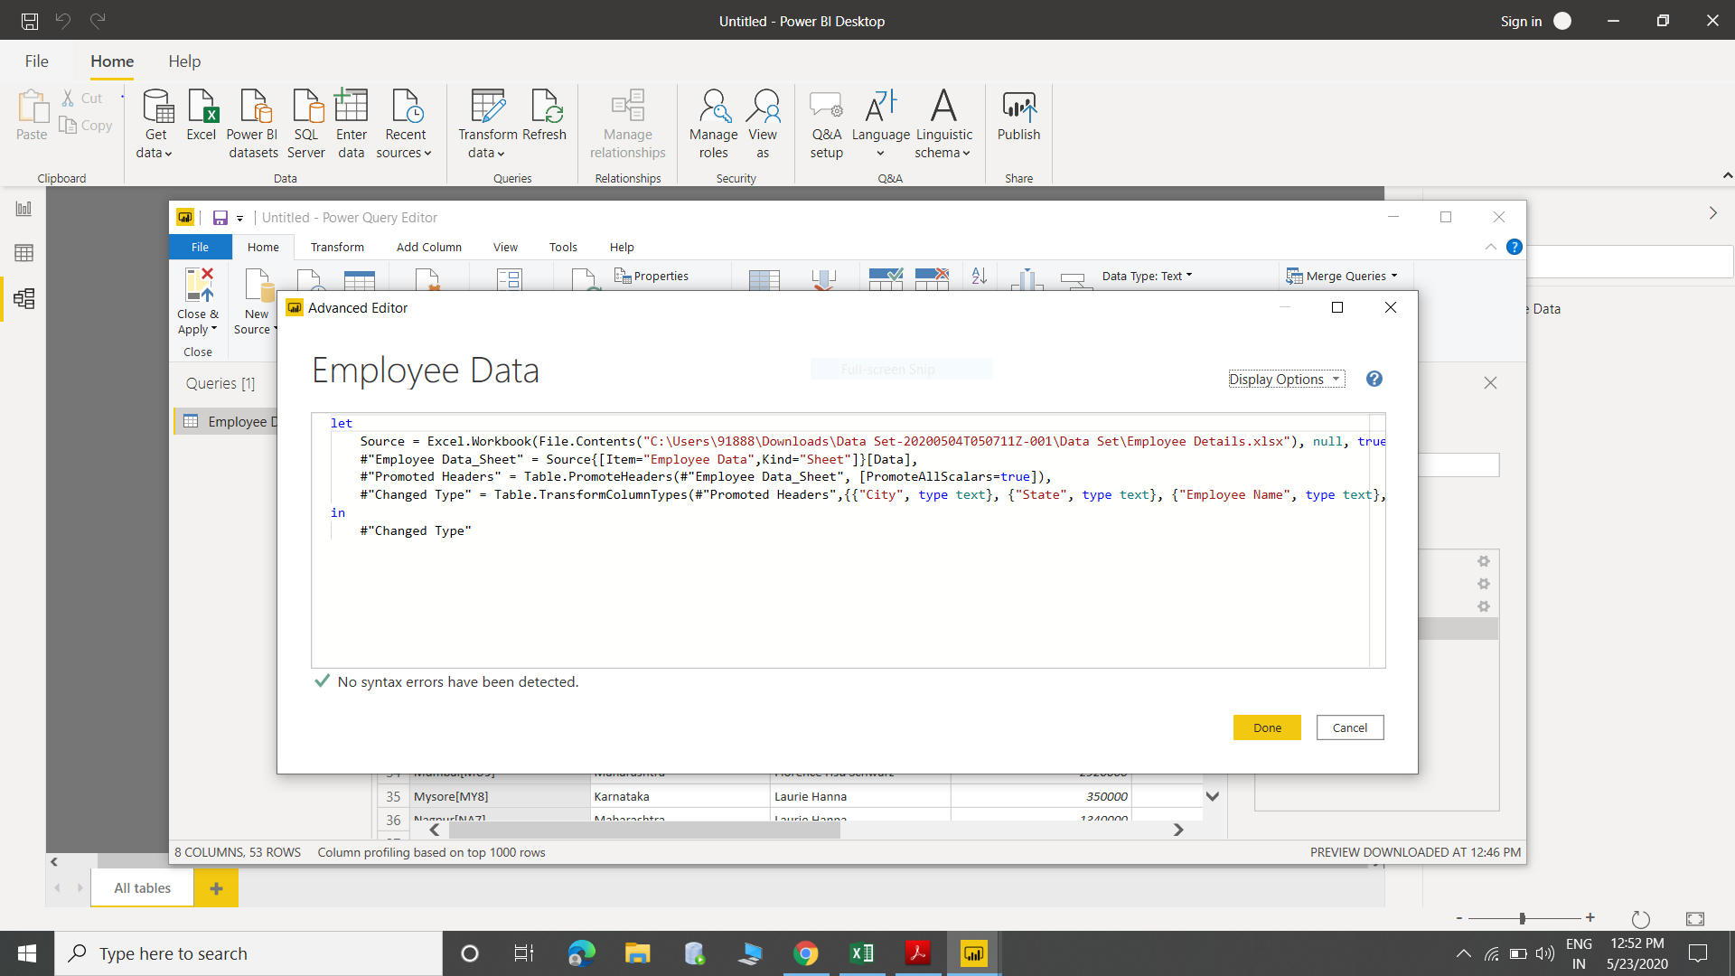

1. **Power BI Desktop**

Power BI Desktop is a free application you install on your local computer that lets you connect to, transform, and visualize your data. With Power BI Desktop, you can connect to multiple different sources of data, and combine them into a data model. This data model lets you build visuals, and collections of visuals you can share as reports, with other people inside your organization. Most users who work on business intelligence projects use Power BI Desktop to create reports, and then use the Power BI service to share their reports with others.

* **Advantages of BI Desktop**

1. Power BI is **simple to use**. Even basic users will find it to have a short learning curve.
2. **Interactive reports and geo-map visualizations.**
3. Dashboards, reports and datasets are at the heart of power. BI.
4. Consistent reporting and analyses with SQL server.
5. Power BI offering security, privacy and compliance.

* **Cost of Power BI Desktop**

It’s free of cost.

1. **Power BI Pro**

Power BI Pro, users are licensed individually and participate fully in the use of Power BI – both the creation of content and the consumption. All Pro users can connect to hundreds of data sources on-premises and in the cloud, create interactive reports and 360-degree dashboards, share that content with other Pro users, and consume content shared by others.

* **Advantages of BI Pro**

1. Self-service and modern BI in cloud
2. Collaboration, Publishing, Sharing, and ad-hoc analysis
3. Fully managed by Microsoft

* **Cost of Power BI Pro**

Paid version cost $9.99 monthly per user

1. **Power BI Premium**

Power BI Premium, you are licensing capacity for your content rather than licensing all users of that content. Content (datasets, dashboards, and reports) is stored in Premium and can then be viewed by as many users as you want, without additional per-user costs. These users can only view content, not create it. Viewing includes looking at dashboards and reports on the web, in our mobile apps, or embedded in your organization’s portals or apps. The creators of content in Premium still need their own Pro licenses.

* **Advantages of BI Premium**

1. Enterprise BI, big data analytics, cloud and on –premises reporting.
2. Advanced administration and deployment controls.
3. Dedicated cloud compute and storage resources.
4. Allows any user to consume power BI content.

* **Cost of Power BI Premium**

$ 4995monthly per dedicate cloud compute and storage resources with annual subscription.