Neural Networks & Deep Learning - ICP-9
Sai Preetham Nagaswaram - 700743350
Git Hub Url:
https://github.com/Saipreethamnagaswaram/ICP9

Program 9:
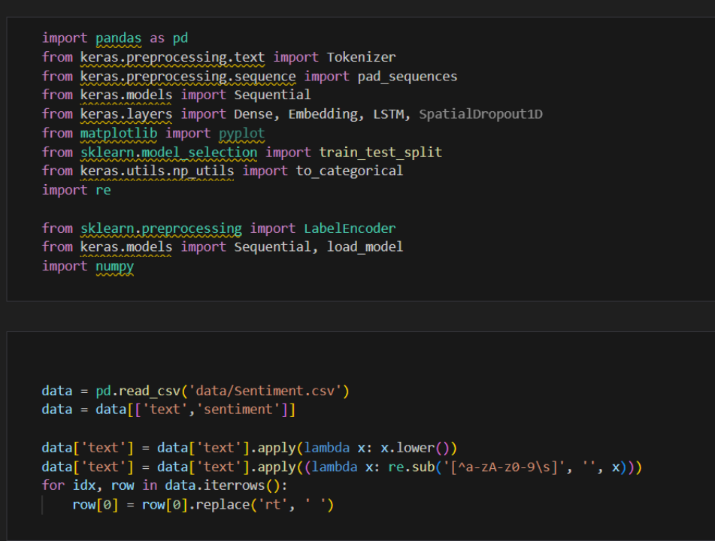

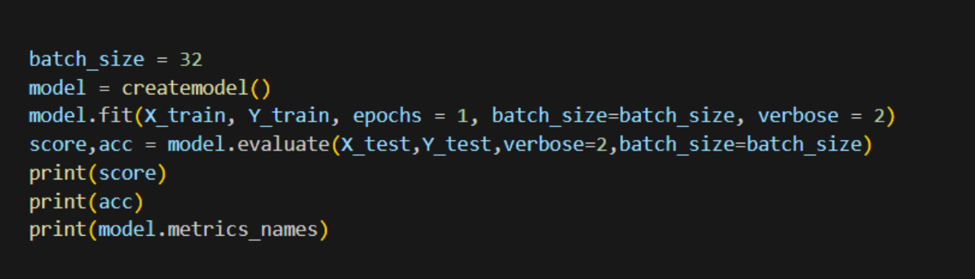

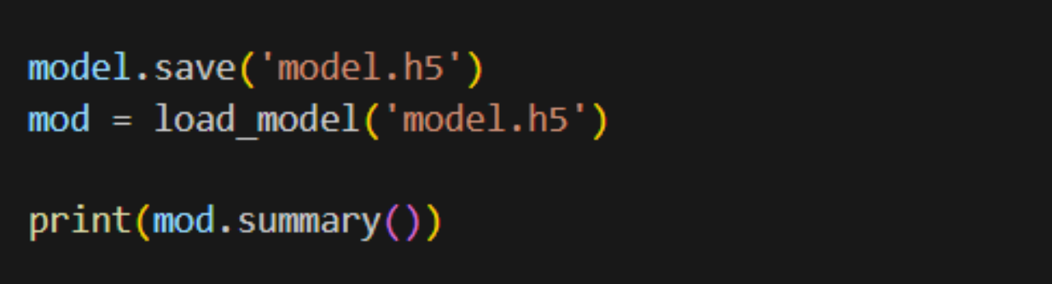
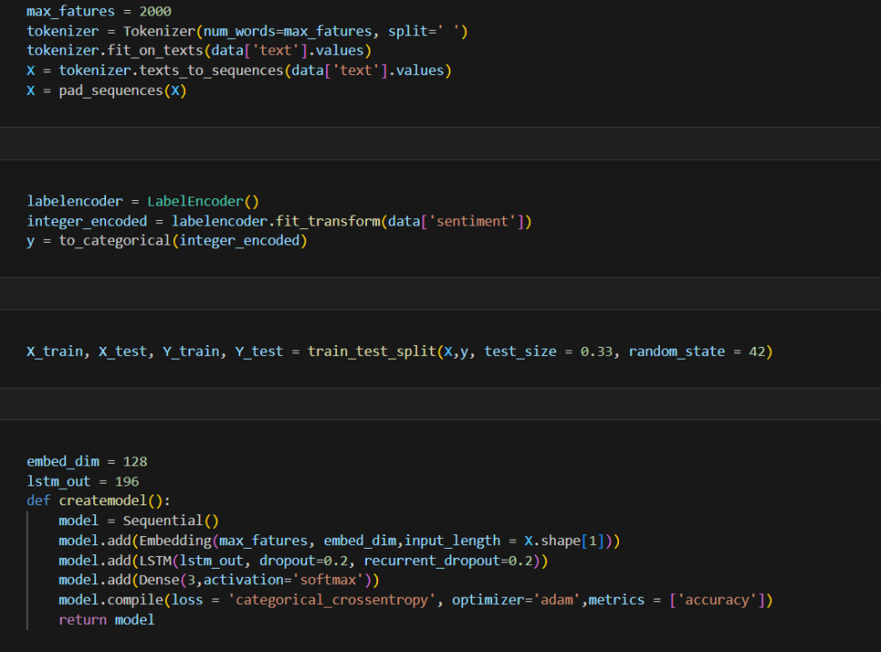

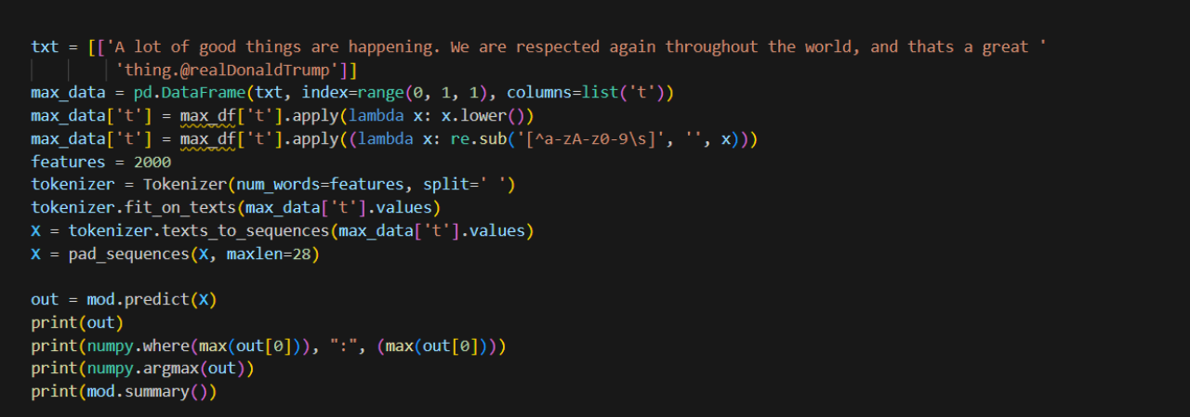

Output:
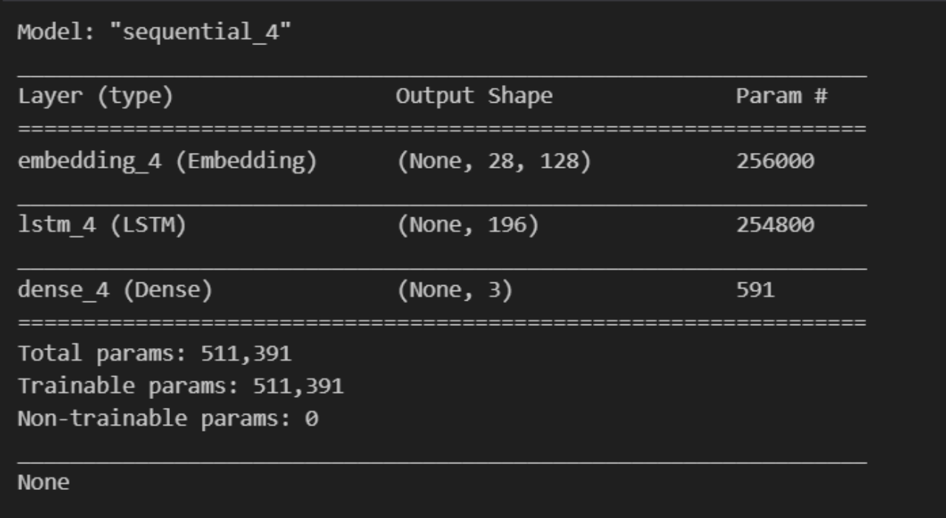
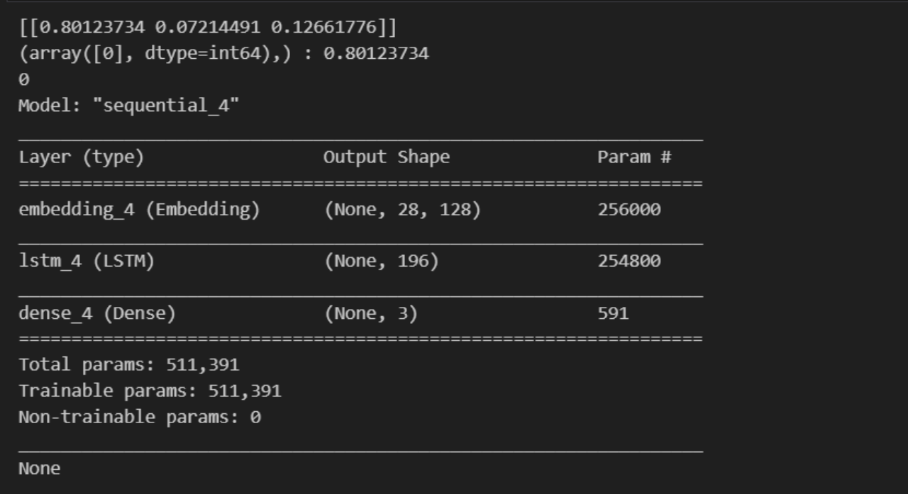

Program 9.2:

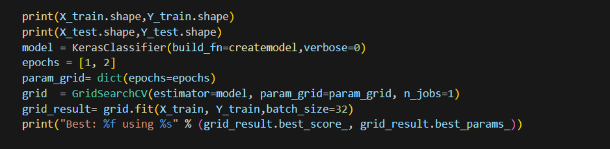

Output:

