**Spring 2024: CS5720 Neural Networks & Deep Learning - ICP-2**

**Sai Preetham Nagaswaram (700743350)**

GitHub Link: <https://github.com/Saipreethamnagaswaram/Neural-Network-Deep-Learning/tree/main/Assignment-2>

Note: Code quality (in terms of time and space complexity) is highly valued

1. Write a program that takes two strings from the user: first_name, last_name. Pass these variables to fullname function that should return the (full name).

o Forexample:  
First_name = “your first name”, last_name = “your last name”

Full_name = “your full name”

o Writefunctionnamed“string_alternative”thatreturnseveryothercharinthefull_namestring. Str = “**G**o**o**d e**v**e**n**i**n**g”  
Output: Go vnn

**Note: You need to create a function named “string_alternative” for this program and call it from main function.**

**Solution:**

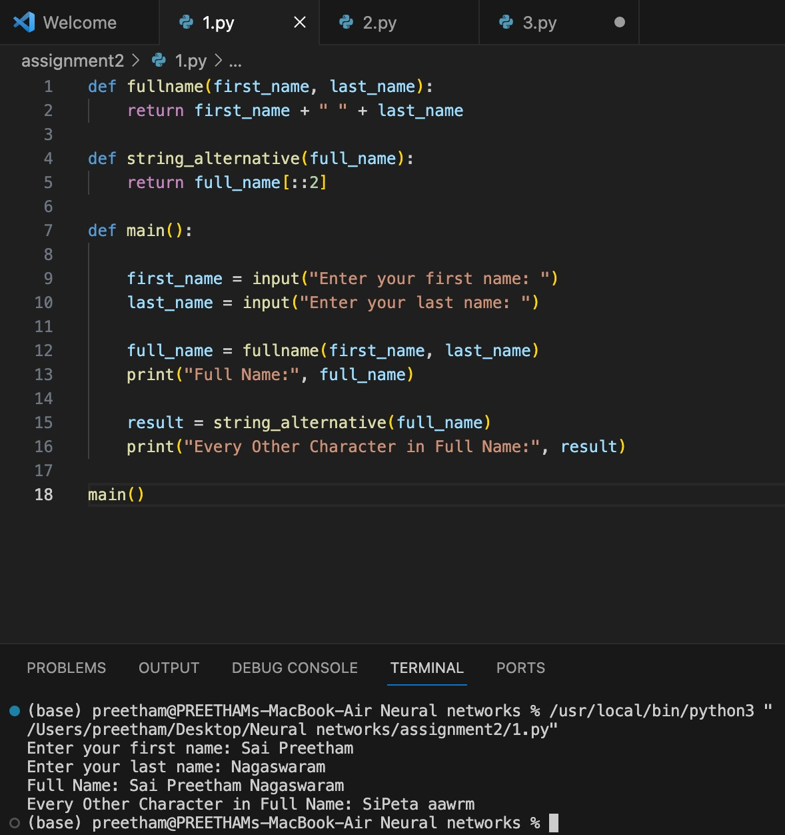

2. Write a python program to find the wordcount in a file (input.txt) for each line and then print the output. o Finallystoretheoutputin**output.txt**file.

Example:

**Input: a file includes two lines:**

Python Course

Deep Learning Course

**Output:**

Python Course  
Deep Learning Course Word_Count:

Python: 1 Course: 2 Deep: 1 Learning: 1

**Solution:**

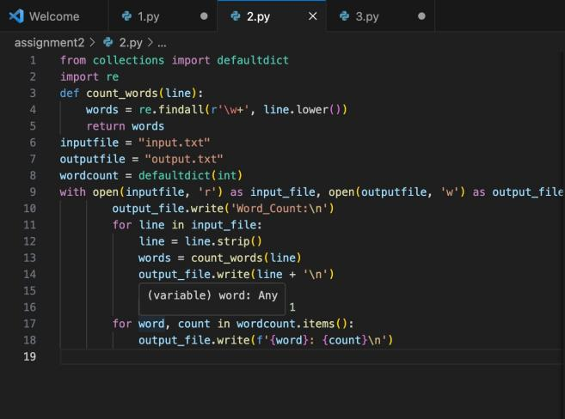

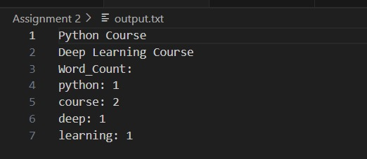

3. Write a program, which reads heights (inches.) of customers into a list and convert these heights to centimeters in a separate list using:  
1) Nested Interactive loop.  
2) List comprehensions

**Example: L1: [150,155, 145, 148]**

**Output: [68.03, 70.3, 65.77, 67.13]**

**Solution:**

